Investigating How Separation Affects Lift and Drag Using the Lafayette College Wind Tunnel with Spheres and a Clark-Y Airfoil

By: Quintin Sefton, Ritika Raghav, and Lauren Leontas
affiliated with the Department of Mechanical Engineering, Lafayette College

- Abstract:
The purpose of this experiment was to investigate bluff and blunt bodies in the Lafayette College wind tunnel using sphere test subjects along with the Clark-Y airfoil. Drag data was taken for 4 smooth spheres of different sizes and a golf ball for varying wind speeds from 0 to 45 m/s. This data was of the general shape and the drag crisis occurred at a consistent Reynolds number of 2.3 * 10^5 and a Cd = .406 +/-.0091. Artificial trips made of wire were attached to a smooth medium sized sphere (10.05cm diam) to trip the flow to turbulence earlier to decrease the drag on the sphere at a lower Reynolds number. With a 40-degree angle wire trip, the coefficient of drag was reduced from Cd = .421 +/- .0065 to Cd = .226 +/- .0057 at Re = 1.4 * 10^5. The flow visualization of the smooth and tripped spheres showed that when turbulence was induced earlier on the sphere, the flow boundary layer stayed attached for longer than the laminar flow counterpart.
A Clark-Y airfoil section was tested in the wind tunnel and compared to Xfoil data at various Re and with experimental results using the Prantl lifting line theory equations. The data showed stall at an angle of attack of 24 degrees and showed a max coefficient of lift of Cl = 2.78 +/- 0.193. The wind tunnel lift coefficient data was on average 27.9% larger in magnitude than the experimental data and there was a 208% error difference for the drag coefficient data. This likely suggests a recalibration of the strain gauges on the sting to account for this error. The flow visualization showed that higher angles of attack showed a larger pressure differential causing more lift, except for when stall occurred causing recirculation zones inducing less lift on the airfoil.

- Introduction and Methods:
Wind tunnels today are used in many applications from autonomous missile design to high-speed aircraft or boats [1]. Ever since George Caley’s first modeling of aircraft using high speeds and smaller objects in 1804, the wind tunnel has provided useful information to be scaled up for larger use in many applications [2]. Aircraft safety in particular benefits from this small-scale testing as Reynolds number scaling allows these results to be scaled up to larger flying objects [3].
This experiment conducted was used to test the viability of the wind tunnel at the Lafayette College Mechanical Laboratory. The data collected was of various spheres to see the graphical “drag crisis”, as well as various angles of attack for the Clark Y airfoil. This data showed the precision and calibration of this wind tunnel and its sensors.
The equations that describe the lift, drag, and Reynolds number for the sphere and airfoil are as follows:
 | $$C_{L}=\frac{F_{L}}{\frac{1}{2}ρv^{2}S}$$ | (1)
$$C_{D}=\frac{F_{D}}{\frac{1}{2}ρv^{2}S}$$ |  | (2)
$${Re}_{D}=\frac{ρvD}{μ} , {Re}_{c}=\frac{ρvc}{μ}$$ |  | (3)
where $ρ$ is the density of the flow, $v$ is the speed of the flow, $μ$ is the viscosity of the fluid, D is the diameter of the sphere, $c$ is the chord length of the airfoil, S is the planform area of the airfoil or the cross-sectional area for the sphere, and $F_{L}$ and $F_{D}$ are the forces of lift and drag respectively. Where the equation for $v$ is:
$$v=\sqrt{\frac{2∆q}{ρ}}$$ | (4)
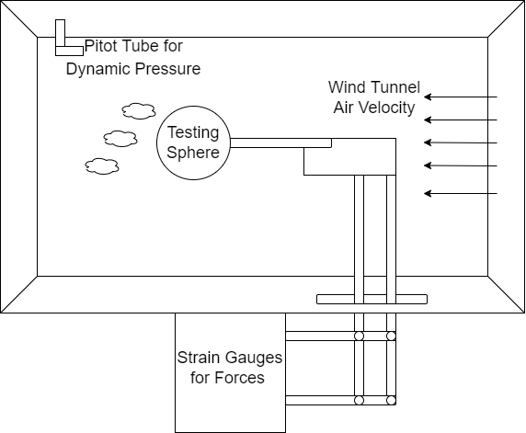
where $α$ is the angle of attack and $∆q$ is the change in dynamic pressure from the room pressure to the pressure in the wind tunnel.
The pressure sting was built and calibrated at Lafayette college. The apparatus consisted of a wind tunnel with velocity of air reaching up to about 45 m/s, multiple different sized wooden test spheres, a Clark Y airfoil with a 10” span and 3.5” chord length, a test golf ball, some wire for trips, a silicon pressure sensor PX137 Series, and strain gauge sensors for normal and axial force measurements.
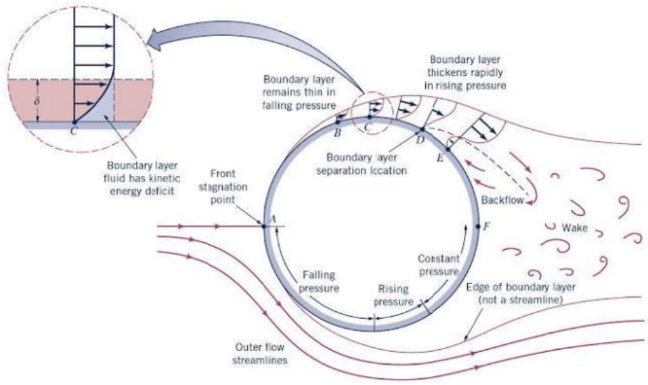
One of the spheres was first places in the test section and the force and pressure sensors were zeroed. Then, dynamic pressure, axial force, and normal force measurements were taken for each increment of 5 m/s going in a range from 0 to 45 m/s. Three to four data points were taken per increment of 5 m/s as the gauges and pressures sensors were very consistent and the standard deviation between data points was small. This was then done with all of the various spheres (a golf ball, D = 4.32cm, and smooth wooden spheres of diameter 4.27cm, 7.66cm, 10.05cm, and 12.59cm). Then, the medium sphere size (10.05cm diam) was investigated for 3 different cases with wire rings taped on to serve as a trip for the air moving over the sphere. This addition of a wire trip would trip the laminar air to turbulence sooner than the air would normally trip on a smooth sphere. This would act similarly to how a golf ball trips the air in its flight pattern. The Clark-Y airfoil measurements were also taken for angles of attack of -21 degrees to 21 degrees of increments of 3 degrees at 30 m/s air speed. This airspeed was fixed as to vary the angle of attack instead. This held the Reynolds number constant for the airfoil analysis.
Figure 1b: Diagram of flow over a blunt body with flow separation due to pressure gradients
Figure 1a: Lab set up with force sensors, pressure gauge, and specimen
The error analysis was calculated for a priori and a posteriori for the sphere data and the airfoil data. The posteriori error was calculated using the standard deviation from the mean. It was found that this a posteriori error was much less significant (<10%) than the a priori error and was therefore omitted from the total calculation of the error bars in the sphere data.
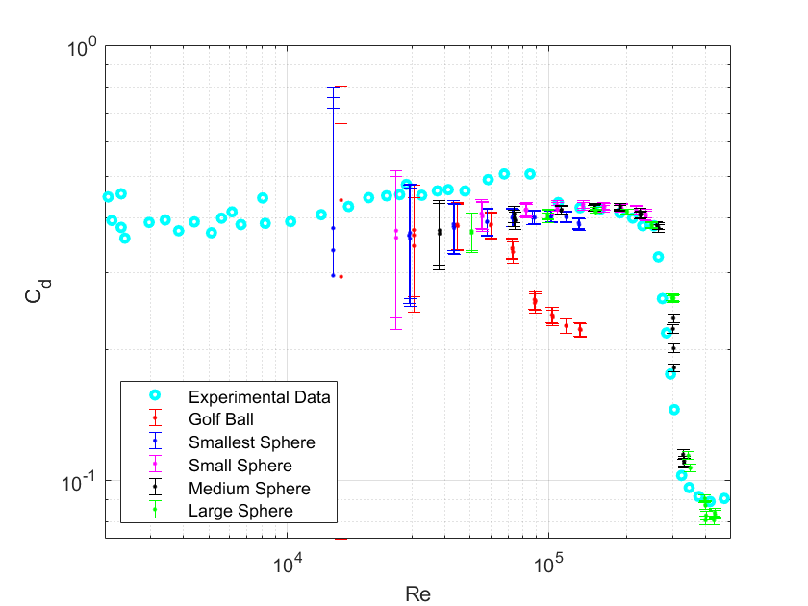
The airfoil data was then compared with Higgins 1927 research data [5] and Xfoil computational data. Similarly, the spherical data was compared with the Morrison 2013 [3] relationship.
- Results and Discussion:
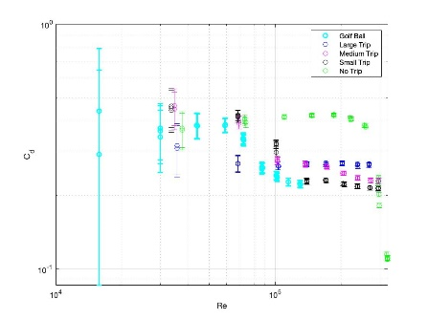
The experiment yielded the results in Figure 2. Spheres were tested and their results were plotted along with experimental data [5] in Figure 2. The data collected shows significant error bars for lower Reynolds numbers as when the wind speed was low in the wind tunnel. The uncertainty in the wind speed became larger as the difference in dynamic pressure became smaller. The general trends for $Re=5*{10}^{4}$ will be the focus for this discussion as the data has reasonable error bars in this region. The qualitative correlation between the current and historical data is very good and follows the experimental drag crisis and end of the drag crisis. The data in Figure 2 is slightly below the experimental data which suggests a calibration issue. Finally, the golf ball should be noted for its departure from the drag crisis at a lower Re than the other spheres. This is because of the dimples on the golf ball allowing for the fluid to ‘trip’ sooner to turbulence and stay closer to the surface of the ball and cause less drag (Fig 4 E). This can be similarly seen in the comparison to Figure 4A and Figure 4C whereas the Re increases, the flow transitions earlier to turbulence along the sphere surface to stay
Figure 3: Various wire trips induced on the medium sized sphere
Figure 2: Coefficient of drag for various spheres
attached to the surface for longer, allowing for a decrease in drag, seen by the end of the drag crisis in Figure 2.

A: Re = 1.04 * 10^5  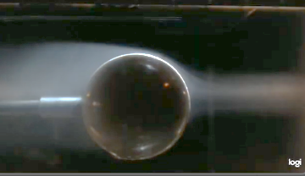 | B: Re = 2.59 * 10^5  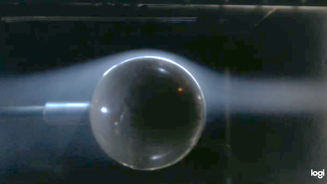
C: Re = 4.43 * 10^5  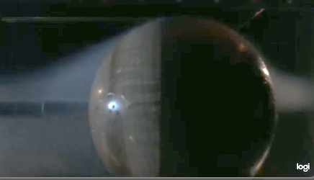 | D: Re = 2.92 * 10^4  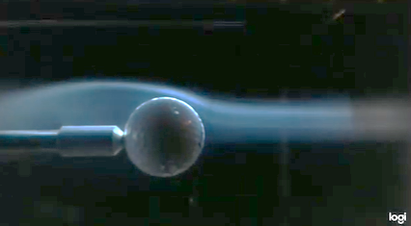
E: Re = 8.75 * 10^4  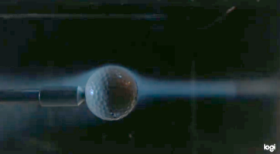 | F: *Tripped* 40-degree trip Re = 2.04 * 10^5  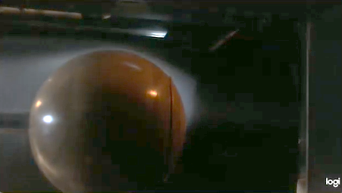
G: $α=12°$ at 30 m/s  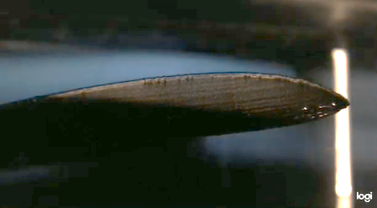 | H: $α=21°$ at 30 m/s  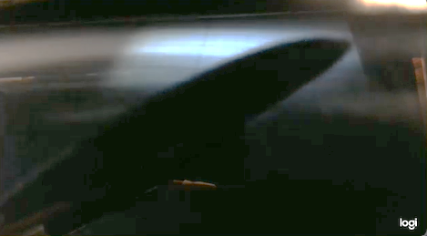
Figure 4: Flow visualization using fog over the various sphere Reynolds numbers and the Clark-Y at different angles of attack
Similarly, Figure 3 and Figure 4F shows how the implementation of various wire planted trips on the spheres impacted the end of the drag crisis. This addition of the trip allowed for the flow to trip to turbulence sooner than it normally would given the Re it is at. This can be seen in the flow visualization of Figure 4F where the boundary layer stays attached to the surface for longer than 4B, showing the end of the drag crisis early for that Re. The red drawn circles indicate the separation point for these spheres.
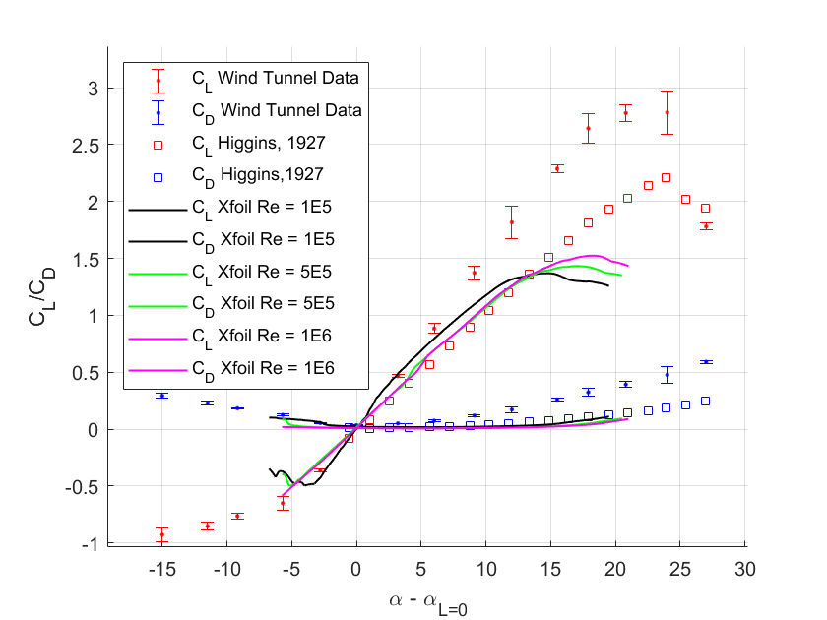
Figure 5 shows the lift and drag coefficient for different angles of attack of the Clark-Y, plotted with Xfoil data at various Re and with experimental results from Higgins, G.J., 1927 [5]. This data was normalized to the angle of attack at zero lift and normalized using the Prandtl lifting line theory with an aspect ratio of 6 to account for the finite length of the wing and test section not allowing for proper wing tip vorticity circulation [4]. The data shows error bars get larger the further from zero lift or drag coefficients become. This is because the main source of uncertainty comes from the a priori error of the pressure gauges which is 1% of the value calculated. The general shape of the data is consistent with the shape of the Xfoil and Higgins 1927 data where the coefficient of lift is linear until stall and the coefficient of drag is parabolic. This stall can be seen in the flow visualization of Figure 4H (as compared to Figure 4G) where the flow has a significant pressure difference across the airfoil until there is a detached boundary layer resulting in a significantly reduced lift force. On the back of the airfoil in Fig 4H, a recirculation zone can also be noticed which also explains the significant reduce in lift coefficient attributing to the stalling process. The data collected is inconsistent with the Xfoil and Higgins data with further deviations from an angle of attack of 0. On average, as compared to the Higgins 1927 data set, there was 31.1% error difference on each data point for the lift coefficient, and 208% error difference on each data point for the drag coefficient. This was a result of an average of 27.9% overshoot on each coefficient of lift data point. This error difference could be a result of the assumption that an aspect ratio of 6 to account for wind tip vortices was not congruent for this airfoil or could warrant a recalibration of the strain gauges. Since this data has been conducted to have less error in the past, the difference is this data is significant enough to warrant a recalibration of the normal and axial force sensors in the future. Likely, the normal force sensor is the most needing of a calibration as this would account for most of the error in coefficient of lift. This experiment helped explain how separation point, pressure differentials, and boundary layer separation play into lift and drag for blunt and bluff bodies.
Figure 5: Drag and lift coefficient for the Clark-Y for experimental data in the wind tunnel, along with Xfoil and Higgins 1927 data
- Conclusions:
Wind tunnel data was taken for 4 smooth sized spheres and a golf ball for varying wind speeds from 0 to 45 m/s. This data was compared with Schlichting, H., & Kestin, J. (1979). The artificial wire trips and golf ball were also put into the wind tunnel which tripped the flow to turbulence earlier to have an end to the drag crisis earlier than the smooth spheres (Fig 3). The most effective trip was the large trip with an angle of about 40 degrees from the horizontal (Fig 4F). The flow visualization of these spheres showed the boundary layers stayed attached for longer when the flow was turbulent on the sphere in higher Re cases, or with an induced trip.
Then, the Clark-Y airfoil section was put into the wind tunnel and compared to Xfoil data at various Re and with experimental results from Higgins, (1927) [5] (Fig 5). The collected data was similar in shape to the previous work but was inconsistent for angles of attack further from 0 degrees. The wind tunnel data lift coefficient data was 31.1% error difference, and 208% error difference on the drag coefficient data points with an average of 27.9% overshoot on each coefficient of lift data (Fig 4). This suggests a recalibration of the force sensors on the wind tunnel to account for this difference.
This work created useful data that can be used to calibrate the wind tunnel in the Lafayette College laboratory to do further research in a new area of research with the certainty that the wind tunnel calibration is consistent with previous and realizable data.
- References:
[1] – Wild, Flint. “What Are Wind Tunnels?” NASA, NASA, 29 Apr. 2015, https://www.nasa.gov/audience/forstudents/k-4/stories/nasa-knows/index.html
[2] - Paur, Jason. “May 27, 1931: Wind Tunnel Lets Airplanes 'Fly' on Ground.” Wired, Conde Nast, 27 May 2010, https://www.wired.com/2010/05/0527langley-field-wind-tunnel
[3] - Morrison, F. A. (2013). An Introduction to Fluid Mechanics. New York, NY: Cambridge University Press.
[4] - Schlichting, H., & Kestin, J. (1979). Boundary- layer Theory (7.th ed.). New York, NY: McGraw-Hill.
[5] - Higgins, G.J., "The characteristics of the N.A.C.A 97, Clark Y, and N.A.C.A.
M6 airfoils with particular reference to the angle of attack", NACA TN 270, Dec 1927.

