Investigating How Fuel Injection and RPM Affects the Efficiency of a Gas Turbine Engine

By: Quintin Sefton, Ritika Raghav, and Lauren Leontas
affiliated with the Department of Mechanical Engineering, Lafayette College

- Abstract:
The purpose of this experiment was to investigate the SR – 30 Minilab turbine engine with military/commercial JP – 8 kerosene fuel and the states efficiencies. The gas turbine was powered on and injected with varying mass flow rates of fuel to result in turbine speeds from 45,000 to 78,000 rpm. K – type thermocouples, and pitot tubes were used to measure the temperature and pressure at various states inside of the turbine. The entropies at each state were calculated to determine the efficiencies. It was found that the propulsive efficiency at full throttle (78,000 rpm) was 0.25 +/- .039. When this is compared to the B707 turbojet, having a propulsive efficiency range of approximately 45-55%, the SR-30 gas turbine was not as propulsively efficient as the B707 engine, but still is efficient to use. [7]. Also, there is a noticible decrease in propulsive efficiency with an increase in RPM due to energy being used by frictional losses. As the RPM increases, there is more energy needed to overcome the increase in friction from the engine, instead of the energy going into thrust. At maximum throttle position, the combustor efficiency was calculated to be 1.79 +/- .075. The combustor efficiency is greater than 1 due to the non-uniform temperature distribution before and after the combustor, and the single point nature of the thermocouples used. This gave rise to “hot spots” and a higher-than-expected efficiency calculated. The increase in combustor efficiency with engine speed was because of higher compression ratios leading to closer together molecules, increased mixing through the dilution air holes in the combustor lining, and a more stable flame. These effects lead to more fuel being burned and a more efficient energy extraction from the fuel. Next, the maximum compressor efficiency was calculated to be 0.58 +/- .024 and it was found that compressor efficiency increased as RPM increased. This was also due to the pressure ratio being directly related to the performance of the efficiency. Finally, the full throttle Thrust Specific Fuel Consumption (TSFC) for this gas turbine was measured to be 42.1 +/- 1.7 g/kN-s. This value was found to be sensible as it is smaller than the older and simpler 1958 J-58 turbojet engine which has a TSFC of 53.8 g/kN-s [6].
- Introduction and Methods:
Gas turbines are used all over the world in providing thrust or mechanical energy from chemical energy stored in fuel molecules [1]. From 2021 to 2028, the market for gas turbines is expected to have a compound annual growth rate of 6.8% [2]. Gas turbines are an integral part of aircraft and missiles in providing thrust, and in generators in providing mechanical work for a system [3]. As fuel prices get higher over the years, more efficient turbines become crucial to saving the most amount of money and creating the least number of emissions necessary [3]. This research measured relevant quantities to determine the various component efficiencies in a gas turbine engine and how they varied with rotations per minute of the turbine.
The equations that describe the efficiency of the propulsion system and the fuel consumption are as follows:
 | $$Thrust Specific Fuel Consumption \left(TSFC\right) = \frac{{\dot{m}}_{fuel}}{Thrust}$$ | (1)
$$η_{prop} = \frac{Thrust ×V_{1}}{\left({\dot{m}}_{air}+{\dot{m}}_{fuel}\right)\left(h_{05}-h_{5}\right)-{\dot{m}}_{air}(h_{01}-h_{1})}$$ |  | (2)
where ${\dot{m}}_{air},{\dot{m}}_{fuel}$ are the mass flow rates of air and fuel, $V_{1}$is the velocity of the air at the inlet, and h is the enthalpy at a given state where the subscript 0 denotes a stagnation quantity. The states are: 1: post inlet, pre-compressor, 2: post compressor, pre-combustor, 3: post combustor, pre-turbine, 4: post turbine, pre-nozzle, 5: nozzle exit. The two main components analyzed were the combustor and the compressor which had efficiency equations as follows:
$$η_{comb} = \frac{(1+f)h_{03}-h_{02}}{fQ_{JetA}}$$ | (3)
$$η_{comp} = \frac{h_{02s}-h_{01}}{h_{02}-h_{01}}$$ | (4)
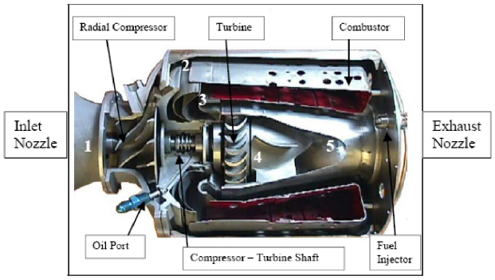
where the fuel fraction, $f={{\dot{m}}_{fuel}}/{{\dot{m}}_{air}}$, $Q_{JetA}=$ heat of combustion, and $h_{02s}$ represents the theoretical enthalpy if a constant entropy process was taken from state 1 to the same isobaric line as state $h_{02}$ lies on.
The gas turbine used was a SR-30 Minilab engine shown in Figure 1. Military/Commercial JP-8 Kerosene was used as fuel with a heat of combustion of 43,000 kJ/kg. Pitot tubes were used to measure the dynamic pressure, and Type K thermocouples were used to measure temperatures at various inlets and exits of the gas turbine components. The CoolProps Thermochemical calculator was used to determine properties of the air fuel mixture at various states and allow for calculations of entropy and then efficiencies of the various states [4].
Figure 1: Gas Turbine engine with pressure and temperature sensors for measuring the various states and processes.
The turbine was first powered on with an initial ignite of the fuel. Then, the injected fuel rate was varied corresponding to twelve different RPM values ranging from 45,000 to 78,000. Each state was allowed to reach steady state, which took approximately 5-6 seconds to reach. The temperature and pressure measurements then allowed for the efficiencies and relevant quantities to be calculated. The efficiencies were then plotted against RPM to see the correlation between RPM (which is proportional to fuel intake) and efficiency.
- Results and Discussion:
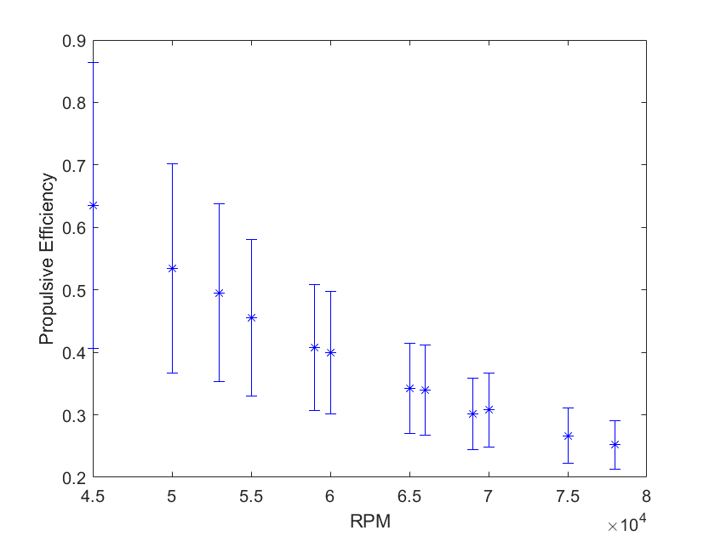
First, Figure 2 shows that the propulsive efficiency decreases with an increase in RPM. The propulsive efficiency is a measure of how efficient the thrust power of the engine is to how much fuel is being injected. There is a noticible decrease in propulsive efficiency with an increase in RPM beause of frictional losses. As the RPM increases, there is more energy needed to overcome the increase in friction from the engine, instead of the energy going into thrust. Next, the error on Figure 2 shows that there is more uncertainty in measurements in values with smaller RPMs. The largest source of error in the propulsive efficiency calculation was the temperature measurements. Since there were four independent temperature measurements in the calculation, the uncertainty was high. Finally, the propulsive efficiency at full throttle was calculated to be 0.25 +/- .039. When this is compared to the B707 turbojet, having a propulsive efficiency range of approximately 45-55%, the SR-30 gas turbine is not as propulsively efficiency as the B707 engine, but still is efficient to use. [7]. This SR-30 engine is not as propulsively efficient as the B707 engine, as the SR-30 prioritized being less expensive to manufacture and more compact, rather than the priority being placed on propulsive efficiency, as is very important commercial Boeing 707 engine.
Figure 2: Propulsive Efficiency decreasing as RPM increases
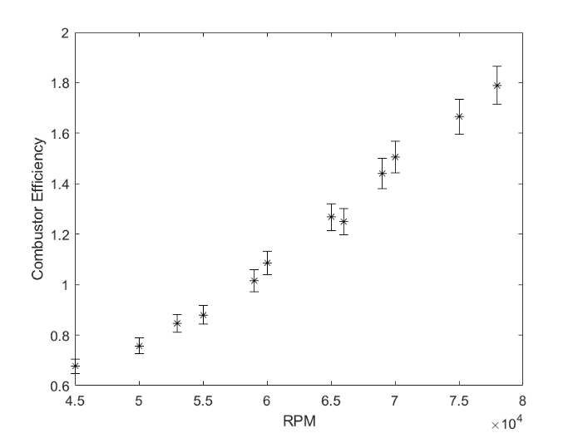
Figure 3 shows the efficicncy of the combustor with respect to RPM. The maximum combustor efficiency recorded was 1.79 +/- .075. This efficiency was greater than 1. This is due to the non-uniform temperature distribution of combustion, and the single point thermocouple readings leading to data that can be susceptible to “hot spots.” These “hot spots” lead to higher than average temperature readings and higher efficiencies. However, this trend of increase in combustor efficiency with RPM is still evident. This suggests that with more fuel being added to the combuster, the more percent of the fuel being combusted: like a chain reaction. Looking at Eqn 3, if this efficiency was going up, then as the ratio of ${{\dot{m}}_{fuel}}/{{\dot{m}}_{air}}$ was increasing slower than the difference of the numerator of Eqn 3. This is because the compression ratio increases with RPM. At higher compression ratios the molecules are closer together: allowing for more efficient combustion to occur and combustion efficiency to rise. At higher compression ratios, there is a larger pressure differential in the combustor lining allowing for more mixing of air into the fuel through the dilution air holes. This increased mixing of the fuel leads to a more stable flame, more fuel being burned, and a higher combustor efficiency. Finally, the error bars on Figure 3 are significantly smaller than Figure 2 because the combustor efficiency calculator depends on less temperature measurements and the uncertainties in the mass flowrate for the fuel is low. The direct relationship between combustor efficiency and RPM is strong with the given uncertainties in Figure 3.
Figure 3: Combustor Efficiency increasing with RPM
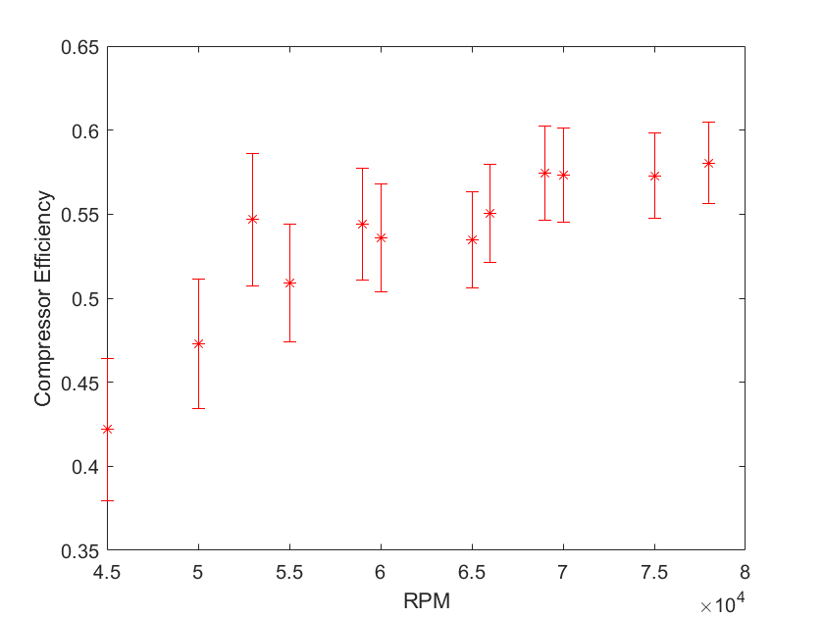
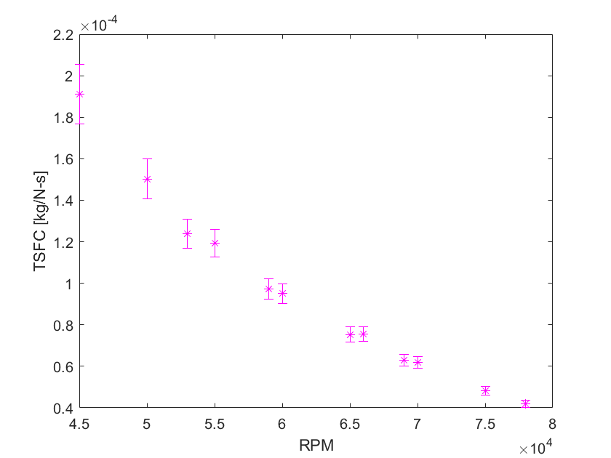
Figure 4 depicts the compressor efficiency increasing with RPM. The compressor efficiency represents the ratio of actual enthalpy change over the compressor, versus the enthalpy change of an isentropic and constant entropy compresson of the ideal Brayton Cycle. The increase in compressor efficiency with RPM can be understood with the idea of compression ratio and delivery of fluid. At a higher RPM of the compressor, the compression ratio increases. If there is a higher compression ratio, then the compression processes is more isentropic and the difference in entropy is very small [5]. The uncertainty in the compressor efficiency values were similar in size to each other but were more uncertain for smaller RPM values. The compressor efficiency at full throttle was calculated to be 0.58 +/- .024.
Figure 4: Compressor Efficiency increasing with RPM
Figure 5 shows TSFC versus RPM and the uncertainty associated with those values. Figure 5 shows that TSFC decreases as RPM increases. This decrease in TSFC translates to a more fuel efficient thrust producing engine as RPM increases. This can be explained by the combustor efficiency. The combustor efficiency increased as RPM increased which is the leading cause of why the TSFC value decreases with RPM. Next, the TSFC value at full throttle was measured to be 42.1 +/- 1.7 g/kN-s. This value is reasonable as it is similar to an example turbojet engine called the 1958 J-58 which has a TSFC of 53.8 g/kN-s [6]. It is interesting to note that the SR-30 MiniLab engine’s TSFC value is smaller than the J-58 as the SR-30 engine is not designed to be fuel efficient or produce a large amount of thrust, but rather for experimental purposes. Finally, the decrease in the uncertainty in the TSFC values as RPM increased was due to increased thrust values with mass flowrate uncertainty being the main uncertainty in the calculation for Eqn 1.
Figure 5: Thrust Specific Fuel Consumption (TSFC) decreasing with RPM
Conclusions:
This experiment investigated how the variance in fuel intake and engine speed (rpm) of the turbine affected the efficiencies of various thrust components for the SR – 30 gas turbine. Temperature, pressure, flow rate, and wind speed measurements were taken and used to find the enthalpies at various states of the turbine cycle. These states were compared with the ideal Brayton Cycle counterpart to investigate efficiencies of this turbine. Specifically, the TSFC, propulsive efficiency, combustor efficiency, and compressor efficiency were measured and plotted against the RPM of the turbine and compressor.
It was found that at max throttle of 78,000 rpm, the propulsive efficiency was calculated to be 0.25 +/- .039 and decreased as RPM increased. This was consistent with the B707 turbojet propulsive efficiency of 45-55%. At max throttle position, the combustor efficiency was 1.79 +/- .075. This combustor efficiency greater than 1 is due to the non-uniform temperature gradients before and after the combustor leading to single point temperature transducers reading possible “hot spots”. The trend of increasing combustor efficiency as turbine speed increased was due to the compression ratio having a direct relationship to combustion efficiency, and the combustion liner air dilution holes being more effective at higher pressures. The compressor efficiency at full throttle was calculated to be 0.58 +/- .024 and would increase as RPM increased. The Thrust Specific Fuel Consumption at maximum throttle position was measured to be 42.1 +/- 1.7 g/kN-s. This was lower than the 1958 J-58 which has a TSFC of 53.8 g/kN-s [6]. This is because the J-58 is simply an older and more simple design than the more recent SR-30 MiniLab engine.
This experiment could be expanded upon in the future by more accurately measuring the average temperatures and pressures in the non-uniform regions at the various states of the gas turbine to better rate the engines enthalpy changes and efficiencies.
- References:
[1] – What is a gas turbine and how does it work? RealPars. (2021, November 21). Retrieved April 17, 2022, from https://realpars.com/gas-turbine/
[2] - Gas turbine market share & trends report, 2021-2028. Gas Turbine Market Share & Trends Report, 2021-2028. (n.d.). Retrieved April 17, 2022, from https://www.grandviewresearch.com/industry-analysis/gas-turbine-market
[3] - How a gas turbine works: GE Gas Power. gepower-v2. (n.d.). Retrieved April 17, 2022, from https://www.ge.com/gas-power/resources/education/what-is-a-gas-turbine
[4] – Bell, I. H., Wronski, J., Quoilin, S., & Lemort, V. (2014). Pure and Pseudo-pure Fluid Thermophysical Property Evaluation and the Open-Source Thermophysical Property Library CoolProp. Industrial & Engineering Chemistry Research, 53(6), 2498–2508. doi:10.1021/ie4033999
[5] - Compression efficiency. Compression Efficiency - an overview | ScienceDirect Topics. (n.d.). Retrieved April 17, 2022, from https://www.sciencedirect.com/
[6] - Mattingly, J. D. (2005). Elements of Gas Turbine Propulsion. https://soaneemrana.org/. Retrieved April 17, 2022, from https://soaneemrana.org/
[7] - Read "commercial aircraft propulsion and Energy Systems Research: Reducing Global Carbon Emissions" at nap.edu. National Academies Press: OpenBook. (n.d.). Retrieved April 19, 2022, from https://nap.nationalacademies.org/read/23490/

