**Microbially Induced Calcite Precipitation**

Background (plagiarized heavily from Graddy et al., 2018)

Worldwide demand for new and sustainable approaches to solve challenging geotechnical engineering problems has generated novel research opportunities in the emerging field of bio-mediated soil improvement (DeJong et al., 2010). The most widely researched of these processes has been Microbially Induced Calcite Precipitation (MICP; DeJong et al., 2006). In many of the first studies, bio-augmented MICP was accomplished by adding to a soil a high density of the constitutively ureolytic bacterium, *Sporosarcina pasteurii*. The amended soil was then supplemented with liquid medium containing calcium salts, urea, and sometimes growth-promoting organic compounds. Bacterial hydrolysis of one molecule of urea generates one molecule of carbonic acid (H2CO3) and two of ammonia (NH3). The resulting ammonia, being a weak base, equilibrates in water to form ammonium and hydroxide ions (pKa = 9.3; Stumm & Morgan, 1996). This shifts the H2CO3 / HCO3- / CO32- equilibrium (pKa1 = 6.35; pKa2 = 10.33; Stumm & Morgan, 1996) toward carbonate, which will precipitate, in the presence of sufficient calcium, as calcium carbonate. Electron microscopy has shown that calcium carbonate deposition can occur in the immediate vicinity of these bacteria, thereby cementing adjacent soil particles, resulting in increases in soil strength and stiffness (DeJong et al., 2006, DeJong et al., 2010).

Bio-augmented MICP has shown promise for a variety of engineering applications (Montoya & DeJong, 2015) including the mitigation of earthquake-induced soil liquefaction (Montoya et al., 2013). The approach has also shown potential for coprecipitation of divalent radionuclides in artificial groundwater (Mitchell & Ferris, 2005, Mitchell & Ferris, 2006). Occasionally, other urease-positive bacterial species have also been employed for bio-augmented MICP (Cheng & Cord-Ruwisch, 2012).

Researchers have also explored an alternate approach, termed bio-stimulated MICP, in which the proliferation of ureolytic bacteria naturally present in soils is promoted prior to the cementation phase, in lieu of adding a cultured strain. Early studies of bio-stimulation focused on ureolytic soil bacteria in aqueous microcosms, sometimes also demonstrating calcite precipitation (Gat et al., 2016). Procedurally, bio-stimulation treats the target soil with a solution that lacks calcium salts, but contains urea and organic compounds that encourage the growth of ureolytic bacteria. When these bacteria have been sufficiently enriched, as judged by the rate of urea disappearance in the pore fluid, bio-cementation is enabled by the inclusion of calcium in subsequent application of the treatment solution. A recent meter-scale side-by-side comparison of MICP completed by using bio-augmentation and bio-stimulation in two separate soil tanks suggested that both approaches were equally effective with respect to improving soil engineering properties (Gomez et al., 2017). In column experiments completed on 14 different sandy soils from different depositional environments, including several samples obtained from natural deposits as deep as 12 m, bio-stimulated MICP was always successful (Gomez et al., 2018). The achievement of bio-stimulated MICP in these experiments, involving diverse, nutrient poor sands, suggests that ureolytic bacteria capable of catalyzing this geotechnical process may be widespread in natural soil systems (Gat et al., 2016).

Materials & Methods (each **bold-faced** item will be found in your lab-in-a-box):

Column setup – Ottawa 50/70 sand:

1. Obtain **two 60-ml syringes** from your lab-in-a-box.
2. Cut circles of the **Scotch-brite** to the exact inner diameter of the syringe (the goal is to prevent sand from escaping the column at the bottom and to prevent disruption of the top of the column as you add media.
3. Coat the inside of the columns (from the 10 ml mark to the 50 ml mark) with mineral oil or petroleum jelly (Vaseline or generic brand), liberally.
   1. To coat with petroleum jelly, place a liberal amount on your finger, coat the inside of the column – you'll likely need to add petroleum jelly from both ends to cover between 10 ml and 50 ml marks.
   2. To coat with mineral oil, put the plunger into the syringe to the 50 ml mark, turn upside down and pour in mineral oil to the 10 ml mark. Pour mineral oil back into bottle and allow the column to drain over paper towel.
4. Insert one of the cut scotch-brite circles from the lower end of the "column".
5. Insert about **18" of aquarium tubing** into the hole in the large end of the **rubber stopper** and insert the small end of the rubber stopper into the bottom of the column.
6. Using a pencil or other long instrument, push the scotch-brite circle down against the rubber stopper.
7. Set up the **pegboard** by inserting it vertically into the **two wooden legs**.
8. Using the **twist ties**, attach each column to the pegboard. Loop the bottom tubing into one of the top holes in the pegboard and secure with a **small binder clip**.
9. Pour **Ottawa 50/70 sand** into one column up to the 50 mL mark. Be sure to label this column as "Ottawa 50/70 sand".
10. Put another cut scotch-brite circle on top of the sand column.
11. To enable your column to stay hydrated for 24 hours (in the next step), be sure the exit tubing (the bottom tubing) is secure in the pegboard.

Column setup – native soil:

1. Venture into the world with your course notebook, a clean sandwich plastic bag, metal spoon, and your phone or other device to gather GPS coordinates.
2. Dig.
3. Avoid the following: mulch, grass, and top soil. You want to dig a few inches down so that you have the mineral layer of earth.
4. Collect 1 – 2 cups of this layer of earth. Write down the GPS coordinates in your notebook. Head home.
5. Set up a second column using steps 1-7 above (substituting your newly collected soil in place of the Ottawa 50/70 sand. Be sure to label this column as "native soil".
6. To enable your column to stay hydrated for 24 hours (in the next step), be sure the exit tubing (the bottom tubing) is secure in the pegboard.

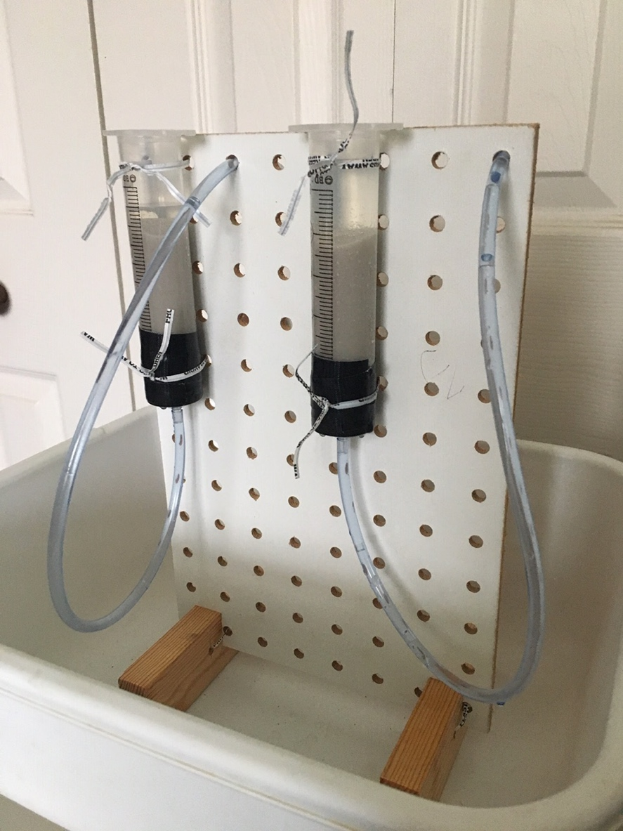

Saturate each column with stimulation solution by following the steps below.

Mixing and using the concentrated **stimulation solution**:

There is a small plastic bottle in your lab-in-a-box with all the ingredients for the concentrated stimulation solution. Add distilled water to the 100 ml mark on the bottle and shake. It will take 10-15 min of shaking to get the chemicals into solution. [Note: the solution will get warm? Cold? Generate gas? – add details here so they know what to expect.]

The stimulation solution contains:

0.1 gm/L yeast extract

100 mM ammonium chloride

42.5 mM sodium acetate

350 mM urea

The care and feeding of your columns:

At approximately the same time of day, for the next seven days, dilute 5 ml of stimulations solution stock with 45 mls of distilled water. You can use the **blue screw-capped conical tube** as your measuring device. Add to column. Watch this video to see how it's done.

Mixing and using the concentrated **cementation solution**:

The second plastic bottle in your lab-in-a-box contains everything you need to mix up the concentrated cementation solution. Add distilled water to the 200 ml mark and shake.

0.1 gm/L yeast extract

100 mM ammonium chloride

42.5 mM sodium acetate

350 mM urea

250 mM calcium chloride

Microbial analysis:

Pore fluid from the biostimulation tank will be serially diluted 10-fold and plated on alkaline culturing agar. Colonies most closely matching the morphology of *S. pasteurii* ATCC 11859 will be purified by sequential passages of isolated colonies (streak for isolation) and frozen at -80°C.

Alkaline culturing broth: 20 g/L yeast extract, 75 mM ammonium sulfate, 130 mM tris base; plates contain 16 g/l agar. All components need to be autoclaved separately and combined once cooled to 55°C. The final pH is approximately 8.5.

Urea hydrolysis will be confirmed on urease slants: 1 g/L peptone, 1 g/L dextrose, 5 g/L sodium chloride, 2 g/L potassium phosphate monobasic, 2.4 mL/L 0.5% phenol red and 15 g/L agar (pH 6.9), autoclave, supplemented (after cooling to 55°C) to a final concentration of 333 mM urea from a filter-sterilized stock, and divided into 3 mL aliquot in angled screw cap 12 mm culture tubes. Isolated colonies from fresh plates will be streaked onto the surface of slants, and urea hydrolysis was determined by the appearance of a pink color within 48 h at 30°C.

Burbank, M., Weaver, T., Green, T., Williams, B., Crawford, R. Precipitation of calcite by indigenous microorganisms to strengthen liquefiable soils. Geomicrobiol. J. 2011, 28: 301-312.

Cheng, L., Cord-Ruwisch, R. In situ soil cementation with ureolytic bacteria by surface percolation. Ecological Engineering, 2012, 42:64-72.

DeJong, J., Mortensen, B., Martinez, B., Nelson, D. Bio-mediated soil improvement. Ecological Engineering 2010, 36:197-210.

DeJong, J., Fritzges, M., Nusslein, K. Microbially induced cementation to control sand response to untrained shear. J. Geotech. Geoenviron. Eng. 2006, 132: 1381-1392.

Gat, D., Roney, Z., Tsesarsky, M. Soil bacteria population dynamics following stimulation for ureolytic microbial-induced CaCO3 precipitation. Environ. Sci. Technol. 2016, 50: 616-624.

Gomez, M., Anderson, C., Graddy, C., DeJong, J., Nelson, D., Ginn, T. Large-scale comparison of bioaugmentation and biostimulation approaches for biocementation of sands. J. Geotech. Geoenviron. Eng. 2017, 143: 04016124.

Gomez, M., Graddy, C.M.R., DeJong, J.T., Nelson, D.C., Tsesarsky, M. Stimulation of native microorganisms for biocementation in samples recovered from field-scale treatment depths. J. Geotech. Geoenviron. Eng. 2017, 143: 04017098.

Graddy, C.M.R., et al., 2018. Diversity of *Sporosarcina*-like bacterial strains obtained from meter-scale augmented and stimulated biocementation experiments. Environmental Science & Technology, 52:3997-4005.

Mitchell, A., Ferris, F. The coprecipitation of Sr into calcite precipitates induced by bacterial ureolytic in artificial groundwater: temperature and kinetic dependence. Geochim Cosmochim. Acta, 2005, 69:4199-4210.

Mitchell, A., Ferris, F. Effect of strontium contaminants upon the size and solubility of calcite crystals precipitated by the bacterial hydrolysis of urea. Environ. Sci. Technology. 2006, 40: 1008-1014.

Montoya, B.M., DeJong, J.T. Stress-strain behavior of sands cemented by microbially induced calcite precipitation. J. Geotech Geoenviron Eng. 2015, 141: 04015019..

Montoya, B.M., DeJong, J.T., Boulanger, R.W. Dynamic response of liquefiable sand improved by microbial-induced calcite precipitation. Geotechnique 2013, 63:302-312.

Stumm, W., Morgan, J.J. Aquatic chemistry: chemical equilibrium and rates in natural waters, 3rd ed.; Wiley: New York, 1996.