**LVAIC Mathematics Contest – November 11, 2018**

*Do as many of these problems as you can.*

*No calculators of any sort, notes, or reference materials are allowed.*

*Your solutions must be complete and your work justified to receive full credit.*

*Each solution must be written on a separate piece of paper with your team’s code on it.*

1. Gary and Tom have invented a new way to waste time. They choose three single digits: *a, b,* and *c* that are different and are all non-zero. They then make up all possible three digit numbers that contain each of the digits exactly one. (Thus, if *a=*3*, b*=7*,* and *c=*2, a possible three digit number is 723.) Whenever they do this, they find that there are always two such three digit numbers *x* and *y* such that *x* and *y* are different and *x-y* is divisible by 20. Prove that this is always the case (so that Gary and Tom can stop trying to check this by hand).

2. Find the number of divisors of 

3. You are on the Island of Alternators, looking for an inhabitant named Pat. The inhabitants of the island are called Alternators because each one alternates telling the truth with lying. That is, if the last statement made by a specific Alternator is true, the next one made by that same Alternator will be false, and if the last statement was false, the next one will be true. You know Pat is one of a group of four Alternators. Each of them makes the statement “I am Pat”. You may now ask a total of two questions with yes or no answers to individual members of the group, and you may direct each question to whomever you choose. Propose a method by which you can determine which inhabitant is Pat. (Note – The inhabitants you ask must be able to give yes or no answers to your questions, regardless of who is Pat.)

4. Suppose you roll a fair six-sided die until you get each of the numbers one through six at least once. On average, how many times will you need to roll the die?

5. An L-quadromino is an L-shaped tile containing 4 squares. The following picture shows how you can tile a 4x4 board using L-quadrominoes. Note that in a tiling, every square of the board must be covered and no square must be covered more than once.



Show that a 2018x2018 board cannot be tiled by L-quadrominoes. An L-quadromino may be rotated or reflected in any direction when placed on the board. You may assume that the sides of   
each L-quadromino are parallel to the sides of the board.  
  
6. Suppose that you are on the xy-plane starting at the origin. Your goal is to move to the point (2018,0). To accomplish this, you are allowed to move your position by taking one of two steps: either you can increase your x-value and y-value both by one, or you can increase your x-value by one and decrease your y-value by one. However, you are not permitted to allow your y-value to go above 1 or below -1. So, the start of one possible path would be:



How many unique paths are there from (0,0) to (2018,0)?

7. Suppose there exist real numbers *a*, *b*, and *c* that satisfy the inequalities

  

Show that one of the numbers *a*, *b*, or *c* must be equal to the sum of the other two.

8. Suppose that the LVAIC competition has grown to include 2018 competing schools. A delegate from each school has been selected and they have been seated around a very large table.   
Each delegate is seated in front of a pair of lights, green or red, to indicate a yes or no vote on an issue, and has a button to enable that delegate to vote. The plan was to have the button toggle the lights in front of the delegate (i.e., if the green light was previously lit, it goes out and the red light is lit instead, and vice versa). Unfortunately, the electrician hired to wire the buttons has gone crazy, and has instead wired all of them to toggle both the pair of lights in front of that delegate, and also the pair of lights immediately to that delegate's right and left. Show that, no matter what the previous states of all the lights, there is a sequence of button pushes that allows each delegate to cast a vote as intended.

9. How many zeros does 2018! end with?

10. Suppose you have two concentric circles, one with radius 1 and the other with radius , between which are  mutually tangent circles, as shown in the figure below.

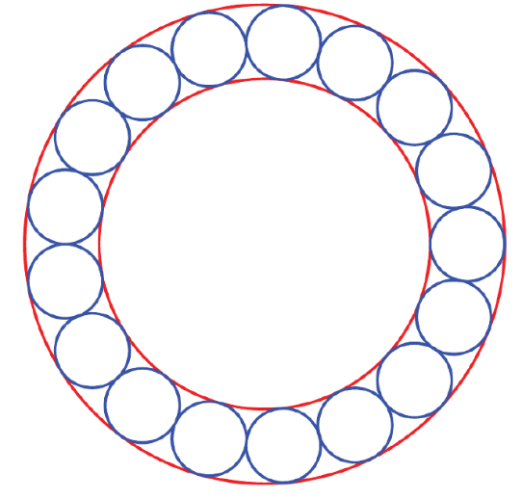

Find the value of  in terms of *n*.