Lafayette College
Department of Civil and Environmental Engineering

CE 321: Introduction to Environmental Engineering and Science Fall 2019

Homework #11
Due: Wednesday, December 5, 2019

- Suppose some wastewater had a BOD₅ equal to a 180 mg/L and a reaction rate k equal to 0.22/day. It also has total Kjedahl nitrogen content (TKN) of 30 mg/L.
  - Find the ultimate carbonaceous oxygen demand (CBOD).
  - Find the ultimate nitrogenous oxygen demand (NBOD).
  - Find the remaining BOD (nitrogenous plus carbonaceous) after five days have elapsed.

- A wastewater treatment plant discharges 1.0 m³/s of effluent having an ultimate BOD of 40 mg/L into a stream flowing at 10.0 m³/s. Just upstream from the discharge point, the stream has an ultimate BOD of 3.0 mg/L. The deoxygenation constant k_{d} is estimated at 0.22/day.
  - Assuming complete and instantaneous mixing, find the ultimate BOD of the mixture of waste and river just downstream from the outfall.
  - Assuming a constant cross-sectional area for the stream equal to 55 m², what BOD would you expect to find at a point 10,000 m downstream.
- The wastewater in Problem 2 has DO equal to 4.0 mg/L when it is discharged. The river has its own DO, just upstream from the outfall, equal to 8.0 mg/L. Find the initial oxygen deficit of the mixture just downstream from the discharge point. The temperatures of sewage and river are both 15ºC.

- Two point sources of BOD along a river (A and B) cause the oxygen sag curve shown in the following image.

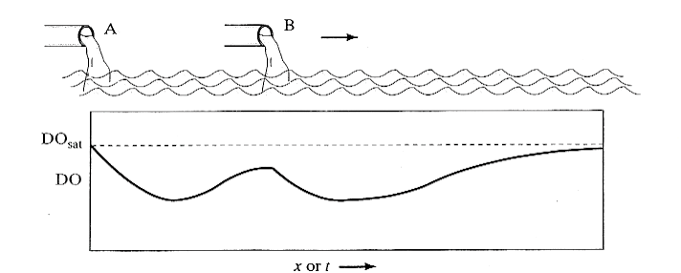
  - Sketch the rate of reaeration vs. distance downriver.
  - Sketch L_{t} (that is, the BOD remaining) as a function of distance downriver.
- Untreated sewage with a BOD of 240 mg/L is sent to a wastewater treatment plant where 50 percent of the BOD is removed. The river receiving the effluent has the oxygen sag curve as shown in the following figure (the river has no other sources of BOD). Notice that downstream is expressed in both miles and days.
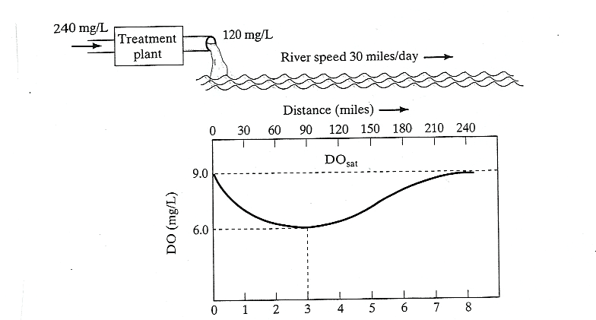

  - Suppose the treatment plant breaks down and it no longer removes any BOD. Sketch the new oxygen sag curve starting just after the breakdown. Label the point which represents the critical distance downriver.
  - Sketch the oxygen sag curve, as it would have appeared four day after the breakdown of the treatment plant.

- The ultimate BOD a river and sewage outfall, after mixing, is found to be 50 mg/L. Also the DO is found to be at a saturation value of 10.0 mg/L after mixing, therefore no initial deficit. The deoxygenation rate coefficient k_{d} is 0.30/day and the reaeration rate coefficient k_{r} is 0.90/day. The river is flowing at the speed of 48.0 miles per day. The only source of BOD in this river is the single outfall.
  - Find the critical distance downstream at which DO is minimum.
  - Find the minimum DO.
  - If a wastewater treatment plant is to be build, what fraction of the BOD would have to be removed from the sewage to assure a minimum DO concentration of 5.0 mg/L everywhere downstream?
- A city of 200,000 people deposits 37 cubic feet per second (cfs) of sewage having a BOD of 28.0 mg/L and 1.8 mg/L of DO into a river that has a flow rate of 250 cfs and a flow speed of 1.2 ft/s. Just upstream of the release point, the river has a BOD of 3.6 mg/L and a DO of 7.6 mg/L. The saturation value of DO is 8.5 mg/L. The deoxygenation coefficient k_{d} is 0.61/day and the reaeration coefficient k_{r} is 0.76/day. Assuming complete and instantaneous mixing of the sewage and river find
  - The initial oxygen deficit and ultimate BOD just downstream of the outfall
  - The time and distance to reach the minimum DO
  - The minimum DO
  - The DO that could be expected 10 miles downstream
- The town of Martins Creek, PA, has filed a complaint with the Department of Environmental Protection (DEP) citing the town of Portland, PA, for the discharge of raw sewage into the Delaware River. The raw sewage is considered to be the cause of high fecal coliform counts and reduced levels of dissolved oxygen (DO), which have lead to foul odors along the river between Portland and Martins Creek. The coliform counts and reduced DO levels have lead to restrictions of recreational areas within the Portland/Martins Creek reach of the Delaware River.
The DEP water quality criterion for the Delaware River is 5 mg/L of DO (i.e. at no point shall the DO concentration drop below 5 mg/L).
Martins Creek is 15.55 km down stream of Portland.
The following data pertain to the 7-year, 10-day low flow at Portland
______________________________________________________________________

Parameter Wastewater Delaware River just above Portland

Flow (m³/sec) 0.1507 1.08
BOD₅ at 16ºC (mg/L) 128.00 Not provided
BOD_{u} at 28ºC (mg/L) Not provided 11.40

DO (mg/L) 1.00 7.95

k at 20ºC (day⁻¹) 0.4375 k of BOD in river is based on WW
Temperature (ºC) 16.00 28.00

Data of river after WWTP

Average Speed (m/sec) N/A 0.390
Average Depth (m) N/A 2.80
Bed-activity coefficient N/A 0.200

A) What is the DO concentration as mg/L at Martins Creek?

B) Does your answer make sense based on the complaint received?

