Lafayette College
Department of Civil and Environmental Engineering

CE 321: Environmental Engineering and Science Fall 2019

Homework #3
Due: Wednesday, 9/18/19

- Calculate the hydraulic residence times (the retention time) for Lake Superior and for Lake Erie using data in the following Table.

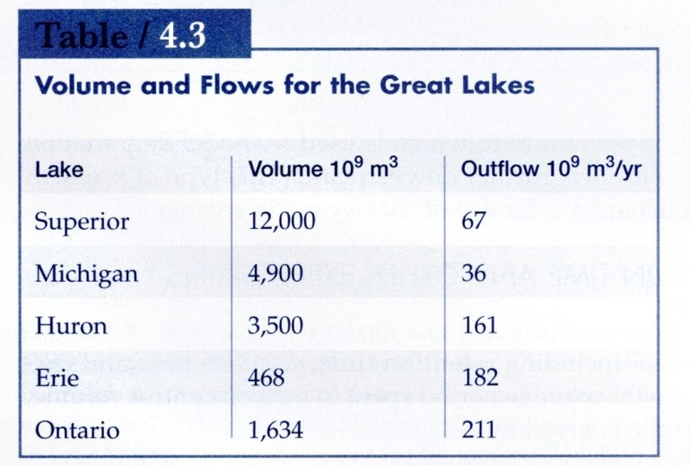

- The Rappahannock River near Warrenton, VA, has a flow rate of 3.00 m³·s⁻¹. Tin Pot Run (a pristine stream) discharges into the Rappahannock at a flow rate of 0.05 m³·s⁻¹. To study mixing of the stream and river, a conservative tracer is added to Tin Pot Run. If the instruments that measure the tracer can detect a concentration of 1.00 mg·L⁻¹, what minimum concentration must be achieved in Tin Pot Run so that 1.00 mg·L⁻¹ of the tracer can be measured after the river and stream mix?
Assume that the 1.00 mg·L⁻¹ of tracer is to be measured after complete mixing of the stream and Rappahannock has been achieved and that no tracer is in Tin Pot Run or the Rappahannock above the point where the two streams mix. What mass rate (in kilogram per day) of tracer must be added to Tin Pot Run? (Answer 263.52 or 264 kg·day⁻¹)
- Five million gallons per day (MGD) of a conservative substance, with concentration 10.0 mg/L, is released into a stream having an upstream flow of 10 MGD and substance concentration of 3.0 mg/L. Assume complete mixing.
  - What is the concentration in ppm just downstream?
  - How many pounds of substance per day pass a given spot downstream?
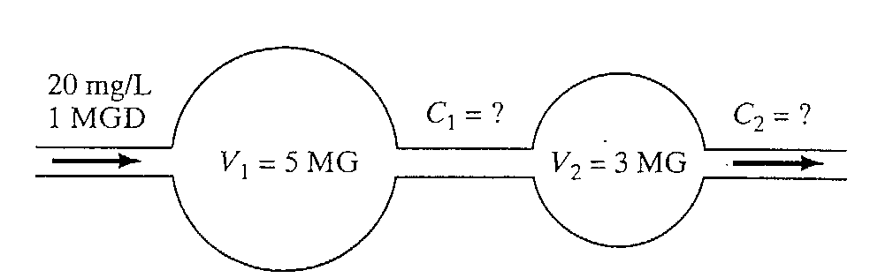
- The two-pond system shown in the following figure is fed by a stream with a flow rate of 1.0 MGD and a BOD (nonconservative pollutant) concentration of 20 mg/L. The rate of decay is 0.30/day. The volume of the first pond is 5.0 million gallons and the second is 3.0 million gallons. Solve for C₁ and C₂ in mg/L.

- Poorly treated municipal wastewater is discharged to a stream. The river flow rate upstream of the discharge point is Q_{u/s} = 8.7 m³/s. The discharge occurs at a flow of Q_{d} = 0.9 m³/s and has a BOD concentration of 50.0 mg/L. Assuming that the upstream BOD concentration is negligible; what is the BOD concentration just after the discharge point? Assume complete mixing.

- A river with 400 ppm of salts (a conservative substance) and an up stream flow of 25 m³/s receives an agricultural discharge of 5.0 m³/s carrying 2000 mg/L of salts (see figure below, P1.7). The salts quickly become uniformly distributed in the river. A municipality just downstream withdraws water and mixes it with enough pure water (no salt) from another source to deliver water having no more than 500 ppm salts to its customers.
What should the mixture ratio (F) of pure water to the river water be?
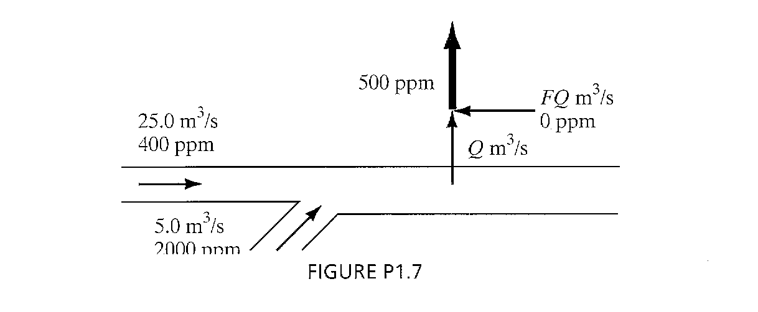
- A pollutant which degrades according to the equation dC/dt = -kC is said to react according to ______________________ kinetics.

- In a material balance problem, the situation where the rate of accumulation is zero is referred to as _____________________________.

- Joe works in an AEC laboratory, room 104. He would like to prepare 1 liter of a sodium chloride solution with a concentration 250 mg/L. Joe is planning on using a standard solution of sodium chloride. The standard solution that Joe purchases has known concentration of sodium chloride equal to 1000 mg/L.
To make the 1 liter, 250 mg/L sodium chloride solution Joe will combine some volume deionized water (DI) with some volume of the of the standard solution. DI is 100% water, no other chemicals are present; therefore the concentration sodium chloride in the DI is 0 mg/L.
What volume of DI water and what volume of standard solution is need to make the 1 liter of a sodium chloride solution with a concentration 250 mg/L? SHOW ALL WORK! Report your answers for each as LITERs.

