Laboratory 1 – CE 321, Fall 2017 (updated 8-14-18)

Hydrology/Water Quality Interaction, Community Engagement, & Watershed Delineation

Objectives
- investigate water quality and mass-balance applications using a model watershed
- demonstrate proficiency through delivery of a community-based engagement lesson
- become familiar with USGS topographic maps and learn how to delineate watersheds

Background
When we use the “watershed management approach” in environmental engineering and science, it is essential to be able to accurately determine the drainage area (i.e. the watershed) for any point of interest along a stream. As we will discuss, water quality at any location along a stream or river or in a lake depends upon land-use within the watershed draining to a particular location. Delineation of a watershed is done by outlining the boundaries, therefore an understanding of how to read a topographic map is a necessary skill. Once delineated one can determine the drainage area within a watershed.

Watershed Management Approach
Watershed Management is a holistic approach to managing water resources for quantity and quality within a watershed. Watershed management is also a useful, proactive approach in areas without immediate problems. By looking at watersheds as a defined, manageable area, a state, municipality or town can better evaluate all the sources of pollution that may be affecting the water quality and quantity.

Water Pollution
When evaluating water quality we generally consider potential sources of pollution. Some sources can be clearly identified as coming from a particular source, i.e., point source. Other sources may be difficult to track to a particular point, and therefore identified as nonpoint sources pollution.
- Point Source Pollution - A source of pollution that can be attributed to a specific physical location -- an identifiable, end-of-pipe "point." The vast majority of point source discharges of nutrients are from wastewater treatment plants, although some come from industries.
- Nonpoint Pollution – Nonpoint source pollution generally results from land runoff, precipitation, atmospheric deposition, drainage, seepage or hydrologic modification. Nonpoint source (NPS) pollution, unlike pollution from industrial and sewage treatment plants, comes from many diffuse sources. NPS pollution is caused by rainfall or snowmelt moving over and through the ground. As the runoff moves, it picks up and carries away natural and human-made pollutants, finally depositing them into lakes, rivers, wetlands, coastal waters and ground waters.

Logistics
There are three parts to this lab: water quality/mass balance pollution interactions within a watershed, development of a community engagement lesson and a lesson about topography and watershed delineation. Group work will be done in teams of 2-3 students.

I. Water quality/hydrology interactions

First we will differentiate between two key contributors to water pollution, turbidity and conductivity. Next we will use a small model of a watershed to demonstrate how elements of turbidity and conductivity migrate through a watershed. Finally we will learn about the chemical and physical properties of turbidity and conductivity.

a. Turbidity vs. Conductivity (Entire Class)
Soil is the primary constituent of turbidity and salts are the primary constituents of conductivity. Soil from farm fields and construction sites are key contributors of turbidity and typically considered as primary sources of nonpoint pollution. Road salt is also a common nonpoint source pollutant to freshwater streams, particularly in northern latitudes where it is used for deicing. Industrial water pollution, a typical type of point source pollution, can include turbidity, conductivity as well as non-ionic chemicals contamination and color of which we will not cover in today’s lab.

Turbidity
Turbidity is caused by particles suspended or dissolved in water that scatter light making the water appear cloudy or murky. It is commonly reported as measurements of Nephelometric Turbidity Units (NTU), but sometime as Jackson Turbidity Units (JTU).
Excessive turbidity in lakes, rivers and streams can affect light penetration and productivity, recreational values, and habitat quality, and cause lakes to fill in faster. In streams, increased sedimentation and siltation can occur, which can result in harm to habitat areas for fish and other aquatic life. Waterways that show an increase in turbidity over time may have an issue of increased erosion along banks, which may have a long-term effect on a body of water.
Excessive turbidity in drinking water is evident by cloudiness, therefore aesthetically unappealing, and may also represent a health concern. Turbidity can provide food and shelter for pathogens. If not removed, turbidity can promote regrowth of pathogens in the distribution system, leading to waterborne disease outbreaks, which have caused significant cases of gastroenteritis throughout the United States and the world. Although turbidity is not a direct indicator of health risk, numerous studies show a strong relationship between removal of turbidity and removal of protozoa. The particles of turbidity provide "shelter" for microbes by reducing their exposure to attack by disinfectants. Microbial attachment to particulate material has been considered to aid in microbe survival. Fortunately, traditional water treatment processes have the ability to effectively remove turbidity when operated properly. (Source: EPA)
We will measure soil concentration in water indirectly through a light scattering technique. A common piece of equipment used to measure turbidity is the turbidimeter.

Conductivity
As one may recall from chemistry class, salts in general are ionic compounds that dissociate in water resulting in the production of cations and anions. Road salts impact water quality by increasing the ionic strength (i.e., conductivity) of water significantly which result in very corrosive conditions. In addition to commonly used road salts found in waterway (NaCl and MgCl₂) other salts found include CaCl₂, CaCO₃, MgCO₃, and NaHCO₃. There are alternatives to traditional road salts that are less corrosive, such as Calcium Magnesium Acetate (CaMg₂(CH₃COO)₆), also known as CMA, but can be 10 to 15 times as expensive.
We will measure the salt concentrations indirectly - by measuring the electronic conductivity. An interesting point as we consider salts in water - it takes only one teaspoon of road salt to permanently pollute 5 gallons of water. Once in the water, the only effective treatment for removing chloride is RO, reverse osmosis. At high concentrations (greater than 1000 ppm (ppm = mg/L)), chloride can harm fish and plant life.

b. Watershed Model (Entire Class) (Combine with Part e)
The watershed model is used to demonstrate the difference between point and nonpoint source pollution as well as the mechanism for transporting pollution to a waterway
- Point Source Pollution: The U.S. Environmental Protection Agency (EPA) defines point source pollution as “any single identifiable source of pollution from which pollutants are discharged, such as a pipe, ditch, ship or factory smokestack” (Hill, 1997). Most such sources are required to have a discharge permit, i.e. a NPDES permit. NPDES is an acronym for National Pollutant Discharge Elimination System
- Nonpoint Source Pollution: Most nonpoint source pollution occurs as a result of runoff. When rain or melted snow moves over and through the ground, the water absorbs and assimilates any pollutants it comes into contact with (USEPA, 2004b). Following a heavy rainstorm, for example, water will flow across a parking lots and roads picking up oil and other chemicals left by cars or used to salt roads as well as particulate matter. Water that flows across large fields, construction sites and large areas of land will also pick up chemicals, soil as well as other types particulate matter. When you see a rainbow-colored sheen on water flowing on an asphalt surface or water containing soil particles, you are actually at evidence of nonpoint source pollution.
Another example of typical non-point pollution is the presence of chemicals referred to as nutrients. Nitrogen (N) and Phosphorus (P) are key fertilizers used to feed our lawn and grow our crops. When these nutrients (i.e. chemicals) are added in excess to lawns and farm fields, the excess N and P can led to cause large algae blooms – when the algae dies off and decays, its decomposition can consume all the oxygen in the water, making it unable to support life (e.g. the dead zone in the Gulf of Mexico).
For obvious reasons, this type of pollution is much more difficult to regulate and control. EPA uses a TMDL approach (TMDL = total maximum daily load) to regulate nonpoint pollution. This is a calculation of the total amount (mass) of pollutant that a waterbody can receive and still meet its water quality standard. The TMDL is then allocated to various sources in the watershed so that a limit on the amount coming from each source can be determined.

c. Measuring turbidity (Group Effort)
Turbidity is measured in NTU: Nephelometric Turbidity Units. The instrument used for measuring it is called nephelometer or turbidimeter, which measures the intensity of light scattered at 90 degrees as a beam of light passes through a water sample.

Using water supplied by the instructor, measure and record the turbidity and conductivity of the following samples. (350 ml DI Water)

- DI Water Turbidity______NTU; Conductivity_______uS/cm

- DI Water with 1 mg. of soil particles Turbidity______NTU; Conductivity_______uS/cm

- DI Water with 1 mg salt Turbidity______NTU; Conductivity_______uS/cm

- Mix 1 mg of soil to #3 Turbidity______NTU; Conductivity_______uS/cm

- Add 5 ml of CMA to DI water Turbidity______NTU; Conductivity_______uS/cm

Discuss and report your observations and results with your partner.

- Do soil particles in water cause high turbidity?

- Does the salt water cause high turbidity? How about CMA?

- Do soil particles in water cause high conductivity?

- Does the salt water cause high conductivity? How about CMA

- What have you learned about conductivity and turbidity from this exercise?

- How might you mitigate water with excessive turbidity? How about water with high conductivity?

d. Establishing a Model to Measure Conductivity (Group Effort)
A simple, indirect way to measure the concentration of salts in water is by evaluating conductivity. In science, as in business, we are always looking for inexpensive ways to measure, evaluate, and test; conductivity provides us just such a tool for helping to understand and evaluate water quality.
The conductivity of a solution is a function of its ion concentration and the ion charges (also known as ionic strength). We measure conductivity by applying a current across a small gap in probe submerged in solution and calculating the difference in voltage across the small gap. Recall that V=IR, where the electrical current (I) flowing across the small gap is proportional to the voltage (V) and inversely proportional to the resistance (R). Therefore, if the voltage is increased, the current will increase provided the resistance of the circuit, in this case the water, does not change. As one can conclude from this discussion, conductivity is the reciprocal of resistance. The SI unit of conductivity is Siemens per meter (S/m). Another common unit is mhos per cm (note that “mhos” is “ohms” spelled in reverse and ohms is a measure of electrical resistance). Cm is the distance in centimeters across the small gap of which the voltage difference is measured.

A basic, empirical approximation is the following:
Conductivity (μS/cm) / 1.8 = total dissolved solids (TDS) (mg/L) –
NOTE: Conductivity is sometimes expressed as κ (See worksheet).

Note that in practice the value 1.8 will depend on the specifics of the solution involved. We will check this value for a system of NaCl dissolved in water. [Worksheet Part a]

Exercise - Using 250 mL DI water and a weighed amount of table salt (~50 mg), determine the conductivity of the salt solution, and then determine the constant X. – USE WORKSHEET, Part a. From here on, you will replace 1.8 with your new constant X

Using an unknown sample supplied by the instructor, check the calibrated X value with the unknown sample.

e. Practical Use of Conductivity Using a Watershed Model (Entire Class)
- Use weighing boats to measure out a bit of salt and soil(record the weight)
- Sprinkle the salt and soil over roads, farms, and homes
- Now simulate rain by sprinkling the model with distilled water and allow sufficient time to drain to the bay. The runoff is collected in a beaker under the model

Measure the following [Worksheet part b]
- Volume of the runoff captured
- Conductivity of the rain water – De-ionized (DI) Water
- Conductivity of the runoff
- Turbidity of the runoff

Determine the amount (mass) of salt that exited the watershed

f. Mixing/Dilution Mass Balance (Group Effort)
Using a measured amount of a Prepared Salt Solution (250 ml) and DI water (100 ml), perform a simple mass balance/dilution exercise (i.e. conservation of mass) [Worksheet part c]

Measure the volume and conductivity of the prepared salt solution. Based on the volumes of water and the measured concentrations, using the concentration and conservation of mass equations from the worksheet, predict the mixed concentration of salty solution (uS/cm and mg/L). After you mix the prepared salt solution and the DI water measure the final, actual conductivity - do the predicted and actual match?

From the perspective of the actual concentration, calculate % error between the predicted and actual measurements and comment on the results

((Predicted – Actual)/Actual)* 100 = % Error

Recall from class that we can write a mass balance for two sources that completely mix as

V₁C₁ + V₂C₂ = V_{mix}C_{mix}

where V are volumes of solution and C are concentrations (mg/L)

Apparatus and Supplies
- 2 Weigh-boats, one for measuring soil and one for measuring salt
- Conductivity Meters
- Turbidimeter
- Samples - 1) DI water, 2) DI + Soil water, 3) DI + Salt water, 4) DI + Soil and Salt water
- Table Salt
- Soil
- Watershed Model
- 4 Beakers per team (500 ml)
- Supply about 10 liters of Salt Water (~ 3,000 – 5,000 uS/cm)
- Supply of about 10 liters De-ionized (DI) Water

Worksheet – one per group (hand in after lab) Names:

Equations
Concentration in a solution: | C = M / V  C: Concentration [mg/L]  M: Mass of dissolved [mg]  V: Volume of solvent [L]
Conductivity :  (Empirical relation) | κ /X = TDS  κ: Conductivity, or specific conductance of solution  (μS = 10⁻³ mS, so mS/L X 1000 = μS/L)  *X: Conversion constant  TDS: Total dissolved solids, concentration [mg/L]
Conservation of Mass: | V₁C₁ + V₂C₂ = V₃C₃ (Under given conditions V₁+V₂ = V₃)  κ₁C₁ + κ₂C₂ = κ₃C₃

- Calibrate TDS/Conductivity Equation (Obtain conversion factor, X):

Volume of DI water (V): ____________ ( ), Mass of Salt (M): __________________ ( )

Calculated concentration of this solution (C = TDS): _____________________________ ( )

Measured Conductivity (κ):____________ ( ), *Calculate Conversion factor (X): ____________

- Watershed Model Data:

Conductivity of the runoff (κ): ___________( ), Volume of runoff: __________________ ( )

Conversion factor* (X): ________________( unitless ), Calculated TDS: _________________ ( )

Calculated amount of salt entering watershed (TMDL): _________________________ ( )

(*use the class average from part a), TMDL = Total Maximum Daily Load = Amount of TDS allowed to enter stream.

- Concentration of Mixtures/% Error:

Volume of prepared salt solution (V₁):_________ ( ), Conductivity of prepared solution (κ₁): _______( )

Calculated concentration of prepared salt solution (C₁): ____________________ ( )

Volume of DI water (V₂):_______ ( ), Conductivity (κ) & Concentration (C₂) of DI water: ______ ______

For Predicted Calculation we will ASSUME DI to have 0 conductivity and 0 concentration of salts (Why - ?)

Volume of the mix (V₃): ___________ ( ), Predicted Conc. of mix (C₃-Predicted) ________

Measured Conductivity of the mix (κ₃): ______ ( ), Measured Conc. of mix (C₃-Actual) _________

Calculated % diff between predicted and measured: ________________________
II. Demonstration of Lesson Proficiency through Community Engagement Activity

Project: Understanding Key Components of Water Quality, Conductivity and Turbidity
Water Quality in our lakes, rivers, streams and even oceans is dependent on how humans use land. As water passes over and through the ground, eventually making its way to the various bodies of water, it picks up “pollutants” such as sediments, dissolved salts and soluble chemicals that may be present. Therefore, by understanding land-use and how it can impact water quality we might better manage land around our lakes, rivers, streams and oceans.
Through this mini-lesson elementary students will learn about two key contributors to water quality, turbidity (i.e., a measurement that tells us how many solids (sediments) are floating around in the water) and conductivity (i.e., a measurement that helps us understand what concentration (mass/volume) of dissolved salts are present in the water). College students will provide hands-on experiments, visual aids, and explanations around practiced lessons to educate how each of these pollutants impact water quality to our elementary school partners.

Objective for Lafayette College Students
- demonstrate proficiency of water quality lessons learn through the delivery of an education module to Easton Area Cheston and Paxinosa Elementary School children
- provide information about the importance of community engagement as well as inspire students to start and/or continue a path to active and engaged citizenship.
- demonstrate effective written and oral communication skills through a poster presentation

Purpose of Lesson and Poster Presentation
- Demonstrate an understanding of how conductivity and turbidity relate to each other and the role they play in water quality
- Introduce students to active community engagement
- Develop communication skills through delivery of a planned lesion and presentation of well thought-out poster.
- Provide a setting that helps to promote the importance of properly considering a “target an audience” when delivering a complicated message

Structure of 50 minute Mini-Lesson
First 15 minutes - Introductions
Name and where your from
Class year and Major
What are you passionate about
After Graduation ?
Lesson (20 to 25 minutes)
First 5 minutes introduce concept
- Objective (imbed the Leader in Me habit within the objective(s))
- Why worth studying/practical application
- to 20 minute lesson with hands on activity
10 minute wrap up and assessment
Review key idea
Assessment
- Most interesting thing you learned
- What will you teach your parents
- Opinion of science different

“Leader in ME” messaging
One or two of the following “Leader in Me” habits must be worked into the mini-lesson. All mini-lessons objectives are to include “Leader in Me” language. This language is to repeated “the word(s)” once in the middle and then again at the end of the lesson (wrap up).
- Leader in Me Message #1 - “Begin with the end in mind”
Important to people in any field who want to be successful to….
- Set a goal
- Plan ahead
- Do something worth doing
- Leader in Me Message #2 - “Synergize”
- Team work often makes for better problem solving

Considerations
- Keep in mind the background of your audience
- Visual Aids are important. Also considering having your students develop visual aids.
- Graphing and Tables
- Sketching
- Pictures
- Consider using examples of various kinds of water quality to help students understand concepts.
- Making comparisons between different types of water and have them think about why they are different
  - Rain water
  - Pond water
  - Water from a puddle
  - Tap water
- Ways to prevent water pollution
- Repeat key points to make sure students are able to remember important points of a lesson.

Mini-Lesson and Poster Event Deliverables/Schedule
- Poster guidelines and grading information will be provided within the first few weeks of classes
- October 18/20, Lab #4 – DUE- Lesson Plan and Handouts (Draft 1) – Practice Session at the end of Laboratory #4.
- Thursday 27, 7 to 9 pm – Practice Session with Teacher – DUE Lesson Plan and Handouts (Draft 2)
- Delivery of Lesson, Laboratory #6 – October 2/4,
- Beginning of Laboratory #7 - October 16/18.
  - Group Report
    - Group summary of event – Used for Poster Event
    - Kid Assessment
      - Most interesting thing you learned
      - What will you teach your parents
      - Opinion of science different
  - Individual one page summary
    - Had you ever done anything like this before
    - What did you learn with this event
    - Will you consider participating in another community engagement activity similar to this? What about other types of community engagement event?
    - Any other observation and/or information you would like to pass along
- Poster Draft due at the beginning of Laboratory, #10, November 6/8.
- Final Poster for printing sent to instructor by the beginning of Laboratory #12, November 27/29
- Poster Session during Laboratory Period # 13, December 2/6

Classroom Lab Exercise – Watershed Delineation

Objective
- become familiar with USGS topographic maps and learn how to delineate watersheds

III. Topography and Watershed Delineation

Typically we work with a 7.5-Minute Series Topographic Quad Map from the United States Geological Survey (USGS). These maps are named by “Quadrangle” - usually the largest town on the map. These maps have a scale of 1:24,000 or 1” = 2000’ and a contour interval of 20 feet. The contours connect points of equal elevation and are shown in brown. Heavy brown lines are the 100-ft contours. Other features shown are rivers, streams, municipal boundaries, towns, roads, schools, buildings, forested areas, etc. On the next page is a portion of the Easton, PA Quadrangle. It shows downtown Easton, Lafayette College, and the lower reaches of Bushkill Creek winding around campus and emptying to the Delaware River.

Look carefully at the contour lines on the map (next page) and verify the following:

- Based on the contours shown, elevations here at Lafayette College range from less than 200 ft down at the Arts Campus on 3rd Street to above 360 ft (note the survey benchmark marked BM 350 near Pardee Hall)
- By looking at the contours surrounding the campus area, it is clear that our campus sits on a hill – of course you also know this from first-hand experience
- The ground surface slopes steeply downward (note the closely spaced contours) to the west and south (toward Bushkill Creek) and to the east (toward the Delaware River). To the north, the land dips down along Hamilton Street by the stadium to ~280 ft, and then rises up to ~380 ft at Sullivan Park, and farther up to a ridge that exceeds 600 ft.

A larger version of the following image is supplied on Page 14.

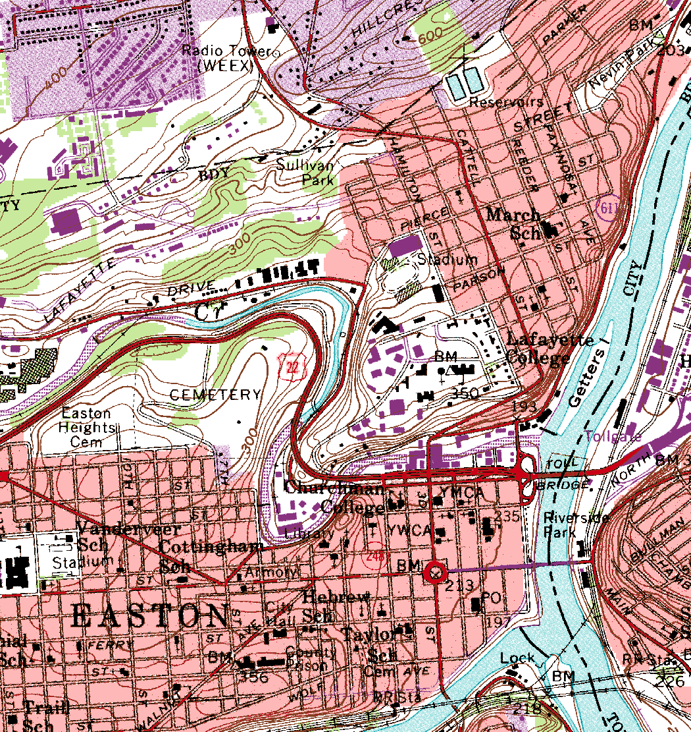
Understanding the hydrologic features on a topographic map

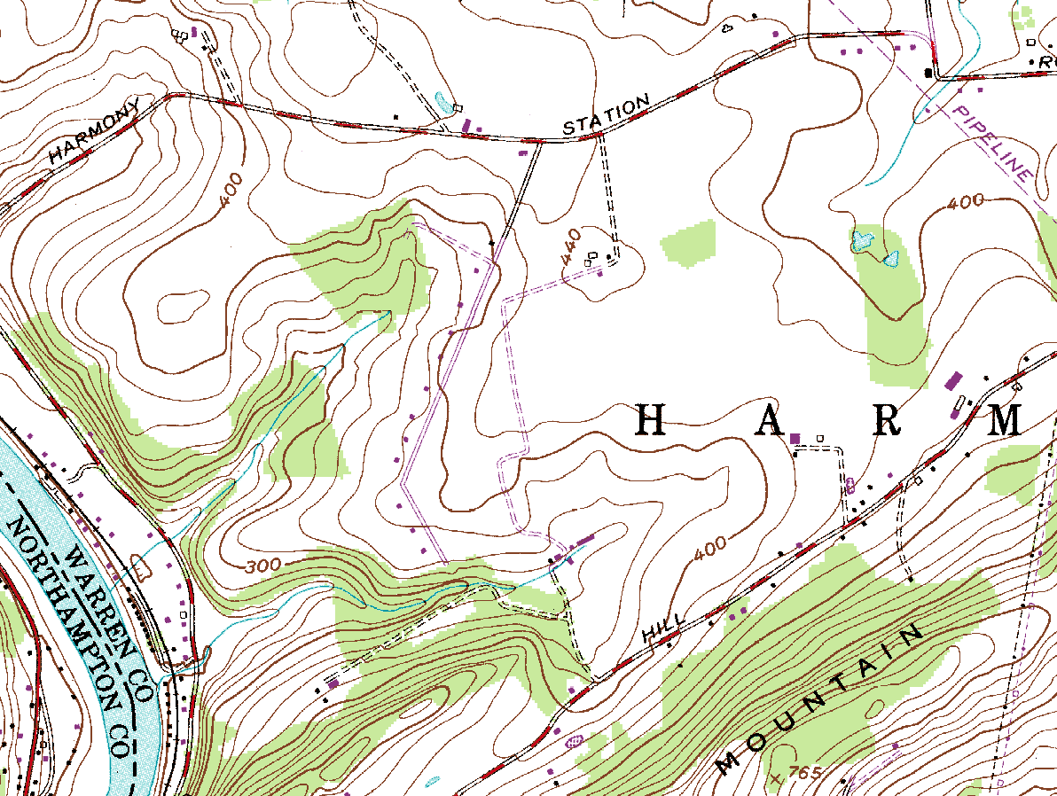

- The closer the contours are spaced on the map, the steeper the slope; the farther apart the contours, the flatter the slope – mark a steep slope SS and a flat area FA

- Drainage divides: these topographic features divide one watershed from the next, thus the name – they are shown as wide loops in the contours representing hills; or narrow loops in the contours represent ridges – mark a drainage divide DD

- Permanent (perennial) streams may not be labeled but are always shown with solid blue lines – intermittent streams (not shown above) are marked with dash-dot line – mark a perennial stream PS

- If the V or U shape in the contours points uphill, the topographic feature is a valley - streams often connect these points – mark an upward pointing U or V shape as UU or UV

- If the V or U shape in the contours points downhill, the feature is the nose of a hill – you will never see a stream here – mark a downward pointing V or U shape as DV or DU

- Contours never cross – if you see a line crossing contours, it is a stream or man-made feature such as a road – mark one of these crossings XC

- Sometimes you may see a loop with tic marks along the inside – this is a depression – mark one of these (a bit hard to find) with a D
Visualizing in 3-D based on 2-D contours

- Delineate a small watershed - Delineate the watershed of the small stream at the point shown (i.e. draw a line that encloses all the area from which runoff will flow to the point):

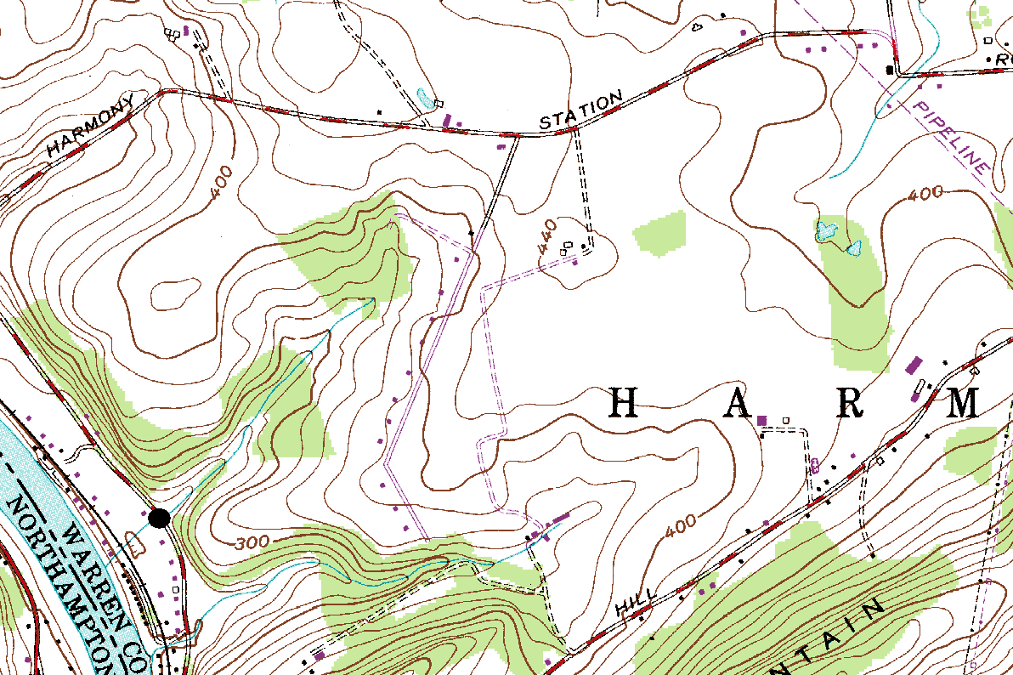

- Model Watershed Features (If time permits) - For the following two topographic features, use Play-Doh to create an accurate 3-D model of the contours shown (note, this can now also be done using a digital elevation map and 3D printer):

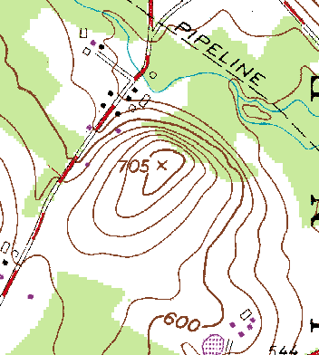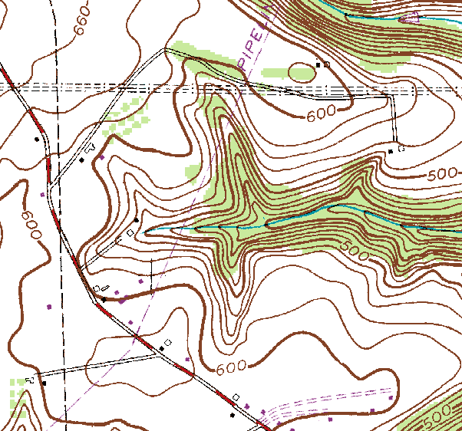

Tools: Pencil (NOT pen!) & a good eraser

General method (practice makes perfect):

- Draw small arrows all over the map indicating the direction of maximum slope at each point

- Based on your arrows, locate the “drainage divides”, the topographic features such as hills and ridges that divide flow between adjacent streams – rough sketch in these boundaries first so you know the general shape of the watershed

- Now carefully sketch your way uphill from the point of interest, always perpendicular to contour lines

- For hills and other contour loops or bends, draw the boundary such that it divides these features in half

- Check that the watershed boundary is everywhere perpendicular to contour lines and does not cross any drainage divides

- Finally, based on your arrows, check that there are (1) no areas inside your delineated watershed where the contours indicate flow going away from the point of interest, (2) no areas outside your delineated watershed where contours indicate flow toward the point of interest

Note:

In practice delineation is now typically done digitally using a “DEM”. A digital elevation model (DEM) is a regularly-spaced grid of elevation values that is the digital equivalent of a contour map. DEMs at various spatial resolutions (90-m, 30-m, 10-m) are available free of charge from the USGS website nationalmap.gov.

Pennsylvania and other states now also have LiDAR elevation data at an amazing 1-m spatial resolution. LiDAR measures distance optically by imaging the ground surface with a laser and analyzing the reflected light.

DEMs can be delineated by computer programs such as ArcGIS Spatial Analyst. You will learn how to do this in CE 351 Water Resources Engineering.

Supplies

- Topographic Maps (Bushkill Quads)
- Play-Doh

Lab Assignment – Due (XXXX)

- Walkabout! Relax and take a walk around campus and neighboring Easton and identify two examples of nonpoint pollution and two examples of point source pollution. Document with pictures and provide a few sentences with each picture describing your findings. (Due at the begin of class #5)

- A lake has a volume of 100,000 m³. As a result of geologic influence (i.e., carbonate bedrock or limestone) the lake has a background conductivity value of 300 uS/cm. During a typical winter event when road salting takes place, a volume of 100 m³ water with high salt concentration enters the lake. The salt concentration measured as conductivity is 10,000 uS/cm. As the town engineer you know that DEP has established a limit of 500 uS/cm for the lake. (Draw a diagram to represent the problem presented.) (Due at the begin of class #5)
  - Based on the information given, what would you predict the conductivity and concentration (mg/L) in the lake to be just after a typical winter storm, assuming full mixing of the lake? As the town environmental engineer, do need to impose any restrictions on road salting? Explain your answer.
  - Suppose half of the salty runoff enters a isolated cove of the lake with a volume of 5,000 m³, rather than mixing into the entire lake. What would you predict the conductivity and concentration to be in this cove?
  - Is this scenario an example of point source pollution or nonpoint source pollution?

- Create a mini-lesson with detailed lesson plan and handouts about water pollution related to conductivity and turbidity for elementary aged school children. Your “Lab 1” team will deliver the lesson during Lab 6, October 3rd or 5th.

Structure of Mini-Lesson
First 15 minutes - Introductions
Name and where your from
Class year and Major
What are you passionate about
After Graduation ?
Lesson (20 to 25 minutes)
First 5 minutes introduce concept
- Objective (imbed the Leader in Me habit within the objective(s))
- Why worth studying/practical application
- o 20 minute lesson with hands on activity
10 minute wrap up and assessment
Review key idea
Assessment
- Most interesting thing you learned
- What will you teach your parents
- Opinion of science different

Lessons are to include “Leader in ME” messaging

One or two of the following “Leader in Me” habits must be worked into the mini-lesson. All mini-lessons objectives are to include “Leader in Me” language. This language is to repeated “the word(s)” once in the middle and then again at the end of the lesson (wrap up).

- “Begin with the end in mind”
Important to people in any field who want to be successful to….
- Set a goal
- Plan ahead
- Do something worth doing
- “Synergize”
- Team work often makes for better problem solving

Mini-Lesson Deliverable Schedule

- October 19/21, Lab #4 – DUE- Lesson Plan and Handouts (Draft 1) – Practice Session at the end of Lab #4.
- Thursday 28, 7 to 9 pm – Practice Session with Teacher – DUE Lesson Plan and Handouts (Draft 2)
- Delivery of Lesson – October 3/5, Lab #6
- Beginning of class #19, October 11.
  - Group Report
    - Group summary of event
    - Kid Assessment
      - Most interesting thing you learned
      - What will you teach your parents
      - Opinion of science different
  - Individual one page summary
    - Had you ever done anything like this before
    - What did you learn with this event
    - Will you consider participating in another community engagement activity similar to this? What about other types of community engagement event?
    - Any other observation and/or information you would like to pass along

- Delineate the Mud Run watershed for the point shown below (Copied from Bangor Quad). When you are done, highlight your pencil line so that it is easily visible. (Due at the begin of class #5)

