Coliform/Water Quality Lab

Georgia Papagianis and Emily Turcott
09/26/14
Professor Arthur Kney
To: Professor Arthur Kney Ref: 092614_1
From: Georgia Papagianis and Emily Turcott
CC: Civil Engineering Department
Date: 09/26/14
Subject: Coliform/Water Quality Lab

Objectives
- The overall objective of this experiment is to perform a laboratory test on various water samples taken from local bodies of water to determine the amount of total coliform and fecal coliform in the sample.
Purpose:
- Coliforms are indicator organisms used to alert water users that there may be a type of contamination that can lead to sickness and possibly even death.
Experiment:
For this experiment, water samples from nine sample locations were taken and stored in a cool environment for lab use. These nine locations are presented in Attachment IV. Each of the water samples were then diluted (10x dilution for fecal coliform tests and 100x dilution for total coliform tests) and filtered through a 0.45µm pore sized filter attached to a vacuum to ensure complete drying. Groups were assigned to test specific sample locations as well as the control, tap water, and were told to test for either total coliform or fecal coliform. Our group, group 3, tested for fecal coliform and were assigned the following sample locations:
- Control
- Sample location 2 - Sober’s Run #7
- Sample location 4 – Little Bush #5
- Sample location 7 – 13th Street Between 1-2
In the meantime, each petri dish was prepared with an absorbent pad and 2.0ml of M-FC medium (lactose rich medium). Once the filter paper was completely dry, it was transferred via a pair of sterile tweezers to the prepared petri dish. The petri dish was then incubated underwater in a watertight plastic bag at 44.5 ± 0.20ºC for 24 hours. After 24 hours passed, the number of blue fecal coliform colonies that grew on the petri dish were counted and recorded in a table. Other groups recorded their counts as well and the total data can be found in Table 1.
Safety:
- Safety glasses, lab coats, and proper gloves must be worn by all group members when performing the experiment
List of Attachments:
- Background and Theory
- Procedure for Total Coliform and Fecal Coliform
- Conclusions
- List of Sampling Locations

- Background and Theory

- What is Coliform?
Coliforms are bacteria that are typically found in the digestive tract of warm blooded animals, including humans, and in plant and soil material. While coliform bacteria itself will not cause illness to those who consume it, their presence in bodies of water usually indicate bad water quality and propose that disease-causing organisms may be found in the water supply. There are three different groups of coliform bacteria that each have a different level of risk and are tested for in their respective ways. The detailed procedure for different types of coliform can be found in Attachment II.
- Total Coliform vs. Fecal Coliform
  - Total coliforms include bacteria that are commonly found in the environment. If total coliform is found in testing, bacteria originated from plant or soil material. Total coliforms are made up of organisms from the following genera:
    - Escherichia
    - Enterobacter
    - Klebsiella
    - Citrobactor
During testing, total coliform results tend to be much higher than those of fecal coliform and are thus, diluted 100 times. The filter paper used to filter samples to be tested for total coliform is placed in a petri dish containing an absorbent pad and M-Endo medium (as opposed to M-FC medium for fecal coliform tests). The petri dishes are also incubated at 35 ± 0.50ºC in an inverted position for 22-24 hours. After incubation, colonies appear to be pink to dark red color with a metal (green-gold) surface sheen.
  - Fecal coliforms are a group of the total coliforms that are considered to be present specifically in the gut and feces of warm-blooded animals. Origins of fecal coliforms are more point-source than the origins of total coliform, fecal coliforms are considered a more accurate indication of animal or human waste than the total coliforms. This is why during testing, fecal coliform results tend to be much lower than those of total coliform and are thus, diluted only 10 times. The filter paper used to filter samples to be tested for total coliform is placed in a petri dish containing an absorbent pad and M-FC medium (as opposed to M-Endo medium for total coliform tests). The petri dishes are also incubated upside down at 44.5 ± 0.20ºC underwater in a watertight plastic bag for 24 hours. After incubation, colonies appear to be blue in color.
  - More detailed procedures can be found in Attachment II.
- “Indicator Organism”
  - What is an indicator organism?
An indicator organism illustrates the presence (or the absence) of a disease-causing organism that has the ability to survive under similar conditions.
  - What are the indicator organisms for the total coliform test?
The indicator organisms for total coliform are Escherichia, Enterobacter, Klebsiella, and Citrobactor.
  - What are the indicator organisms for the fecal coliform test?
The indicator organisms for fecal coliform are Escherichia coli commonly known as E. coli.
  - Why are coliforms indicator organisms?
Coliforms are indicator organisms because they originate from the same sources as disease-causing organisms. Coliforms are easy to identify, quickly deliver results, are cost effective, and do not require extensive laboratory skills or expensive machinery to grow.
  - What is a pathogen and how do they relate to coliforms?
A pathogen is a disease-causing biological agent. Pathogens can range from viruses and bacteria to fungus and protozoan. Pathogens typically infect their host. Coliform, on the other hand, are not usually harmful bacteria and do not infect their host. Coliform are used to indicate the presence of harmful pathogens in water supply.
- Negative Fecal Coliform Test
A negative fecal coliform test does not necessarily indicate that there are no pathogens present. This is because the sample collected is only a very small part of the body of water the sample originally came from. The more samples tested, the more accurate and varied the results become, thus further verifying the body of waters water quality.
- Specific Pore Size
A specific filter pore size of 0.45µm is used when filtering the samples for petri dish incubation. This pore size is used for the coliform membrane filter technique because the use of 0.45µm filters are generally recommended for filtration of cloudy, turbid, and opaque solutions. Working with filters of this pore size is also commonly used for sterility testing mainly due to the fact that the largest pore is 0.42 micron (as opposed to 0.22) which allows for a faster flow rate through the filter with the same results.
- E. coli in my BigMac?
Most strains of E. coli are harmless and do not infect the host. However, one strain called E. coli O157:H7, commonly found in cows, produces a powerful poison and can severely infect whatever consumes it. This strain can be mixed into a vat of ground beef, packaged by the producer, sold to a market, and eventually bought and consumed by a consumer. If ground beef is eaten with any other strain of E. coli, the host would not become ill however, if the certain strain is present in the meat, chances are the eater would become sick. If raw meat contaminated with E. coli O157:H7 is cooled thoroughly however, the extreme heat denatures the bacteria and prevents it from reproducing in the host. Thus, the host would not get ill and would enjoy a well-cooked burger.

- Procedure for Total Coliform and Fecal Coliform
These procedures are taken from the Lafayette College Department of Civil and Environmental Engineering Total and Fecal Coliforms – Membrane Filter Technique General handout written by Arthur Kney:
- Procedure to Test for Total Coliform
a. Using a sterile graduated cylinder, obtain 100 ml of sample to be filtered.
b. Place sterile membrane filter on the filter apparatus with sterile forceps.
c. Filter the sample with use of a vacuum pump.
d. Place membrane filter onto an absorbent pad, which has been saturated with 1.8 to 2.0 ml of M-Endo medium.
e. Incubate the petri dish at 35 ± 0.50C, at 100% relative humidity, in an inverted position for 22-24 hours.
- Count coliform colonies and report results as "total coliforms/100 ml of sample."
- Procedure to Test for Fecal Coliform
a. Select sample size to give 20-60 fecal coliform colony count on membrane filter.
b. Filter sample and place on an absorbent pad, which has been saturated with 2.0 ml of M-FC medium.
c. Incubate sample underwater in a watertight plastic bag at 44.5 + 0.20C for 24 hours.
- Count fecal coliform colonies (blue color) and report results as "total fecal coliforms/100 ml of sample."

- Conclusions
- Discussion
As expected, the number of total coliform colonies was found to be much higher than those of fecal coliform. From the results gathered in Table 1 and graphed in a column plot in Figure 1 below, one can conclude that the results are fairly varied.
- Results for data set number 1 are those from the control group which was tap water. As expected, there were no readings for total and fecal coliform, the pH read neutral, and the conductivity is within healthy standards.
- Sampling site #2 was taken at Sober’s Run under concrete bridge next to stone bridge in Jacobsburg. While the conductivity was fairly low and the pH slightly over neutral, the total coliform reading seemed fairly low but the fecal coliform results were comparatively high with regards to the other sampling sites.
- Sampling site #3 was at Little Bushkill Creek at Stockertown Borough Park. Results from this site came in with an average pH and conductivity reading however, a relatively high total and fecal coliform reading.
- Sampling site #4 was taken just above the confluence of Shoeneck/Bushkill Creek. Record low total and fecal coliform readings were obtained here yet a spike in pH and conductivity was observed.
- Sampling site #5 was taken at the confluence of Shoeneck/Bushkill Creek. The second highest total coliform, fecal coliform readings were obtained and record high pH, and conductivity readings were observed in this sample.
- Sampling site #6 was taken just below the confluence of Shoeneck/Bushkill Creek. Relatively fair total coliform readings were obtained however, the highest fecal coliform reading was observed. The pH and conductivity decreased significantly when compared to sampling site #5.
- Sampling site #7 was taken in between the upstream of the dam above 3rd street and 25th street tributary at the bridge in Lower Hackett Park. Total coliform count hit a record high yet fecal coliform was observed to be fairly low. pH and conductivity readings remained fairly constant relative to sampling site #6.

Table 1: Results of Coliform Data
Sample | Control | Sobers Run  #7 | Little Bush  #5 | Shoeneck  Above - #3b | Shoeneck | Shoeneck  Below - #3a | 13th Street  Between 1-2
pH | 7.00 | 7.25 | 7.35 | 7.60 | 8.05 | 8.00 | 8.00
Conductivity  (µS/cm) | 204 | 155 | 394 | 644 | 735 | 675 | 650
Total  Coliform  (# colonies  per 100 ml) | 0 | 1500 | 1800 | 1400 | 2500 | 2000 | 3500
Fecal  Coliform  (# colonies  per 100 ml) | 0 | 400 | 500 | 300 | 500 | 600 | 400

Figure 1: Column Graph of Results of Coliform Data

- List of Sampling Locations
These locations are taken from the Laboratory 1- CE 321 Bushkill Stream Monitoring Sites written by Arthur Kney:
Sample Locations
Following are descriptions of the nine sampling locations, from downstream to upstream (please note: poison ivy, ticks, and various bothersome insects are common along Bushkill Creek!):
- Just upstream of the dam (Gauge 1) above 3rd Street (#1)
(at the base of College Hill, behind Jac & Co)
- 25th Street tributary at the bridge in Lower Hackett Park (#25 or 1a)
(along Wood Avenue, through the stone arch, park across the stream)

- Catch-and-Release area downstream of Binney & Smith (#2)
(along Bushkill Drive, between the light at 13th Street and Edgewood Ave - there is a wide pullout and a wooden "Catch-and-Release Area" sign, go down the path through the woods)
- Just below the confluence of Shoeneck/Bushkill Creek (#3a)
Just above the confluence of Shoeneck/Bushkill Creek (#3b)
(these two adjacent sites are along Bushkill Drive between Binney & Smith and Tatamy – look for the stumps along the road. There is a paved path and footbridge over the creek, then a small path to the left)
- Gauge 2 on Bushkill Street bridge at Tatamy (#4)
(sample on the downstream side of the bridge)
- Little Bushkill Creek at Stockertown Borough Park (#5)
(there is a gravel parking area along Sullivan Trail just before the bridge as you enter Stockertown)
- Above footbridge at Jacobsburg SP main parking area/visitor center (#6)
(there is a small path through the bushes from the first parking spaces - sample where a large oak tree overhangs the stream)
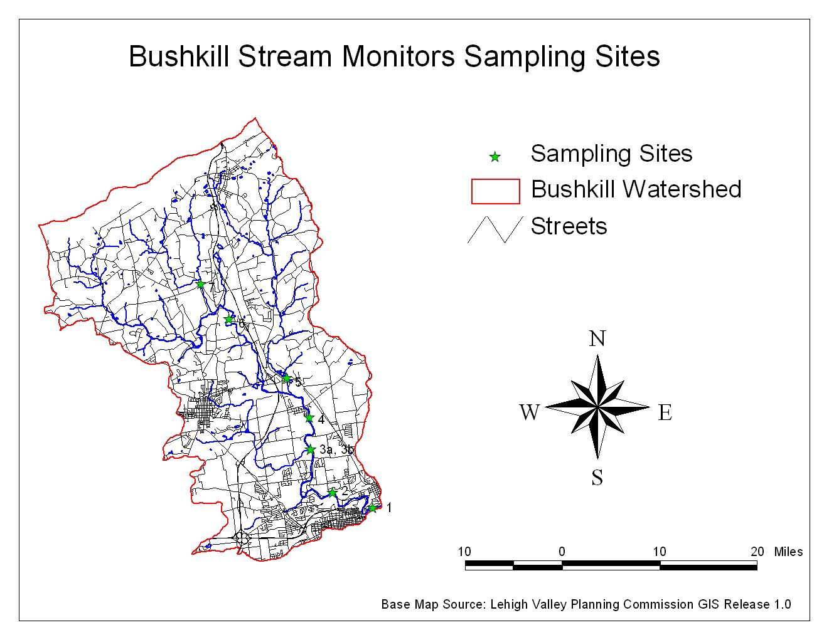
- Sobers Run under concrete bridge next to stone bridge in Jacobsburg SP (#7) (north of the Jacobsburg Park Office - there is a trailhead parking area on the left. Walk down the path between the two bridges to some concrete slabs below the concrete bridge)

Figure 2: Map of Bushkill Stream Monitors Sampling Sites

