2018 Formula Hybrid Electrical System Form 2 (ESF-2)
INTRODUCTION
The goal of the ESF is to ensure that vehicles are as safe as possible, and that they comply with the Formula-Hybrid completion rules. The ESF is divided seven main sections:

1 – Overview
2 – Cables, Fusing & Grounding
3 – Isolation & Insulation
4 – Electric Tractive System
5 – Accumulator System
6 – Safety Controls and Indicators
7 – GLV System
The Cables and Fusing, and Insulation and Isolation sections are at the beginning of the ESF as these are the areas where teams most often have trouble in complying with FH rules.

A clear, concise ESF will help you to build a better car. It will also help you to pass tech testing as most common tech problems can be addressed before the car reaches the track.

IMPORTANT INSTRUCTIONS AND REQUIREMENTS
Read carefully!
- Every part of this ESF must be filled with content. If a section is not relevant to your vehicle, mark it as “N/A” and describe briefly why not.
- Please leave the written instructions in place and add your responses below them.
- All figures and tables must be included. An ESF with incomplete tables or figures will be rejected.
- The maximum length of a complete ESF is 100 pages.
- Note that many fields ask for information that was submitted in your ESF-1. This information must be reentered – in some cases will be different than what was entered in ESF-1, which is OK.
- When completed, submit this document (in Word format – i.e. do not convert it to PDF) to: http://formula-hybrid.com/uploads/

Please submit any questions, corrections and suggestions for improvement to: http://www.formula-hybrid.org/level2/support

REVIEW PROCESS

NOTE: THE REVIEW PROCESS HAS CHANGED
Feedback on your ESF occurs through both this Google Doc and the FH ticket system:
http://formula-hybrid.com/level2/support/

Your ESF will be reviewed by a team of “section reviewers” - experts in specific areas of the FH rules, AND “team reviewers” who will be your main points of contact through the competition.
Reviewers will add comments coded with “//” for an informational comment, or “!!!” indicating that more information is needed, or that a concern is raised, for example:

// This diagram is well done. A suggestion in future would be to …

!!! We have a concern regarding your accumulator construction - how did you calculate required fuse capacity?

No action is required for informational (//) comments.
(!!!) comments DO require action - either by responding to the comment in the Google doc, or opening a rules ticket (and adding a response “See FH Ticket 1234 for resolution”

When a (!!!) comment is resolved, the inspector involved may indicate this with a final comment:
// RESOLVED //

If you are not receiving a response to a critical Google doc question, please open a ticket and ask for resolution.
The ESF2 is a tool for your team to make sure your car is rules compliant and ready to run at the competition. It is up to you and your team to follow up with all open items.
Our goal is to have all ESF2s reviewed in depth, and all questions resolved before the competition. This will speed up the electrical tech testing process, especially document review.
Finally, please be sure to bring supporting documentation (printed or PDF) and a READABLE full electrical schematic to the event for your physical tech inspections.
We look forward to seeing you at the track --
The Electrical Tech Team

TITLE PAGE

Please include team logo, car picture, etc..

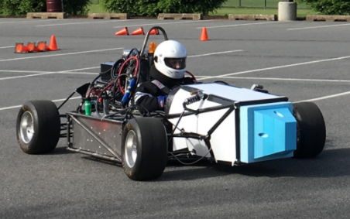

University Name: | Lafayette College
Team Name: | Lafayette Motorsports
Car Number: | 212

Main Team Contact for ESF related questions:
Name: | Waseh Ahmad
e-mail: | ahmadw@lafayette.edu

Table of Contents

TITLE PAGE iii
I List of Figures vii
II List of Tables ix
III List of Abbreviations x
Section 1 Vehicle Overview 1
Section 2 Cables, Fusing & Grounding 11
2.1 Fusing & Overcurrent Protection 11
2.2 Component Fusing 12
2.3 System Wire Tables 13
2.4 Grounding System 19
2.5 Conductive Panel Grounding 19
Section 3 Isolation & Insulation 20
3.1 Separation of Tractive System and Grounded Low Voltage System 20
3.2 Isolation & Insulation 24
3.3 Conduit 25
3.4 Shielded dual-insulated cable 26
3.5 Firewall(s) 26
Description/materials 26
Section 4 Electric Tractive System 28
4.1 Motor(s) 28
4.2 Motor Controller 29
4.3 Tractive System Measurement Points (TSMP) 29
4.4 Pre-Charge circuitry 30
4.5 Discharge circuitry 32
4.6 HV Disconnect (HVD) 34
4.7 Accelerator Actuator / Throttle Position Sensor 34
4.8 Accelerator / throttle position encoder error check 37
Section 5 Accumulator System 39
5.1 Accumulator Pack 39
5.2 Cell description 40
5.3 Cell configuration 41
5.4 Segment Maintenance Disconnect 41
5.5 Lithium-Ion Pouch Cells 42
5.6 Cell temperature monitoring 42
5.7 Accumulator Isolation Relays (AIR) 45
5.8 Accumulator Management System (AMS) 46
5.9 Accumulator wiring, cables, current calculations 47
5.10 Accumulator indicator 49
5.11 Charging 49
5.12 Accumulator Container/Housing 51
Section 6 Safety Controls and Indicators 55
6.1 Shutdown Circuit 55
6.2 IMD 60
6.3 Reset / Latching for IMD and AMS 61
6.4 Shutdown System Interlocks 62
6.5 Tractive System Active Lamp (TSAL) 62
6.6 Safety Systems OK Lamp (SSOK) 63
6.7 Ready-To-Drive-Sound (RTDS) 63
Section 7 GLV System 65
7.1 GLV System Data 65
Section 8 Appendices 66

List of Figures
Figure 1 Electrical System Block Diagram 3
Figure 2 Front of Vehicle 4
Figure 3 Side of Vehicle 5
Figure 4 Top of vehicle 5
Figure 5 Location of all major TS Components 6
Figure 6 Packs 2-3-4 Wiring 6
Figure 7 Pack 1 Wiring 7
Figure 8 Wiring Diagram 8
Figure 9 TSI Wiring Schematic 9
Figure 10 TSI (TS and GLV Separation) 20
Figure 11 GLV Enclosure (TS GLV Separation) 21
Figure 12 PACMan board layout with Spacing in white 22
Figure 13 Team Designed PCB _ TSI Board 23
Figure 14 Battery Pack Firewall Containers Relative to Driver Seat 27
Figure 15 Driver Seat Firewall CAD drawing 27
Figure 16 Motor Controller Startup -Pre-Charge 31
Figure 17 Discharge Circuit for Capacitor in TSI 32
Figure 18 Calculated Discharge Current Vs Time 33
Figure 19 Discharge Circuit Resistor Power vs Time 34
Figure 20 Throttle biasing circuit (From piston potentiometers) 36
Figure 21 Throttle Plausability Window Check 37
Figure 22 Cell Configuration 41
Figure 23 AMS Boards Schematic 43
Figure 24 AMS Voltage/Temp monitoring schematic 44
Figure 25 Pack With Cell Config 45
Figure 26 Wiring for one Accumulator Segment 48
Figure 27 High Current Discharge for Pack 49
Figure 28 Charging Ciruit 50
Figure 29 Charging Circuit with Fusing 51
Figure 30 Pack Container View with cells 53
Figure 31 Pack Container View 2 with cells 53
Figure 32 Pack Container Fully assembled container 54
Figure 33 Shutdown Safety Circuit Schematic 55
Figure 34 Cockpit View 57
Figure 35 Side View- Shutdown 58
Figure 36 Side View- Shutdown 58
Figure 37 Top View -Shutdown Circuit Components 59
Figure 38 Shutdown State Diagram 60
Figure 39 IMD Indicator LED Circuit 61
Figure 40 Latching/Reset Circuit 62
Figure 41 TSAL Wiring in the TSI 63

Must be hyperlinked!

List of Tables
Table 1- General Electrical System Parameters 10
Table 2 - Fuse Table 11
Table 3 - Component Fuse Ratings 12
Table 4 - System Wire Table 18
Table 5 - PCB Spacings 22
Table 6 – List of Containers with TS and GLV wiring 25
Table 7- Insulating Materials 25
Table 8 - Conduit Data 26
Table 9 - Shielded Dual Insulated Cable Data 26
Table 10 - Motor Data 28
Table 11 - Motor Controller Data 29
Table 12 – TSMP Resistor Data 30
Table 13 - Data for the pre-charge resistor 31
Table 14 - Data of the pre-charge relay 32
Table 15 - Data of the discharge circuit. 33
Table 16 - Throttle Position encoder data 35
Table 17 - Main accumulator parameters 39
Table 18 - Main cell specification 41
Table 19 - SMD Data 42
Table 20 - Cell Temperature Monitoring 45
Table 21 - AIR data 46
Table 22 - AMS Data 47
Table 23 - Charger data 51
Table 24 - Switches& devices in the shutdown circuit 56
Table 25 - Shutdown circuit Current Draw 57
Table 26 - Parameters of the IMD 60
Table 27- GLV System Data 65

Must be hyperlinked!

List of Abbreviations

AIR Accumulator Isolation Relay
AMS Accumulator Management System
FH Rules Formula Hybrid Rule
GLV Grounded Low-Voltage
IMD Insulation Monitoring Device
SMD Segment Maintenance Disconnect
TS Tractive System
TSEL Tractive System Energized Light
TSMP Tractive System Measurement Point
TSV Tractive System Voltage
TSVP Tractive System Voltage Present
TSI Tractive System Interface
MARSET Master Reset

(Add more as needed)

Vehicle Overview
Person primarily responsible for this section:
Name: | Waseh Ahmad
e-mail: | ahmadw@lafayette.edu

Check the appropriate boxes:

Vehicle is
☒ New (built on an entirely new frame)
☐ New, but built on a pre-existing frame (FSAE, FS, FH-HIP, FH electric-only, etc.)
☐ Updated from a previous year vehicle

Architecture
☐ Hybrid
☐ Series
☐ Parallel
☐ Hybrid in Progress (HIP)
☒ Electric-only

Drive
☐ Front wheel
☒ Rear wheel
☐ All-wheel

Regenerative braking

☐ Front wheels
☒ Rear wheels
☐ None
NARRATIVE OVERVIEW
Provide a brief, concise description of the vehicles main electrical systems including tractive system, accumulator, hybrid type (series or parallel) and method of mechanical coupling to wheels. Describe any innovative or unusual aspects of the design.

Include the following figures:
- Figure 1 – an electrical system block diagram showing all major parts associated with the tractive-system. (Not detailed wiring).
- Figure 2-4 – Drawings or photographs showing the vehicle from the front, top, and side
- Figure 5– A wiring diagram superimposed on a top view of the vehicle showing the locations of all major TS components and the routing of TS wiring.
- Figure 6-9 -- A complete TSV wiring schematic per FH Rule EV13.2.1 showing connections between all TS components.
This should include:
  - Accumulator Cells
  - AIRs
  - SMDs
  - Fuses
  - Wire Gauges
  - Motor controller
  - Motor
  - Pre-charge and discharge circuits
  - AMD
  - IMD
  - Charging port
  - Any other TS connections.

NOTE: Figures 6-9 is the most important diagram in the ESF

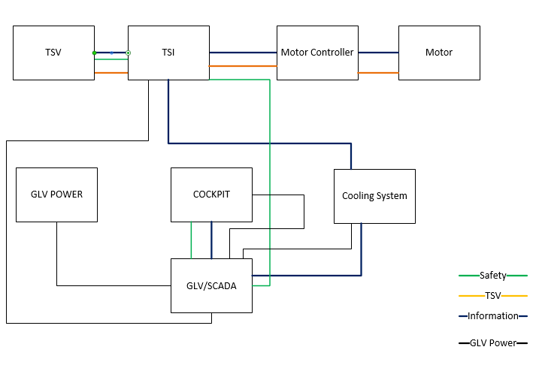
Figure 1 Electrical System Block Diagram

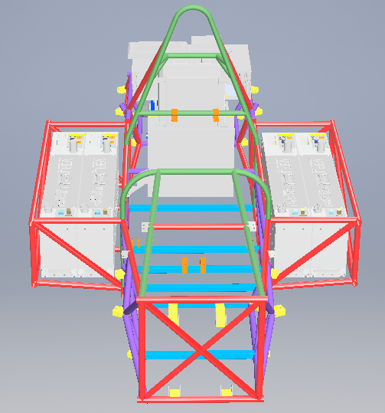
Figure 2 Front of Vehicle

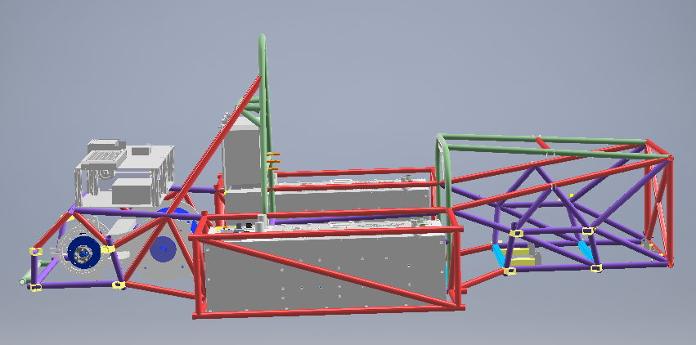
Figure 3 Side of Vehicle
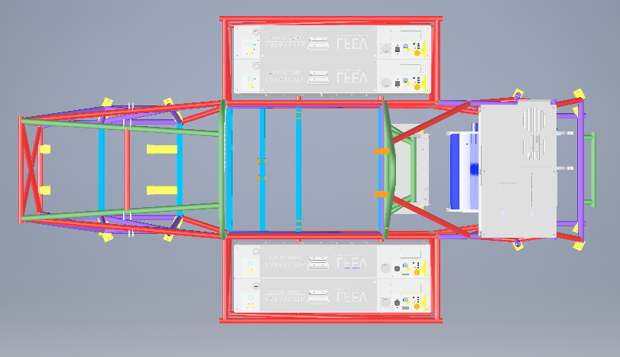
Figure 4 Top of vehicle

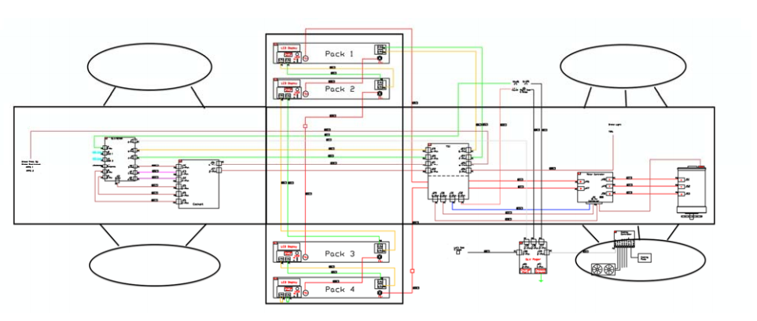
Figure 5 Location of all major TS Components
(Click for Detail)

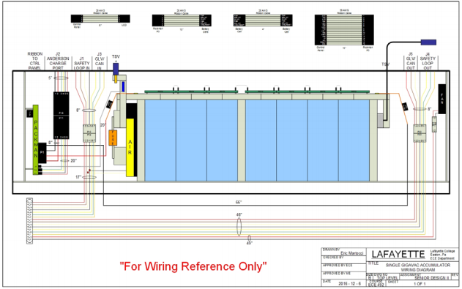
Figure 6 Packs 2-3-4 Wiring
Packs 2-3-4 Wiring (Click for detail)
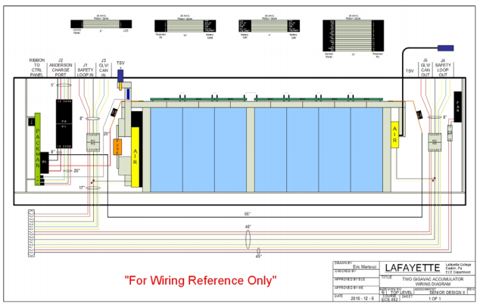
Figure 7 Pack 1 Wiring
Pack 1 Wiring (Click for Details)

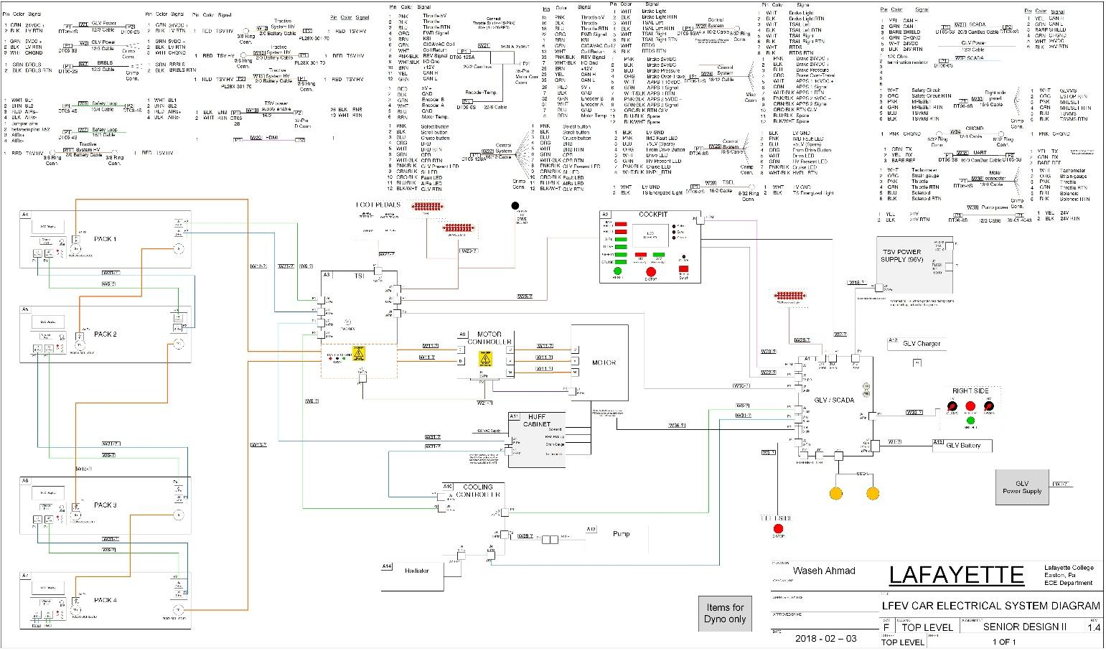
Figure 8 Wiring Diagram
Wiring Diagram (Click for details)
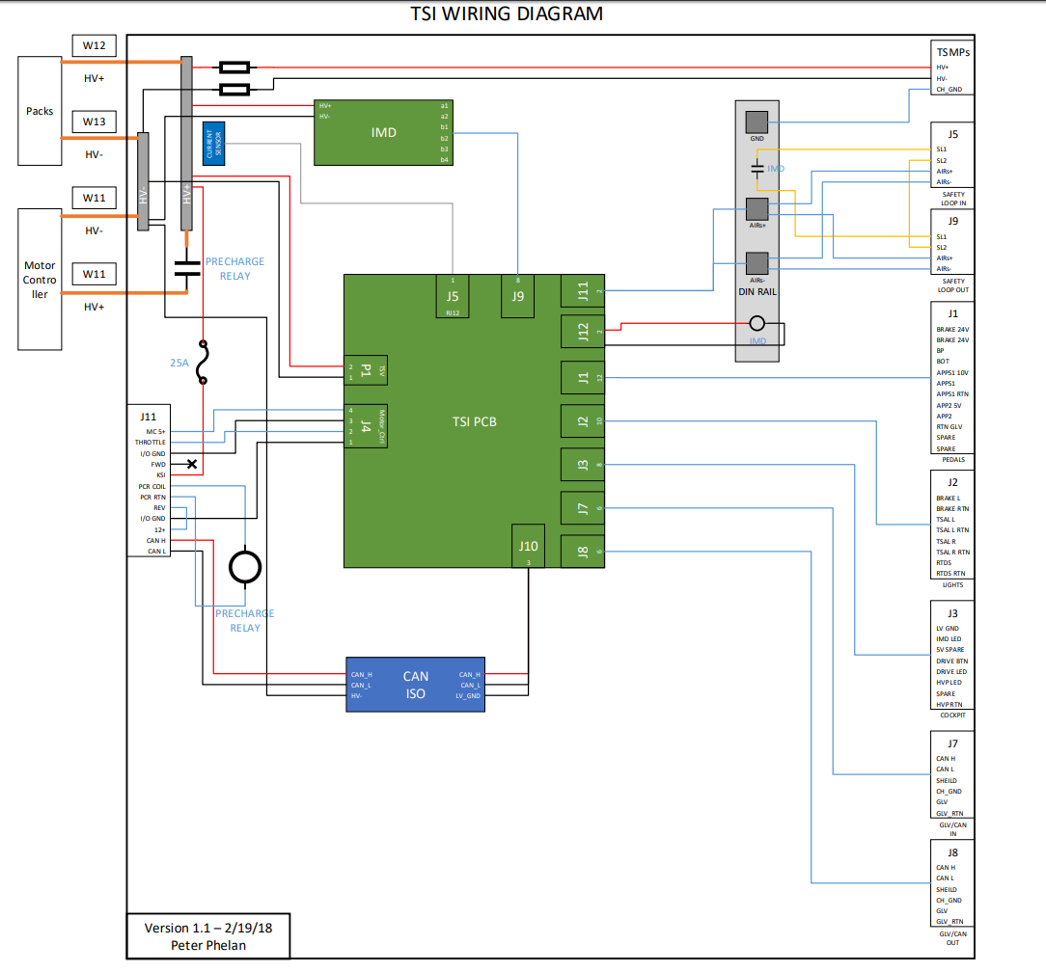
(Click here for more detail)
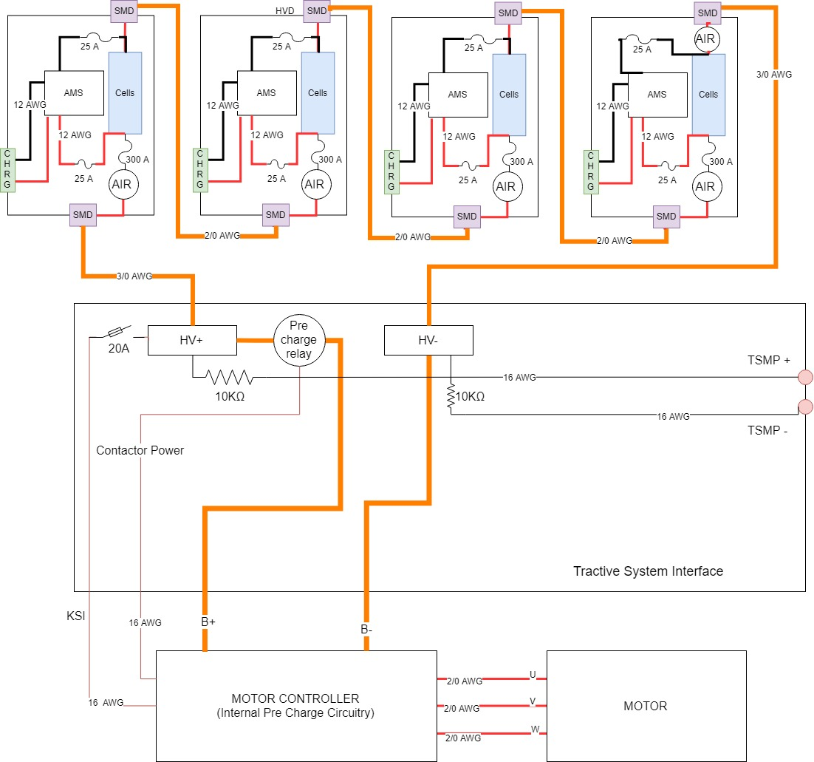
Figure 9 TSI and TSV Wiring Schematic
(Click here for more detail)

Fill in the following table:
Item | Data
Nominal Tractive System Voltage (TSV) | 89.6 VDC
Max. TSV (typically this is during charging) | 96 VDC
Control System voltage (GLV) | 24 VDC
Total Accumulator capacity (Wh) | 3605 Wh
Accumulator type (Lead-acid, Li-Ion, NiMH, Ultracap..) | LiFePO4
Number of electric motors, total | 1
Are wheel motors used? | ☐Yes / ☒ No
Table 1- General Electrical System Parameters
Capacity = V_{nom}Ah(0.8)=3.2*28*50.3*0.8

Cables, Fusing & Grounding
Person primarily responsible for this section:
Name: | Waseh Ahmad
e-mail: | ahmadw@lafayette.edu

Fusing & Overcurrent Protection
List TS and GLV fuse (or circuit breaker) data, and where used
Mfg. | Fuse Part Number | Cont. Rating (A) | DC Voltage Rating | DC Interrupt Rating (A) | Where Used
Merse  n/Ferr  az  Shaw  mut | A3T300 | 300 A | 160V | 50,000 AIC | Accumulator container; between the positive input terminal of the first cell and the AIRS.
Littlefuse | 0224001.HXP | 1 A | 125V | 10kA @ 125VDC | PacMAN board; separates the incoming high voltage from the accumulator from the 5V in the high voltage section of the PacMAN board.
Littelfu se | 0287025 .PXCN | 25 A | 32V | 1kA @ 32 VDC | Accumulator segment container; one between positive input terminal of the first cell and PacMAN board. One between the negative input terminal of the last cell and the PacMAN board.
TE Connectivity | W28 -XQ1A -2 | 2 A | 32 VDC | 1kA @ 32VDC | GLV Circuit Breaker
TE Connectivity | W28 -XQ1A -2 | 2 A | 32 VDC | 1kA @ 32VDC | GLV Circuit Breaker
Littlefuse | 0314.500HXP | 0.5 | 125 VDC | 10kA @ 125 VDC | TSI: TS to voltage monitor
Littelfu se | 0314025.HXP | 25 A | 250V | 400 A @ 125 VDC | Motor Controller
Littelfu se | 0314020.HXP | 20 A | 250V | 10kA @ 125VDC | TSI
Table 2 - Fuse Table

Component Fusing
List major components (e.g., motor controller, dc-dc converter) and data sheet max fuse rating. Ensure that the rating of the fuse used is less than the maximum value for the component
Component | Fuse Part Number | Max Fuse Rating A | Installed Fuse Rating A | Notes
DC-DC Converter (Murata Power Solutions, NCS6S1205C) | Internal  (current fold back) | Internal | Internal | PacMAN Board
Curtis 1238 Motor Controller KSI | 0314025.HXP | 400 A | 25 A
DC-DC Converter  VYB20 W-Q24- S5 | Internal  ( short circuit, over current, and over voltage protection) | Internal | Internal | GLV BoB board
DC-DC Converter  PDQ10-Q24-S5-D | Internal  ( over voltage, input under voltage lockout, and short circuit protections ) | Internal | Internal | TSI Board: GLV to lv- TSI
Isolated Module DC/DC converter  RUW15SL12C | Internal  (over voltage and short circuit protection) | Internal | Internal | TSV to TSI HV
Table 3 - Component Fuse Ratings

System Wire Tables
List wires and cables used in the Tractive System and the GLV system - wires protected by a fuse of 1 A or less may be omitted.
Cable capacity is the value from FH Rules Appendix E (Wire Current Capacity).
Show available fault current and how calculated.
Available fault current can be calculated from $Fault Current= Vsource / (Rsource + Rwiring)$

Mfg. | Part Number | Size  AWG | Insulation Type | Voltage Rating | Temp. Rating C | Cable Capacity  A | Fuse Part # | Fuse Cont.  A |  | Fuse  Interrupting Rating  Adc |  | Available Fault Current A |  | Where Used & How fault current is calculated
IEWC | EXRAD2/0-XLEOBS | 2/0 | Irradiated cross-linked elastomer | 600V | -70 to 150 | 300 | A3T300 | 300 | 50 K AIC |  | 12K |  | Input into Pack1  24/2mohm
IEWC | EXRAD2/0-XLEOBS | 2/0 | Irradiated cross-linked elastomer | 600V | -70 to 150 | 300 | A3T300 | 300 | 50 K AIC |  | 12K |  | Pack1-Pack2  24/2mohm
IEWC | EXRAD2/0-XLEOBS | 2/0 | Irradiated cross-linked elastomer | 600V | -70 to 150 | 300 | A3T300 | 300 | 50 K AIC |  | 12K |  | Pack2-Pack3  24/2mohm
IEWC | EXRAD2/0-XLEOBS | 2/0 | Irradiated cross-linked elastomer | 600V | -70 to 150 | 300 | A3T300 | 300 | 50 K AIC |  | 12K |  | Pack3-Pack4  24/2mohm
IEWC | EXRAD2/0-XLEOBS | 2/0 | Irradiated cross-linked elastomer | 600V | -70 to 150 | 300 | A3T300 | 300 | 50 K AIC |  | 12K |  | Pack4-Output  24/2mohm
IEWC | EXRAD2/0-XLEOBS | 2/0 | Irradiated cross-linked elastomer | 600V | -70 to 150 | 300 | A3T300 | 300 | 50 K AIC |  | 12K |  | TSI-Motor Controller  96/(8mohm)
IEWC | EXRAD2/0-XLEOBS | 2/0 | Irradiated cross-linked elastomer | 600V | -70 to 150 | 300 | A3T300 | 300 | 50 K AIC |  | 9.6K |  | TSI-Motor Controller  96/10mohm
IEWC | EXRAD2/0-XLEOBS | 2/0 | Irradiated cross-linked elastomer | 600V | -70 to 150 | 300 | A3T300 | 300 | 50 K AIC |  | 9.6K |  | TSI-Right Side Control  96/10mohm
IEWC | EXRAD2/0-XLEOBS | 2/0 | Irradiated cross-linked elastomer | 600V | -70 to 150 | 300 | A3T300 | 300 | 50 K AIC |  | 9.6K |  | Motor Controller-Motor  96/10mohm
IEWC | EXRAD2/0-XLEOBS | 2/0 | Irradiated cross-linked elastomer | 600V | -70 to 150 | 300 | A3T300 | 300 | 50 K AIC |  | 9.6K |  | Motor Controller-Motor  96/10mohm
IEWC | EXRAD2/0-XLEOBS | 2/0 | Irradiated cross-linked elastomer | 600V | -70 to 150 | 300 | A3T300 | 300 | 50 K AIC |  | 9.6K |  | Motor Controller-Motor  96/10mohm
WTW | WT16- 4 | 16 | PVC | 60V | -55 to 80 | 20 | W28 -XQ1A -10 | 10A | 1kA @ 32VDC |  | 331 |  | S-Loop input Pack 1  24/(72mohm)
WTW | WT16- 4 | 16 | PVC | 60V | -55 to 80 | 20 | W28 -XQ1A -10 | 10A | 1kA @ 32VDC |  | 271 |  | S-Loop Pack 1 – Pack 2  24/(88ohm)
WTW | WT16- 4 | 16 | PVC | 60V | -55 to 80 | 20 | W28 -XQ1A -10 | 10A | 1kA @ 32VDC |  | 186 |  | S-Loop Pack 2 – Pack 3  24/(128mohm)
WTW | WT16- 4 | 16 | PVC | 60V | -55 to 80 | 20 | W28 -XQ1A -10 | 10A | 1kA @ 32VDC |  | 165 |  | S-Loop Pack 3 – Pack 4  24/(144mohm)
WTW | WT16- 4 | 16 | PVC | 60V | -55 to 80 | 20 | W28 -XQ1A -10 | 10A | 1kA @ 32VDC |  | 745 |  | S-Loop TSI to Cooling  24/(32mohm)
WTW | WT16- 4 | 16 | PVC | 60V | -55 to 80 | 20 | W28 -XQ1A -10 | 10A | 1kA @ 32VDC |  | 1.49K |  | S-Loop GLV/SCADA to Cooling  24/(16mohm)
Prestolite Wire | 152077 | 20 | HDPE | 60 V | -60 to 125 | 10 | W28 -XQ1A -10 | 10A | 1kA @ 32VDC |  | 102 |  | CAN bus TSI to Pack 1  24/233mohm
Prestolite Wire | 152077 | 20 | HDPE | 60 V | -60 to 125 | 10 | W28 -XQ1A -10 | 10A | 1kA @ 32VDC |  | 84 |  | Pack1-Pack2 CAN bus  24/283mohm
Prestolite Wire | 152077 | 20 | HDPE | 60 V | -60 to 125 | 10 | W28 -XQ1A -10 | 10A | 1kA @ 32VDC |  | 62 |  | Pack2-Pack3 CAN bus  24/386mohm
Prestolite Wire | 152077 | 20 | HDPE | 60 V | -60 to 125 | 10 | W28 -XQ1A -10 | 10A | 1kA @ 32VDC |  | 55 |  | Pack3-Pack4 CAN bus  24/436mohm
Prestolite Wire | 152077 | 20 | HDPE | 60 V | -60 to 125 | 10 | W28 -XQ1A -10 | 10A | 1kA @ 32VDC |  | 181 |  | TSI to Cooling Controller  24/131mohm
Prestolite Wire | 152077 | 20 | HDPE | 60 V | -60 to 125 | 10 | W28 -XQ1A -10 | 10A | 1kA @ 32VDC |  | 147 |  | TSI to Motor Controller  24/162mohm
Prestolite Wire | 152077 | 20 | HDPE | 60 V | -60 to 125 | 10 | W28 -XQ1A -10 | 10A | 1kA @ 32VDC |  | 472 |  | GLV/SCADA to Cooling Controller  24/50mohm
General Cable/ Carol Brand | C2410A.41.10 | 12 | PVC | 300V | -20 to 80 | 40 | W28 -XQ1A -10 | 10A | 1kA @ 32VDC |  | 2.16K |  | GLV Power to Right Side Control  24/11mohm
General Cable/ Carol Brand | C2410A.41.10 | 12 | PVC | 300V | -20 to 80 | 40 | W28 -XQ1A -10 | 10A | 1kA @ 32VDC |  | 2.16K |  | GLV Power to Left Side Control  24/11mohm
General Cable/ Carol Brand | C2410A.41.10 | 12 | PVC | 300V | -20 to 80 | 40 | W28 -XQ1A -10 | 10A | 1kA @ 32VDC |  | 2.16K |  | GLV/SCADA to Right Side Control  24/11mohm
General Cable/ Carol Brand | C2410A.41.10 | 12 | PVC | 300V | -20 to 80 | 40 | W28 -XQ1A -10 | 10A | 1kA @ 32VDC |  | 2.16K |  | GLV Power Supply  24/11mohm
General Cable/ Carol Brand | C2410A.41.10 | 12 | PVC | 300V | -20 to 80 | 40 | W28 -XQ1A -10 | 10A | 1kA @ 32VDC |  | 2.16K |  | GLV battery  24/11ohm
General Cable/ Carol Brand | C2410A.41.10 | 12 | PVC | 300V | -20 to 80 | 40 | W28 -XQ1A -10 | 10A | 1kA @ 32VDC |  | 2.16K |  | GLV Charger  24/11ohm
General Cable/ Carol Brand | C2410A.41.10 | 12 | PVC | 300V | -20 to 80 | 40 | W28 -XQ1A -10 | 10A | 1kA @ 32VDC |  | 2.16K |  | GLV Power to GLV/SCADA  24/11 ohm
General Cable/ Carol Brand | C2410A.41.10 | 12 | PVC | 300V | -20 to 80 | 40 | W28 -XQ1A -10 | 10A | 1kA @ 32VDC |  | 5K |  | TSI to GLV/SCADA  24/5 ohm
General Cable/ Carol Brand | C2405 A.46.1 0 | 16 | PVC | 300V | -20 to 90 | 20 | W28 -XQ1A -10 | 10A | 1kA @ 32VDC |  | 2K |  | GLV/SCADA to Right Side Control  24/12mohm
General Cable/ Carol Brand | C2405 A.46.1 0 | 16 | PVC | 300V | -20 to 90 | 20 | W28 -XQ1A -10 | 10A | 1kA @ 32VDC |  | 851 |  | TSI to Right Side Control  24/28mohm
Alpha Wire | 5178C SL001 | 16 | PVC | 300V | -35 to 105 | 20 | W28 -XQ1A -10 | 10A | 1kA @ 32VDC |  | 331 |  | TSI to Motor Controller  24/72mohm
Alpha Wire | 5178C SL001 | 16 | PVC | 300V | -35 to 105 | 20 | W28 -XQ1A -10 | 10A | 1kA @ 32VDC |  | 331 |  | TSI to Foot Pedals  24/72mohm
Alpha Wire | 5178C SL001 | 16 | PVC | 300V | -35 to 105 | 20 | W28 -XQ1A -10 | 10A | 1kA @ 32VDC |  | 397 |  | TSI to Cockpit  24/60mohm
Alpha Wire | 5178C SL001 | 16 | PVC | 300V | -35 to 105 | 20 | W28 -XQ1A -10 | 10A | 1kA @ 32VDC |  | 851 |  | GLV/SCADA to Cockpit  24/28mohm
Alpha Wire | 5178C SL001 | 16 | PVC | 300V | -35 to 105 | 20 | W28 -XQ1A -10 | 10A | 1kA @ 32VDC |  | 851 |  | TSI to TSAL  24/28mohm
Alpha Wire | 5178C SL001 | 16 | PVC | 300V | -35 to 105 | 20 | W28 -XQ1A -10 | 10A | 1kA @ 32VDC |  | 851 |  | TSI to Brake Light  24/28mohm
Alpha Wire | 5178C SL001 | 16 | PVC | 300V | -35 to 105 | 20 | W28 -XQ1A -10 | 10A | 1kA @ 32VDC |  | 1.19K |  | GLV/SCADA to TS Energized Light  24/20mohm
Alpha Wire | 5178C SL001 | 16 | PVC | 300V | -35 to 105 | 20 | W28 -XQ1A -10 | 10A | 1kA @ 32VDC |  | 1.19K |  | GLV/SCADA to SSOK lamps  24/20mohm
Table 4 - System Wire Table

Grounding System
Describe how you keep the resistances between accessible components below the required levels as defined in FH Rules EV8.1. If wire is used for ground bonding, state the AWG or mm² of the wire
To ensure that we will have proper grounding to the chassis, we will be using 12AWG wire for distributing the chassis ground.
Each components (TSV, TSI, Motor Controller, Cooling System, GLV/VSCADA) will have its conductive components (such as enclosure, shielded cables, conductive connectors etc.) connected to GLV ground using 12AWG cables.

Conductive Panel Grounding
If carbon fiber or coated conductive panels are used in your design, describe the fabrication methods used to ensure point to point resistances that comply with EV8.1.2. Describe results of measurements made per EV8.1.5.

The GLV container is made up of fiberglass and each mechanical part within it is connected to GLV ground. As there is no concern of the fiberglass container being energized, it complies with the rules.

The TSI box is made up of Aluminum bent sheet metal with insulated paint coat on the outside. To comply with the rules, the inside of the container is connected to GLV ground. Thus post collision/accident/removal of paint, the underlying container would still be grounded.

Isolation & Insulation
Person primarily responsible for this section:
Name: | Waseh Ahmad
e-mail: | ahmadw@lafayette.edu

Separation of Tractive System and Grounded Low Voltage System
Describe how the TS and GLV systems are physically separated (EV5.3). Add CAD drawings or photographs of how TS and GLV are segregated in key areas of the electrical system.

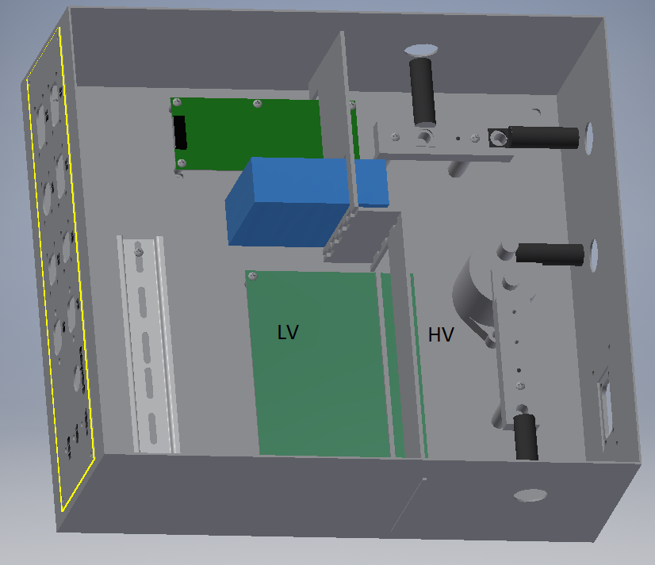
Figure 10 TSI (TS and GLV Separation)

q
Figure 11 GLV Enclosure (TS GLV Separation)

The enclosures above are grounded.

List all electrical circuit boards designed by team that contain TS and GLV voltage in the following table.
Device / PCB | TS Voltage Present (V) | Minimum Spacing mm | Thru Air of Over Surface | Notes
TSI-PCB-HV-LV | Max 96 | 8.89 mm | OS
TSV-PACMan | Max 24 | 3.80mm | OS
Table 5 - PCB Spacings

Add a figure (board layout drawing) for each team-designed PCB showing that spacings comply with EV5.5.
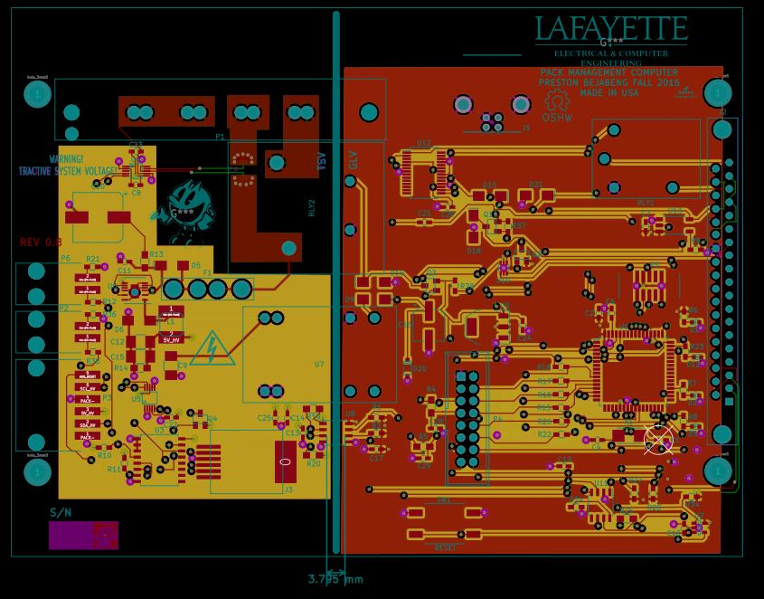
Figure 12 PACMan board layout with Spacing in white

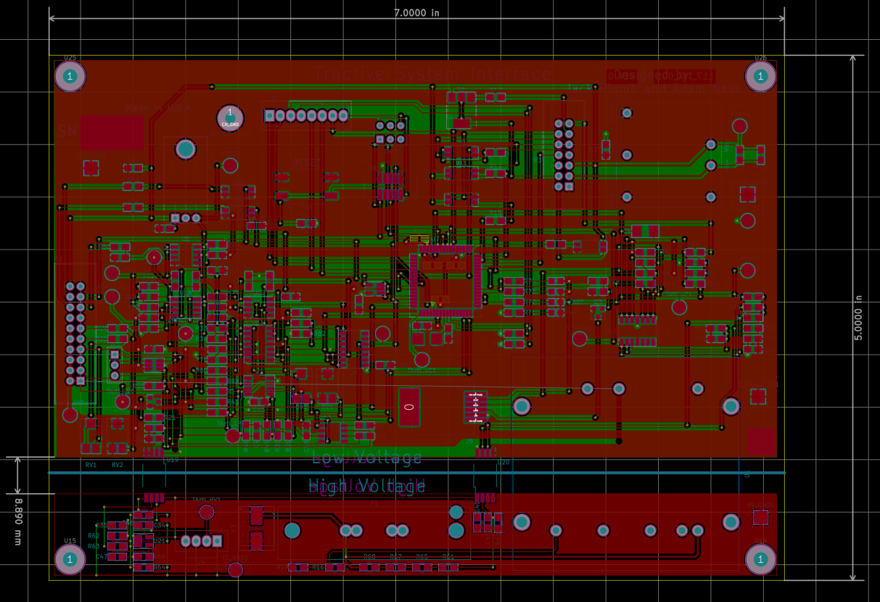
Figure 13 Team Designed PCB _ TSI Board

List all purchased components with both TS and GLV connections (at min motor controller and AMS)
Our AMS boards are powered from the TSV system so they do not have a GLV connection. To ensure isolation there is a DC to DC converter between the cell and the AMS board.

Component | Isolation Method | Link to Document Describing Isolation | Notes
Bender ISOMETER IR155-3203 | Galvanic Isolation | http://www.bender-es.com/fileadmin/products/doc/IR155-32xx-V004_D00115_D_XXEN.pdf | Recommended by the Rules committee
Curtis 1238 Motor Controller | Separated within TSI and then internally separated within controller | http://www.thunderstruck-ev.com/Manuals/1234_36_38%20Manual%20Rev%20Feb%2009.pdf  http://assets.curtisinstruments.com/Uploads/Datasheets/50265_123638E_RevC3.pdf
Current Sensor BBM-01 | Electrical Isolation | http://www.gmw.com/magnetic_sensors/ametes/documents/BBM-01Spec%20v3.pdf | Used in Each TSV Segment and the TSI
Can Bus Isolator CANOP | Optical Isolation | https://upverter.com/datasheet/c4e7f1a56b7f5ba03c9a1bfb3bd7f579843b0f1d.pdf | Used in TSI
AIRs GX14CB | Electrical Isolation | http://www.gigavac.com/sites/default/files/catalog/spec_sheet/gx14.pdf | Total of 5 AIRs, one in each Segment and an extra one in Pack 4

Isolation & Insulation
Provide a list of containers that have TS and GLV wiring in them. If a barrier is used rather than spacing, identify barrier material used (reference Table 7- Insulating Materials).

Container Name | Segregation by Spacing  (Y or N) | How is Spacing maintained | Actual Measured Spacing mm | Alt – Barrier Material P/N | Notes
TSI | Y | Physical barrier | 15 | Garolite/Acrylic | N/A
Motor Controller | Y | Physical barrier | N/A | Garolite/Acrylic | N/A
Pack 1 | Y | Physical barrier | 10 | Garolite | N/A
Pack 2 | Y | Physical barrier | 10 | Garolite | N/A
Pack 3 | Y | Physical barrier | 10 | Garolite | N/A
Pack 4 | Y | Physical barrier | 10 | Garolite | N/A
Table 6 – List of Containers with TS and GLV wiring

List all insulating barrier materials used to meet the requirements of EV2.4 or EV5.4
Insulating Material / Part Number | UL  Recognized(Y / N) | Rated Temperature ºC | Thickness mm | Notes
Garolite | Y | 93.8 - 148.8 | 17.145 | N/A
Table 7- Insulating Materials

Conduit
List different types of conduit used in the design. Specify location and if manufacturer’s standard fittings are used. Note Virtual Accumulator Housing FH Rules EV2.12 requires METALLIC type LFMC.
NO conduit is being used

Describe how the conduit is anchored if standard fittings are not used.

Conduit Type | MFR | Part Number | Diameter  Inch or mm | Standard Fittings  (Y or N) | Location / Use
Table 8 - Conduit Data
Is all conduit contained within the vehicle Surface Envelope per EV3.1.6? (Y or N).
Does all conduit comply with EV3.2? (Y or N).

Shielded dual-insulated cable
If Shielded, dual-insulated cable per EV3.2.5 used in the vehicle, provide specifications and where used:

MFR | Part Number | Cross Section mm2 | Shield grounded at both ends (Y or N) | Location / Use
IEWC | EXRAD2/0-XLEOBS | 70 | Y | Between TSV containers; TSV to TSI;TSI to motor controller; Motor Controller to Motor
Table 9 - Shielded Dual Insulated Cable Data

Firewall(s)

Description/materials
Describe the concept, layer structure and the materials used for the firewalls. Describe how all firewall requirements in FH Rules T4.5 are satisfied. Show how the low resistance connection to chassis ground is achieved.

The firewall is made out of Al sheet, steel welded to frame, and covered with fire resistant tape.
Layers: Sheet aluminum (1.5 mm aluminum), fire resistant tape

The Al sheets run underneath the driver and behind the main roll hoop to separate the driver from the fuel tanks, all components of fuel supply, cooling systems, GLV, TSI, external engine oil systems, and all conductors carrying tractive system voltages. The panels are mechanically fastened in place and sealed at the joints. The firewall is extended upward behind the driver to a height where a straight line cannot be drawn between 150 mm below the top of the tallest driver’s helmet and the T4.5.1 components behind the driver. The batteries are contained within an Al casing of 1/8” and thus act as the side accumulator firewalls as checked with the FSAE rules committee.

The Chassis is connected to GLV ground using a 12 AWG cable.

Position in car
Provide CAD-rendering or photographs showing the location of the firewall(s).

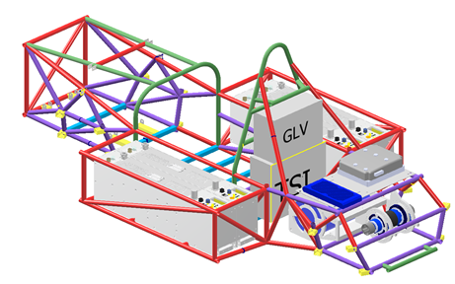
Figure 14 Battery Pack Firewall Containers Relative to Driver Seat
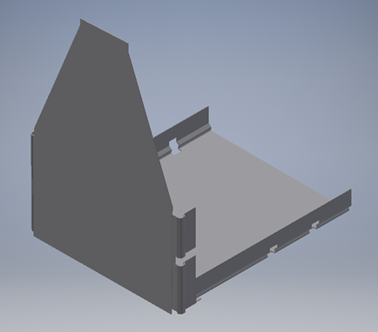
Figure 15 Driver Seat Firewall CAD drawing

Electric Tractive System
Person primarily responsible for this section:
Name: | Waseh Ahmad
e-mail: | ahmadw@lafayette.edu

Motor(s)
Describe the motor(s) used and reason for this particular choice. Add additional tables if multiple motor types are used

We are using this motor as it is the appropriate motor recommended by the manufacturer, to be used with the specifically chosen Motor Controller. Its nominal voltage and current usage are within range of the designed batteries.

Manufacturer and Model: | HPEVS AC 50-27.28.11
Motor type (PM, Induction, DC Brush) | Induction
Number of motors of this type used | 1
Nominal motor voltage (Vrms l-l or Vdc) | 96
Nominal / Peak motor current (A or A/phase) | Nom: 200A / Peak: 650A
Nominal / Peak motor power | Nom: 19 HP / Peak: 71 HP
Motor wiring – conductor size and type | 3/8” Ring Connectors w/ 00 Gauge Copper Wire
Table 10 - Motor Data

Provide calculations for currents and voltages. State how this relates to the choice of cables and connectors used.

Cable used is the 2/0 Gauge cable which has a capacity of 300A. For peak current protection, 300A fuses are used within the TSV packs.

Motor Controller
Describe the motor controller(s) used and reason for this particular choice. Add additional tables if multiple motor controller types are used.

We are using the Curtis 1238 due to its voltage rating allowing for 96V input as well as its nominal current rating.

Manufacturer and Model: | Curtis 1238
Number of controllers of this type used: | 1
Maximum Input voltage: | 130 V
Nominal Input Current (A) | 200 A
Max Input Fuse (A) per Mfr. | 650 A
Output voltage (Vac l-l or Vdc) | 96 V_{AC}
Isolation voltage rating between GLV (power supply or control inputs) and TS connections | 1 KVDC
Is the accelerator galvanically isolated from the Tractive System per EV3.5 & EV5? | ☒Yes / ☐ No
Table 11 - Motor Controller Data

If the answer to the last question is NO, how do you intend to comply with EV3.5 (an external isolator is acceptable).

Provide calculations for currents and voltages. State how this relates to the choice of cables and connectors used.
The values for voltages/currents are provided in the table above. The choice of cable is 2/0 AWG cables as the current rating is above that of the nominal input current to the controller. Connectors used are 3/8 Ring terminals, appropriate for the 2/0 Cable used.

Tractive System Measurement Points (TSMP)
The TSMP must comply with FH Rule EV10.3. Describe the TSMP housing and location. Describe TSMP electrical connection point.
TSMP Output Protection Resistor Value | 10 kΩ
Resistor Voltage Rating | 460 V
Resistor Power Rating | 5 W
Table 12 – TSMP Resistor Data
The TSMP are located on the TSI box enclosure along with the GLV ground. They are Shrouded 4 mm banana jacks that accept shrouded (sheathed) banana plugs with nonretractable shrouds. The TSMP connect to the TSV positive and negative terminals incoming to the TSI enclosure.

Pre-Charge circuitry
Describe your design for the pre-charge circuitry. Describe wiring, connectors and cables used.
- Include a schematic of the pre-charge circuit
- Include a plot of calculated TS Voltage vs. time
- Include a plot of calculated Current vs. time
- Include a plot of resistor power vs time.

As per Curtis 1238 data, the pre-charge circuit is built into the motor controller.
http://www.evwest.com/catalog/product_info.php?products_id=103

As per page 103 of the manual, http://www.thunderstruck-ev.com/Manuals/1234_36_38%20Manual%20Rev%20Feb%2009.pdf , the capacitor bank charges to 3V of the KSI i.e. Battery voltage. This is well within 90% of the nominal or max voltage for the TSV. As it also allowed to pre-charge the circuit for a conservative time as well, the motor-controller pre-charge also may charge the capacitor bank for one second.

If the shutdown sequence is initiated, no power will be supplied from the TSV to TSI to motor controller and the pre-charge circuit will shut down and not charge.

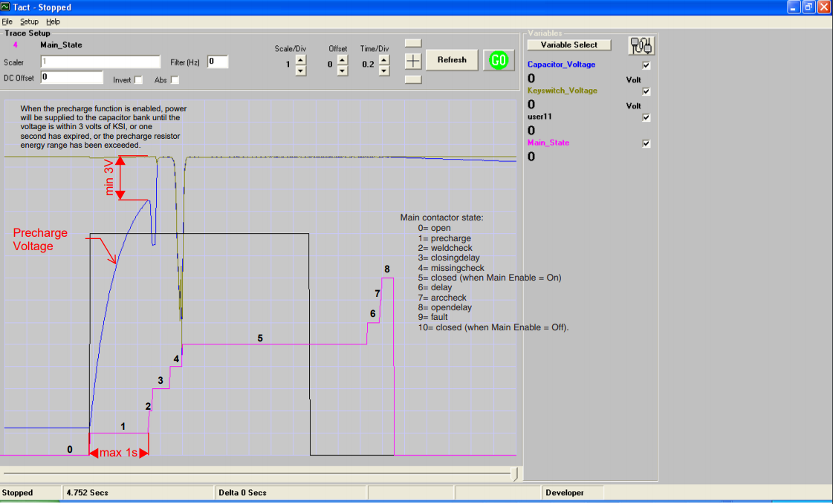
Figure 16 Motor Controller Startup -Pre-Charge

Provide the following information:
Resistor Type: | N/A Within Motor Controller
Resistance: | Ω
Continuous power rating: | W
Overload power rating: | W for sec
Voltage rating: | V
Table 13 - Data for the pre-charge resistor

Relay MFR & Type: | GIGAVAC GV200QA
Contact arrangement (e.g. SPDT) | SPST- Normally open
Continuous DC contact current (A): | 400 A
Contact voltage rating (Vdc). | 1000 V
Table 14 - Data of the pre-charge relay

Discharge circuitry
Describe your concept for the discharge circuitry. Describe wiring, connectors and cables used.
- Include a schematic of the pre-charge circuit
- Include a plot of calculated TS Voltage vs. time
- Include a plot of calculated “Discharge current” vs. time
- Include a plot of resistor power vs time.

The motor controller does have internal capacitance but has its own discharge circuit designed by Curtis.

There is a capacitor across the HV in the TSI as shown in the figure below. The capacitor used is 10uF with a connected resistance of 254.3K for a time constant of
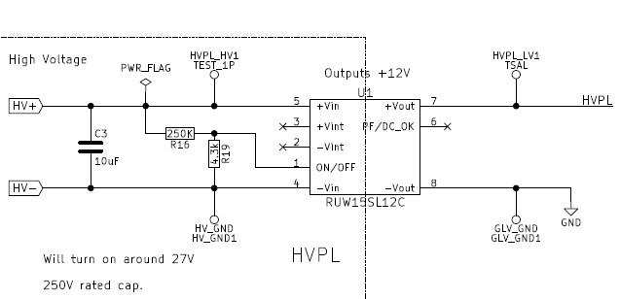
Figure 17 Discharge Circuit for Capacitor in TSI

Provide the following information:
Resistor Type: | ERA-6AEB432V Series ERJ-6ENF2493V
Resistance: | 254.3kΩ
Continuous power rating: | 0.125 W
Overload power rating: | 1 W for 5 sec
Voltage rating: | 200 V
Maximum expected current: | 0.378 mA
Average current: | 0.352 mA
Table 15 - Data of the discharge circuit.
Max Current = 96/(254.3 kohm)
Average Current = 89.6/(254.3 kohm)

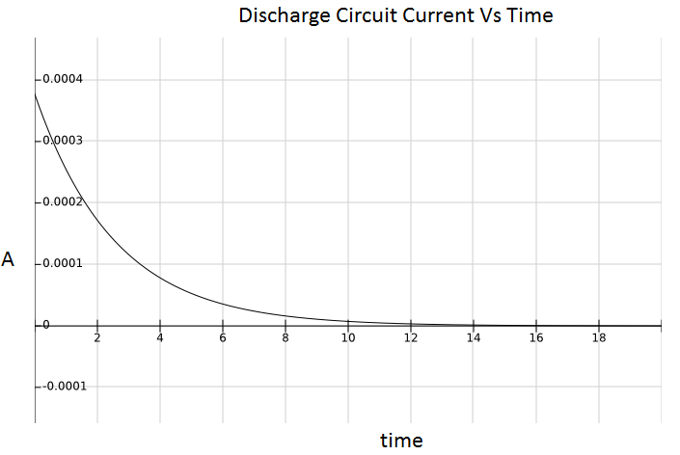
Figure 18 Calculated Discharge Current Vs Time

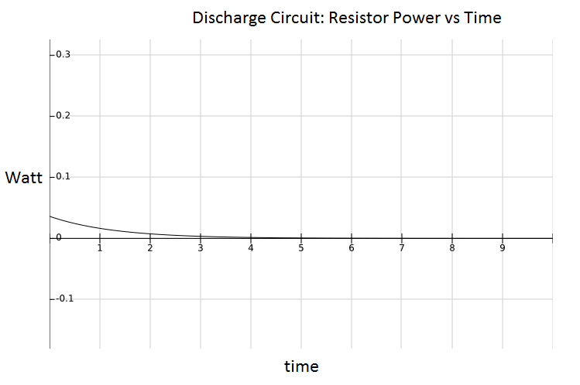
Figure 19 Discharge Circuit Resistor Power vs Time

HV Disconnect (HVD)
Describe your design for the HVD and how it is operated, wiring, and location. Describe how your design meets all requirements for EV2.9.

The HVD is an Amphenol PowerLok connector, connected to pack 2, coming from pack 3. It is operated by manually unplugging the connector from its receptacle. It can maintain its disconnected state as long as it is not connected to the receptacle, fitted using the keying method for the connector. It is accessible by the driver and can be removed within 10 seconds of ready to race conditions. It is also located near the middle of the series of cells. As such, if disconnected, it will de-energize the TSAL and the TSMPs.

Accelerator Actuator / Throttle Position Sensor
Describe the accelerator actuator and throttle position sensor(s) used, describe additional circuitry used to check or condition the signal going to the motor controller. Describe wiring, cables and connectors used. Provide schematics and a description of the method of operation of any team-built signal conditioning electronics. Explain how your design meets all of the requirements of FH Rules IC1.6 and EV3.5.

The throttle position sensor consists of two 5k piston potentiometers (figure 20). They are mechanically linked in parallel and will actuate over the same range. The pedal is mechanically limited to 90% of the potentiometer travel range for open/short detection. The first pot (APPS1) is biased from 5-10 volts and the second pot (APPS2) is biased from 0-5 volts. In order to detect open/short circuit conditions APPS2 is passed through a window comparator with a valid range of 0.25-4.75, similarly, APPS1 has the 5 volt bias removed and is passed through a window comparator with the same range. In order to detect throttle plausibility, the biased APPS1 and APPS2 signals are passed through a differential amplifier. The output of the diff-amp is then passed through a window comparator with valid range of 4.5-5.5 volts. This range tolerates up to a 10% difference between APPS1 and APPS2. All of the comparator outputs are tied to a NAND gate. If all comparators have logic high outputs the NAND gate sets the throttle plausibility signal low, allowing the throttle signal from APPS2 to pass through an isolator and then be sent to the motor controller.

Actuator / Encoder manufacturer and model: | LPPS Linear Potentiometer – LPPS-050
Encoder type (e.g.Potentiometer): | Potentiometer
Output: | 5V range of signals (max 5-10V)
Is motor controller accelerator signal isolated from TSV? | ☒Yes / ☐ No
If no, how will you satisfy rule EV3.5? | NA
Table 16 - Throttle Position encoder data

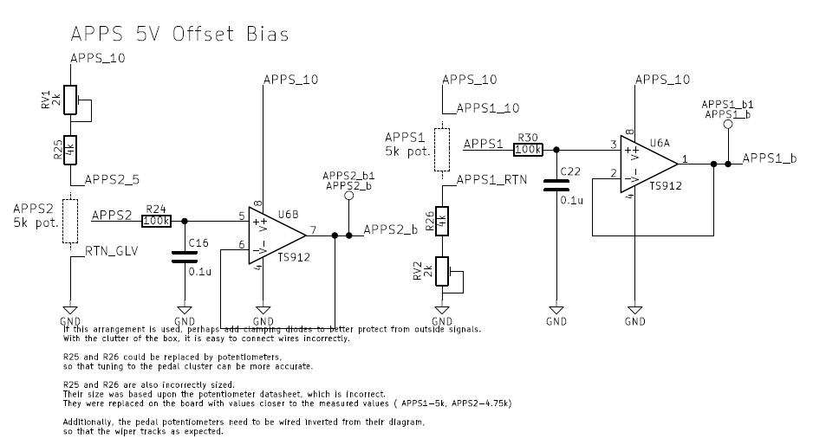
Figure 20 Throttle biasing circuit (From piston potentiometers)

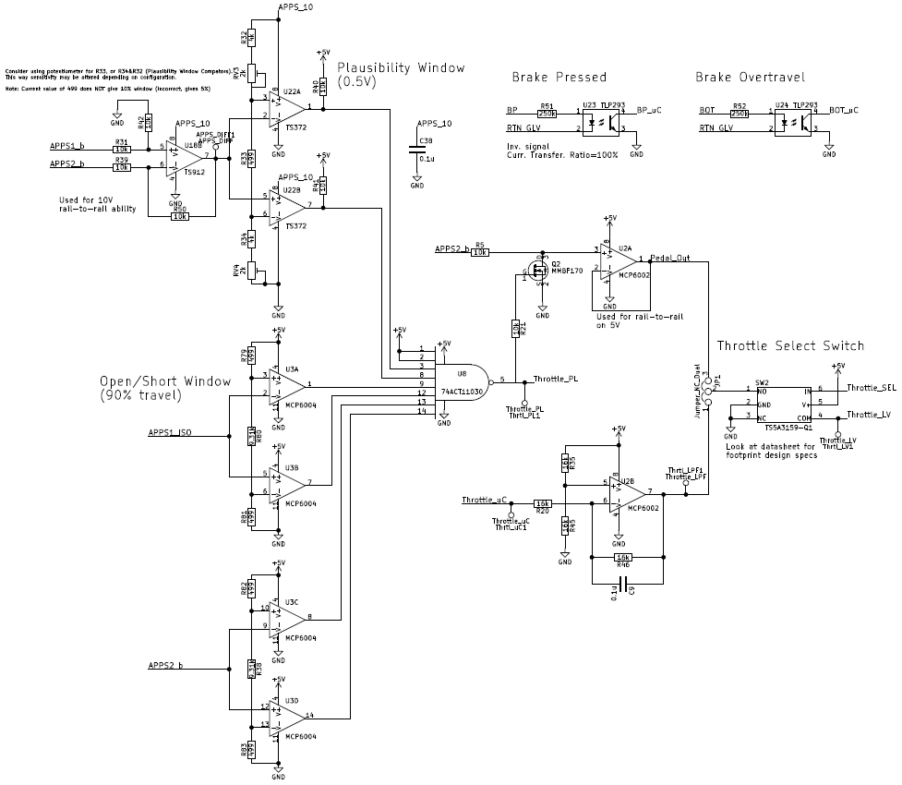
Figure 21 Throttle Plausability Window Check
(Click Here for more details)

Accelerator / throttle position encoder error check
Describe how the system reacts if an error (e.g. short circuit or open circuit or equivalent) is detected. Describe circuitry used to check or condition the signal going to the motor controller. Describe how failures (e.g. Implausibility, short circuit, open circuit etc.) are detected and how the system reacts if an error is detected. State how you comply with EV3.5.4.

If a throttle plausibility error is detected, the NAND gate outputs a logic high. This output is tied to the gate of a power MOSFET, and ties the throttle input to the motor controller to 0 volts. The low voltage throttle signal is isolated from the motor controller through the use of a Broadcom ACPL-C870 optical isolator. The plausibility signal goes to the microcontroller which takes the system out of drive mode.

Accumulator System
Person primarily responsible for this section:
Name: | Waseh Ahmad
e-mail: | ahmadw@lafayette.edu

Accumulator Pack
Provide a narrative design of the accumulator system and complete the following table.

The Tractive System Voltage is provided by four accumulator containers placed in series to provide the power necessary to operate the motor. An accumulator segment, housed within each container, is comprised of a battery of 7 LiFeP04 cells (3.2 V nominal) connected in series. Each cell is monitored for temperature and voltage by an AMS (accumulator), which communicates this information to the Pack Management Computer (PacMAN). The PackMAN utilizes an AT90CAN128 Atmel microcontroller.

The accumulator high current output is available through Amphenol PowerLok Connectors. Accumulator voltage is present only while the safety loop is closed. A low current output is also available through an Anderson Power connector. This output is limited to 20 A. Charging is also accomplished through this connector, and is similarly limited to 20 A and 30 V, and implements “plug and forget” charging. The functioning of both ports is controlled by the PackMAN board.

Maximum Voltage (during charging): | 96 VDC
Nominal Voltage: | 89.6 VDC
Total number of cells: | 28
Cell arrangement (x in series / y in parallel): | 28 in series
Are packs commercial or team constructed? | ☐Commercial / ☒ Team
Total Capacity (per FH Rules Appendix A): | 3.6 kWh
Maximum Segment Capacity | 4.05 MJ
Number of Accumulator Segments | 4 (#)
Table 17 - Main accumulator parameters

Describe how pack capacity is calculated. Provide calculation at 2C (0.5 hour) rate? How is capacity derived from manufacturer’s data? If so, include discharge data or graph here. Include Peukert calculation if used (See FH Rules Appendix A)

Cp = (I^k)*t = (3^1.05)*20 = 63.4 AH
63.4 = (I^1.05)*0.5
I = 100.686 (half hour discharge)
2C = 50.3 AH

Capacity = V_{nom}Ah(0.8)=3.2*28*50.3*0.8
Segment Capacity = 3.2*50.3*7*3.6=4.05

Show your segment energy calculations. The segment energy is calculated as

$$Vnom x Cell AH (2C rate) x Number of Cells x 3.6 (kJ)$$

(The 80% factor is not applied for this calculation.)

Cell description

Describe the cell type used and the chemistry and complete the following table.
Cell Manufacturer and Model | AA Portable Power Corp, LFP-G60
Cell type (prismatic, cylindrical, pouch, etc.) | ☒Yes / ☐ No
Are these pouch cells | ☐Yes / ☒ No
Cell nominal capacity at 2C (0.5 hour) rate: | 50.3 Ah
Data sheet nominal capacity | 60 Ah at 1C rate
Maximum Voltage (during charging): | 3.42 V
Nominal Voltage (data sheet value): | 3.2 V
Minimum Voltage (AMS setting): | 2.7 V
Maximum Cell Temperature (charging - AMS setting) | 60 °C
Maximum Cell Temperature (discharging - AMS setting) | 60 °C
Cell chemistry: | LiFePO4 in prismatic case
Table 18 - Main cell specification
IMPORTANT: Show your calculations here for 2C nominal AH capacity if the data sheet uses a different discharge rate. Refer to FH rules Appendix A

Cell configuration
Describe cell configuration, show schematics, cover additional parts like internal cell fuses etc.
Describe configuration: e.g., N cells in parallel then M packs in series, or N cells in series then M strings in series.

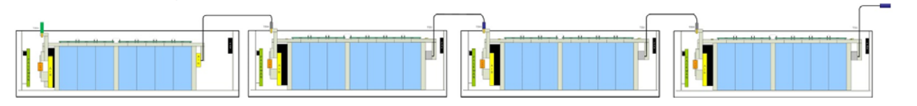
Figure 22 Cell Configuration

In each accumulator segment, seven cells are placed in series. Each segment is within an accumulator container. There are four containers, each of which is placed in series. In total, seven cells in four containers are all in series i.e. 28S1P configuration.

Does the accumulator combine individual cells in parallel without cell fuses? ☐Yes / ☒ No
If Yes, explain how EV2.6 is satisfied.

Segment Maintenance Disconnect
Describe segment maintenance disconnect (SMD) device, locations, ratings etc.
The SMD consists of Amphenol PowerLok right angled connectors from one segement (pack) to the next as shown in the drawings of section 5.12
Is HVD used as an SMD? | ☒Yes / ☐ No
Number of SMD Devices / Number of Segments | [ 5 ] / [ 4 ]
SMD MFR and Model | Amphenol  PL28W-301-70  PL28X-301-70  PL00W-301-10D10  PL00X-301-10D10
SMD Rated Voltage (if applicable) | 1000 V
SMD Rated Current (if applicable) | 250 A (continuous; used with 2/0 cabling which according to Appendix E, have a current capacity of 300 A)
Segment Energy (6 MJ max) | 4.05 MJ
Segment Energy Discharge Rate (Ref FH Rules Appendix A) | 2 C
Table 19 - SMD Data

Lithium-Ion Pouch Cells
The vehicle accumulator uses individual pouch cells. Yes ☐ No ☒

Note that designing an accumulator system utilizing pouch cells is a substantial engineering undertaking which may be avoided by using prismatic or cylindrical cells.

If your team has designed your accumulator system using individual Lithium-Ion pouch cells, include drawings, photographs and calculations demonstrating compliance with all sections of rule EV11. If your system has been issued a variance to EV11 by the Formula Hybrid rules committee, include the required documentation from the cell manufacturer.

Cell temperature monitoring
Describe how the temperature of the cells is monitored, where the temperature sensors are placed, how many cells are monitored, etc. Show a map of the physical layout. Provide schematics for team-built electronics.

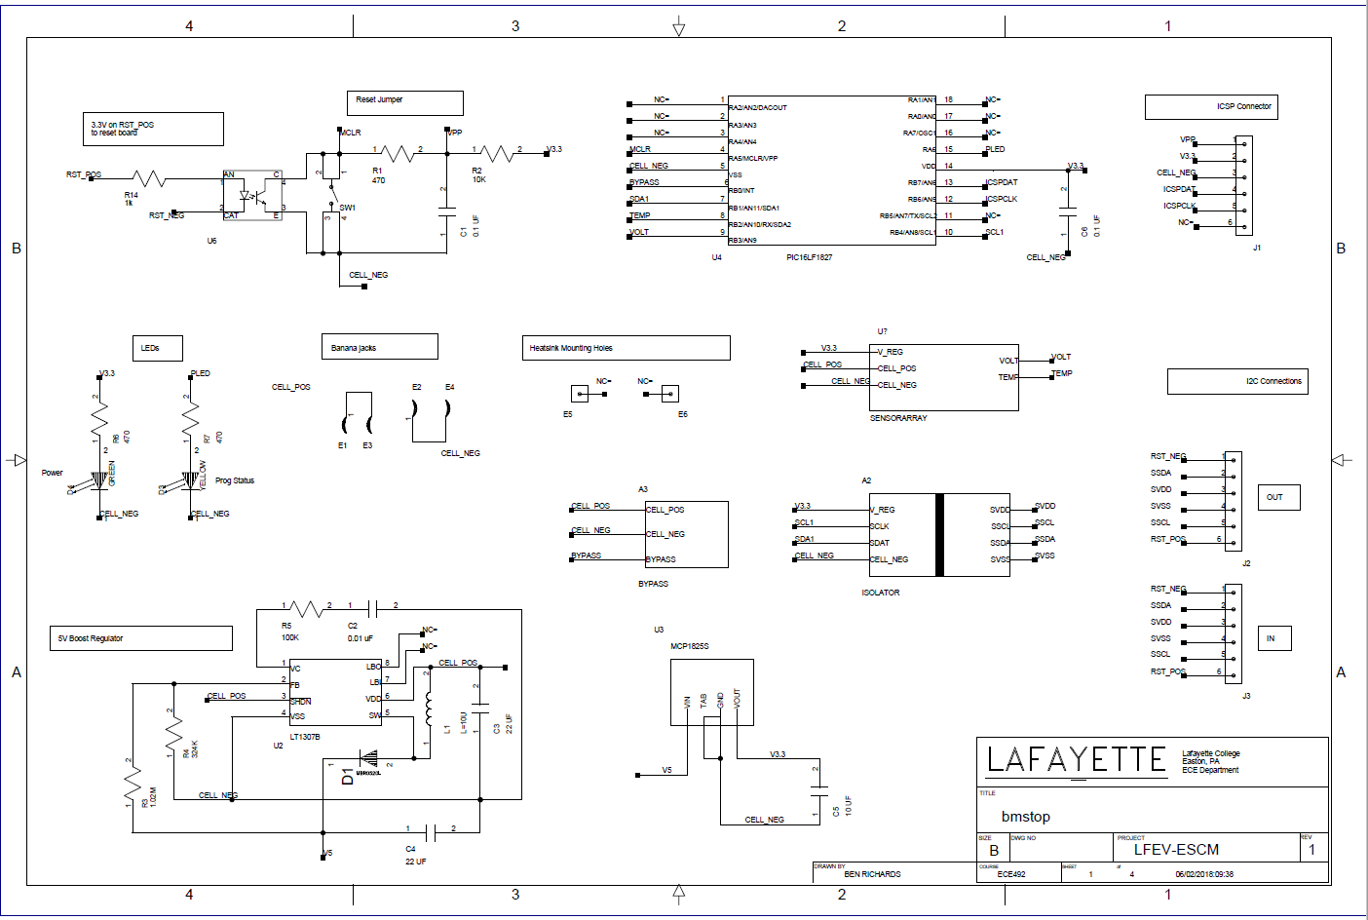
Figure 23 AMS Boards Schematic

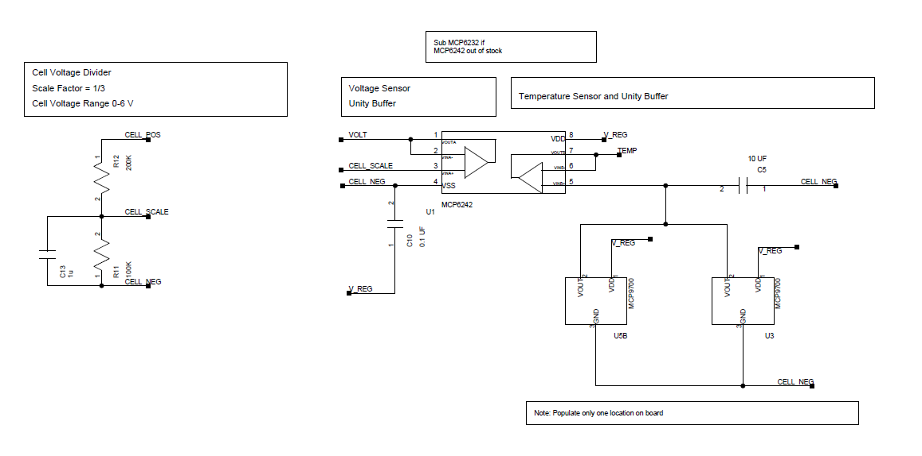
Figure 24 AMS Voltage/Temp monitoring schematic
The above two diagrams are taken from the schematics of the AMS board placed on top of each cell.

Each cell within each accumulator segment is monitored by an AMS board. Each AMS board contains a linear active thermistor (MCP9700, Microchip) that measures the temperature of each cell. The AMS boards communicate this information via I2C to the PacMAN board within their respective accumulator containers, which determines if any cell has exceeded 60º C. If this is the case, a fault case is asserted and the safety loop is opened.
Figure 25 shows the configuration of AMS boards attached to each individual cell.
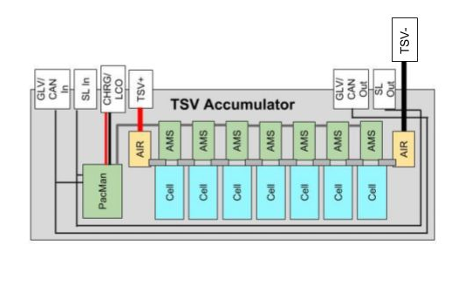
Figure 25 Pack With Cell Config

Number of Cells with Temperature Monitoring (#1) | 28
Total Number of Cells (#2) | 28
Percentage Monitored (#1 / #2) | 100%
Percentage Required by FH Rules: Table 11 | 30%
If each sensor monitors multiple cells, state how many: | N/A
Table 20 - Cell Temperature Monitoring

Accumulator Isolation Relays (AIR)
Describe the number of AIRs used and their locations. Also complete the following table.
MFR & Model | Gigavac GX14CB
Contact arraignment: | Single Pole Single Throw Normally Open
Continuous DC current rating: | 350 A
Overload DC current rating: | 1000 A for 85 sec
Maximum operation voltage: | 32 VDC
Nominal coil voltage: | 24 VDC
Normal Load switching: | Make and break up to 600 A
Table 21 - AIR data

Accumulator Management System (AMS)
Describe the AMS and how it was chosen. Describe generally how it meets the requirements of
EV2.11.

The AMS within each accumulator consists of one PacMAN board and seven AMS boards. The PacMAN board is comprised of a microcontroller (Microchip Technology, AT90CAN128-16AUR) which monitors overall pack current and voltage directly and receives individual cell information from the AMS boards. Each AMS board monitors a single cell for temperature and voltage and communicates this to the PacMAN via I2C. If the PacMAN detects a fault, defined as cell temperature exceeding 60°C, cell voltage exceeding 3.6 V, accumulator segment voltage exceeds 26 V, or an AMS board is unresponsive, the PacMAN board opens the safety loop relay which opens the airs. Accumulator voltage is only present when the safety loop is closed.

PacMAN also keeps track of accumulator state, state of charge, and the state of the safety loop relay on PacMAN. All of these data are regularly sent via CAN frames to the VSCADA computer. The microcontroller communicates on the CAN bus through a Microchip MCP2551 CAN interface IC. This information is also displayed on the top of each accumulator container through the control panel. Managed by PacMAN, this LCD will be able to display pack voltage, pack current, cell voltage, cell temperature, state of charge, cell balancing state, charging state, charging history, discharge history and safety loop state. It will also have functionalities of going into sleep mode and choosing calibration factors where they are necessary.

When either the charging or low current output port (Anderson Power connector on the control panel that is limited to 20 A and 30 V), are in use, a relay on the PacMan computer closes allowing access to the positive and negative terminal of the accumulator. These connections are fused at the terminals with 25A blade fuses. Current flowing through the charge relay also flows through a 1 mOhm current sensing resistor that is monitored via a Kelvin connection by a Texas Instruments INA 226 current monitor. This IC also allows voltage sensing for the full accumulator voltage.

While charging, the voltage of each cell is monitored by the AMS boards, and communicated to PacMAN via I2C. A cell will be placed in bypass mode when its voltage reaches 3.4 V, allowing other cells to continue to charge without overcharging. This is accomplished by allowing some current to pass through a resistor attached to a heat sink instead of the cell. A 5V fan is allowed to run at all times while charging to maintain the ambient temperature inside the accumulator. Once every cell reaches 3.4 V, charging is considered complete. Both bypassing and completion of a charge cycle trigger an entry in a charge history stored on the microcontroller. This data will be accessible in debug via USB, and an abbreviated history is available on the control panel LCD.

Isolation between TSV and GLV is on the pack manager board with the use of DC/DC converter and opto-isolator.

AMS MFR and Model | Manufactured/Designed in House
Number of AMSs | 4 (1 per segment, includes 7 cell monitoring boards and 1 Pack manager)
Upper cell voltage trip | 3.6 V
Lower cell voltage trip | 2.7 V
Temperature trip | 60 °C
Table 22 - AMS Data

- Describe other relevant AMS operation parameters.
- Describe how many cells are monitored by each AMS board, the configuration of the cells, the configuration of the boards and how AMS communications wiring is protected and isolated.
- Describe how the AMS opens the AIRs if an error is detected
- Indicate in the AMS system the location of the isolation between TS and GLV
The isolation is in the PACMan board which uses a DC/DC converter and an optoisolator. Each PACMan only sees at max 24V.

Accumulator wiring, cables, current calculations
Describe internal wiring with schematics if appropriate. Provide calculations for currents and voltages and show data regarding the cables and connectors used. Discuss maximum expected current, DC and AC, and duration Compare the maximum values to nominal currents

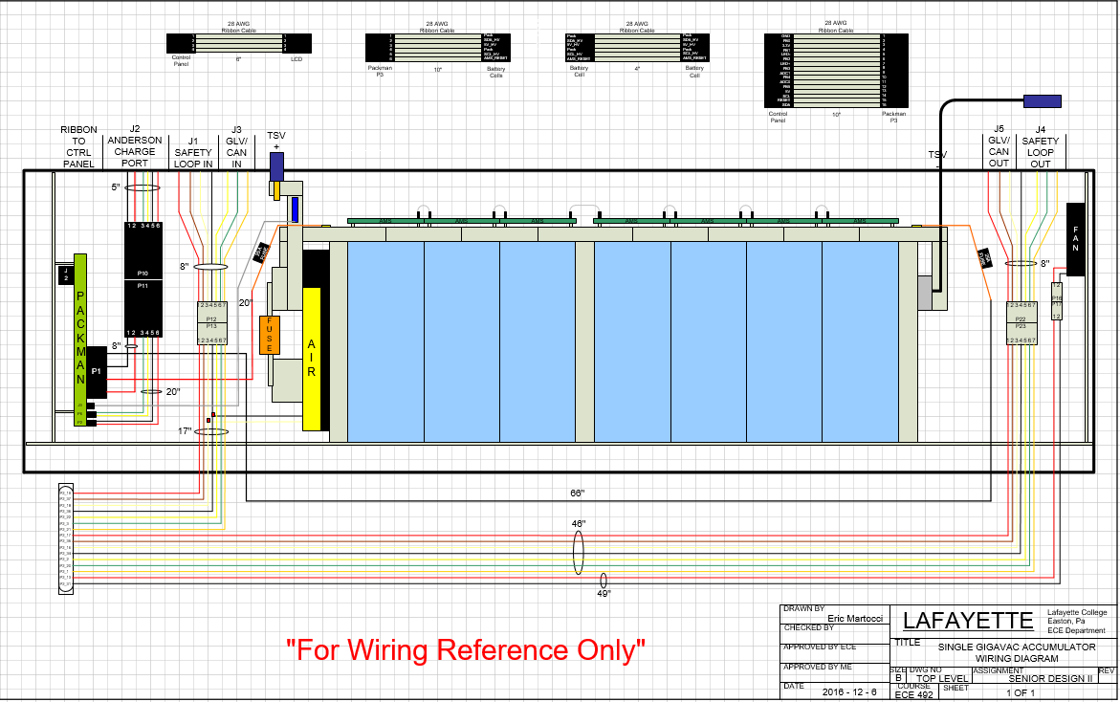
Figure 26 Wiring for one Accumulator Segment
The diagram above shows the wiring for one of the Accumulator Segments.
We expect no AC voltage. For an accumulator container we expect a thevenin voltage of 23.6 V with 14 mOhm thevenin resistance at 100% state of charge. With a fully charged accumulator container, we expect roughly 24 V with seven cells charged to 3.4 V. With a fully charged accumulator system we expect 96 V. From experimentation, it takes 53 minutes for full discharge for a single accumulator container. The low current output draws 20 A. Each cell has 60A-h for 1C.

Through a motor and controller characterization, the maximum RPM is 4500 RPM with a maximum possible torque of 92 ft-lbs. The maximum efficiency motor speed in the fully integrated car is 2500 RPM with steady state torque estimate of 15 ft-lbs based upon a constant power experiment showing the maximum efficiency for the motor reached at and above 2500 RPM. At this maximum efficiency, the motor will draw 71 A from the accumulator. This means the battery will dissipate from this analysis in 51 minutes or 0.85 hours.

The DC current from the accumulator is measured utilizing a current sensor from each accumulator container.

For the rate of charge and discharge of an accumulator container, assuming the slowest possible discharge current for an accumulator at 20A, the actual current is expected to be within the range of 20.366 and 19.634A. Given an accumulator capacity of 60 Ah, the capacity in Coulombs is equal to 216000. At 20 Coulombs per second, the pack will discharge in 10800 seconds, meaning a discharge rate of 1% every 108 seconds. For 20.366 and 19.634 A, the pack discharges 1.018% or 0.982% every 108 seconds respectively. .018 multiplied by 100 to account for the possible accumulation of error gives a confidence interval of +/ 1.8% between the measured and expected values for state of charge.

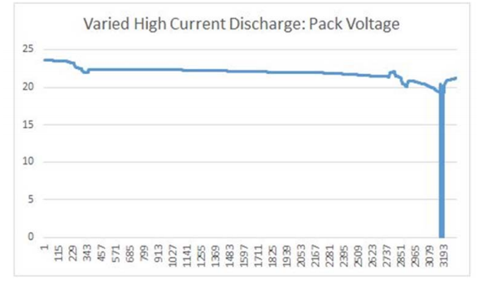
Figure 27 High Current Discharge for Pack

The connectors used are Amphenol PowerLok 300 Series connectors (Section 5.4), with 2/0 fully Shielded cables.

Accumulator indicator
If accumulator container is removable, describe the indicator, including indicating voltage range

Our Accumulator container is divided into 4 segments, each with a max voltage below 30V. The TSAL light will thus be used as an indicator of the Accumulator, meeting the requirement of turning on when TSV exceeds 32V.

Charging
Describe how the accumulator will be charged. How will the charger be connected? How is the accumulator to be supervised during charging? Include a diagram showing how the charging circuit is fused.

This design utilizes coulomb counting, integrating the current flowing through the current sensing resistor to determine the increase in state of charge due to charging as well as the decrease in state of charge due to low current output and the operation of the PacMan computer.

To monitor current flowing through the high current output, an Ametes BBM01 current sensor is attached to the 0.5 in by 1 in aluminum bar wire that attaches the negative accumulator terminal to the negative terminal of battery of cells. This sensor provides a differential voltage output that is available to the microcontroller over I2C through a Texas Instruments ADS1115 analog to digital converter.

While charging, the voltage of each cell is monitored by the AMS boards, and communicated to PacMAN via I2C. A cell will be placed in bypass mode when its voltage reaches 3.4 V, allowing other cells to continue to charge without overcharging. This is accomplished allowing some current to pass through a resistor attached to a heat sink instead of the cell. A 5V fan is allowed to run at all times while charging to maintain the ambient temperature inside the accumulator. Once all cells reaches 3.4 V, charging is considered complete. This allows for plug-and-forget charging. Both bypassing and completion of a charge cycle trigger an entry in a charge history stored on the microcontroller. This data will be accessible in debug via USB, and an abbreviated history is available on the LCD.

When the charge relay is closed in figure 28 with the use of the CHRG_CTRL signal, charge+ feeds into Pack +, which is then protected by a 5A fuse as shown in figure 29.
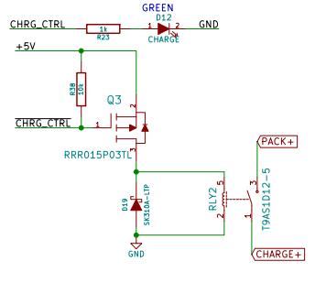
Figure 28 Charging Ciruit
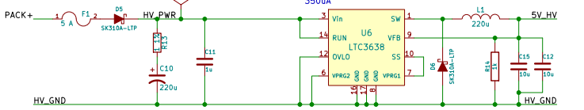
Figure 29 Charging Circuit with Fusing
Complete the table
Charger Manufacturer and model: | TDK-Lambda, GenH30-25
Maximum charging power: | 0.75 kW
Isolation | ☒Yes / ☐ No
UL Certification (If “no”, fill in the line below) | ☒Yes / ☐ No
Do you have a waiver from the FH rules committee? | ☐Yes / ☐ No
Maximum charging voltage: | 30 V
Maximum charging current: | 25 A
Interface with accumulator (e.g. CAN, relay etc) | Anderson Charging Port
Input voltage: | 85-265 VAC continuous
Input current: | 9.5 A
Table 23 - Charger data

Accumulator Container/Housing
Describe the design of the accumulator container. Include the housing material specifications and construction methods. Include data sheets for insulating materials. Include information documenting compliance with UL94-V0, FAR25 or equivalent.

If the housing is made of conductive material, include information on how the poles of the accumulators are insulated and/or separated from the housing, and describe where and how the container is grounded to the chassis.

Include additional photographs if required to comply with rule EV2.4.

Show how the cells are mounted, use CAD-Renderings or sketches and include calculations showing compliance with FH Rules EV2.5.

The cells are mounted within the individual segments of the container. The cells are shown in figure 30 and 31 below. The cells are connected in series using aluminium bars. They are packed together using GLV grounded aluminium bars on the sides (as shown in the figures) and across the top rim of the cells.

The accumulator container will be made of 1/8” Al sheet/plate and each (2) will contain 2 battery packs. The wires are connected to the poles of the accumulators and are encased in an insulated casing. That entire accumulator container will go in the side pods on the car, the area designated for the storage of the packs. The segments are fastened to the car using 5/16-8 grade 5 bolts, 8 per segment, directly to the frame of the car. There will also be cutouts for small amounts of air to help cool the accumulators, although the cells don’t end up reaching that high of a temperature during discharge. There will also be through-holes for the mounting method for the battery packs and accumulator containers.
Requirements for V-0
- The specimens may not burn with flaming combustion for more than 10 seconds after either application of the test flame.
- The total flaming combustion time may not exceed 50 seconds for the 10 flame applications for each set of 5 specimens.
- The specimens may not burn with flaming or glowing combustion up to the holding clamp.
- The specimens may not drip flaming particles that ignite the dry absorbent surgical cotton located 300 mm below the test specimen.
- The specimens may not have glowing combustion that persists for more than 30 seconds after the second removal of the test flame.
1/8” steel sheet/plate will fulfill the requirements above

The figures below show the accumulator segment containers (at different viewpoints) with the cells.

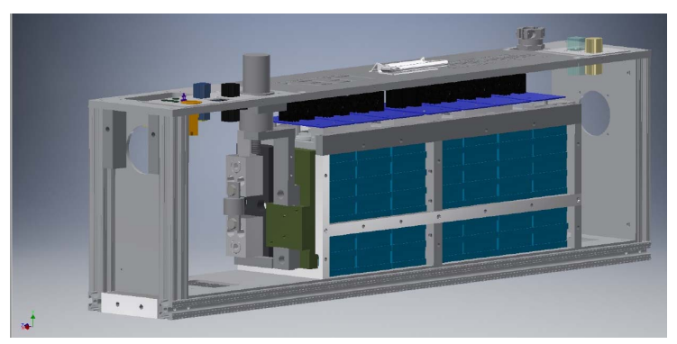
Figure 30 Pack Container View with cells

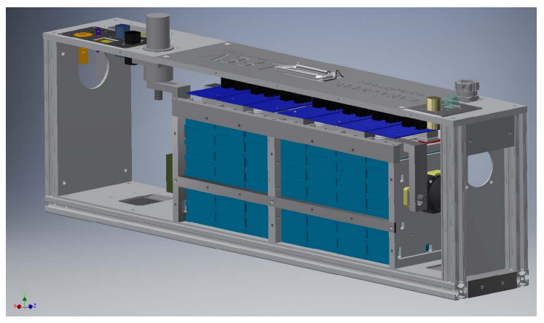
Figure 31 Pack Container View 2 with cells

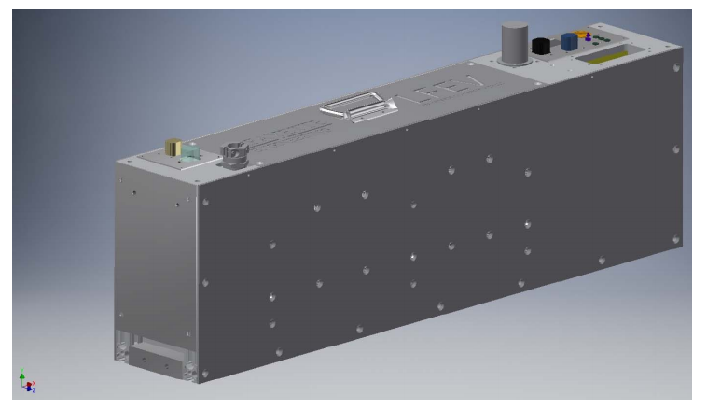
Figure 32 Pack Container Fully assembled container

Safety Controls and Indicators

Shutdown Circuit
Include a schematic of the shutdown circuit for your vehicle including all major components in the loop

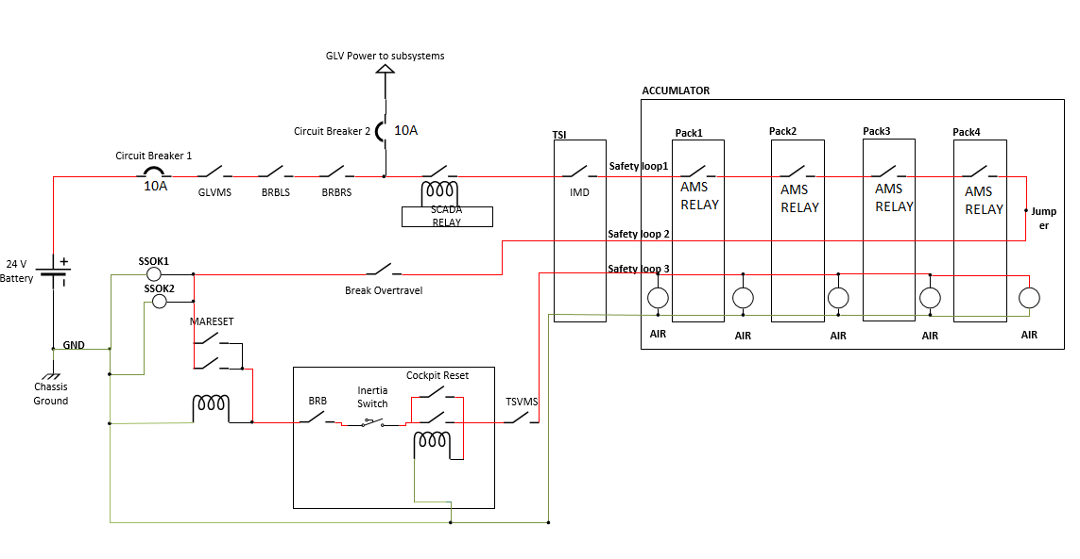
Figure 33 Shutdown Safety Circuit Schematic
Describe the method of operation of your shutdown circuit, including the master switches, shut down buttons, brake over-travel switch, etc. Also complete the following table

Master switches and BRB’s shut down entire system. SCADA monitoring, Cooling, AMS and IMD systems have the ability to shut down AIR’s in TSV. Then post AMS the Brake overtravel switch and TSV master switch shut down the AIR’s outside cockpit. The only Driver resettable switches are the BRB, inertia switch and CPR located directly before the AIR’s.

Part | Function  (Momentary, Normally Open or Normally Closed)
Main Switch (for control and tractive-system; CSMS, TSMS) | Normally Closed
Brake over-travel switch (BOTS) | Push pull switch that will be pressed when the brake lines do not create enough pressure to stop the pedal. This will stop voltage from reaching the motor controller throttle input. Normally Closed.
Shutdown buttons (BRB) | Normally Closed
Insulation Monitoring Device (IMD) | Bender ISOMETER IR155-3203. Operating with normal specs stated on the datasheet. OKHS will be used for monitoring ground 2017 Formula Hybrid ESF (Rev 0C) 42 faults. Normally outputs digital HIGH.  Relay Connected is Normally open
Battery Management System (AMS) | Normally Open Relay
Interlocks (if used) | N/A

Describe wiring and additional circuitry controlling AIRs. Write a functional description of operation

Each accumulator container houses one AIR between the HV positive input terminal of each container and the Mersen/Ferraz Shawmut A3T300 fuse, which then connects to the positive terminal of the first cell in the accumulator segment. Thus, simply, the AIR is in series with the HV input, fuse, and first cell. This AIR in each accumulator container is then connected to the PacMAN board and out the CAN output of the container. Only the first accumulator container in the series contains a second AIR which connects between the minus terminal of the last cell in series in the accumulator segment and the HV negative output terminal of the accumulator container.

If the PacMAN detects a fault, defined as cell temperature exceeding 60°C, cell voltage exceeding 3.6 V, accumulator segment voltage exceeds 26 V, or an AMS board is unresponsive, the PacMAN board opens the AIR. Accumulator voltage is only present when the safety loop is closed. Externally, the AIR can be opened or closed via the CAN connectors on each container from the safety loop

Total Number of AIRs: | 5
Coil holding current per AIR: | 0.1 A
Current drawn by other components wired in parallel with the AIRs. | 0.58 A
Total current in shutdown loop: | 1.08 A
Table 25 - Shutdown circuit Current Draw

Provide CAD-renderings showing the shutdown circuit parts. Mark the parts in the renderings

The markings for the system buttons/switches aren’t sure

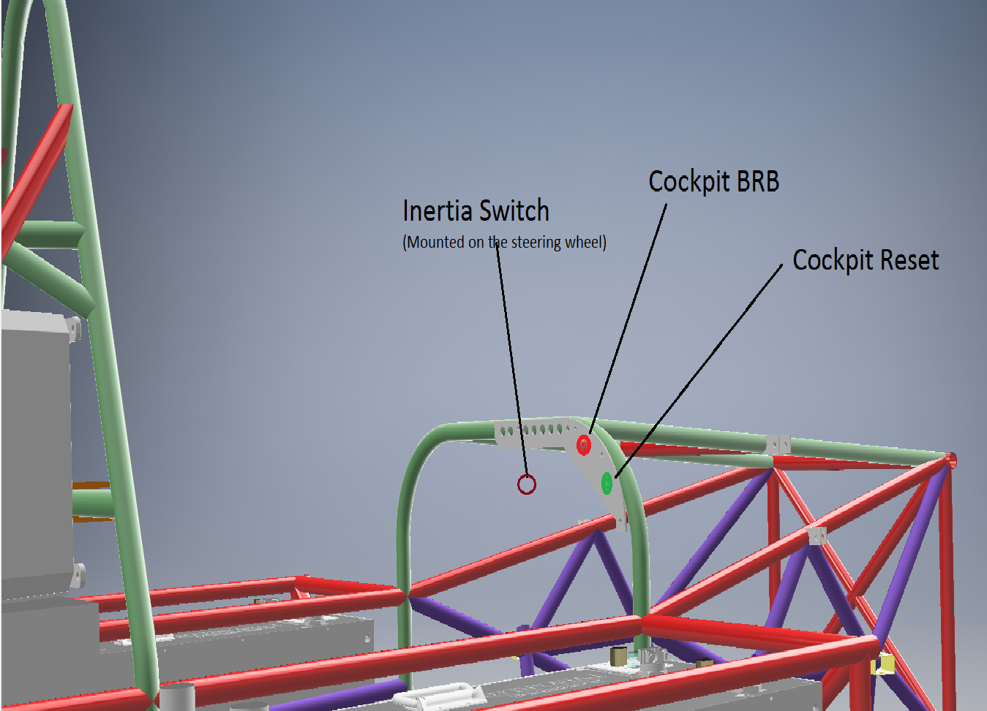
Figure 34 Cockpit View
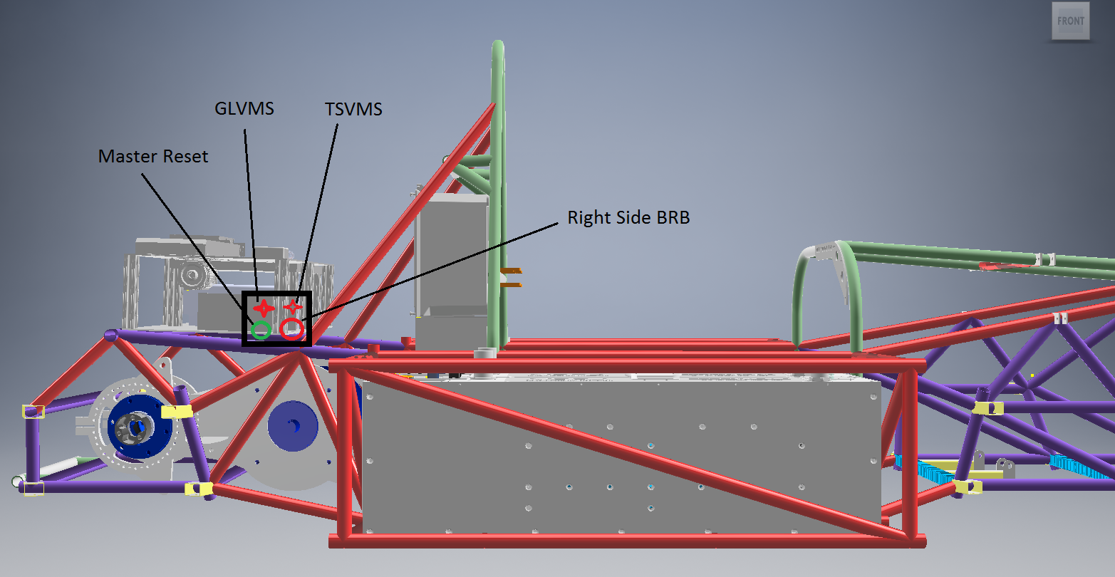
Figure 35 Side View- Shutdown
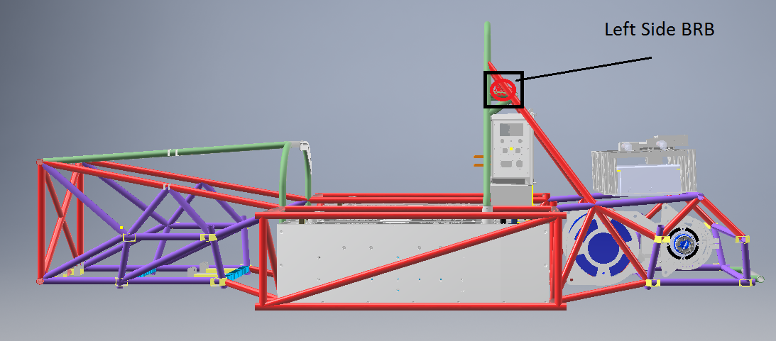
Figure 36 Side View- Shutdown
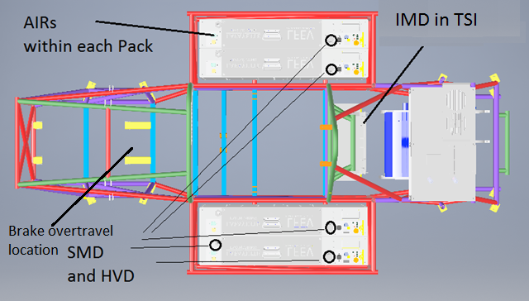
Figure 37 Top View -Shutdown Circuit Components
If your shutdown state diagram differs from the one in the Formula Hybrid rules, provide a copy of your state diagram (commented as necessary).

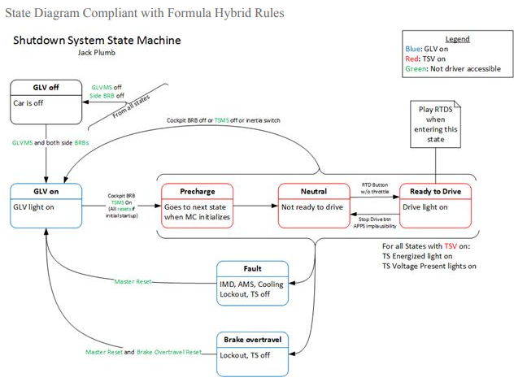
Figure 38 Shutdown State Diagram

IMD
Describe the IMD used and use a table for the common operation parameters, like supply voltage, temperature, etc. Describe how the IMD indicator light is wired. Complete the following table.
MFR / Model | Bender ISOMETER IR155-3203
Set response value: | 100 kΩ (1KΩ/Volt)
Table 26 - Parameters of the IMD
Describe IMD wiring with schematics.

The IMD is connected directly to the HV source within the TSI. It has 3 connections to GLV gnd as well as one connection to the 24V GLV. One connection goes to the IMD relay which is normally open. This relay has control over the safety loop. The last connection is the IMD_PWM signal from a microcontroller in the TSI. Refer to figure 9 for details regarding the IMD wiring.

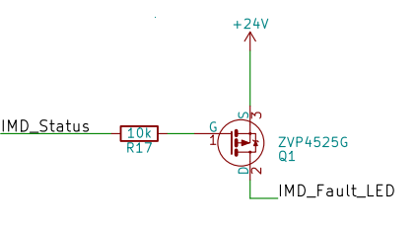
Figure 39 IMD Indicator LED Circuit
The IMD Status is fed into the TSI board from the IMD. This signal then uses a mosfet switch to control the IMD_FAULT_LED as shown in the figure 35 above.

Reset / Latching for IMD and AMS
Describe the functioning and circuitry of the latching/reset system for a tripped IMD or AMS. Describe wiring, provide schematics.
The IMD tripped circuit will open a relay that is use to complete the safety loop. When the OKHS signal is not producing the normal 24V during safe usage, the relay will open and the override button that is not driver resettable will need to be pushed in order to close this relay again.

When AMS or IMD breaks the safety loop two reset buttons must be pushed to re-engage the AIR’s. The Master reset on the outside of the car and the CPR in the cockpit of the car. Both are latching buttons. By pressing the reset it shorts the second switch and provides current through the inductor closing the bottom switch. Refer to figure 33 for a schematic of the wiring for the reset button.

The IMD interface can be seen in figure 9. The IMD is connected to the TSI board which has internal connections to the IMD relay. The following diagram shows IMD connected to an OMRON 24V DC relay. The safety loop passes through this relay and then through the 4 segments of the accumulator, each containing an OMRON SPST relay. The final relay then connects to the Master reset switch as shown in figure 33 (did not include brake over travel in the circuit below). The reset switch is normally open and held closed by the coil. When the safety loop opens due to the IMD or AMS fault, current ceases to pass via the coil, opening the switch. The switch is located behind the driver, close to the BRB-RS.The switch therefore acts as the latch.
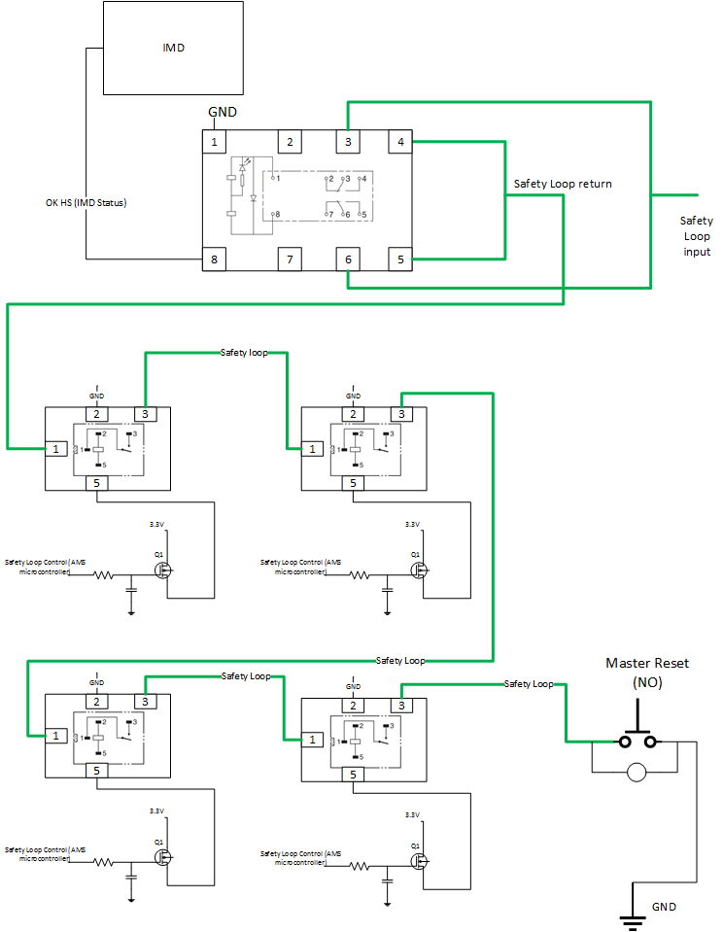
Figure 40 Latching/reset Circuit
(click for detail)

Shutdown System Interlocks
(If used) describe the functioning and circuitry of the Shutdown System Interlocks. Describe wiring, provide schematics.
N/A

Tractive System Active Lamp (TSAL)
Describe the tractive system active lamp components and method of operation. Describe location and wiring, provide schematics. See EV9.1.

The red TSAL will be connected to the TSV via the TSI. Once the AIRS are closed, the TSI has access to the TSV. The voltage will pass through a DC/DC converter on the TSI PCB to provide power to the TSAL lamps as shown in the figure 41 below. As the system has been configured to open the safety loop if voltage goes below 80V and the voltage the light turns on at is 27V, the 32V min voltage requirement is met (where the light must be on if voltage exceeds 32 V in TS). The TSAL will also flash at a rate of 2-3 Hz.

There has been a change in the schematic a bit and there is no longer a voltage divider. Therefore, the TSAL lamp will now turn on for any voltage greater than 16V. This can be shown by the minimum input voltage for the DC/DC converter (of 16V) ( RUW15L12C datasheet).

Figure 41 TSAL Wiring in the TSI
The TSAL will be located under the highest point of the main roll hoop.

Safety Systems OK Lamp (SSOK)
Describe the Safety Systems OK Lamp components and method of operation. Describe location and wiring, provide schematics. See EV9.3
The SSOK Lamps are Amber and comply with DOT FMVSS 108. The position can be seen relative to other systems in section 6.1 figure. They are powered by a 12V supply from the GLV via a diode.

GLV Master Switch
Both side-mounted shutdown buttons (BRBs)
Brake over-travel switch
Accumulator Monitoring System (AMS)
Insulation Monitoring Device (IMD)
Master Reset (MARSET)

Refer to Section 6.1 for position of SSOK in the safety loop.

Ready-To-Drive-Sound (RTDS)
Describe your design for the RTDS system. See EV9.2.

The ready to drive sound will activate when the drive button is pressed assuming the correct startup sequence has been met up to that point. This information will be made available to us by the VSCADA system over CAN bus. If all conditions are met when the button is pressed, the microcontroller used in the TSI system will drive a sound maker similar to the provided sound clips for 2 seconds.

GLV System
Person primarily responsible for this section:
Name: | Waseh Ahmad
e-mail: | ahmadw@lafayette.edu

GLV System Data
Provide a brief description of the GLV system and complete the following table

The GLV system is comprised of the 24V LiFePo4 battery, vehicle computer interface (VCI), the vehicle user interface (VUI) and the safety loop. The battery provides 24V to all sub-systems. The VCI provides hardware for VSCADA interfacing. The VUI is the driver interface including buttons and dashboard display screen. The safety loop assures all systems are functioning properly before opening airs and allowing HV from the accumulators.

GLV System Voltage | 24V
GLV Main Fuse Rating | 10A
Is a Li-Ion GLV battery used? | ☒Yes / ☐ No
If Yes, is a firewall provided per T4.5.1? | ☒Yes / ☐ No
Is a dc-dc converter used from TSV? | ☐Yes / ☒ No
Is the GLV system grounded to chassis? | ☒Yes / ☐ No
Does the design comply with EV4? | ☒Yes / ☐ No
Table 27- GLV System Data

Appendices

Include only highly-relevant data. A link to a web document in the ESF text is often more convenient for the reviewer.

The specification section of the accumulator data sheet, and sections used for determining accumulator capacity (FH Rules Appendix A) should be included here.

Cell MSDS
http://www.batteryspace.com/prod-specs/MSDS/2015/MSDS-LFP-G60%20ECO%202015.pdf

HIP does not need to be declared prior to the competition. If unsure, check “Hybrid”
Calculate accumulator capacity per 2017 FH Rules Appendix A. Be sure to use the 2C (0.5 hour) discharge rate for the Ah value.
This includes an 80% derating for available traction energy
Note Segment energy = rated AH x nominal voltage. The 80% derating is NOT applied for this calculation.

