LFEV-Y6
v0.7
Lafayette College: Electrical and Computer Engineering
Acceptance Test Plan: v0.7
Made by: Greg Flynn ‘17
Modified by: Waseh Ahmad ‘18
This document outlines all of the tests required to deliver LFEV-Y6. The plan is presented as an overview with the ATP number next to the test. This refers to the document that describes the test procedure. The requirements are from the SoW for 2018

08
Fall

Table of Contents
ATP overviews 6
Compliance Matrix 9
Deliverables 11
D000: PDR 11
D001: CDR 11
D002: User Manuals 11
D003: Final Report and Maintenance Manual 11
Final report 11
Maintenance manual 12
D004: ATP 13
D005: ATR 13
D007: Project Website 13
D008: Final Presentation and Delivery 13
D009: Conference Paper, Presentation, and Video 13
D010: Project Poster 14
D012: Software Maintainability Plan 14
D013: Purchasing Report 14
D014: Project Management and Status Letters 14
Waived or modified requirements and questions 15
ATP-01 checklist: Accumulator integration 16
ATP-02 checklist: Charging Accumulator 17
ATP-03 checklist: CAN Bus link 18
ATP-04 checklist: Safety loop 19
ATP-07 checklist: Shutdown 20
ATP-08 checklist: GLV grounding 21
ATP-09 checklist: Documentation 22
TSV: Pacman 23
TSV: AMS 23
TSV: Pack 23
TSV: Pack panel 24
TSV: Bus bar 24
TSV: Control panel PCB 24
TSI: Container 25
TSI: Front Panel 25
TSI: Back Panel 25
TSI: Bus bar 1 (AIR to connector) 26
TSI: Bus bar 2 (connector to connector) 26
TSI: PCB 26
TSI: Dyno panel 27
GLV: Container 28
GLV: Front panel 28
GLV: Back panel 28
GLV: PCB 29
GLV: Dyno panel 29
Cooling: Assembly 29
ATP-10 checklist: Hazmat 30
ATP-11 checklist: Safety practice 30
Wires 30
Internal wiring 30
W1 30
W2 30
W3 31
W6 32
W7 33
W11 33
W12 33
W13 34
W15 34
W18 34
W20 34
W21 34
W22 35
W23 35
W24 35
W25 35
W26 35
W28 36
W31 36
W32 37
W33 37
W34 37
W35 37
W36 37
Indicators 38
IMD fault light 38
Fault light 38
AIRs Light 38
Drive light 38
Safety light 38
Cruise light 39
High Voltage Present light 39
Grounded Low Voltage Present light 39
Tractive System Energized Light 39
Tractive System Active Light 39
Brake light 40
Buttons and switches 40
FWD/REV switch 40
Driver Reset 40
Driver BRB 40
Inertial switch 40
Drive button 41
Cruise button 41
Scroll button 41
Select button 41
GLV Master Switch 41
TSV Master Switch 42
RHSBRB 42
RHS MReset 42
LHSBRB 42
PCBs 43
AMS 43
Pacman 43
TSI PCB 43
GLV PCB 43
Fuses 44
Accumulator fuse 44
Pacman fuse 44
TSI precharge relay fuse 44
GLV high current fuse 44
GLV low current fuse 45
Enclosures 46
Pack 46
TSI 46
GLV 46
ATP-12 checklist: Maintainability 47
Software 47
Pacman code 47
AMS code 47
VSCADA code 47
Cell application code 48
TSI code 48
Remote software code 48
Hardware 49
Packs 49
TSI 49
GLV 49
Cooling 49
ATP-13 checklist: Demonstration 50
ATP-14 checklist: Disposal 51
Formula-Hybrid 2016 Electrical Inspection 52
Accumulator Data 53
ACCUMULATOR DATA FOR BATTERIES 53
ACCUMULATOR DATA FOR CAPACITORS 53
Preliminary Electrical Inspection (required prior to Mechanical Inspection) 54
Operating Voltage 54
Safety Circuit 54
Indicator Operation 54
TSMPs 54
Ground Low Voltage 55
Vehicle Grounding 55
Tractive System Wiring 55
TSMPs 55
Indicators and Safety Labels 55
Safety Components 55
Full Inspection: Documentation/ESF 58
Full Electrical: Inspection 61
Full Electrical: Pouch Cells 63
Final Demonstration 64
Inspectors Reference 67

ATP overviews
None of these tests can be viewed as completed until appropriate documentation has been uploaded to the webpage.

Item | Item description | Demonstrated Requirements | Successful Test Criteria | Verification Method
ATP-01 | Accumulator integration | R001a  R001c  R001d  R001e  R002a  R002c  R004a (TSV part)  R005a  R005b (Manual) | Packs power motor and all telemetry is recorded by VSCADA. Control by using the throttle.  Verify by accelerating and looking at dash, pack screens, and log files remotely | Test
ATP-02 | Charging Accumulator | R001b  R001g  R002b  R002h | Packs charge by the charging port and open the safety loop  VSCADA reacts correctly  Verify by looking at the dash | Test
ATP-03 | CAN Bus link | R002a  R002c  R002d  R002e  R002f  R002g  R002j  R002k  R003a(8)  R003d  R004a (CAN Bus part)  R005a (CAN Bus part)  R005c (CAN Bus part)  R007c  R007d | DAQ by VSCADA of TSI, GLV, TSV, Cooling. Verify by looking at GLV Screen. All DAQ methods should happen simultaneously | Test
ATP-04 | Safety loop | R001g  R002b  R002c  R002d  R002k  R002m  R003b  R003c  R003d  R004a (Safety loop part)  R005c (IMD fault)  R007b | Fault by:  Crashing  BRB  IMD  Cooling  VSCADA limit  Pack fault  Throttle fault  Brake fault  User defined limit (halt)  Pack charging  Verify by looking at the dash, the remote computer and the cellphone | Test
ATP-06 | 24h endurance test | GPR006 | At the end of all other tests leave the car running for 24h | Test
ATP-07 | Shutdown | R002k  R002i | VSCADA works after unexpected GLV shutdown  All hardware in safe state  Packs stop powering motor with GLV shutdown  TSI works after unexpected TSV shutdown | Test
ATP-08 | GLV grounding | R003a(2) | Ensure that there is only 1 connection between ground and chassis ground | Inspection
ATP-09 | Documentation | GRP001 | Complete and accurate documentation | Inspection
ATP-10 | Hazmat | GPR004 | No hazardous materials used | Analysis
ATP-11 | Safety practice | GPR005 | Good practice used for safety | Inspection
ATP-12 | Maintainability | GPR007 | Ensure that the project is maintainable | Analysis and test
ATP-13 | Demonstration | GPR011 | Have a video and demo setup | Inspection
ATP-14 | Disposal | GPR012 | Dispose of all materials as required | Inspection

Compliance Matrix
All requirements should also have a QA by each subsystem before integration.
Requirement | Test(s) to demonstrate acceptance
R001a | ATP-01
R001b | ATP-02 OR https://sites.lafayette.edu/ece492-sp16/files/2016/05/QAR001b.pdf
R001c | ATP-01
R001d | ATP-01
R001e | ATP-01
R001f | https://sites.lafayette.edu/ece492-sp16/files/2016/05/QAR001e.pdf
R001g | ATP-02
R002a | ATP-01 or ATP-03
R002b | ATP-02
R002c | ATP-01 OR ATP-03 OR ATP-04
R002d | ATP-01 OR ATP-03 OR ATP-04
R002e | ATP-03
R002f | ATP-03
R002g | ATP-03
R002h | ATP-02 OR ATP-03
R002i | ATP-02
R002j | ATP-03
R002k | ATP-03
R002l | Waived
R002m | ATP-04
R003a(1) | Any ATP
R003a(2) | ATP-08
R003a(3) | QA by GLV
R003a(4) | ATP-02
R003a(5) | ATP-02
R003a(5) | ATP-02
R003a(6) | ATP-02
R003a(7) | ATP-02
R003a(8) | ATP-03
R003b | ATP-04
R003c | QA by GLV
R003d | ATP-03
R004a | ATP-01 AND ATP-03 AND ATP-04
R004b | QA by Interconnect
R005a | ATP-01 AND ATP-03
R005b | ATP-01 AND ATP-07
R005c | ATP-04
R005d | QA by TSI
R006 | Any ATP
R007a | QA by Cooling
R007b | ATP-04
R007c | ATP-03
R007d | ATP-03
R007e | Waived
R007f | QA by Cooling
R007g | QA by Cooling
GPR001 | ATP-09
GPR003 | Inspection
GPR004 | ATP-10
GPR005 | ATP-11 (MTBF + power waived)
GPR006 | ATP-06 and ATP-11
GRP007 | ATP-12
GPR008 | ATP-09
GPR011 | ATP-13
GPR012 | ATP-14

Deliverables

D000: PDR

https://sites.lafayette.edu/ece492-sp18/files/2017/11/PDR_fall2017.pptx.pdf

D001: CDR
https://sites.lafayette.edu/ece492-sp18/files/2018/03/Critical-Design-Review-1-1.pdf

D002: User Manuals
Note this is a checklist for the video
System | Getting started | FAQ | Functions and controls | Troubleshooting calibration and maintenance
TSI
TSV
GLV
Cooling
VSCADA
Dyno room
Attach link to each of the videos to demonstrate competing the deliverable.

D003: Final Report and Maintenance Manual

Final report
Check | Completed
Maintenance manuals completed
3x DVD presented (or flash drive)
DVD artwork
ATP-09 completed
Attach image of DVD or flash drive. Attach link to the final report with all of the documentation.

Maintenance manual
Part | TSI | TSV | GLV | Cool | VSCADA | Dyno | Andriod
Maintenance
Calibration
PCB schematic
PCB BOM
Mechanical drawing
Mechanical BOM
Block diagram
Wiring diagram
Gerber files
QA testing
Principal of operation
Software binaries
Software source
Software make file
ATP-12 completed

Attach link to each of the maintenance manuals for this document.

D004: ATP
Check | Completed
Compliance matrix
Forms present
http://sites.lafayette.edu/ece492-sp17/testing/atp/

D005: ATR
Check | Completed
All tests included
Test date for all tests
Photos as required
Tester named
Witness signature if available
Test results
Attach link to the ATR.

D007: Project Website
Check | Completed
All documents as portable static documents (PDF/TXT/XML)
Original version present
Links to any cloud storage
Attach link to the site for each document required.

D008: Final Presentation and Delivery
Check | Completed
GPR006
GPR007
GPR008
GPR011
D010
Video for D009
Video of GPR011
Delivered per GPR012
Any other items disposed per GPR012
Links to the final presentation provided. Link to the video.

D009: Conference Paper, Presentation, and Video
Waived

D010: Project Poster
Waived

D012: Software Maintainability Plan
Waived by Professor Nadovich upon demonstration during CDR

D013: Purchasing Report
Check | Completed
Table for all purchases
Summary based on team
Summary based on week
Link to purchasing reports provided.

D014: Project Management and Status Letters
Check | Completed
Status letter submitted
WBS delivered
Link to WBS and status letter provided.

Waived or modified requirements and questions
Requirement | Reason
R003a(4) | Cannot tell if GLV is from the battery or 24VDC
R002h | Cannot tell if GLV is from the battery or 24VDC
R007e | Waived
R005d | We’ve changed the switches
R002l | Waived
GPR003 | Waived
GPR005 | (Power and MTBF/MTTR waived)

ATP-01 checklist: Accumulator integration
Test | Pass
- Packs can deliver 200A through TSI
- Voltage measured at TSVMP is as expected
- Throttle controls RPM
- Throttle implausibility causes exit of drive mode
- Two moves required to enter drive mode
- Throttle and brake together prevent drive mode from starting
- Throttle and brake together exit drive mode
- TSAL lights come on when HV present outside packs
- TSEL lights come on when AIRS closed
- RTDS come on for 1-3 seconds when drive mode entered
- HV present light comes on when HV present
- Packs display telemetry on GLV screen
- Dyno can set the throttle
- Dyno can set the valve on the dyno

Pass count: /14

(Test) Variable to measure | Value
(a) Current according to current sensor
(a+l) Current according to pack 1
(a+l) Current according to pack 2
(a+l) Current according to pack 3
(a+l) Current according to pack 4
(a) Current according to TSI
(b) Voltage at TSVMP with 50A load
(b) Voltage at TSVMP with no draw
(c) Max RPM
(d) APPS1 voltage at implausibility
(d) APPS2 voltage at implausibility
(m) Max RPM
(n) Max torque

ATP-02 checklist: Charging Accumulator
Test | Pass
- Safety loop opens when charging
- VSCADA shows that packs are charging
- Packs can be left charging after they are full
Pass count: /4

Attach VSCADA data dump showing voltage and current with respect to time. This should be an excel document with data as well as a graph.

ATP-03 checklist: CAN Bus link
Test | Seen by VSCADA
Cell Temperature | /28
Cell Voltage | /28
Pack Current | /4
Pack SoC | /4
Pack Status | /4
Pack Voltage | /4
GLV Voltage
GLV SoC
GLV Current
GLV Temperature
Safety loop status
RPM gauge (Dyno)
Strain gauge
Throttle position
Brake status
IMD resistance
FWD/REV status
Precharge status
MC temp
MC current
Cooling temp in
Cooling flow
Cooling temp out
TSI temp
Speed
Safety loop status

Pass count: /26

Attach excel document of data for VSCADA receiving data. Attach graphs from the android application. Attach screen shots of the remote computer in operation.

ATP-04 checklist: Safety loop
Fault | Safety loop trip  (Fault lit) | Seen on VSCADA
Driver resettable BRB
Non driver resettable BRB
Crash protection
Over temperature cooling
Under flow cooling
IMD fault
Cell overtemp
Cell overcurrent
Cell overvoltage
Cell undervoltage
Brake overtravel
VSCADA defined violation
Pass count: /24

Add logs from VSCADA showing faults. Add screen shots from the remote computer showing the faults. Add screen shots from the android application showing the faults.

ATP-07 checklist: Shutdown
Test | Pass
VSCADA powers up with no user input
GLV shutdown prevents TSV being present at TSVMP
TSVMS shutdown prevents TSV being present at TSVMP
VSCADA has recorded data up to the shutdown
TSVMS shutdown while under load does not create any issues

Pass count: /5

Shutdown time (yyyy-mm-dd hh:mm:ss UTC):

Attach log from VSCADA showing data up until GLV shutdown.

ATP-08 checklist: GLV grounding
Attach image of the grounding connection.

ATP-09 checklist: Documentation
For every subassembly in a subsystem this checklist should be completed. I have attempted to capture them all but if there are parts not included they need to be added. Part numbers should go in a tree structure all the way down to commercial parts.

TSV: Pacman
Check | Pass
Unique part number
Document delivered to instructor
Document uploaded to website
Units defined on diagram clearly
Have a complete BOM with document if required
Part number on title block
Part number on file name
Part number on fabricated object
Lafayette Electrical and Computer Engineering marked
BOM had alternative or justification of only 1 supplier
Pass count: /10
Part number:
Link:

TSV: AMS
Check | Pass
Unique part number
Document delivered to instructor
Document uploaded to website
Units defined on diagram clearly
Have a complete BOM with document if required
Part number on title block
Part number on file name
Part number on fabricated object
Lafayette Electrical and Computer Engineering marked
BOM had alternative or justification of only 1 supplier
Pass count: /10
Part number:
Link:

TSV: Pack
Check | Pass
Unique part number
Document delivered to instructor
Document uploaded to website
Units defined on diagram clearly
Have a complete BOM with document if required
Part number on title block
Part number on file name
Part number on fabricated object
Lafayette Electrical and Computer Engineering marked
BOM had alternative or justification of only 1 supplier
Pass count: /10
Part number:
Link:

TSV: Pack panel
Check | Pass
Unique part number
Document delivered to instructor
Document uploaded to website
Units defined on diagram clearly
Have a complete BOM with document if required
Part number on title block
Part number on file name
Part number on fabricated object
Lafayette Electrical and Computer Engineering marked
BOM had alternative or justification of only 1 supplier
Pass count: /10
Part number:
Link:

TSV: Bus bar
Check | Pass
Unique part number
Document delivered to instructor
Document uploaded to website
Units defined on diagram clearly
Have a complete BOM with document if required
Part number on title block
Part number on file name
Part number on fabricated object
Lafayette Electrical and Computer Engineering marked
BOM had alternative or justification of only 1 supplier
Pass count: /10
Part number:
Link:

TSV: Control panel PCB
Check | Pass
Unique part number
Document delivered to instructor
Document uploaded to website
Units defined on diagram clearly
Have a complete BOM with document if required
Part number on title block
Part number on file name
Part number on fabricated object
Lafayette Electrical and Computer Engineering marked
BOM had alternative or justification of only 1 supplier
Pass count: /10
Part number:
Link:

TSI: Container
Check | Pass
Unique part number
Document delivered to instructor
Document uploaded to website
Units defined on diagram clearly
Have a complete BOM with document if required
Part number on title block
Part number on file name
Part number on fabricated object
Lafayette Electrical and Computer Engineering marked
BOM had alternative or justification of only 1 supplier
Pass count: /10
Part number:
Link:

TSI: Front Panel
Check | Pass
Unique part number
Document delivered to instructor
Document uploaded to website
Units defined on diagram clearly
Have a complete BOM with document if required
Part number on title block
Part number on file name
Part number on fabricated object
Lafayette Electrical and Computer Engineering marked
BOM had alternative or justification of only 1 supplier
Pass count: /10
Part number:
Link:

TSI: Back Panel
Check | Pass
Unique part number
Document delivered to instructor
Document uploaded to website
Units defined on diagram clearly
Have a complete BOM with document if required
Part number on title block
Part number on file name
Part number on fabricated object
Lafayette Electrical and Computer Engineering marked
BOM had alternative or justification of only 1 supplier
Pass count: /10
Part number:
Link:

TSI: Bus bar 1 (AIR to connector)
Check | Pass
Unique part number
Document delivered to instructor
Document uploaded to website
Units defined on diagram clearly
Have a complete BOM with document if required
Part number on title block
Part number on file name
Part number on fabricated object
Lafayette Electrical and Computer Engineering marked
BOM had alternative or justification of only 1 supplier
Pass count: /10
Part number:
Link:

TSI: Bus bar 2 (connector to connector)
Check | Pass
Unique part number
Document delivered to instructor
Document uploaded to website
Units defined on diagram clearly
Have a complete BOM with document if required
Part number on title block
Part number on file name
Part number on fabricated object
Lafayette Electrical and Computer Engineering marked
BOM had alternative or justification of only 1 supplier
Pass count: /10
Part number:
Link:

TSI: PCB
Check | Pass
Unique part number
Document delivered to instructor
Document uploaded to website
Units defined on diagram clearly
Have a complete BOM with document if required
Part number on title block
Part number on file name
Part number on fabricated object
Lafayette Electrical and Computer Engineering marked
BOM had alternative or justification of only 1 supplier
Pass count: /10
Part number:
Link:

TSI: Dyno panel
Check | Pass
Unique part number
Document delivered to instructor
Document uploaded to website
Units defined on diagram clearly
Have a complete BOM with document if required
Part number on title block
Part number on file name
Part number on fabricated object
Lafayette Electrical and Computer Engineering marked
BOM had alternative or justification of only 1 supplier
Pass count: /10
Part number:
Link:

GLV: Container
Check | Pass
Unique part number
Document delivered to instructor
Document uploaded to website
Units defined on diagram clearly
Have a complete BOM with document if required
Part number on title block
Part number on file name
Part number on fabricated object
Lafayette Electrical and Computer Engineering marked
BOM had alternative or justification of only 1 supplier
Pass count: /10
Part number:
Link:

GLV: Front panel
Check | Pass
Unique part number
Document delivered to instructor
Document uploaded to website
Units defined on diagram clearly
Have a complete BOM with document if required
Part number on title block
Part number on file name
Part number on fabricated object
Lafayette Electrical and Computer Engineering marked
BOM had alternative or justification of only 1 supplier
Pass count: /10
Part number:
Link:

GLV: Back panel
Check | Pass
Unique part number
Document delivered to instructor
Document uploaded to website
Units defined on diagram clearly
Have a complete BOM with document if required
Part number on title block
Part number on file name
Part number on fabricated object
Lafayette Electrical and Computer Engineering marked
BOM had alternative or justification of only 1 supplier
Pass count: /10
Part number:
Link:

GLV: PCB
Check | Pass
Unique part number
Document delivered to instructor
Document uploaded to website
Units defined on diagram clearly
Have a complete BOM with document if required
Part number on title block
Part number on file name
Part number on fabricated object
Lafayette Electrical and Computer Engineering marked
BOM had alternative or justification of only 1 supplier
Pass count: /10
Part number:
Link:

GLV: Dyno panel
Check | Pass
Unique part number
Document delivered to instructor
Document uploaded to website
Units defined on diagram clearly
Have a complete BOM with document if required
Part number on title block
Part number on file name
Part number on fabricated object
Lafayette Electrical and Computer Engineering marked
BOM had alternative or justification of only 1 supplier
Pass count: /10
Part number:
Link:

Cooling: Assembly
Check | Pass
Unique part number
Document delivered to instructor
Document uploaded to website
Units defined on diagram clearly
Have a complete BOM with document if required
Part number on title block
Part number on file name
Part number on fabricated object
Lafayette Electrical and Computer Engineering marked
BOM had alternative or justification of only 1 supplier
Pass count: /10
Part number:
Link:

ATP-10 checklist: Hazmat
Check | Pass
All PCBs are RoHS
No NiCd/Pb-Acid batteries
Dispose pre 2002/96/EC WEEE Directive

Attach link to hazmat documentation.

ATP-11 checklist: Safety practice

Wires

Internal wiring
System | Clean cabling | No rats-nest | Color coded | Labeled
TSI
TSV
GLV
Cooling
Attach pictures of the inside of each system to document.

W1
Count: 3
Check | Pass
Wires correctly color coded
Cable labeled with gauge/max temperature/max voltage
Cable labeled with reference designator

Check | Pass
Wires correctly color coded
Cable labeled with gauge/max temperature/max voltage
Cable labeled with reference designator

Check | Pass
Wires correctly color coded
Cable labeled with gauge/max temperature/max voltage
Cable labeled with reference designator
Pass count: /9
Attach image as evidence

W2
Count: 1
Check | Pass
Wires correctly color coded
Cable labeled with gauge/max temperature/max voltage
Cable labeled with reference designator
Pass count: /3
Attach image as evidence

W3
Count: 1
Check | Pass
Wires correctly color coded
Cable labeled with gauge/max temperature/max voltage
Cable labeled with reference designator
Pass count: /3
Attach image as evidence

W6
Count: 6
Check | Pass
Wires correctly color coded
Cable labeled with gauge/max temperature/max voltage
Cable labeled with reference designator

Check | Pass
Wires correctly color coded
Cable labeled with gauge/max temperature/max voltage
Cable labeled with reference designator

Check | Pass
Wires correctly color coded
Cable labeled with gauge/max temperature/max voltage
Cable labeled with reference designator

Check | Pass
Wires correctly color coded
Cable labeled with gauge/max temperature/max voltage
Cable labeled with reference designator

Check | Pass
Wires correctly color coded
Cable labeled with gauge/max temperature/max voltage
Cable labeled with reference designator

Check | Pass
Wires correctly color coded
Cable labeled with gauge/max temperature/max voltage
Cable labeled with reference designator

Check | Pass
Wires correctly color coded
Cable labeled with gauge/max temperature/max voltage
Cable labeled with reference designator

Pass count: /18
Attach image as evidence

W7
Count: 1
Check | Pass
Wires correctly color coded
Cable labeled with gauge/max temperature/max voltage
Cable labeled with reference designator
Pass count: /3
Attach image as evidence

W11
Count: 5
Check | Pass
Wires correctly color coded
Cable labeled with gauge/max temperature/max voltage
Cable labeled with reference designator

Check | Pass
Wires correctly color coded
Cable labeled with gauge/max temperature/max voltage
Cable labeled with reference designator

Check | Pass
Wires correctly color coded
Cable labeled with gauge/max temperature/max voltage
Cable labeled with reference designator

Check | Pass
Wires correctly color coded
Cable labeled with gauge/max temperature/max voltage
Cable labeled with reference designator

Check | Pass
Wires correctly color coded
Cable labeled with gauge/max temperature/max voltage
Cable labeled with reference designator

Pass count: /15
Attach image as evidence

W12
Count: 1
Check | Pass
Wires correctly color coded
Cable labeled with gauge/max temperature/max voltage
Cable labeled with reference designator
Pass count: /3
Attach image as evidence

W13
Count: 1
Check | Pass
Wires correctly color coded
Cable labeled with gauge/max temperature/max voltage
Cable labeled with reference designator
Pass count: /3
Attach image as evidence

W15
Count: 1
Check | Pass
Wires correctly color coded
Cable labeled with gauge/max temperature/max voltage
Cable labeled with reference designator
Pass count: /3
Attach image as evidence

W18
Count: 1
Check | Pass
Wires correctly color coded
Cable labeled with gauge/max temperature/max voltage
Cable labeled with reference designator
Pass count: /3
Attach image as evidence

W20
Count: 1
Check | Pass
Wires correctly color coded
Cable labeled with gauge/max temperature/max voltage
Cable labeled with reference designator
Pass count: /3
Attach image as evidence

W21
Count: 1
Check | Pass
Wires correctly color coded
Cable labeled with gauge/max temperature/max voltage
Cable labeled with reference designator
Pass count: /3
Attach image as evidence

W22
Count: 1
Check | Pass
Wires correctly color coded
Cable labeled with gauge/max temperature/max voltage
Cable labeled with reference designator
Pass count: /3
Attach image as evidence

W23
Count: 1
Check | Pass
Wires correctly color coded
Cable labeled with gauge/max temperature/max voltage
Cable labeled with reference designator
Pass count: /3
Attach image as evidence

W24
Count: 1
Check | Pass
Wires correctly color coded
Cable labeled with gauge/max temperature/max voltage
Cable labeled with reference designator
Pass count: /3
Attach image as evidence

W25
Count: 1
Check | Pass
Wires correctly color coded
Cable labeled with gauge/max temperature/max voltage
Cable labeled with reference designator
Pass count: /3
Attach image as evidence

W26
Count: 1
Check | Pass
Wires correctly color coded
Cable labeled with gauge/max temperature/max voltage
Cable labeled with reference designator
Pass count: /3
Attach image as evidence

W28
Count: 1
Check | Pass
Wires correctly color coded
Cable labeled with gauge/max temperature/max voltage
Cable labeled with reference designator
Pass count: /3
Attach image as evidence

W31
Count: 7
Check | Pass
Wires correctly color coded
Cable labeled with gauge/max temperature/max voltage
Cable labeled with reference designator

Check | Pass
Wires correctly color coded
Cable labeled with gauge/max temperature/max voltage
Cable labeled with reference designator

Check | Pass
Wires correctly color coded
Cable labeled with gauge/max temperature/max voltage
Cable labeled with reference designator

Check | Pass
Wires correctly color coded
Cable labeled with gauge/max temperature/max voltage
Cable labeled with reference designator

Check | Pass
Wires correctly color coded
Cable labeled with gauge/max temperature/max voltage
Cable labeled with reference designator

Check | Pass
Wires correctly color coded
Cable labeled with gauge/max temperature/max voltage
Cable labeled with reference designator

Check | Pass
Wires correctly color coded
Cable labeled with gauge/max temperature/max voltage
Cable labeled with reference designator
Pass count: /21
Attach image as evidence

W32
Count: 1
Check | Pass
Wires correctly color coded
Cable labeled with gauge/max temperature/max voltage
Cable labeled with reference designator
Pass count: /3
Attach image as evidence

W33
Count: 1
Check | Pass
Wires correctly color coded
Cable labeled with gauge/max temperature/max voltage
Cable labeled with reference designator
Pass count: /3
Attach image as evidence

W34
Count: 1
Check | Pass
Wires correctly color coded
Cable labeled with gauge/max temperature/max voltage
Cable labeled with reference designator
Pass count: /3
Attach image as evidence

W35
Count: 1
Check | Pass
Wires correctly color coded
Cable labeled with gauge/max temperature/max voltage
Cable labeled with reference designator
Pass count: /3
Attach image as evidence

W36
Count: 1
Check | Pass
Wires correctly color coded
Cable labeled with gauge/max temperature/max voltage
Cable labeled with reference designator
Pass count: /3
Attach image as evidence

Indicators

IMD fault light
Check | Pass
Clear indicator of function
Red LED
Located in cockpit
Illuminates when IMD resistance is low
Pass count: /4
Attach image of illuminated light

Fault light
Check | Pass
Clear indicator of function
Red LED
Located in cockpit
Illuminates when fault detected
Pass count: /4
Attach image of illuminated light

AIRs Light
Check | Pass
Clear indicator of function
Green LED
Located in cockpit
Illuminates when AIRs closed detected
Pass count: /4
Attach image of illuminated light

Drive light
Check | Pass
Clear indicator of function
Green LED
Located in cockpit
Illuminates when Drive mode entered
Pass count: /4
Attach image of illuminated light

Safety light
Check | Pass
Clear indicator of function
Green LED
Located in cockpit
Illuminates when safety loop closed
Pass count: /4
Attach image of illuminated light

Safety System OK lights
Check | Pass
Clear indicator of function
Orange LED
Located Either Side
Illuminates when safety loop closed
Pass count: /4
Attach image of illuminated light

High Voltage Present light
Check | Pass
Clear indicator of function
Red LED
Located in cockpit
Illuminates when HV outside of packs
Pass count: /4
Attach image of illuminated light

Grounded Low Voltage Present light
Check | Pass
Clear indicator of function
Green LED
Located in cockpit
Illuminates when GLV powered
Pass count: /4
Attach image of illuminated light

Tractive System Active Lamp
Check | Pass
2Hz-5Hz frequency when on
Red Strobe
Mounted on the main hull, above driver helmet
Illuminates when AIRs closed
Pass count: /4
Attach image of illuminated light

Brake light
Check | Pass
1 light present
Red light
Located on dyno specific panel (will be on car in future)
Illuminates when brake pressed and GLV on
Pass count: /4
Attach image of illuminated light

Buttons and switches

FWD/REV switch
Check | Pass
Clearly labeled
Key switch 2 position
Key can be removed in either state
Mounted on TSI box
Pass count: /4
Attach image of button/switch:

Driver Reset
Check | Pass
Clearly labeled
Green button
Momentary switch
Mounted in cockpit
Pass count: /4
Attach image of button/switch:

Driver BRB
Check | Pass
Clearly labeled
Red button
Latching button, twist to unlatch
Mounted in cockpit
Pass count: /4
Attach image of button/switch:

Inertial switch
Check | Pass
Clearly labeled
Inertial switch
Resettable by driver
Mounted in cockpit
Pass count: /4
Attach image of button/switch:

Drive button
Check | Pass
Clearly labeled
Tactile switch
Momentary button
Mounted in cockpit
Pass count: /4
Attach image of button/switch:

Scroll button
Check | Pass
Clearly labeled
Tactile switch
Momentary button
Mounted in cockpit
Pass count: /4
Attach image of button/switch:

Record Button
Check | Pass
Clearly labeled
Tactile switch
Momentary button
Mounted in cockpit
Pass count: /4
Attach image of button/switch:

GLV Master Switch
Check | Pass
Clearly labeled
Red key switch
2 position
Mounted on RHS panel
Pass count: /4
Attach image of button/switch:

TSV Master Switch
Check | Pass
Clearly labeled
Red key switch
2 position
Mounted on RHS panel
Pass count: /4
Attach image of button/switch:

RHSBRB
Check | Pass
Clearly labeled
Red button
Latching button, twist to unlatch
Mounted on RHS panel near shoulder of Driver
Pass count: /4
Attach image of button/switch:

RHS MReset
Check | Pass
Clearly labeled
Green button
Momentary switch
Mounted on RHS panel near shoulder of Driver
Pass count: /4
Attach image of button/switch:

LHSBRB
Check | Pass
Clearly labeled
Red button
Latching button, twist to unlatch
Mounted on LHS panel
Pass count: /4
Attach image of button/switch:

PCBs

AMS
Check | Pass
Silkscreens marking reference designators
Silkscreens marking power and critical signals
Silkscreen showing Lafayette College, Made in USA, Electrical and Computer Engineering, part number
Space for serial number
Bottom copper has part number and rev
Pass count: /5
Attach picture of front and back of PCB.

Pacman
Check | Pass
Silkscreens marking reference designators
Silkscreens marking power and critical signals
Silkscreen showing Lafayette College, Made in USA, Electrical and Computer Engineering, part number
Space for serial number
Bottom copper has part number and rev
Pass count: /5
Attach picture of front and back of PCB.

TSI PCB
Check | Pass
Silkscreens marking reference designators
Silkscreens marking power and critical signals
Silkscreen showing Lafayette College, Made in USA, Electrical and Computer Engineering, part number
Space for serial number
Bottom copper has part number and rev
Pass count: /5
Attach picture of front and back of PCB.

GLV PCB
Check | Pass
Silkscreens marking reference designators
Silkscreens marking power and critical signals
Silkscreen showing Lafayette College, Made in USA, Electrical and Computer Engineering, part number
Space for serial number
Bottom copper has part number and rev
Pass count: /5
Attach picture of front and back of PCB.

Fuses

Accumulator fuse
Check | Pass
UL listed socket as a holder
5 spares
Easy to access
Pass count: /3
Holder part number:
Fuse part number:
Attach image of fuse location

Pacman fuse
Check | Pass
UL listed socket as a holder
5 spares
Easy to access
Pass count: /3
Holder part number:
Fuse part number:
Attach image of fuse location

TSI precharge relay fuse
Check | Pass
UL listed socket as a holder
5 spares
Easy to access
Pass count: /3
Holder part number:
Fuse part number:
Attach image of fuse location

GLV high current Circuit Breaker
Check | Pass
UL listed socket as a holder
5 spares
Easy to access
Pass count: /3
Holder part number:
Fuse part number:
Attach image of fuse location

GLV low current circuit Breaker
Check | Pass
UL listed socket as a holder
5 spares
Easy to access
Pass count: /3
Holder part number:
Fuse part number:
Attach image of fuse location

Enclosures

Pack
Check | Pass
Access panel present
Pilot lights and indicators present
All interconnect cables have at least 1 return signal
PCBs are not mounted directly to enclosure
Enclosures are grounded if they are conductive
Labeled internally and externally
Pass count: /6
Attach 6 images of enclosures (All views)

TSI
Check | Pass
Access panel present
Pilot lights and indicators present
All interconnect cables have at least 1 return signal
PCBs are not mounted directly to enclosure
Enclosures are grounded if they are conductive
Labeled internally and externally
Pass count: /6
Attach 6 images of enclosures (All views)

GLV
Check | Pass
Access panel present
Pilot lights and indicators present
All interconnect cables have at least 1 return signal
PCBs are not mounted directly to enclosure
Enclosures are grounded if they are conductive
Labeled internally and externally
Pass count: /6
Attach 6 images of enclosures (All views)

ATP-12 checklist: Maintainability

Software

Pacman code
Check | Pass
Version controlled
Can startup with no input from the user
Have an install script (.exe/make/RPM)
Configurable without requiring a recompile
Data stored in a well-supported format
Any files that grow should be automatically trimmed
A procedure for backing up data
Passwords should be avoided
If a port is needed it should enumerate automatically
Pass count: /9

AMS code
Check | Pass
Version controlled
Can startup with no input from the user
Have an install script (.exe/make/RPM)
Configurable without requiring a recompile
Data stored in a well-supported format
Any files that grow should be automatically trimmed
A procedure for backing up data
Passwords should be avoided
If a port is needed it should enumerate automatically
Pass count: /9

VSCADA code
Check | Pass
Version controlled
Can startup with no input from the user
Have an install script (.exe/make/RPM)
Configurable without requiring a recompile
Data stored in a well-supported format
Any files that grow should be automatically trimmed
A procedure for backing up data
Passwords should be avoided
If a port is needed it should enumerate automatically
Pass count: /9

Cell application code
Check | Pass
Version controlled
Can startup with no input from the user
Have an install script (.exe/make/RPM)
Configurable without requiring a recompile
Data stored in a well-supported format
Any files that grow should be automatically trimmed
A procedure for backing up data
Passwords should be avoided
If a port is needed it should enumerate automatically
Pass count: /9

TSI code
Check | Pass
Version controlled
Can startup with no input from the user
Have an install script (.exe/make/RPM)
Configurable without requiring a recompile
Data stored in a well-supported format
Any files that grow should be automatically trimmed
A procedure for backing up data
Passwords should be avoided
If a port is needed it should enumerate automatically
Pass count: /9

Hardware

Packs
Check | Pass
Recommended list of spare hardware
Basic troubleshooting guidelines for a beginner
Advance troubleshooting for an expert
A beginner can diagnose a simple problem (loose connector)
An expert can diagnose a complex problem (TBA)
Pass count: /5
Link to documentation:

TSI
Check | Pass
Recommended list of spare hardware
Basic troubleshooting guidelines for a beginner
Advance troubleshooting for an expert
A beginner can diagnose a simple problem (loose connector)
An expert can diagnose a complex problem (TBA)
Pass count: /5
Link to documentation:

GLV
Check | Pass
Recommended list of spare hardware
Basic troubleshooting guidelines for a beginner
Advance troubleshooting for an expert
A beginner can diagnose a simple problem (loose connector)
An expert can diagnose a complex problem (TBA)
Pass count: /5
Link to documentation:

Cooling
Check | Pass
Recommended list of spare hardware
Basic troubleshooting guidelines for a beginner
Advance troubleshooting for an expert
A beginner can diagnose a simple problem (loose connector)
An expert can diagnose a complex problem (TBA)
Pass count: /5
Link to documentation:

ATP-13 checklist: Demonstration
Check | Pass
1080p compressed video supplied
Video ~5min in length
Slideshow of final project
Demonstration of final project
Standalone self-contained display provided
Pass count: /5
Attach link to video, slides and image of display.

ATP-14 checklist: Disposal
Check | Pass
All materials stored in the same room
Webpage updated to a final version
Old material removed from webpage
Test equipment returned
Trash cleaned in 400 and 401
Items disposed in accordance with Hazmat procedures
Paper recycled
Webpage matches demonstration
Pass count: /8
Attach link to disposal procedure. Attach image of clean lab at the end.

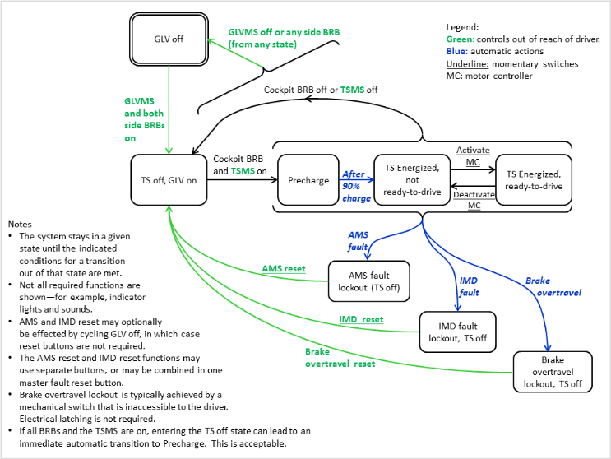
Figure 1 - FSM for TSI

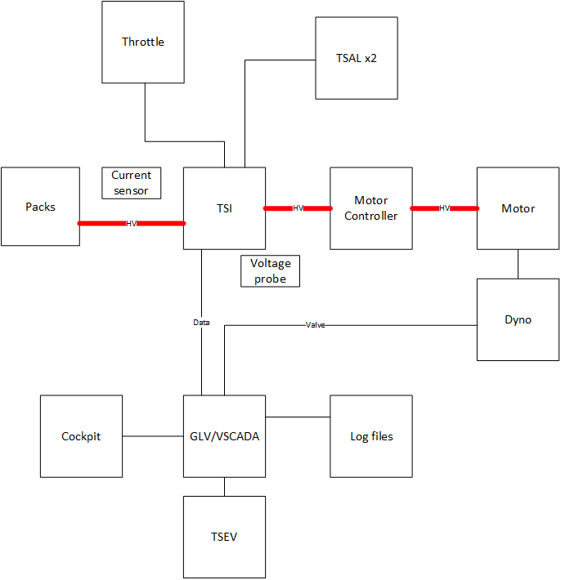
Figure 2 - ATP-01 block diagram

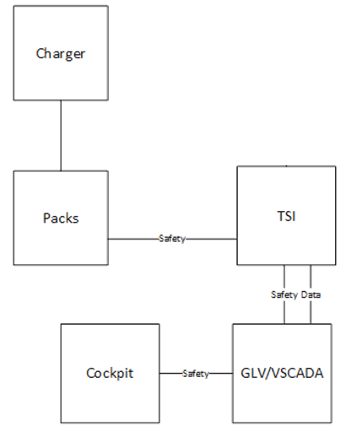
Figure 3 - ATP-02 block diagram
Figure 4 - ATP-03 block diagram
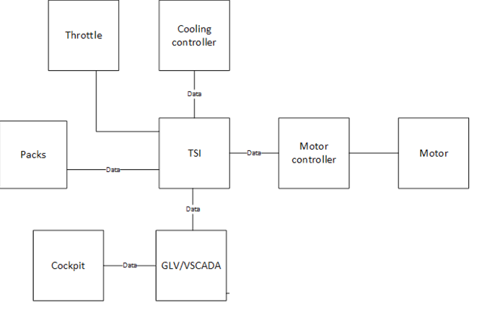
Figure 5 - ATP-04 block diagram
