Lafayette College: Electrical and Computer Engineering
08
Fall
Accumulator Verification: QA-TSV
Written by: Greg Flynn ‘17
Modified by: Waseh Ahmad ‘18
This document contains information about how to verify the electrical connections inside the pack.
Table of Contents
Desired objectives 3
Required Hardware 3
Required Software 3
Hardware Setup 4
Single pack 4
Software Setup 5
Test 5
Desired data 5
Appendix A: Wiring requirements 6
Appendix B: Measurement location images 7

Desired objectives
This test verifies all mechanical connections in the TSV circuit are electrically connected.

Required Hardware
- 1 Pack
- Simulated load
- Basic GLV safety loop
- PPE per safety plan
- Danger zone per safety plan
- Cables as specified in Appendix A
- Multi-meter
- Current probe

Required Software
None

Hardware Setup

Single pack

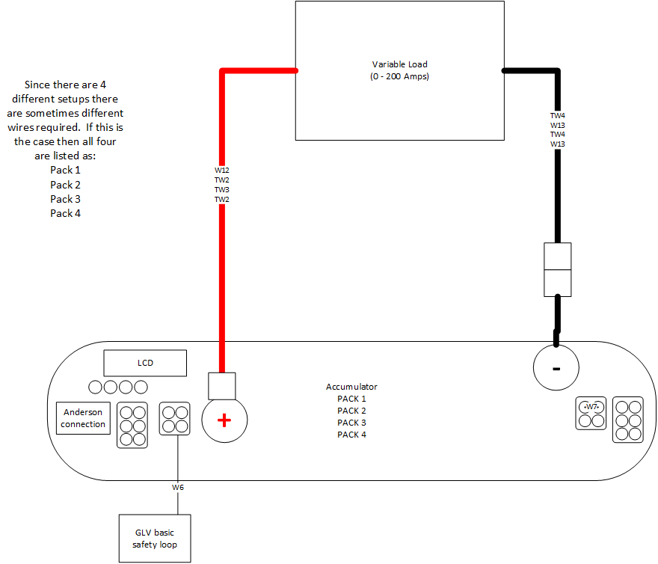
Figure 1 Single pack connections

Software Setup
N/A

Test
Suggestion: Run test at 20A.

Desired data
It is desired to get the resistance between all connections. Use the picture in Appendix B. Note that in figure five pack one has an air between X1 and X2.

Fill out attached excel document for each pack in a new sheet.

___________________________________________ ____________________ ____________________
Witness/examiner signature Date Pass/Fail

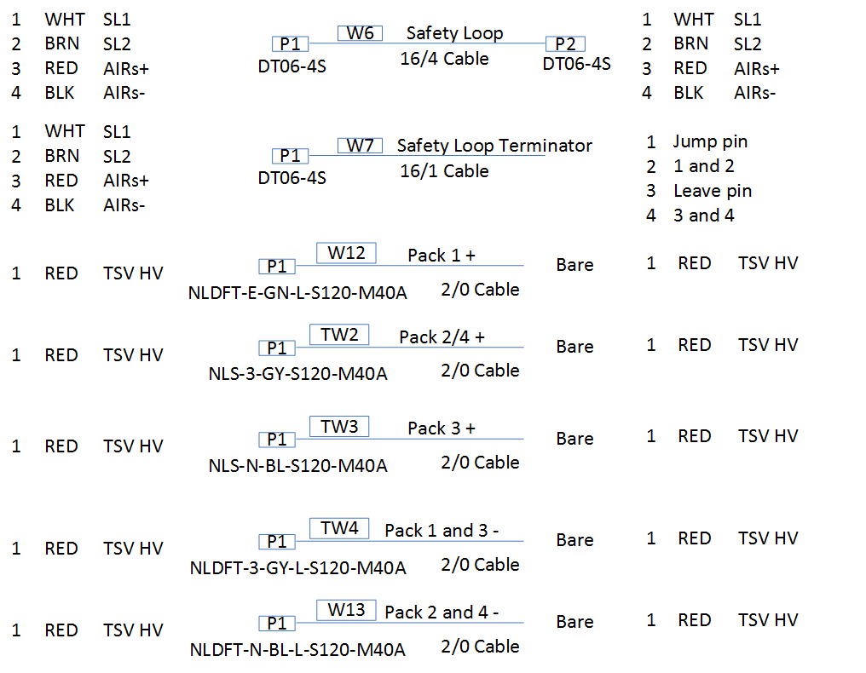
Appendix A: Wiring requirements
Cable | What packs use it | Total count for full test
W6 | 1,2,3,4 | 4
W7 | 1,2,3,4 | 1
W12 | 1 | 1
TW2 | 2,4 | 1
TW3 | 3 | 1
TW4 | 1,3 | 1
W13 | 2,4 | 1

Appendix B: Measurement location images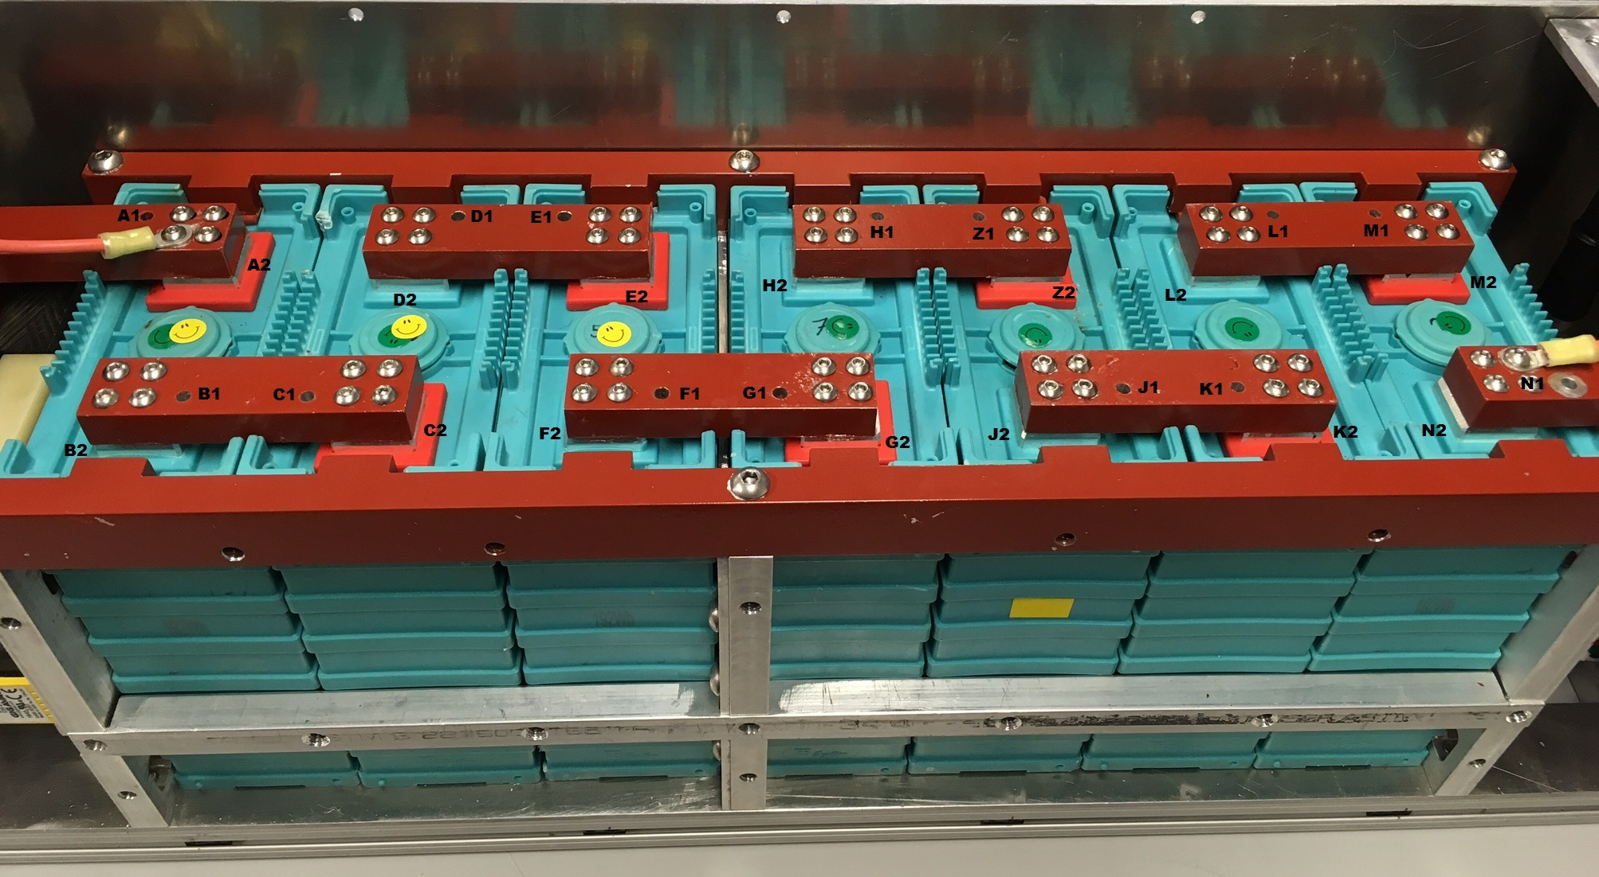
Figure 2 Top of cells
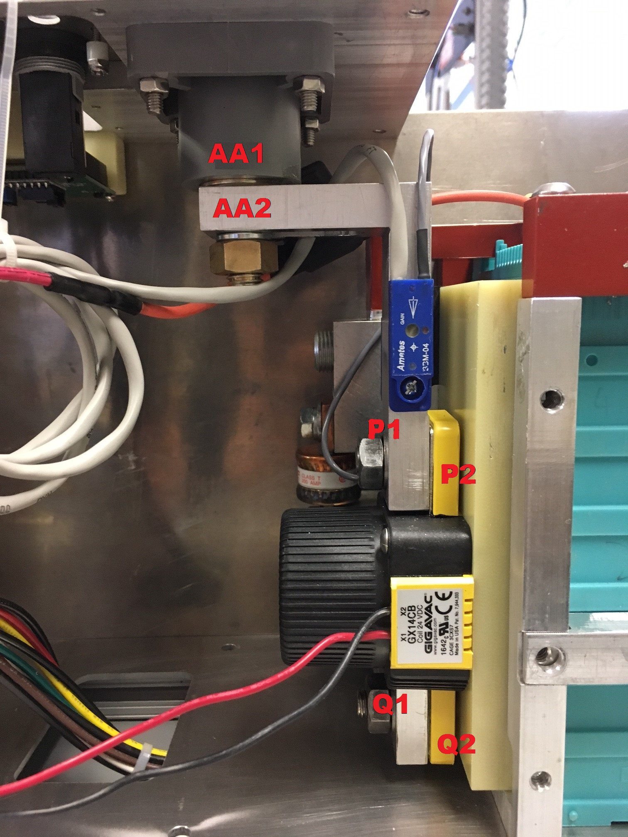
Figure 3 Positive connections front
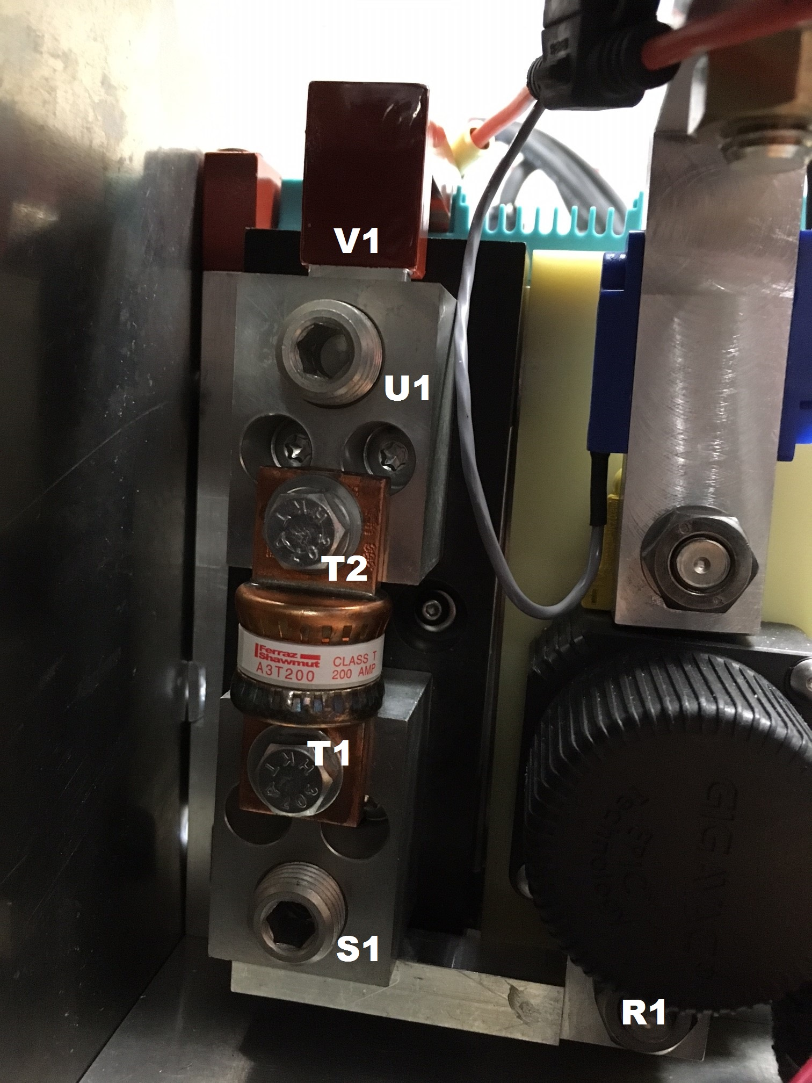
Figure 4 Positive terminal side
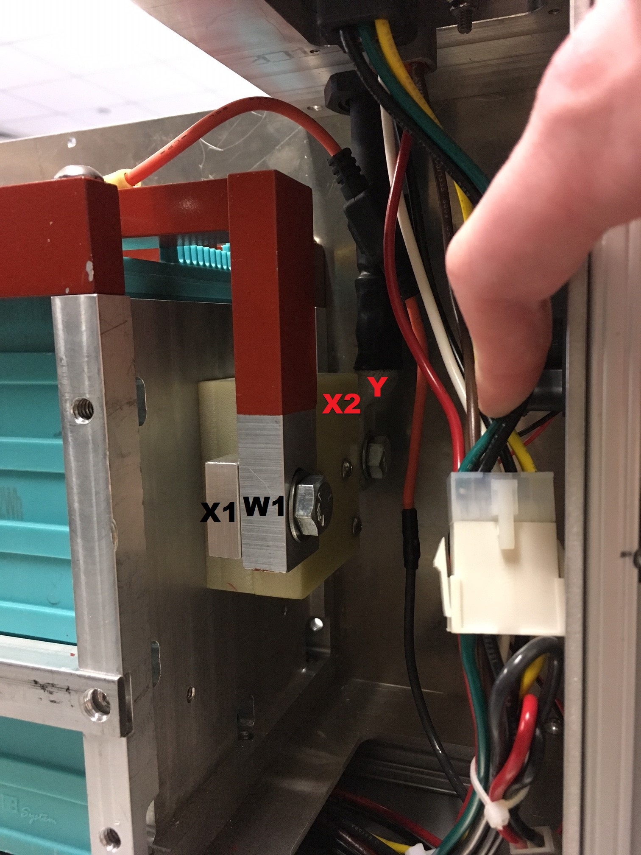
Figure 5 Negative connection side

