Lafayette College | Electrical and Computer Engineering

JGB Maintenance Manual
ECE 492 Spring 2017

Prepared by Raji Birru

Contents

Overview 3
Hardware 4
Problem Solving 4
Software 5
IDE 5
Code 5

Overview
This document details the most common problems one might face when working with the JGB and related hardware, how best to face these issues and a general maintenance strategy. As a system the JGB isn’t the most complex but can still cause various issues. Below are some common issues and how they can be remedied. The following picture of the JGB will be referenced in this document.
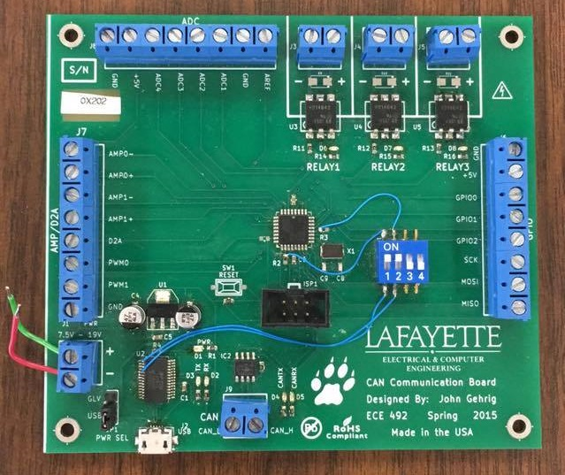

Hardware

JGB Hardware
The JGB hardware is detailed through a BOM and Schematic diagram posted on the project website. Any future reproduction should be straightforward. Any changes to be made to the hardware should be well documented and subsequent changes should be made to the schematic documents as well as the BOM.

ICE Debugger
The Atmel ICE debugger is used for programming the microcontroller onboard the JGB. The proprietary cable that is packed with it is used. The User Manual can be found on Atmel’s website (See Here: http://www.atmel.com/Images/Atmel-42330-Atmel-ICE_UserGuide.pdf).

Problem Solving
The following are some common hardware issues that can be encountered while working with the JGB and the appropriate alleviating measures.
- Issue: JGB is not receiving power. All LEDs down.
Possible Fix:
- If using USB power make sure the cable is plugged in and check power switch on the bottom left hand side of the JGB is on the USB option and not GLV and vice versa,
- If using Power Source make sure all connections are correct. Also make sure Ground is connected to ‘-’ port on JGB.

- Issue: Atmel Studio is displaying errors when trying to program board. Board isn’t being recognized but is powered on.
Possible fix:
- Make sure cables are connected in the right ports.
- Make sure the debugger cabled all the way in on the board and is plugged into the right port (i.e. AVR port) on the debugger instead of the SAM port.
- Make sure the JGB is connected to power.
- Switch between JGB boards and try above methods.
- Make sure switches 1 & 2 on JGB are switched on as shown in the pictured JGB board above. These are crucial to proper functionality.

Software

IDE
The IDE of choice for the JGB at the moment is Atmel’s own Atmel Studio. It is available for free on Atmel’s website (See here: http://www.atmel.com/tools/atmelstudio.aspx ) and is necessary to work with the ICE debugger the JGB operates with. It has caused several installation issues in the past and required some Windows Updates be installed. If the machine to be worked on has it installed already this won’t be an issue. But be ready to face some issues in the other case. The installed will alert which updates it required and these must be downloaded first.

Code
All code is stored on the repository linked on the website. The contents of the repository have been detailed in the User Manual on the project website. The following is a list of all files and their respective functions. When trying to make changes to a specific functionality of the JGB refer to the files lined below
File | Function
uart.c, uart.h | UART functionality.
timer.c, timer.h | PWM functionality.
jgb.c, jgb.h | D2A functionality is currently located here. It is recommended that this be moved to its own class.
main.c | Demo
can_lib.c, can_drv.c, can_lib.h, can_drv.h | CAN bus functionality. This is proprietary code from Atmel and isn’t to be altered unless with specific reason.
config.h | List of static variables
ringbuf.c,  ringbuf.c | Ring buffer employed by UART library for data storage. Ring buffers are recommended for use on embedded systems for space conservation.

