Formula Hybrid ESF -- Part 1

INTRODUCTION

Part 1 of the Formula Hybrid ESF is intended to help teams solidify those design decisions that need to be made early in the program. This will also help the technical reviewers identify possible areas of concern early.

Many of the fields in this form will also be found in the ESF Part 2 and the information in those fields will need to be reentered when the ESF Part 2 is submitted.

It is expected that some of the information will change during the development of the vehicle. Teams should not feel “locked in” by the data provided here, however data entered in the ESF Part 2 will be considered final.

The information in this form will also be provided to the design judges, so teams may expect questions during the design event relating to why a particular aspect of the vehicle was changed during development.

INSTRUCTIONS AND REQUIREMENTS

.
- Enter the information requested as accurately as possible. If a particular portion of the design has not been finalized, give a short description of the options being considered.

- Please submit any questions, corrections and suggestions for improvement to:
http://www.formula-hybrid.org/level2/support/index.php

- When completed, this document must be converted to a pdf and submitted to:

http://formula-hybrid.com/uploads/

Table of Contents

Section 1 Vehicle Overview 2
Section 2 Frame and Body 3
Section 3 Engine 4
3.1 Engine Data 4
3.2 Architecture 4
Section 4 Electrical System Overview 5
4.1 Block Diagram 5
4.2 Vehicle Layout 5
4.3 Electrical System Parameters 6
4.4 Firewall(s) 6
Section 5 Tractive System 7
5.1 Motor(s) 7
5.2 Motor Controller 7
Section 6 Accumulator System 8
6.1 Accumulator Pack 8
6.2 Cell Description - Batteries 8
6.3 Cell Description - Capacitors 9
6.4 Cell Configuration 9
6.5 Lithium-Ion Pouch Cells 9
6.6 Accumulator Management System (AMS) 10
6.7 Charging 10
6.8 Accumulator Container/Housing 11
6.9 Shutdown Circuit 11
6.10 IMD 11
Section 7 GLV System 13
7.1 GLV System Data 13

List of Figures
Figure 1- Electrical System Block Diagram 5
Figure 2 - Locations of major TS components 5
Figure 3 – Safety Shutdown Circuit Schematic 11
Must be hyperlinked!
List of Tables
Table 1 - Engine Data 4
Table 2 - General Electrical System Parameters 6
Table 3 - Motor Specifications 7
Table 4 - Motor Controller Specifications 7
Table 5 - Main Accumulator Parameters 8
Table 6 - Main Cell Specification 9
Table 7 - Capacitor Specifications 9
Table 8 - AMS Data 10
Table 9 - Accumulator Charging Data 10
Table 10 - IMD parameters 12
Table 11 - GLV Data 13
Must be hyperlinked!

TITLE PAGE

Please include team logo, car picture, team picture, etc..

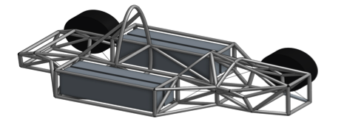

University Name: | Lafayette College
Team Name: | Lafayette Motor Sports
Car Number: | 217

Main Team Contact for ESF related questions:
Name: | Graham Thomas
e-mail: | thomasg@lafayette.edu

Vehicle Overview

Check the appropriate boxes:

Vehicle is
☒New (built on an entirely new frame)
☐New, but built on a pre-existing frame (FSAE, FS, FH electric-only, etc.)
☐Updated from a previous year vehicle

Architecture
☐Hybrid
☐Series
☐Parallel
☐Hybrid in Progress (HIP)
☒Electric-only

Drive
☐Front wheel
☒Rear wheel
☐All-wheel

Regenerative braking
☐Front wheels
☐Rear wheels
☐All wheels
☒None

Frame and Body

List the materials used and the construction methodology for the frame and body. Include CAD drawings, photos or sketches as appropriate.

Frame

Materials

- Minimum FSAE required Steel
- Bending & Buckling strength calculations
  - Youngs Modulus = 200 GPa
  - Yield Strength = 305 MPa
  - Ultimate Strength = 365 MPa

Joining Methods and Construction

- Welds
- We are outsourcing manufacturing of our frame to VR3

Body

Materials

- Fiberglass

Construction

- Student fabricated in-house
- No CAD drawings for body yet

Engine

Skip this section if electric-only

Engine Data

Manufacturer
Model Number
Modified? (Per IC1.1) | ☐Yes ☐No
Number of Cylinders
Bore | mm
Stroke | mm
Displacement | liters
Fuel type | ☐Gasoline ☐E-85 ☐Diesel
Max. Power | kW @ RPM
Max. Torque | N⋅m @ RPM
Weight (Approximate) | kg
Table 1 - Engine Data

Architecture
Describe how the outputs from the I.C. engine and electric drive systems are merged:

Electrical System Overview

Block Diagram

Figure 1 – include an electrical system block diagram showing all major parts associated with the tractive-system. (Not detailed wiring).

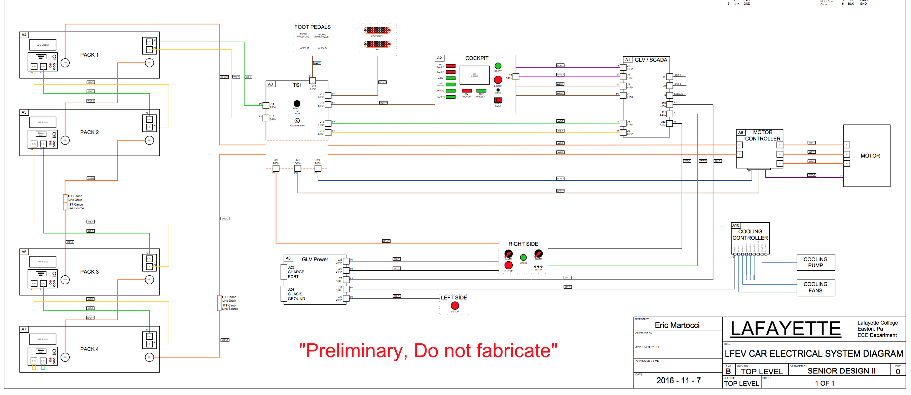
Figure 1- Electrical System Block Diagram

Vehicle Layout

Figure 2 – include a diagram showing the location of all major parts associated with the tractive-system superimposed on a top view of the vehicle.
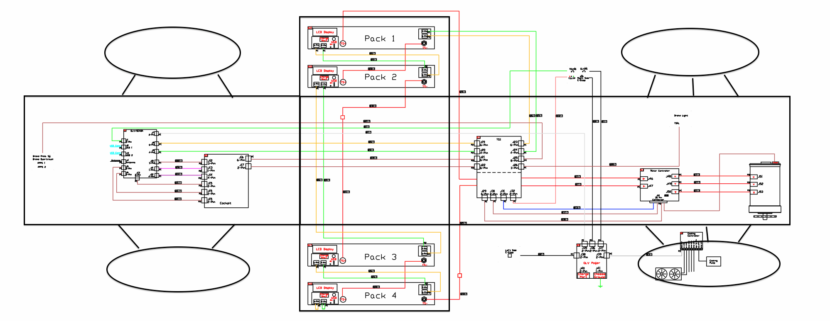
Figure 2 - Locations of major TS components

Electrical System Parameters

Fill out the following table:

Nominal Tractive System Voltage (TSV) | 96 VDC
Max. TSV (typically this is during charging) | 120 VDC
Control System voltage (GLV) | 24 VDC
Total Accumulator capacity | 16 Wh
Accumulator type (Lead-acid, Li-Ion, NiMH, Ultracap…) | Li-Ion Polymer
Number of electric motors. (Total) | 1
Are wheel motors used? | ☐Yes ☒No
Table 2 - General Electrical System Parameters

Firewall(s)

Description/materials

Describe the concept, layer structure and the materials used for the firewalls.
- Sheet steel welded to frame and covered with fire resistant tape
- Layers
  - Sheet aluminum
  - Fire resistant tape

Position in car
Provide CAD-rendering or sketches showing the planned location of the firewall(s).

- The grey sheets underneath and seperating the driver from the accumulators as well as on top of the accumulators and behind the main roll hoop in the drawing is our firewall (1.5 mm aluminum)
- There will be conduits for all the TSV wiring, not on the CAD-rendering yet (haven’t made a decision where it will be yet)
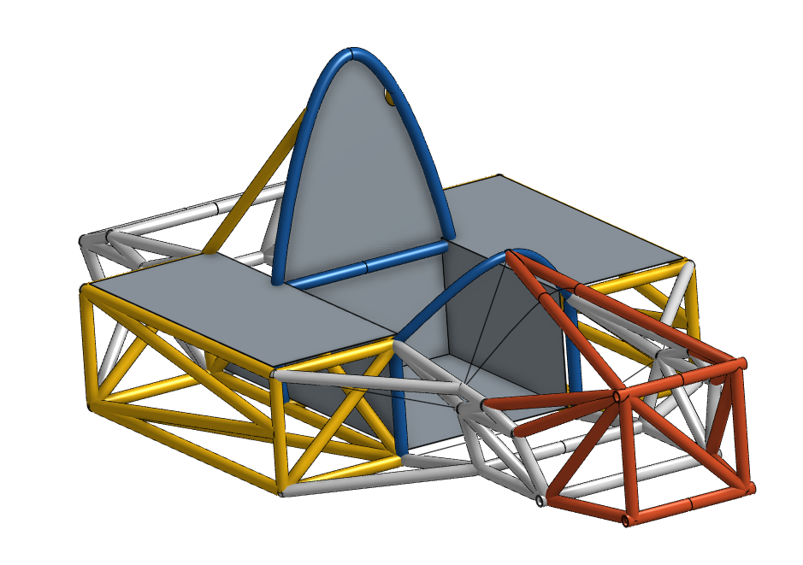

Tractive System

Motor(s)

Add additional tables if multiple motor types are used

Manufacturer | HPEVS, Inc
Model Number | AC50-27.28.11
Motor Type (PM, Induction, DC Brush…) | AC-50 Induction Motor Brushless
Number of motors of this type used | 1
Nominal motor voltage (V_{rms} l-l or V_{dc}) | 96
Nominal / Peak motor current (A or A/phase) | Nom: 200 Peak: 600
Nominal / Peak motor power | Nom: 52 HP Peak: 100 HP
Table 3 - Motor Specifications

Motor Controller

Manufacturer | Curtis
Model Number | 1238R
Number of controllers of this type used: | 1
Maximum Input voltage: | 96 V
Nominal Input Current: | 200 A
Output voltage (V_{ac} l-l or V_{dc}) | 24 V
Isolation voltage rating between GLV and TS connections | .25 V
Is motor controller accelerator input isolated from TSV? | ☒Yes ☐No
Table 4 - Motor Controller Specifications

Accumulator System

Accumulator Pack

Provide a narrative design of the accumulator system and complete the following tables.

- The accumulator system is divided into four separate battery packs in series each at 24 V. This makes the total accumulator system voltage 96 V which supplies power to the motor controller. Within the accumulator system there are five Accumulator Isolation Relays, which remain open until the safety loop is closed.

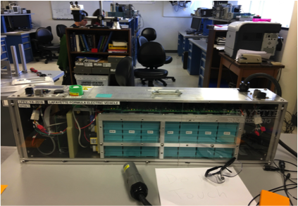

Maximum Voltage (during charging): | 26 VDC
Nominal Voltage: | 26 VDC
Total number of cells: | 7
Are packs commercially or team constructed? | ☐Commercial ☒Team
Total Capacity: | 4 Wh
Maximum Segment Capacity: | 4.8384 MJ
Table 5 - Main Accumulator Parameters

Cell Description - Batteries

Cell Manufacturer | Powerizer
Model Number | 20121024
Cell type (prismatic, cylindrical, pouch, etc.) | Prismatic
Are these pouch cells | ☐Yes ☒No
Cell nominal capacity: | 60 Ah
Discharge rate for nominal capacity (e.g. 1C, 2C etc.) | 1C
Maximum Voltage: | 4.1 V
Nominal Voltage: | 3.2 V
Minimum Voltage: | 2.3 V
Maximum Cell Temperature (charging) | 60 °C
Maximum Cell Temperature (discharging) | 60 °C
Cell chemistry: | LiFeP04
Table 6 - Main Cell Specification

Cell Description - Capacitors

Capacitor Manufacturer: | N/A
Model Number: | N/A
Rated Capacitance: | N/A
Rated Voltage: | N/A
Stored Energy | N/A
Maximum Temperature | N/A
Table 7 - Capacitor Specifications

Cell Configuration

Describe configuration: e.g., N cells in parallel then M packs in series, or N cells in series then M strings in series.

- 7 Cells in Series then 0 strings in series

Lithium-Ion Pouch Cells

The vehicle accumulator ☐DOES / ☒DOES NOT use individual pouch cells. (Check one)

Note: Designing an accumulator system utilizing pouch cells is a substantial engineering undertaking which may be avoided by using prismatic or cylindrical cells.

If your team has designed your accumulator system using individual Lithium-Ion pouch cells, include drawings and calculations demonstrating compliance with all sections of rule EV3.9. If your system has been issued a variance to EV3.9 by the Formula Hybrid rules committee, include the required documentation from the cell manufacturer.

Accumulator Management System (AMS)

AMS Manufacturer | Lafayette College
Model Number | N/A
Number of AMSs | 1 per cell
Upper Cell Voltage Trip | 4.05 V
Lower Cell Voltage Trip | 2.35 V
Temperature Trip | 50 °C
Table 8 - AMS Data

Charging

Charger Manufacturer | TDK-Lambda
Model Number | GENH30-25-U
Maximum Charging Power: | .48 kW
GLV/TS isolation location:  (i.e. cell boards, main unit, etc.) | Main unit
UL Certification? | ☒Yes ☐No
Maximum Charging Voltage: | 29 V
Maximum Charging Current: | 20 A
Input Voltage: | 120 VAC single phase
Input Current: | 9.5 A
Table 9 - Accumulator Charging Data

Accumulator Container/Housing

Describe the design of the accumulator container. Include the housing material specifications and construction methods.

- The accumulator container is designed with 8020 aluminum. All of the walls and barriers were designed to the rulebook set by FSAE electric to ensure that we it will pass tech. but more importantly be safe to use. There are small air intakes and fans to ensure that the packs do not overheat during charging or usage. We also took the time to make sure that every structural component is well within our factor of safety.

Where will the accumulators be located?
- 2 accumulator packs on each side of the driver

Will you be taking advantage of the virtual accumulator housing rule? (EV3.3)
- No

Shutdown Circuit

Include a schematic of the shutdown circuit for your vehicle including all major components in the loop.
Note: The design of the shutdown circuit and team members understanding of how it works is extremely important. Take the time to be sure it is right.

- The Red Circles on the Diagram are our emergency stops. There is an emergency stop in the cockpit for the driver and one on each side of the car around the roll hoop (left and right). There is also an emergency stop on the brake pedal over travel switch, which is in the foot pedals box. The emergency shut off switches are either a push button that must stay pulled to keep the car running or turn on. There are also key switches that will be on the roll hoop.
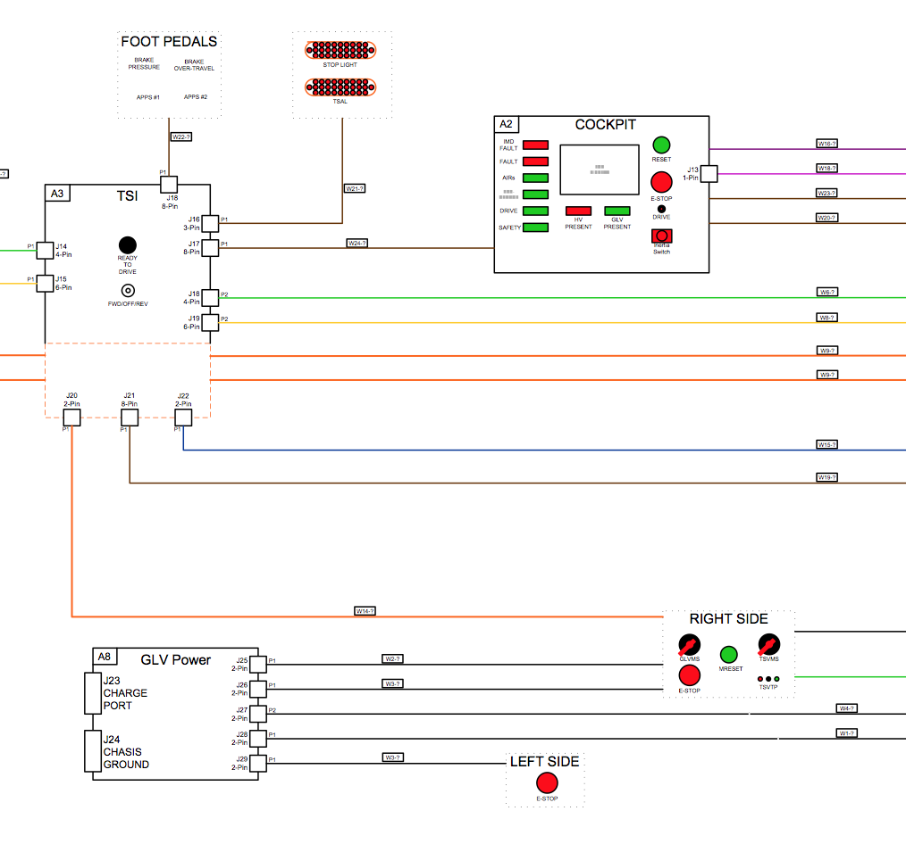
Figure 3 – Safety Shutdown Circuit Schematic

IMD

Describe the IMD used and complete the following table:

Standard Bender board that will be wired correctly

Manufacturer | Bender
Model Number | IR155-3204
Set response value: | _100__ kΩ ( __1042_ Ω/Volt)
Table 10 - IMD parameters

GLV System

GLV System Data

Provide a brief description of the GLV system and complete the following table.

We are using two 24V batteries to power the following components: VSCADA, cockpit controls/display, brake press/over-travel switch, accelerator pedal potentiometers, and tentative cooling controller

GLV System Voltage | 24 V
GLV Main Fuse Rating | 20 A
GLV Accumulator type | IMH
How is the GLV storage recharged? | Commercial charger
Table 11 - GLV Data

Use the formula given in Appendix A of the Formula Hybrid rules. This will differ slightly from the manufacturer’s rating.

