Lafayette College | Electrical and Computer Engineering

TSV Accumulator Interconnectivity Document
ECE 492 Spring 2017

Assembled by Emilie Grybos

Table of Contents

Overview 3
PCB Connector Pinouts 4
PacMAN 4
AMS 6
Control Panel 7
Pack Wiring 8
Accumulator Wiring 11

Overview
The purpose of this document is to provide wiring and interconnect information about the Tractive System Voltage (TSV) subsystem and all its components for the Lafayette Formula Electric Vehicle as of spring 2017. All of the images included below are provided in .pdf and original form in the zip folder located here: https://sites.lafayette.edu/ece492-sp17/files/2017/01/Wiring-Schematics.zip

For information about TSV and these subsystems, see the User Manual and Maintanence Manual, both of which can be accessed here: http://sites.lafayette.edu/ece492-sp17/subsystems/tsv/

PCB Connector Pinouts

PacMAN
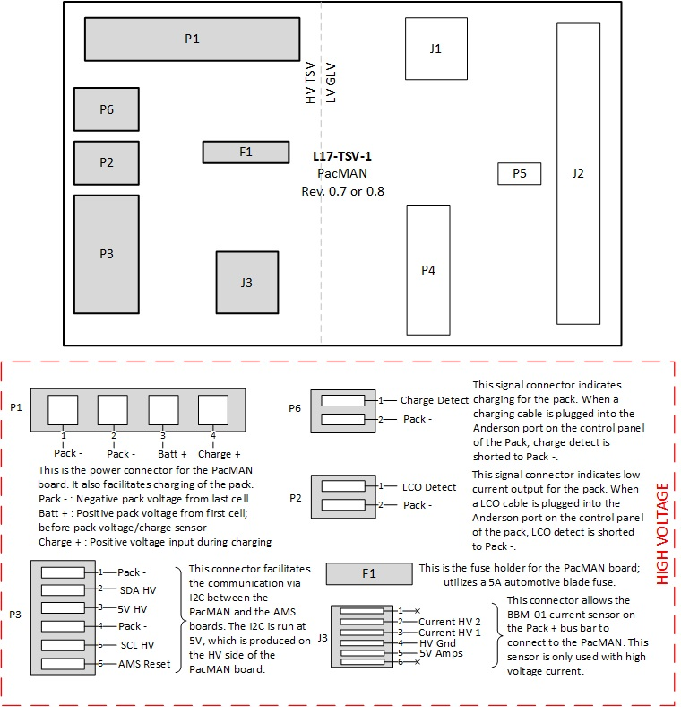
Figure 1. PacMAN High Voltage Connectors and Descriptions.

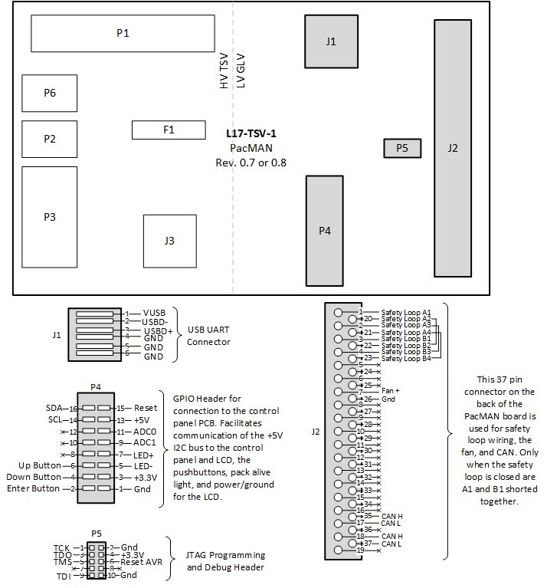
Figure 2. PacMAN Low Voltage Connectors and Descriptions.

AMS
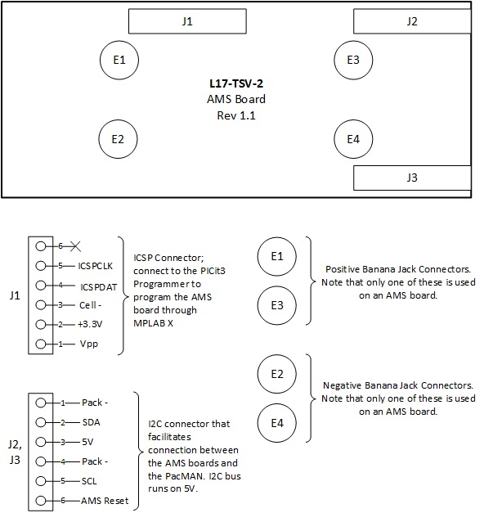
Figure 3. AMS Connectors and Descriptions.

Control Panel
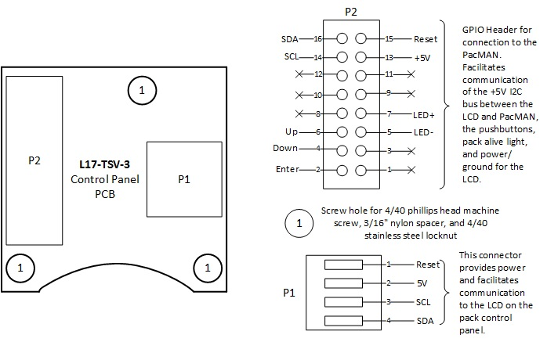
Figure 4. Control Panel Connectors and Descriptions.

Pack Wiring

Figure 8. Pack Wiring Diagram 2.
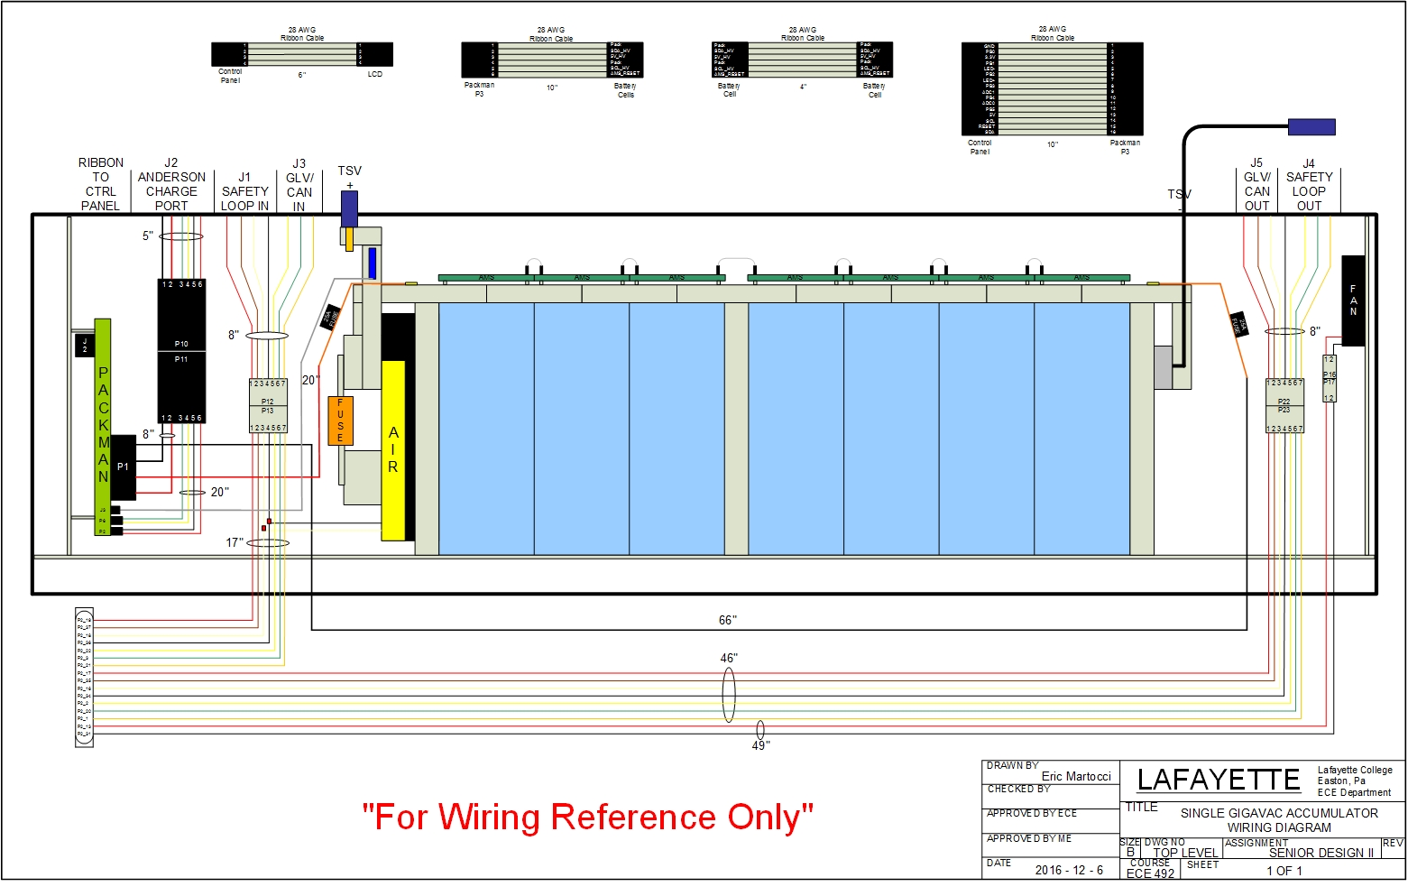
Figure 5. Pack wiring diagram for Pack 1 with a single AIR.
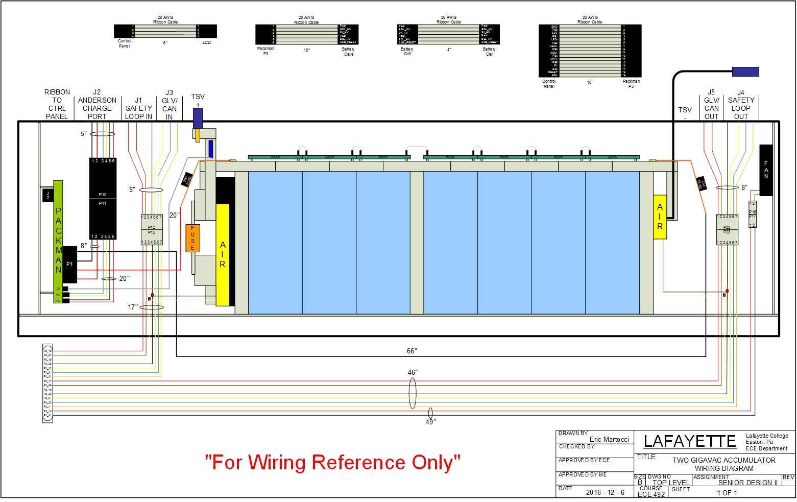
Figure 6. Pack wiring diagram for Packs 2,3, and 4 with two AIRs.

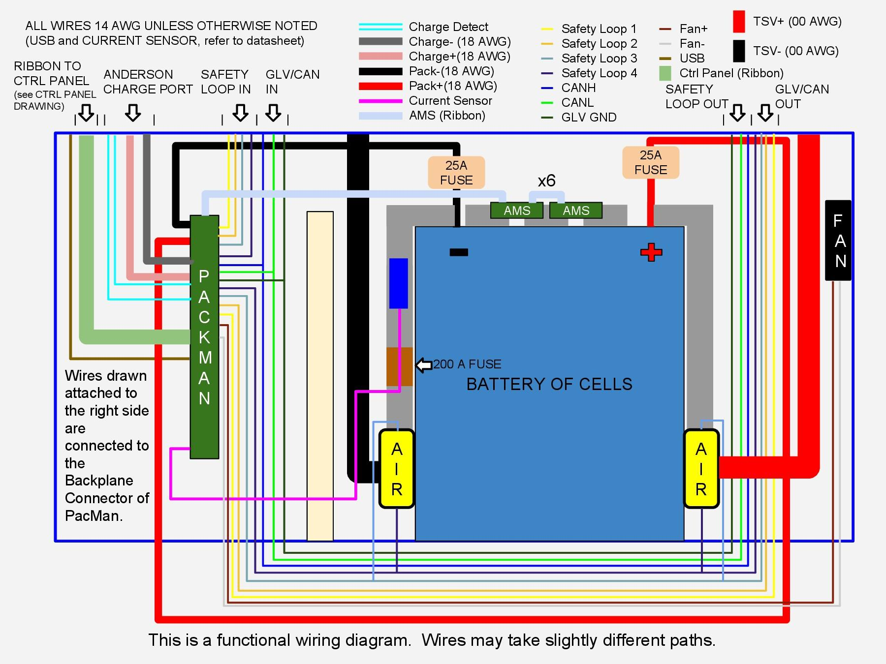
Figure 7. Pack Wiring Diagram 1.

Accumulator Wiring
Pack 1
Pack 2
Pack 3
Pack 4

-
+
Figure 8. Wiring Accumulator with ITT Cannon connectors. Connection to TSI enters from the green end into Pack 1 then exits through a blue connector.

