Lafayette Formula Electric Vehicle
ECE492 Spring 2017
Tractive Sysytem Interface interconnectivity document

Table of Contents
Table of Contents 1
Overview 2
internal interconnect 2
Wiring diagram 3
Ribbon cable pinouts 4
Overview 4
20-pin ribbon cable 4
14-pin ribbon cable 5

Overview
The purpose of this document is to provide wiring and interconnect information about the Tractive System Interface box. This document specifically regards the interconnect information for the components within the TSI box. All of the images included below are provided in .pdf and original form in the zip folder located here: http://sites.lafayette.edu/ece492-sp17/subsystems/tsi/
For information about TSI and these subsystems, see the User Manual and Maintenance Manual, both of which can be accessed here: http://sites.lafayette.edu/ece492-sp17/subsystems/tsi/

internal interconnect
For information on the external interconnect and cabling, refer to the Overall System Diagram v1.2 which can be found here:
https://sites.lafayette.edu/ece492-sp17/files/2017/02/Car_v1.2.pdf

Wiring diagram
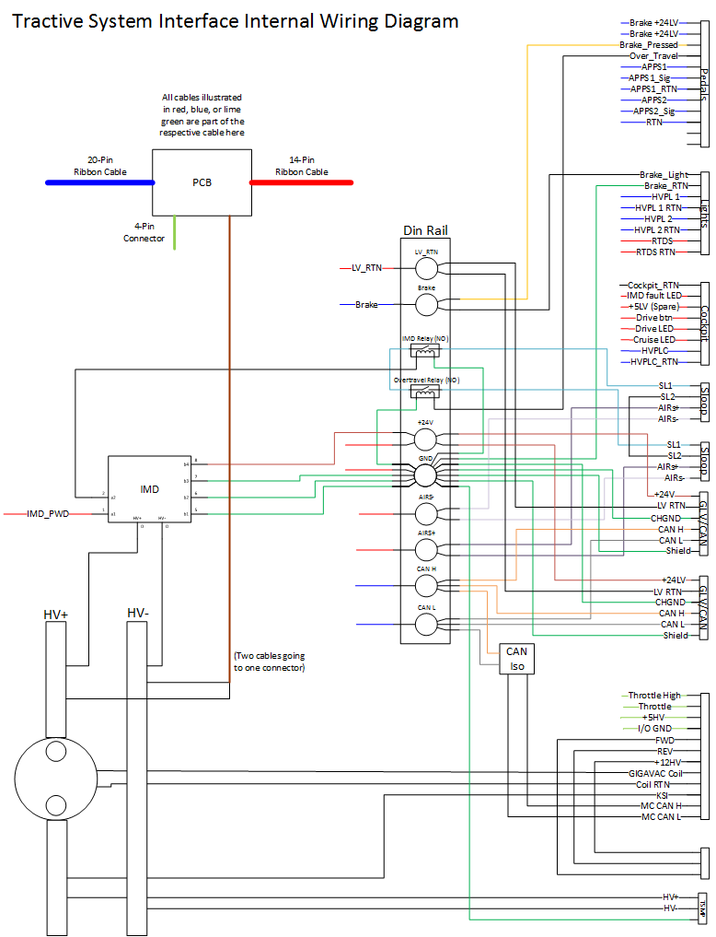

Ribbon cable pinouts

Overview
This section contains information relating to the pinouts for the two ribbon cables used in the TSI box. For both ribbon cables, pin 1 is a brown cable at the bottom of the ribbon.

20-pin ribbon cable

Pin Number | Name | Color | Going to | Wire
20 | Brake_24 | Black | 1.1 | W24
19 | Brake_24 | White | 1.2 | W24
18 | BOT | Grey | BOT din
17 | APPS2 | Purple | 1.9 | W24
16 | BP | Blue | Brake Din
15 | APPS1 | Green | 1.6 | W24
14 | NC | Yellow
13 | RTN_GLV | Orange | 1.10 | W24
12 | HVPL_Cock_RTN | Red | 3.8 | W25
11 | APPS1_RTN | Brown | 1.7 | W24
10 | HVPL_2_RTN | Black | 2.4 | W23
9 | APPS2_5 | White | 1.8 | W24
8 | HVPL_1_RTN | Grey | 2.6 | W23
7 | APPS1_10 | Purple | 1.5 | W24
6 | HVPL_Cock | Blue | 3.6 | W25
5 | NC | Green
4 | HVPL_2 | Yellow | 2.3 | W23
3 | CAN_L | Orange | Can L Din
2 | HVPL_1 | Red | 2.5 | W23
1 | CAN_H | Brown | Can H Din

14-pin ribbon cable

Pin Number | Name | Color | Going to | Wire
14 | RTDS_RTN | Yellow | 2.8
13 | IMD_PWM | Orange | IMD PWM
12 | RTDS | Red | 2.7 | W23
11 | IMD_Status | Brown | IMD
10 | Drive_LED | Black | 3.5 | W25
9 | AIRs- | White | AIRs- Din
8 | Drive_BTN | Grey | 3.4 | W25
7 | AIRs+ | Purple | AIRSs+ Din
6 | Drive_BTN_+5 | Blue | 3.3 | W25
5 | 24LV | Green | 24LV Din
4 | IMD_Fault_LED | Yellow | 3.2 | W25
3 | LV_RTN | Orange | LV_RTN Din
2 | CC_LED | Red | 3.7 | W25
1 | CHGND | Brown | GND Din

