TSI User Manual
ECE492 Spring 2017

Introduction
This is the user manual to the TSI System of the LFEV 2017 Project. Here we will discuss the proper usage of the system and common issues you may encounter. The purpose of the TSI is to safely deliver power from the TSV system to the motor controller. This is achieved by maintaining isolation between the high and low voltage and performing various safety checks. We also interface with the throttle, brakes, and indicator lights relating to these signals. A simplified block diagram for the TSI can be seen below. Out git repository is accessible from this link: https://github.com/LafayetteFormulaElectricVehicle/TSI.git

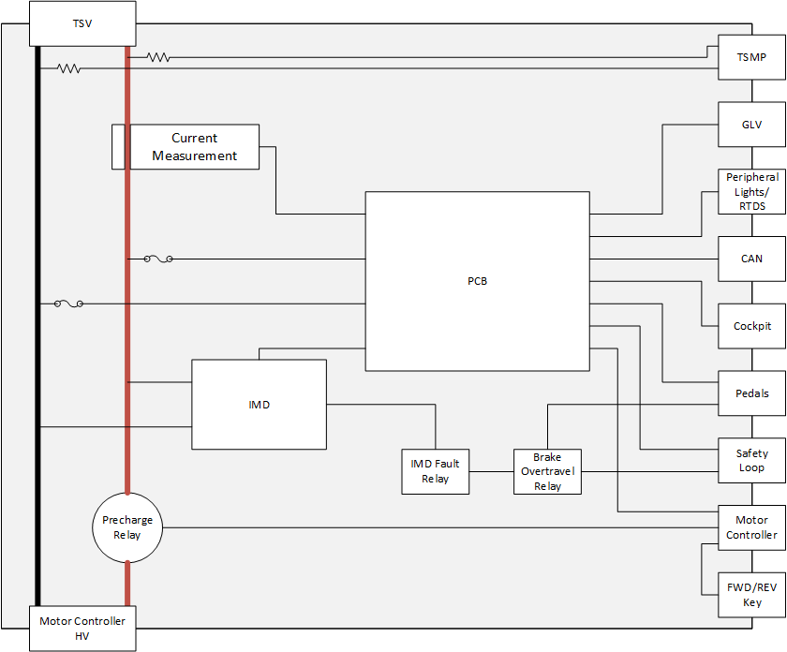

Hardware

IMD
A pinout for the IMD can be found on the datasheet here under IR155-3204:
http://www.bender-es.com/fileadmin/products/doc/IR155-32xx-V004_D00115_D_XXEN.pdf

The main connections that need to be connected are the power and three grounds to the GLV signals, the OK_{HS} used in a 24V relay to control the safety loop, and the PWM output of measured resistance to the PCB. The high voltage side needs to be connected to the proper high voltage bar.

CAN Isolator
The CAN Isolator used in the TSI box connects to the can signal coming from the motor controller. This is used to ensure the high voltage signal is isolated from the low voltage. This is mounted on din rail and should span the high and low voltage sides of the box.

TSI Board
The TSI Board was designed by Adam Ness and Jack Plumb. This is the brains of the TSI system and interfaces with most of the I/O that comes into the box. There are two connection points on the low voltage side of the PCB where ribbon cables are currently used. The larger of the two, situated near the edge of the board, should be connected with the ribbon leaving out the side of the board. The other should have the cable leaving the opposite direction. For the high voltage side, the power connectors need to be connected to the proper high voltage aluminum bar in the high voltage side of the box. Pictures of the board can be found on the TSI website here:
- http://sites.lafayette.edu/ece492-sp17/subsystems/tsi/

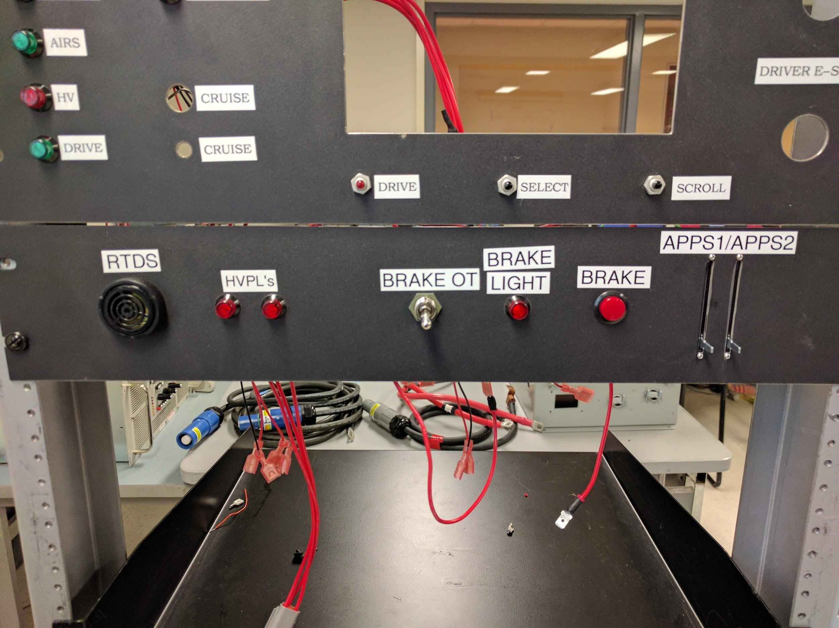
TSI Test Panel
This is the TSI test panel designed by Jack Plumb. It is used to simulate the driver interactions in the dyno room. The two slide potentiometers labeled APPS1/APPS2 are used to control the throttle and give the user the ability to cause an implausibility in the system. The brake button generates a binary signal similar to what the pressure sensor does in the car. The brake overtravel switch will give simulate what happens if there is a mechanical brake failure in the car and how the TSI would respond. The RTDS is simply a speaker that would sound when drive mode can be accessed. The HVPL are both of the high voltage lights that indicate when power is flowing through the system.

Software

Programming Instructions
The microcontroller used in the TSI board is the same as what is currently used in the PacMan. Therefore, the programming of the board is identical to that of the PacMan. The TSV team created a comprehensive and easy to follow guide for programming; “Program Instructions REV A VER 5.11 and up.pdf”.

The document may be found in our Git Repository here:
- https://github.com/LafayetteFormulaElectricVehicle/TSI

Or in the .zip on the class website here:
- http://sites.lafayette.edu/ece492-sp17/subsystems/tsi/

Getting Started
The TSI system is fairly easy to setup. The connectors on the outside of the box are used to interface with the other subsystems on the car, mainly GLV, TSV, and the motor controller. The larger of the two panels is used for the low voltage connections while the sides and back connect with high voltage systems. There are a few connections on the inside of the box that will interface with the IMD, PCB, Precharge Relay, and high voltage bars. The positive bar is the one that connects to the Precharge Relay and the minus bar is on the other side of the box. The IMD connectors on the high voltage side have the positive connection closer to the edge of the board. The PCB setup was talked about in the TSI Board section above.

FAQ
Q: Why can I not enter drive mode?
A: There are various signals that need to be asserted before the user can put the car into drive mode. These include the AIRS being closed, the IMD not faulting, and GLV power provided. If these are all okay, make sure the brake is pressed before hitting the drive button.

Q: How do I use the test panel?
A: The test panel made by Jack Plumb can be used to simulate the import components of the car to the TSI system in the Dyno room. The two slide potentiometers are the two throttle inputs that the pedals connect to. Make sure these are set near each other to not cause implausibility. The brake button acts as a binary signal of whether or not the brake has been pressed. The switch for brake overtravel will be held as long as you need it to as the user will need to reset this manually in the car as well.

Q: Why am I seeing throttle implausibility?
A: The slide potentiometers may be set too far apart from one another. Use a multimeter to measure the resistance you are seeing across them and verify they are within the acceptable range. If this is not the case, there may be an issue in the implausibility circuit on the PCB. Make sure the resistors are setting the correct gain and no shorts have occurred.

Q: Why am I seeing 0V from one of my throttle signals?
A: To ensure the core functionality of driving, the plausibility circuit needed to be bypassed and the throttle from one of the potentiometers fed directly into the motor controller. The other signal is not being used at all and will not show up on the PCB.

