Lafayette College | Electrical and Computer Engineering

PacMAN Installation Guide
ECE 492 Spring 2017

Assembled by Emilie Grybos & Meridith Guro

Getting Started
This document is meant to be used for installing a PacMAN version 0.8 into a fully functional pack. You will need a fully assembled PacMAN board, Phillips head screwdriver, 2 4-40 x 5/8 Button Head Socket Cap Screw, and 44-40 x 1/4 Button Head Socket Cap Screw as seen below. **Note: Always follow Proper Safety Procedures while Installing the PacMAN. Wear safety glasses, remove all jewelry/ medal, enlist a team member to be on Safety Watch.**
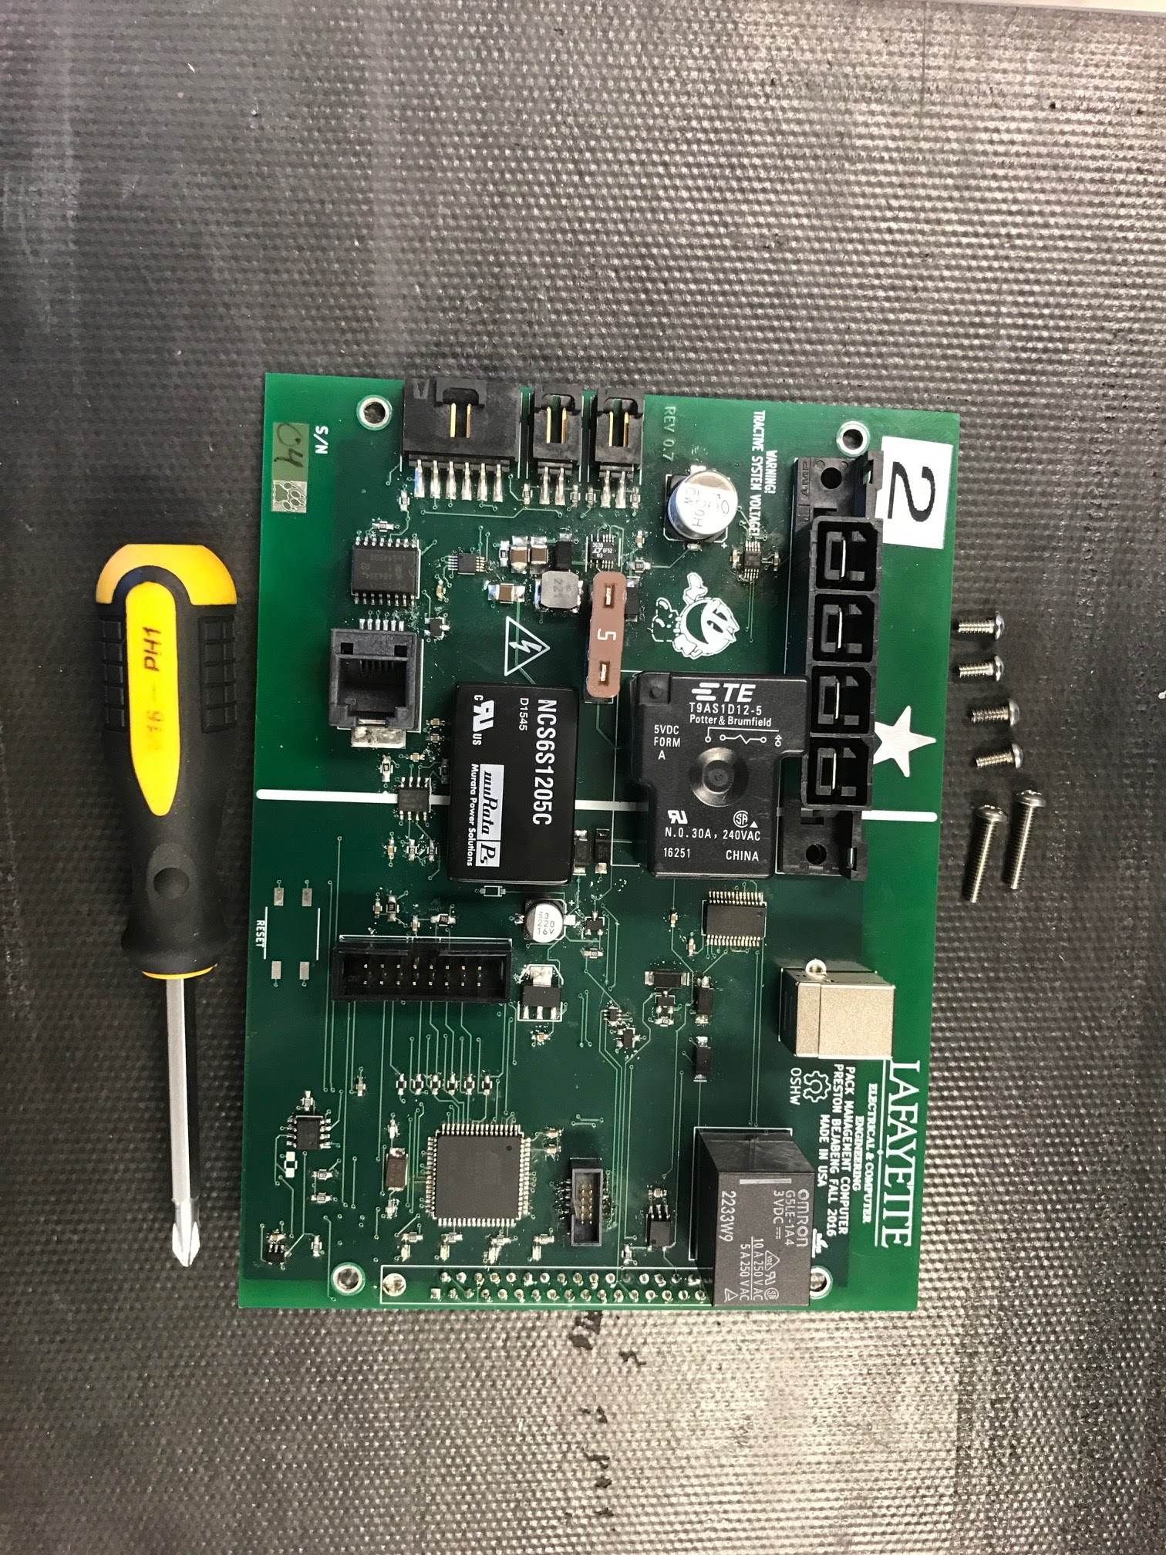
Figure 1. Needed tools for installation.

Installation Process

Step One: Install 37 Pin Connector
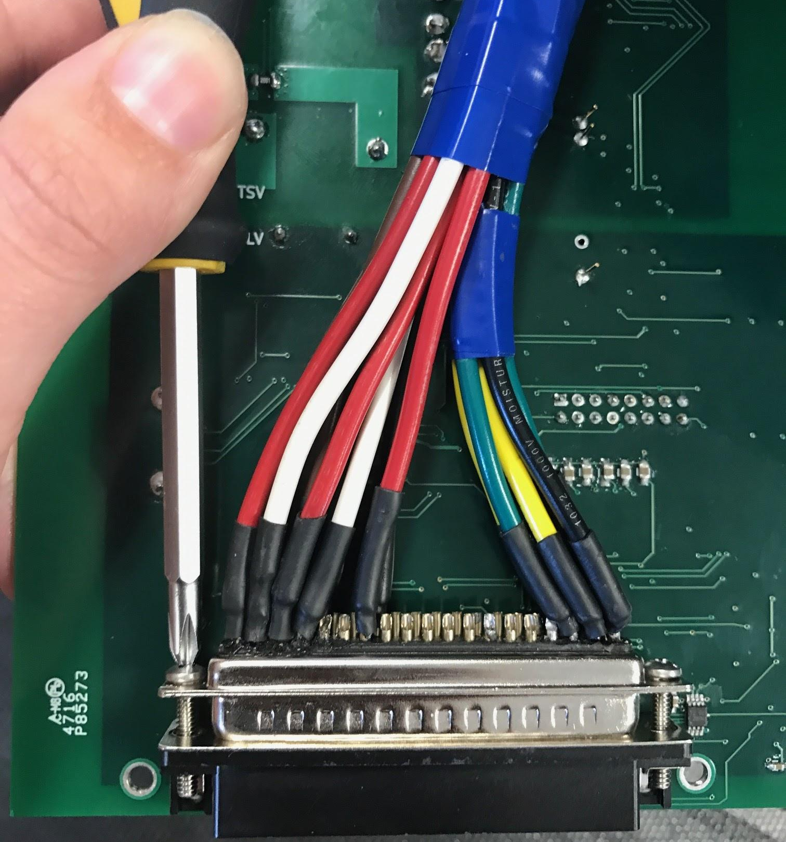
Figure 2. Installed 37 Pin connector using the two 4-40 x 5/8 Button Head Socket Cap Screw.

Step Two: Install Charge, LCO, AMS Connectors
Figure 3. Installed Charge, LCO, and AMS connectors. **Note (as of 04/10/2017) that the green and white wires are Charge in packs 2, 3, and 4 while LCO is the red and black. In pack 1, this is backwards. LCO is green and white while charge is red and black**

Step Three: Install Pack Current Sensor Connector
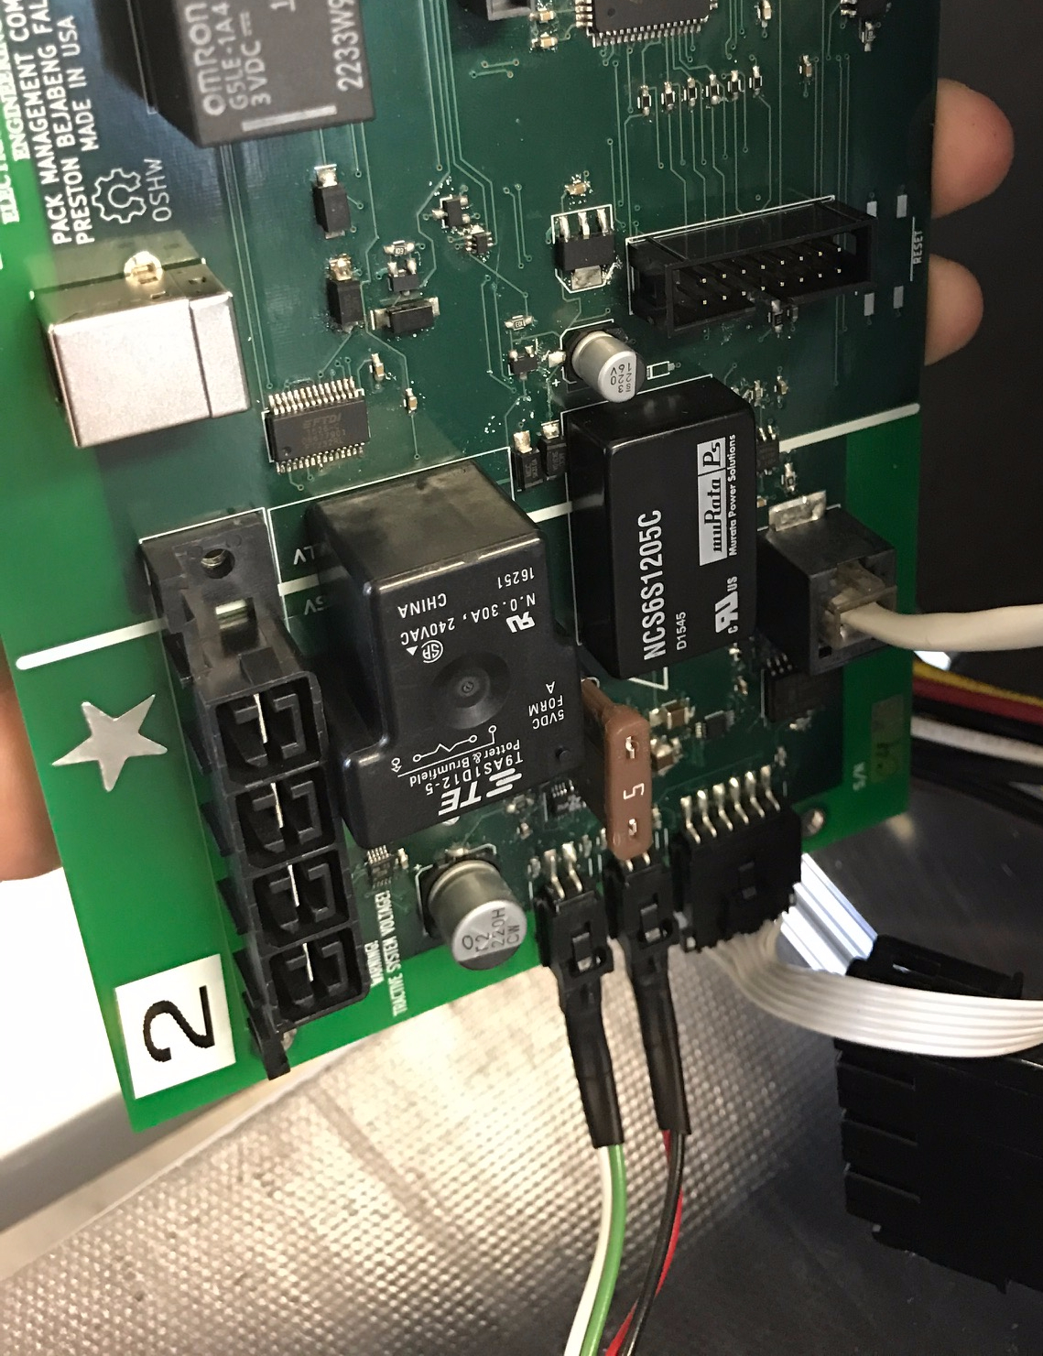
Figure 4. Installed Pack Current Sensor

Step Four: Install Control Panel Connector
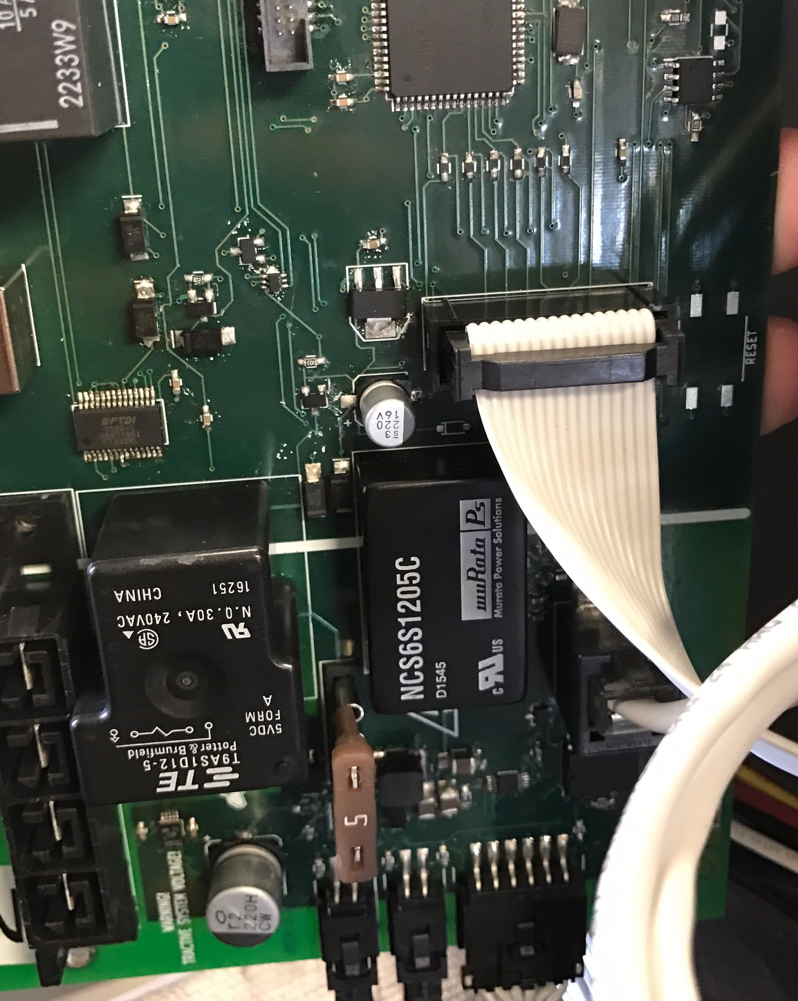
Figure 5. Installed Control Panel Connector

Step Five: Install PacMAN
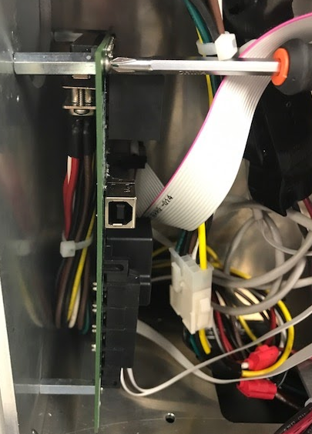
Figure 6. Install PacMAN into the Pack using the four 4-40 x 1/4 Button Head Socket Cap Screw screws and the Phillips Head screwdriver. The screws are to be screwed into the 4 standoffs mounted on inside side panel beneath the LCD.

Step Six: Power PacMAN
Figure 7. Installed Power Connector. LCD should turn on, AMS boards should ACK the PacMAN, Power LED should be on on the PacMAN, Heartbeat LED should be blinking. You have now successfully installed a PacMAN board into a pack.

