Lafayette College | Electrical and Computer Engineering

Systems Interconnect User Manual
ECE 492 Spring 2017

Assembled by Larisa Chiesa and Jeremy Port

Video User Manuals
For instructions on assembling the following cables, please visit our website to see the videos.
<http://sites.lafayette.edu/ece492-sp17/subsystems/interconnect-cabling-icd/>
AMS Ribbon Cable - see video
Crimping Connections - see video
DT06 Series Connectors - see video
ITT Cannon PowerLock Source and Drain
These connectors are used for the TSV battery packs with a 2/0 welding wire.

Step 1:
Unscrew PowerLock connector revealing the interior metal. Place bottom part on the wire you are going to be attaching the connector to.

Step 2:
Strip wire about half an inch, you should be able to line it up with reduction ring (the metal cylinder you put over the copper)

Step 3:
Insert exposed copper into reduction ring, put that in the metal connector in the PowerLock housing

Step 4:
Use Allen wrench to crimp metal interior to wire, there are two screws to tighten

Step 5:
Once the wire is secured to metal place, place housing over metal. Line up the holes on the side so you can see through. Hammer plastic pin through in order to align the metal and plastic

Step 6:
Screw bottom of housing to the top(this creates strain relief)
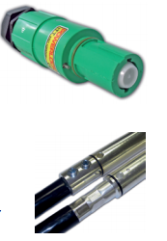
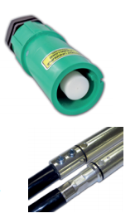

Shielded Battery Cable Crimp Connections
The purpose of the shielded battery cable is to prevent EMF during car operation.

Step 1:
Strip wire down to bare copper the length of what you are crimping

Step 2:
Strip another ½ inch to 1 inch to the inner insulation so the connect will not touch the shield

Step 3:
Expose the shield where specified for design

Step 4:
Add heat shrink to cable as needed (some for terminal and some for frayed part of shield

Step 5:
Place terminal in giant hedge trimmer sized crimps and press hard together

Step 6:
Heat the heat shrink

