Charging View
This is a sample of what the pack charging cycles will show. It can be seen in the image that packs 1 and 2 are connected in this “demo” and 3 and 4 are disconnected.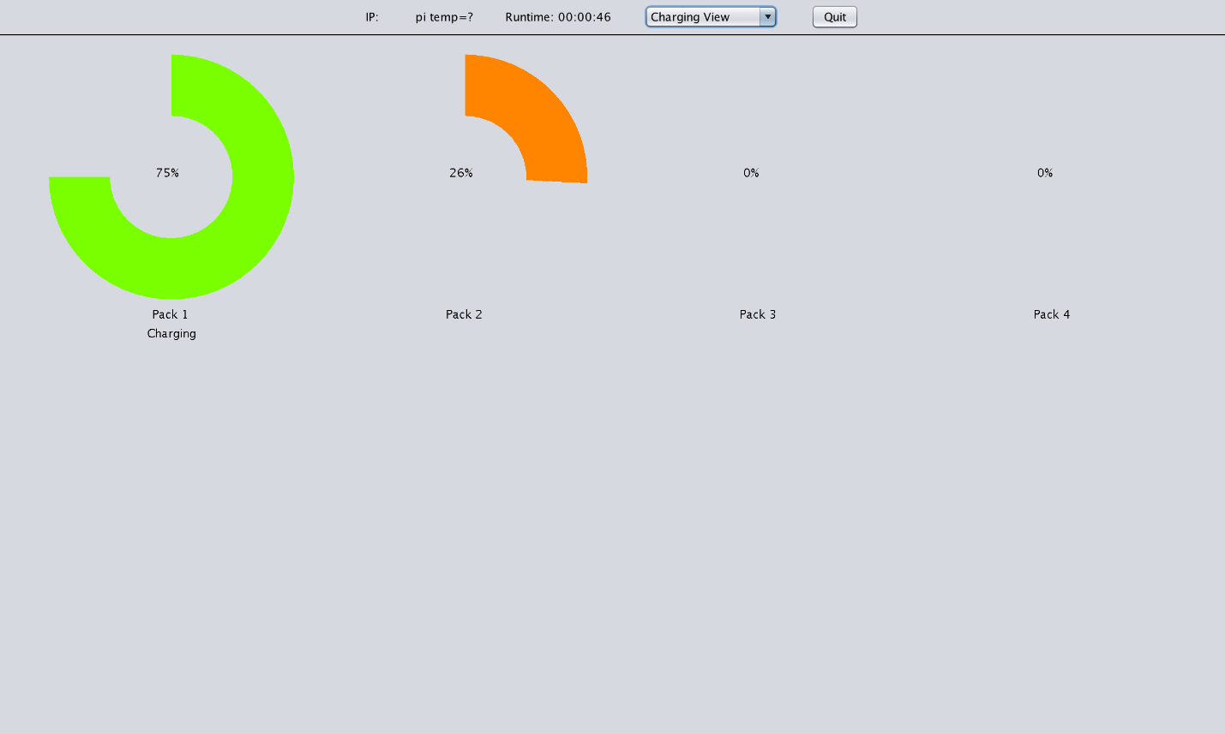

Configuration View
This is where a user will go to edit the backend DB without touching the code or needing to know any SQL. All changes can be made through this page.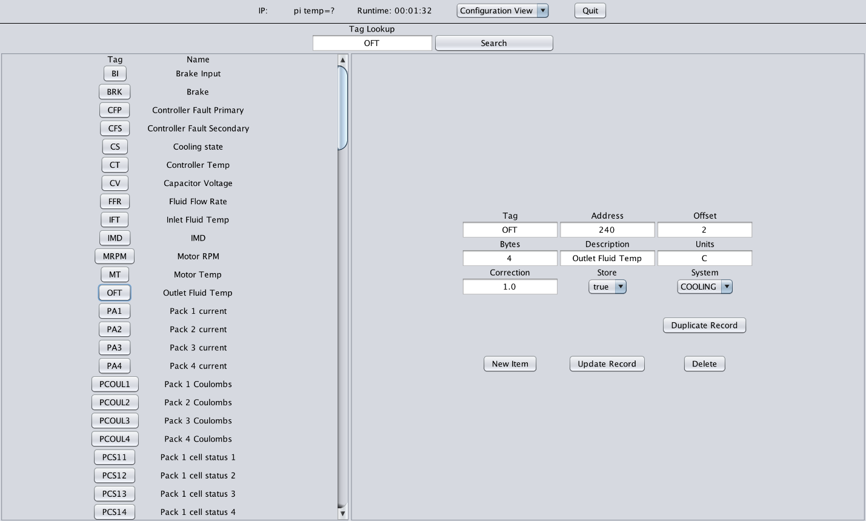

Drive View
This is what the cockpit will look like, the dials are not labeled as they are designed to be customized by the user.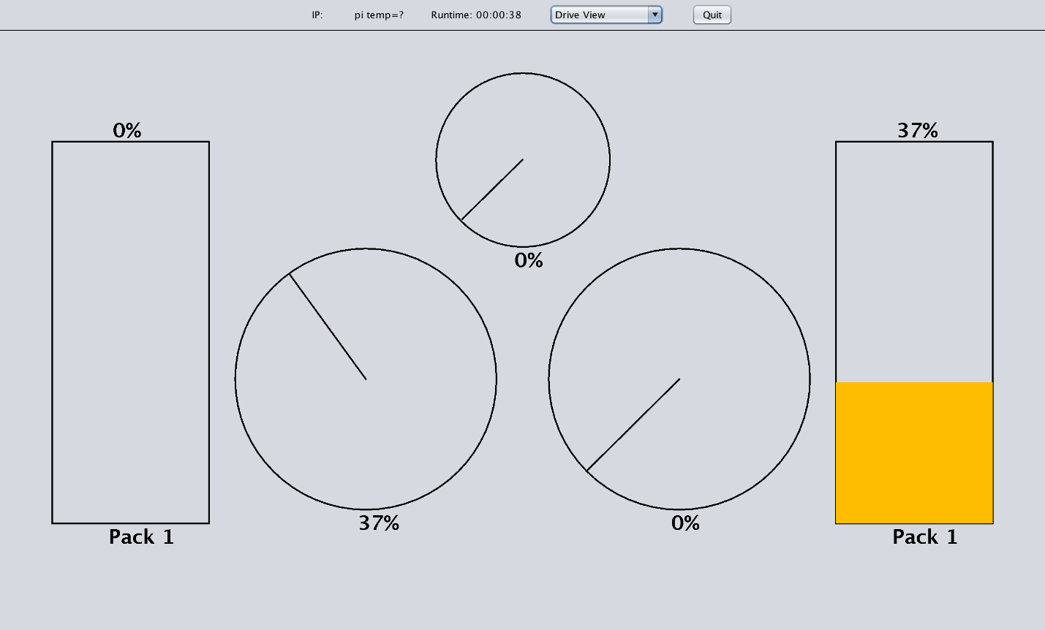

Equation View
This view allows users to enter in custom equations which will be evaluated from Left to Right NOT with PEMDAS. Equations can consist of tags and numbers and support the basic math functions of + - * /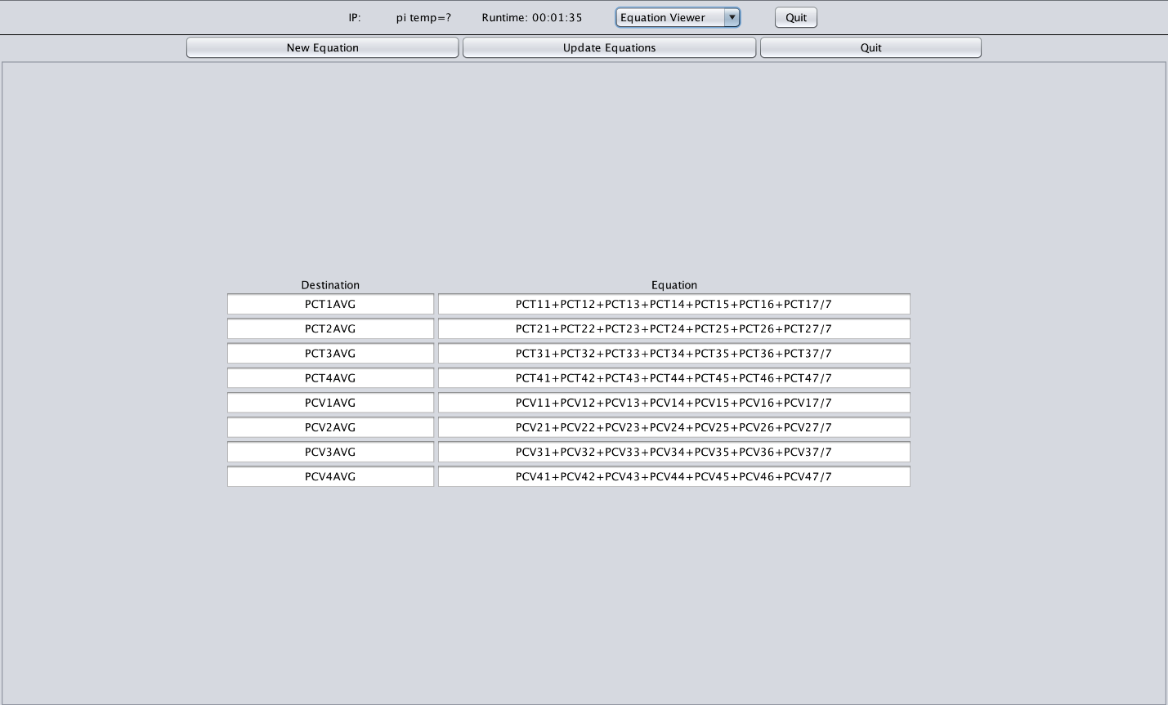

Maintenance View
This is the single column view for the Maintenance View. The cockpit has a single column view while the desktop application has two.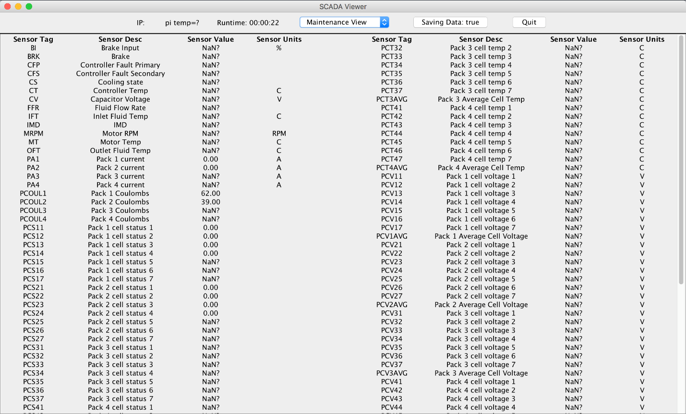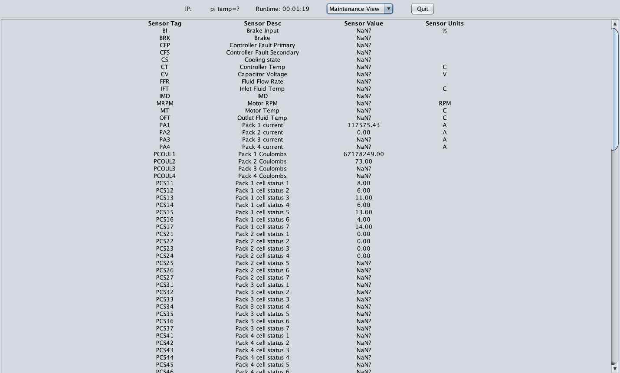

Query View
The Query view is where a user may go and get data collected by the SCADA system without any need for knowledge of the database.

