Lafayette College | Electrical and Computer Engineering

Grounded Low Voltage (GLV)
Interconnectivity Document
ECE 492 2017

Contents
Overview 3
GLV ICD Overview 4
GLV BoB Pinouts 7

Overview
The purpose of this document is to provide wiring and interconnect information about the Grounded Low Voltage box. This document specifically regards the interconnect information for the components within the GLV box. A separate ICD can be found for how the GLV box connects with its external components. All of the images included below are provided in .pdf and original form in the zip folder located here:
For information about GLV and these subsystems, see the User Manual and Maintanence Manual, both of which can be accessed here: http://sites.lafayette.edu/ece492-sp17/subsystems/glv/

GLV ICD Overview
The image below shows a full wiring diagram of all the components within the GLV box. Below is also a corresponding wire lists, listing wire number, A/B connections and voltage for each of the wires. A higher resolution image of this photo can be found at: https://sites.lafayette.edu/ece492-sp17/files/2017/01/GLV_Board_wirelist.pdf
A copy of the wire list can be found at: https://sites.lafayette.edu/ece492-sp17/files/2017/01/GLV_BOX_wirelist.pdf

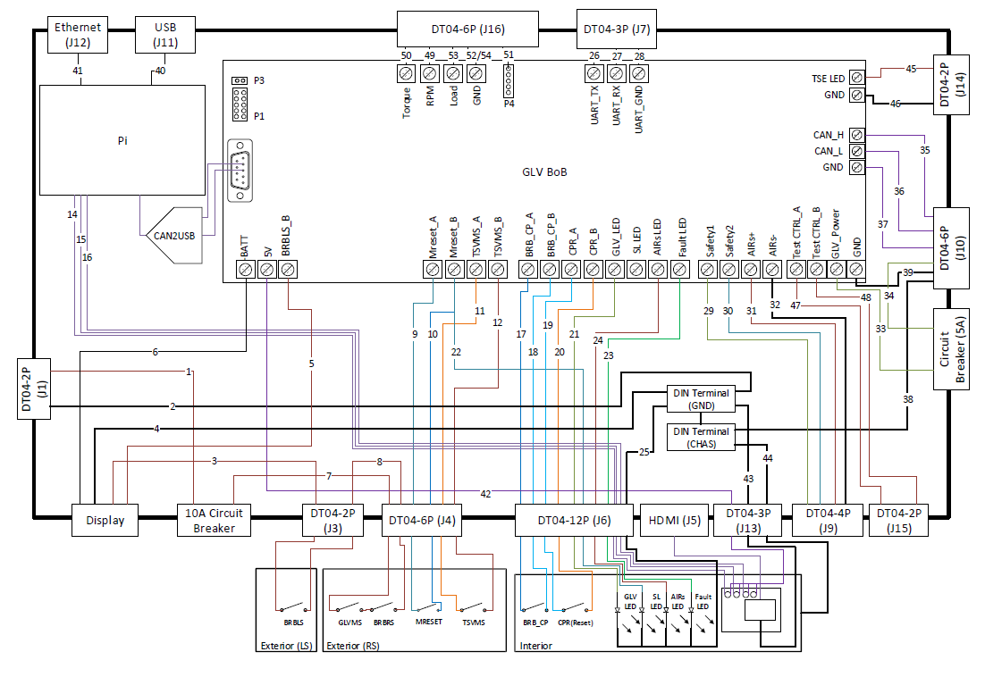
Figure 1: GLV Box Internal Connections

Wire Number | Conn A | Conn B | Voltage
1 | J1-1 | 15A Circuit Breaker A | 24V
2 | J1-2 | DIN Terminal (GND) | GND
3 | Display (DCin +) | J3-1 | 24V
4 | Display (DCin -) | DIN Terminal (GND) | GND
5 | Display (Load +) | GLV BoB (BRBLS_B) | 24V
6 | Display (Load -) | GLV BoB (-BATT) | GND
7 | 15A Circuit Breaker B | J4-1 | 24V
8 | J3-2 | J4-2 | 24V
9 | J4-3 | GLV BoB (Mreset_A) | 24V
10 | J4-4 | GLV BoB (Mreset_B) | 24V
11 | J4-5 | GLV BoB (TSVMS_A) | 24V
12 | J4-6 | GLV BoB (TSVMS_B) | 24V
13 | J5 (HDMI) | Pi HDMI | (HDMI)
14 | J6-1 | Pi I/O | 5V
15 | J6-2 | Pi I/O | 5V
16 | J6-3 | Pi I/O | 5V
17 | J6-4 | GLV BoB (BRB_CP_A) | 24V
18 | J6-5 | GLV BoB (BRB_CP_B) | 24V
19 | J6-6 | GLV BoB (CPR_A) | 24V
20 | J6-7 | GLV BoB (CPR_B) | 24V
21 | J6-8 | GLV BoB (GLV_LED) | 24V
22 | J6-9 | GLV BoB (Mreset_A) | 24V
23 | J6-10 | GLV BoB (Fault_LED) | 5V
24 | J6-11 | GLV BoB (AIRs_LED) | 24V
25 | J6-12 | DIN Terminal (GND) | GND
26 | J7-1 | GLV BoB (UART_TX) | 5V (UART)
27 | J7-2 | GLV BoB (UART_RX) | 5V (UART)
28 | J7-3 | GLV BoB (UART_GND) | GND
29 | J9-1 | GLV BoB (Safety1) | 24V
30 | J9-2 | GLV BoB (Safety2) | 24V
31 | J9-3 | GLV BoB (AIRS+) | 24V
32 | J9-4 | GLV BoB (AIRS-) | GND
33 | 8A Circuit Breaker A | GLV_BoB (GLV_Power) | 24V
34 | 8A Circuit Breaker B | J10-5 | 24V
35 | J10-1 | GLV_BoB (CAN_H) | CAN_H
36 | J10-2 | GLV_BoB (CAN_L) | CAN_L
37 | J10-3 | GLV_BoB (GND) | GND
38 | J10-4 | DIN Terminal (CHAS) | GND
39 | J10-6 | DINTerminal (GND) | GND
40 | J11 (USB) | Pi USB | (USB)
41 | J12 (Ethernet) | Pi Ethernet | (Ethernet)
42 | J13-1 | GLV_BoB (+5V) | 5V
43 | J13-2 | GLV_BoB (GND) | GND
44 | J13-3 | GLV_BoB (CHAS) | GND
45 | J14-1 | GLV_BoB (TSE_LED) | 24V
46 | J14-2 | GLV_BoB (GND) | GND
47 | J15-1 | GLV_BoB (TestCTRL_A) | Dyno Room supply cntl
48 | J15-2 | GLV_BoB (TestCTRL_B) | Dyno Room supply cntl
49 | J16-1 | GLV_BoB (RPM) | 5V
50 | J16-2 | GLV_BoB (Torque) | 5V
51 | J16-3 | GLV_BoB (P4-1) | 5V
52 | J16-4 | GLV_BoB (GND) | GND
53 | J16-5 | GLV_BoB (Load) | 5V
54 | J16-6 | GLV_BoB (GND) | GND
55 | GLV_BoB (P1) | Pi Pins | 5V
56 | GLV_BoB (P3) | Pi Pins | 5V

GLV BoB Pinouts
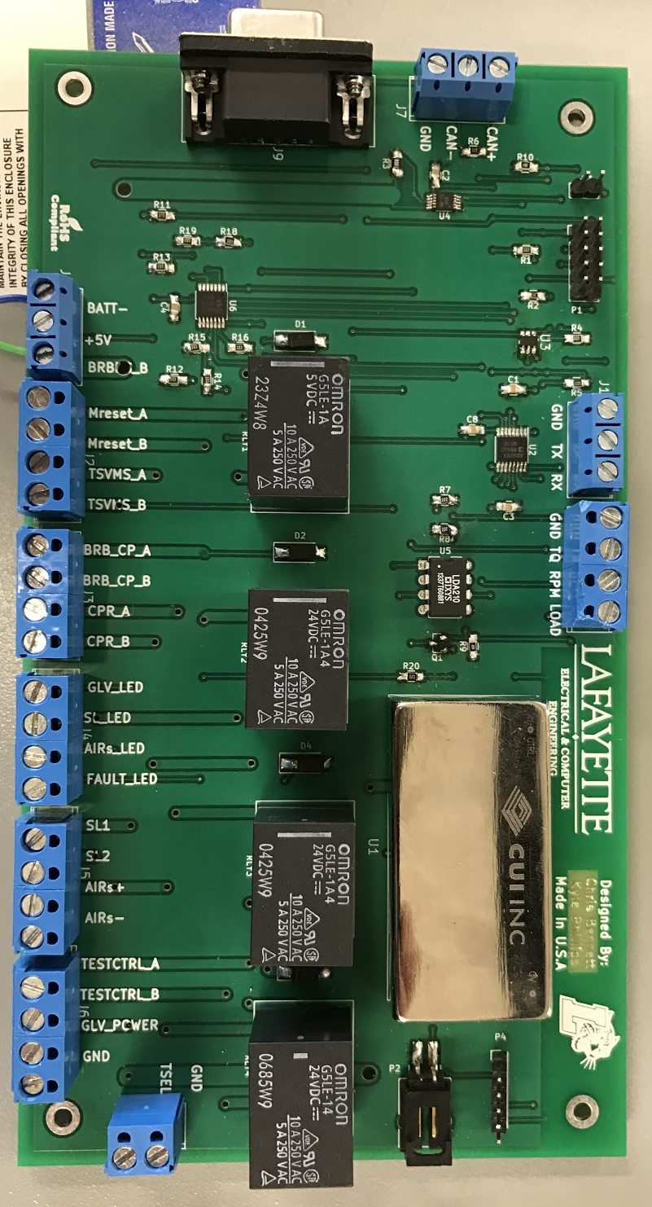
Figure 2: GLV BoB
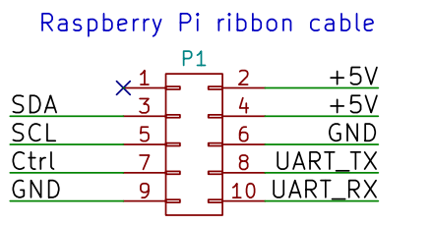
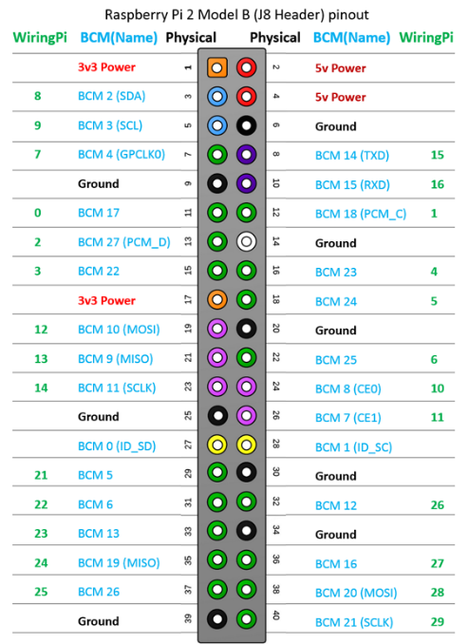
Almost all the connections on the GLV BoB are made via screw terminals. Ideally you should use stranded wire for these connections as they are more secure connections. The only different types of connections on this board is the 9-pin usb connector used for the CAN2USB line and the header pins which connect to the PI. The 10pin header connection P1 can connect directly to the top 10 pins of the Pi via a 10 pin ribbon cable. The Ctrl signal is a GPIO pin that can be used by the Pi to open or close the VSCADA relay.
Figure 3: Pi Pin connections

Figure 4: Pi Pin Connections

In addition to these connections, there is also the 2-pin header, P3, and the 5 pin header, P4. P3 provides two logic high or logic low (5V) signals to GPIO (General Purpose Input Output) pins on the Pi in order to deliver the status of the safety loop. The P4 header provides additional input/output ports for the ADC/DAC on board the GLV BoB. However, Pin 1 on P4 is specifically an output.

