May 4, 2017

Abstract
This document describes maintenance for the GLV system.
Grounded Low Voltage (GLV) Maintenance Manual

Contents
Maintenance 3
Charging the GLV Battery 3
Calibration 3
Principal of Operation 3
Safety Loop 1 3
Safety Loop 2 4
Car Operation – Starting GLV 4
Car Operation – Operator Cutting Power 4
GLV PCB Operation 4
Block Diagrams 5
GLV Systems Block Diagram 5
GLV BoB Block Diagram 6
Conceptual Diagrams 7
Safety Loop Schematic 7
Safety Loop Monitoring Diagram 7
Wiring Diagram 8
GLV Wiring Diagram 8
GLV Wire List 8
PCB Schematic (L17_GLV_07) 10
GLV PCB Schematic 10
GLV PCB Layout 11
PCB BOM 12
Mechanical Drawings 13
GLV Dyno Panel – Car Exterior (GLV_L17_02) 13
GLV Dyno Panel – Car Interior (GLV_L17_03) 13
GLV Enclosure Base Plate (GLV_L17_04) 14
GLV Enclosure Panels (GLV_L17_05/06) 15
GLV Enclosure (GLV_L17_08) 16
Mechanical BOM 17
QA Testing 20
Safety Loop Q/A Testing 20
GLV PCB Q/A Testing – Continuity Tests 22
GLV PCB Q/A Testing – Power on Tests 25
GLV PCB Q/A Testing – Relay Tests 26
GLV PCB Q/A Testing – LED and Optoisolator Test 27
Note 1: There is no Software is involed in the GLV System
Note 2: GLV Gerber files are attached.
Note 3: Mechanical Parts and Drawings are attached.

Maintenance
Being that the GLV system is implemented entirely in hardware, maintenance of the system generally involves ensuring the wiring is correct throughout the system (see GLV Wire List). It is also important to ensure that the chips on the GLV PCB are functioning properly (see GLV PCB Q/A Testing Procedures). The mechanical components of the GLV system do not require regular maintenance.

Charging the GLV Battery
The GLV Battery must be charged for proper operation of the GLV system. The GLV battery can be charged using a PST-G100-24F8 charger. This charger charges the 24V battery at 1.5A, and it includes a plug and forget algorithm which allows it to be plugged in without the possibility of overcharging the battery. The charger has lights which indicate when the battery has finished charging.

Calibration
The chips on the GLV PCB are calibrated using specific resistors and capacitors. Resistors are clearly labeled in the PCB Schematic.
A 0.01Ω resistor (R3) is used for current sensing. When testing on board, this resistor was be measured to be 0.02Ω, so when calibrating the ina226 chip, specify a shunt resistance of 0.02Ω. Two 2.2KΩ resistors (R7 and R8) used for current limiting into the opto-isolator. There is a 120Ω terminating resistor (R6) between the positive and negative CAN lines. Two 20kΩ pull-up resistors (R4 and R5) are used as pull-up resistors for I2C. Current limiting resistors are sized at 1kΩ (R9 and R10), with one 200Ω limiting resistor (R20). All resistors used with the buffering op amps are sized at 10kΩ, and all caps on the board are .1uF decoupling caps.

Principal of Operation
The GLV system provides 24V DC to power all low voltage electrical systems as well as the five AIRs on the four TSV battery packs. The GLV system includes a safety loop was designed accordance with the Formula Hybrid Rules. The safety loop was I/O integrated in the dyno room on two rack mount panels. The safety loop is implemented on a PCB which interfaces with the safety loop I/O and provides GLV battery data to VSCDA. The PCB is housed on an aluminum place in the mechanical enclosure along with the VSCADA Raspberry Pi, and mechanical connector panels were mounted on the GLV enclosure to hold connectors extending wires to other electrical systems.

Safety Loop 1
The safety loop is composed of two loops. For GLV power to be provided to the car subsystems, safety l must be closed. This loop is composed of the circuit breakers, GLV master switch, left side E-stop, and right side E-stop. This is all accessible from the exterior of the car (or on the exterior panel in the dyno room). When power is provided to the car subsystems, the GLV LED on the interior panel will turn on.

Safety Loop 2
After the first part of the safety loop is active, additional actions must be taken to energize the AIRs in the TSV battery packs. First, each of the GLV subsystems must be closing the safety loop. This includes a cooling controller fault switch, TSI IMD fault switch, and packman fault switches. If these are all closed, the SAFETY LED (on the interior panel) will turn on, but if there is a fault in any one of these, the FAULT LED (on the interior panel) will turn on instead. Following this, the Master Reset button (exterior panel) must be pressed, and the driver E-Stop (interior panel) must be closed. The Crash Protection (interior panel) must then be pressed, and the TSV Master Switch (exterior panel) must be switched on. If all of these actions are taken, the AIRs will become energized, and the AIRs LED will turn on. In the car, a Tractive System Energized Light (TSEL) will be wired in parallel with the AIRs LED and placed on top of the car.

Car Operation – Starting GLV
The GLV system requires an operator on the outside of the car to turn the master switches and press Master Reset before the car can start. The driver is required to press the crash protection reset after the Master Reset is pressed to start the car. This will energize the AIRs if there are no safety loop faults in the GLV powered subsystems. There is also an inertia switch in the cockpit which will open the safety loop if the car crashes. The driver can press the inertia switch and the Driver Reset to reenergize the AIRs after a crash, if desired.

Car Operation – Operator Cutting Power
This GLV safety loop allows an operator on the outside of the car to turn off the GLV system entirely or turn off power to the AIRs using the exterior E-stops and master switches. The Driver only has access to the driver E-stop so that the driver can turn off the AIRs if needed, but the driver cannot cut power to the entire GLV system or power down subsystems.

GLV PCB Operation
The GLV PCB encompasses most of the routing for the safety loop, and it provides data to the Raspberry Pi (VSCADA) through CAN, UART, and I2C. CAN is routed to VSCADA through the GLV PCB so that TSV, Cooling, and TSI can relay information to VSCADA. UART is also routed to VSCADA through the GLV PCB so that TSI can communicate motor data such as torque, rpm, and load. On board chips communicate through I2C to relay the voltage and current of the GLV battery as well as the temperature of the PCB to VSCADA. These each will be displayed on the VSCADA display. There is a 24V to 5V DC/DC converter used to power the Raspberry Pi as well. There is a 5V relay on the GLV PCB which allows VSCADA to trip the safety loop, and there are additional 24V relays allowing the GLV system to trip the safety loop.

Block Diagrams

GLV Systems Block Diagram

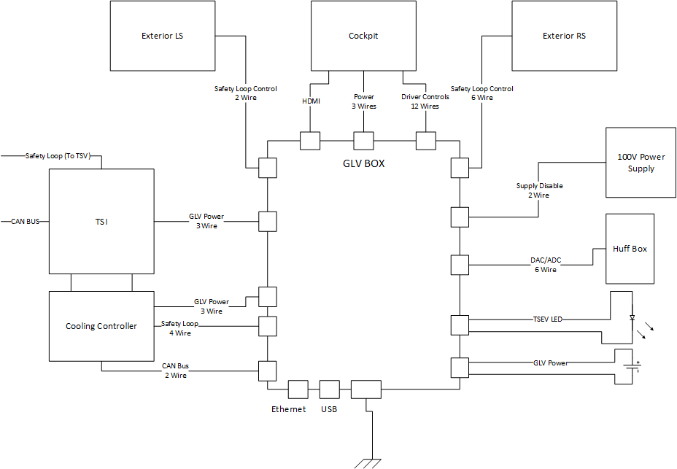

GLV BoB Block Diagram

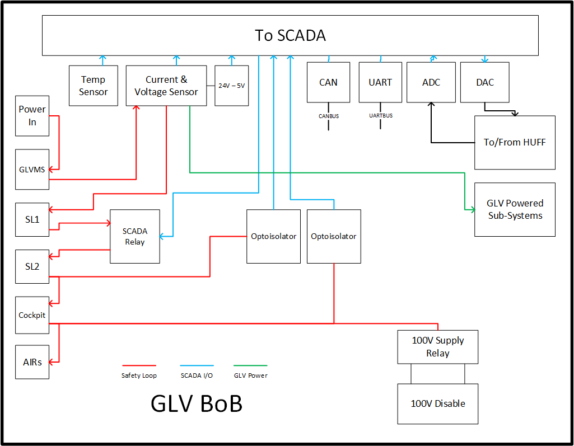

Conceptual Diagrams

Safety Loop Schematic
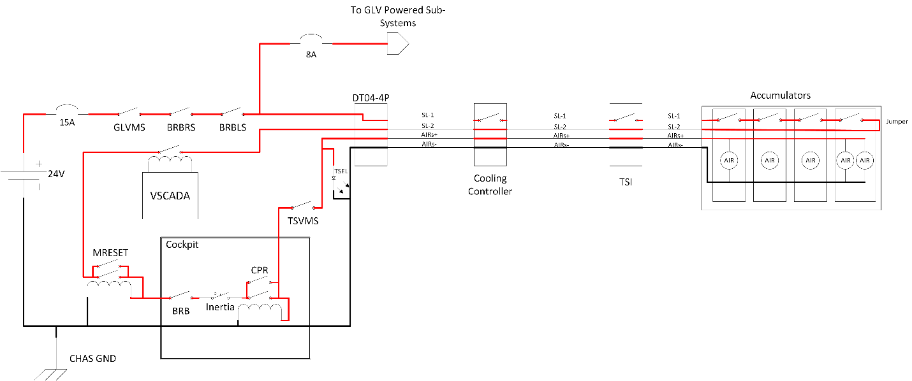

Safety Loop Monitoring Diagram

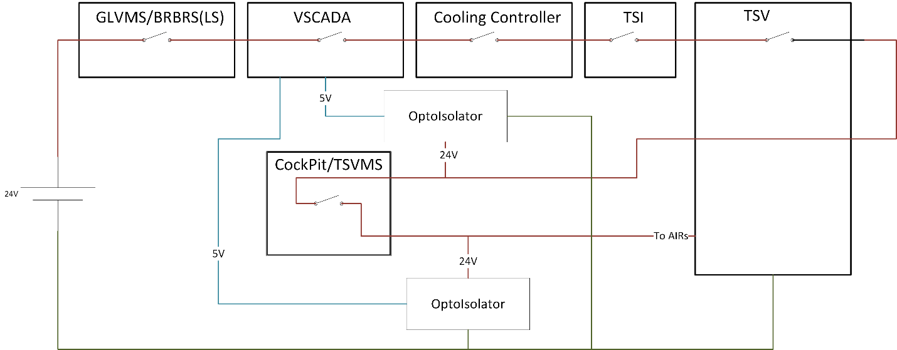

Wiring Diagram

GLV Wiring Diagram
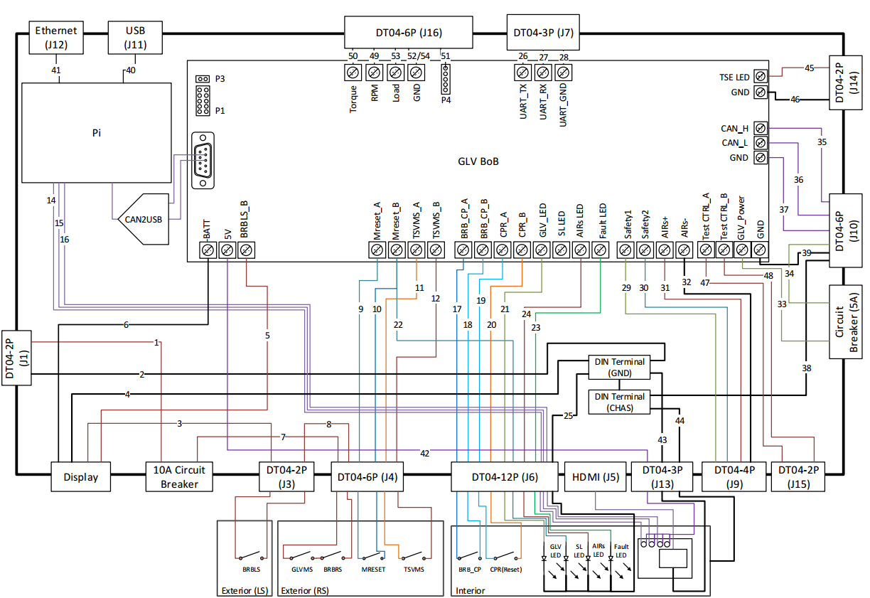

GLV Wire List
Wire Number | Conn A | Conn B
1 | Battery + | High Amp Circuit Breaker In
2 | Battery - | DIN Terminal (GND)
3 | High Amp Circuit Breaker | BoB (+24VBatt)
4 | CHAS GND | DIN Terminal (CHAS)
5 | BoB (-BATT) | DIN Terminal (GND)
6 | DIN Terminal (GND) | DIN Terminal (CHAS)
7 | BoB (GND) | GLV Power Out (GND)
8 | DIN Terminal (CHAS) | GLV Power Out (CHAS)
9 | DIN Terminal (GND) | Int Panel Power (GND)
10 | DIN Terminal (CHAS) | Int Panel Power (CHAS)
11 | BoB (GLVMS_A) | Ext Panel RS (GLVMS)
12 | Ext Panel RS (BRBRS) | BoB (BRBRS_B)
13 | BoB (BRBLS_A) | Ext Panel LS
14 | Ext Panel LS | BoB (BRBLS_B)
15 | BoB (Safety1) | SL OUT (SL1)
16 | SL OUT (SL2) | BoB (Safety2)
17 | BoB (Mreset_A) | Ext Panel RS (Mreset)
18 | Ext Panel RS (Mreset) | BoB (Mreset_B)
19 | BoB (BRB_CP_A) | Int Panel (BRB_CP)
20 | Int Panel (BRB_CP) | BoB (BRB_CP_B)
21 | BoB (CPR_A) | Int Panel (CPR)
22 | Int Panel (CPR) | BoB (CPR_B)
23 | BoB (TSVMS_A) | Ext Panel RS (TSVMS)
24 | Ext Panel RS (TSVMS) | BoB (TSVMS_B)
25 | BoB (AIRs+) | SL OUT (AIRs+)
26 | BoB (AIRs-) | SL OUT (AIRs-)
27 | BoB (Test_CTRL_A) | 100V Supply Disconnect A
28 | 100V Supply Disconnect A | BoB (Test_CTRL_B)
29 | BoB (GLV_Power) | Low Amp Circuit Breaker In
30 | Low Amp Circuit Breaker Out | GLV Power (24V)
31 | BoB (GLV_LED) | Int Panel (GLV_LED)
32 | BoB (SL_LED) | Int Panel (SL_LED)
33 | BoB (AIRs LED) | Int Panel (AIRs LED)
34 | BoB (Fault LED) | Int Panel (Fault LED)
35 | BoB (TSE LED) | TSE Light (+)
36 | BoB (GND) | TSE Light (-)
37 | BoB (CAN_H) | CAN (H)
38 | BoB (CAN_L) | CAN (L)
39 | BoB (GND) | CAN (GND)
40 | From HUFF (Torque) | BoB (Torque)
41 | From HUFF (RPM) | BoB (RPM)
42 | From HUFF (Load) | BoB (Load)
43 | BoB (UART_TX) | UART (TX)
44 | BoB (UART_RX) | UART (RX)
45 | BoB (GND) | UART (GND)
46 | Ethernet | Pi (Ethernet)
47 | USB | Pi (USB)
48 | BoB (+5V) | Int Panel Power (5V)
49 | Pi (I/O) | Int Panel (Buttons)
50 | Pi (I/O) | Int Panel (Buttons)
51 | Pi (I/O) | Int Panel (Buttons)
52 | Pi (I/O) | Int Panel (Buttons)
53 | Pi (HDMI) | Int Panel (HDMI
54 | BoB (10 Pin Header) | Pi pins
55 | BoB (2 Pin Header) | Pi pins
56 | BoB (GND) | Huff Box (GND)

PCB Schematic (L17_GLV_07)
GLV PCB Gerber Files are attached.

GLV PCB Schematic
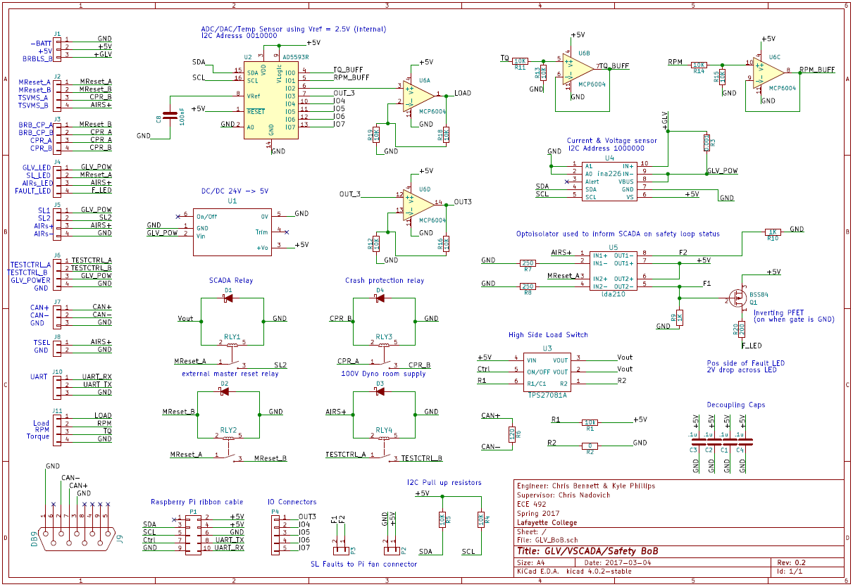

GLV PCB Layout
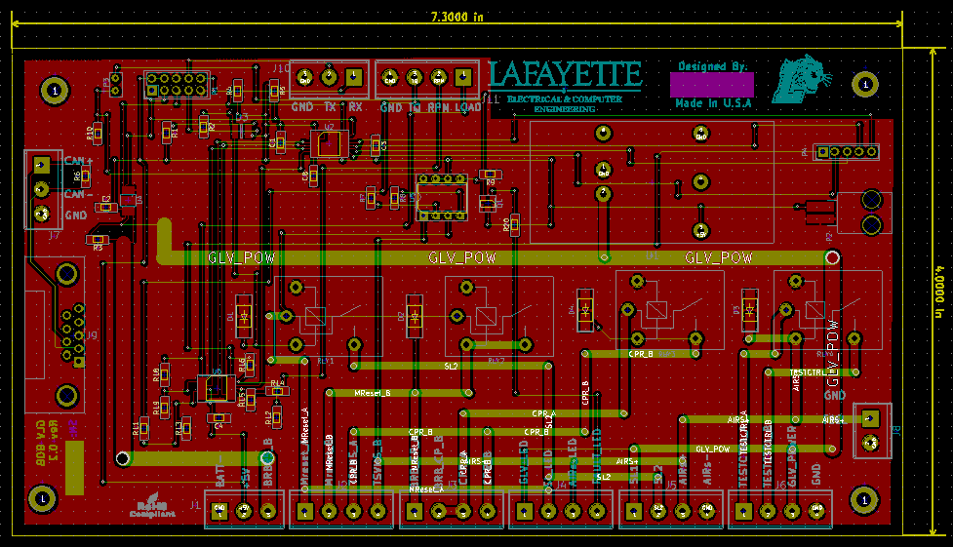

PCB BOM
Referance | Description | Manufacturer | Part Number | Supplier
U1 | 24V-5V DC/DC | CUI inc | PYB20-Q24-S5 | Digikey
U2 | ADC/DAC & Temp I2C | Analog Devices inc | AD5593RBRUZ | Digikey
U3 | IC Switch | TI | TPS27081ADDCR | Digikey
U4 | Current Monitor | TI | INA226AIDGSR | Digikey
U5 | Opto-Isolator | IXYS | LDA210 | Digikey
U6 | Quad Op-Amp | Microchip Tech | MCP6004-I/P | Digikey
Q1 | PFet | Fairchild | BSS84 | Digikey
RLY1 | Relay | Omron | G5LE-1A4 | Digikey
RLY2 | Relay | Omron | G5LE-1A5 | Digikey
RLY3 | Relay | Omron | G5LE-1A6 | Digikey
RLY4 | Relay | Omron | G5LE-1A7 | Digikey
C1 | .1u | AVX Corp | 08055C104KAT2A | Digikey
C2 | .1u | AVX Corp | 08055C104KAT2A | Digikey
C3 | .1u | AVX Corp | 08055C104KAT2A | Digikey
C4 | .1u | AVX Corp | 08055C104KAT2A | Digikey
C5 | 100n | AVX Corp | 08055C104MAT2A | Digikey
D1 | Diode Schottky | Micro Commercial | SK310A-LTP | Digikey
D2 | Diode Schottky | Micro Commercial | SK310A-LTP | Digikey
D3 | Diode Schottky | Micro Commercial | SK310A-LTP | Digikey
D4 | Diode Schottky | Micro Commercial | SK310A-LTP | Digikey
R1 | 10k | Panasonic Electronic Componants | ERJ-6ENF1002V | Digikey
R3 | 0.001 | Stackpole Electronics inc | CSNL1206FT1L00 | Digikey
R4 | 10k | Panasonic Electronic Componants | ERJ-6ENF1002V | Digikey
R5 | 10k | Panasonic Electronic Componants | ERJ-6ENF1002V | Digikey
R6 | 120 | Stackpole Electronics inc | RMCF0805JT120R | Digikey
R7 | 250 | Stackpole Electronics inc | RNCF0805TKY250R | Digikey
R8 | 250 | Stackpole Electronics inc | RNCF0805TKY250R | Digikey
R9 | 1k | Yageo | RC0805JR-071KL | Digikey
R10 | 1k | Yageo | RC0805JR-071KL | Digikey
R11 | 10k | Panasonic Electronic Componants |  | Digikey
R12 | 10k | Panasonic Electronic Componants |  | Digikey
R13 | 10k | Panasonic Electronic Componants | ERJ-6ENF1002V | Digikey
R14 | 10k | Panasonic Electronic Componants | ERJ-6ENF1002V | Digikey
R15 | 10k | Panasonic Electronic Componants | ERJ-6ENF1002V | Digikey
R16 | 10k | Panasonic Electronic Componants | ERJ-6ENF1002V | Digikey
R17 | 10k | Panasonic Electronic Componants | ERJ-6ENF1002V | Digikey
R18 | 10k | Panasonic Electronic Componants | ERJ-6ENF1002V | Digikey
R19 | 10k | Panasonic Electronic Componants | ERJ-6ENF1002V | Digikey
R20 | 200 | Stackpole Electronics inc | RMCF0805FT200R | Digikey

Mechanical Drawings
Below shows informational drawings including labels or basic dimensions for each of the GLV mechanical parts. Inventor files with all dimensions and screw hole taps attached.

GLV Dyno Panel – Car Exterior (GLV_L17_02)

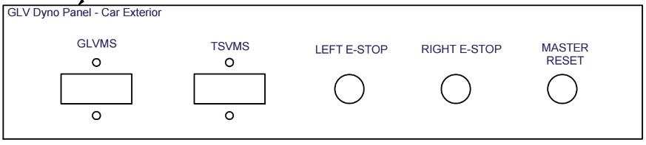

GLV Dyno Panel – Car Interior (GLV_L17_03)

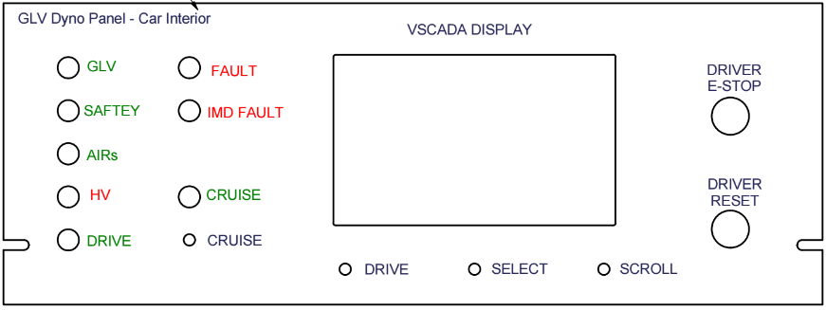

GLV Enclosure Base Plate (GLV_L17_04)
This is the mounting place for GLV components inside the GLV enclosure.
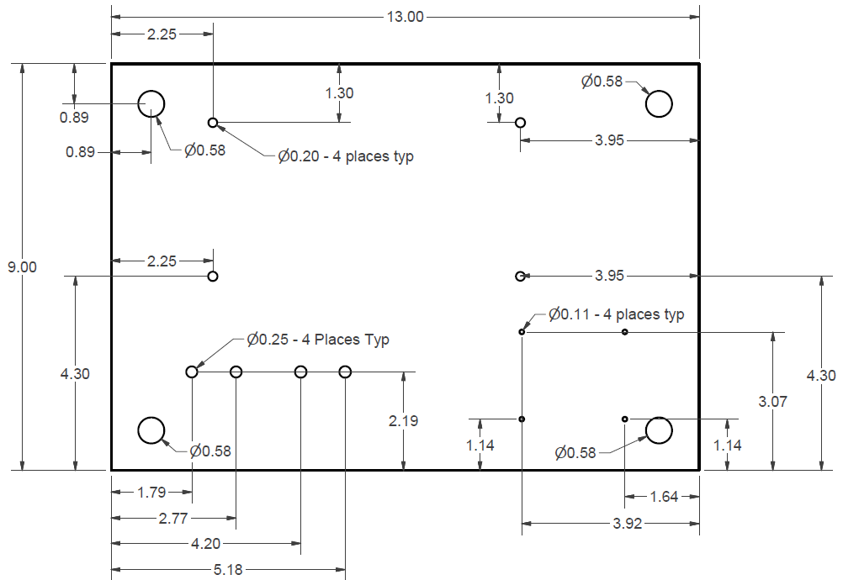

GLV Enclosure Panels (GLV_L17_05/06)

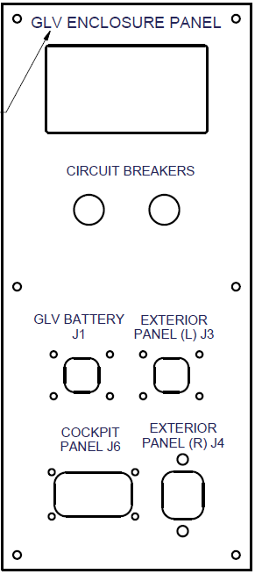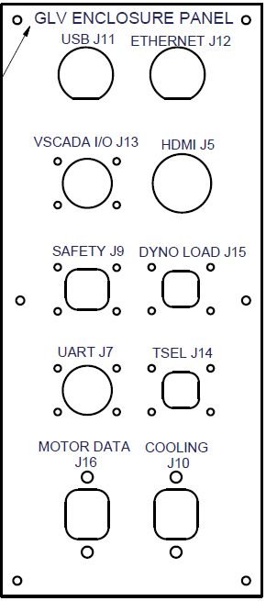

GLV Enclosure (GLV_L17_08)
Both 16” x 6” sides of the GLV enclosure which was purchased from McMaster-Carr were cut to mount the GLV Enclosure Panels.
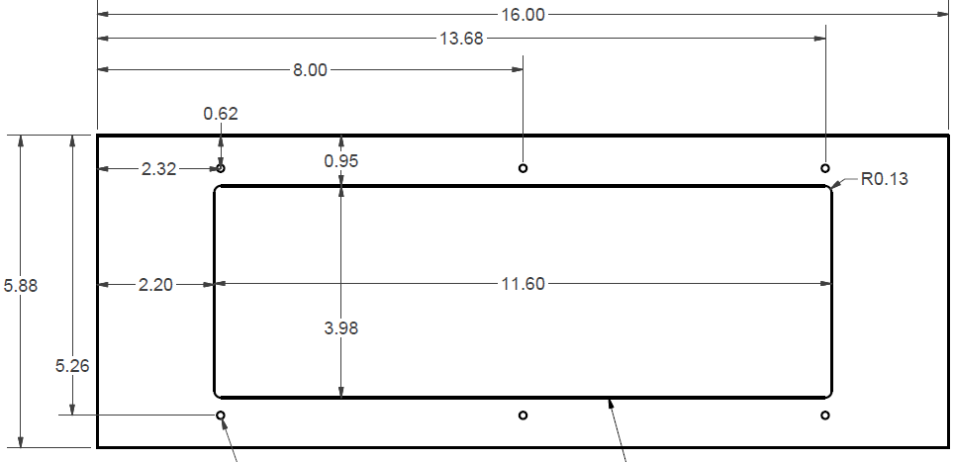

Mechanical BOM
GLV Mechanical Bill of Materials
Reference Designator | Value | Description | Manufacturer | Manufacturer P/N | Supplier | Supplier P/N | Unit Cost
Battery | 24V, 10AH | Lithium Iron Phosphate Rechargeable Lithium Battery | PowerStream | LFP256099 | PowerStream | LFP256099 | $295.00
Battery Charger | 24V | Battery charger UL approved | PowerStream | PST-G100-24F8 | PowerStream | PST-G100-24F8 | $50.00
Battery Enclosure |  | Battery Box | PowerStream | 69995K81 | PowerStream | 69995K81 | $13.13
BRBRS (Left side E-stop) |  | 22MMHW SeriesEmergency Stop Switches | IDEC | HW1E-LV402Q4R
BRBLS (Right side E-stop) |  | 22MMHW SeriesEmergency Stop Switches | IDEC | HW1E-LV402Q4R
BRB (Driver Accessible) |  | 22MMHW SeriesEmergency Stop Switches | IDEC | HW1E-LV402Q4R
Master Reset |  | Momentary Push Button (Non-Illuminated) | NEMA | 22PB-NO-X-PM-GN
CPR |  | Momentary Push Button (Non-Illuminated) | NEMA | 22PB-NO-X-PM-GN
GLVMS |  | Car Rotating Battery/Electrical Master Switch
TSVMS |  | Car Rotating Battery/Electrical Master Switch
Interia Switch | 24V | First Technology Inertia Switch | First Tech |  | EVWEST |  | 52.8
Cruise Control Switch (SCADA I/O 1) | 5V | SWITCH PUSH SPST-NO 0.15A 5V | Greyhill | 30-601 RED | Digikey | GH1368-ND | 3.04
Scroll Menu Button (SCADA I/O 2) | 5V | SWITCH PUSH SPST-NO 0.15A 5V | Greyhill | 30-601 BLK | Digikey | GH1367-ND | 3.04
Select Menu Item Buttom (SCADA I/O 3) | 5V | SWITCH PUSH SPST-NO 0.15A 5V | Greyhill | 30-601 BLK | Digikey | GH1367-ND | 3.04
Drive Button | 5V | SWITCH PUSH SPST-NO 0.15A 5V | Greyhill | 30-601 RED | Digikey | GH1368-ND | 3.04
GLV LED | 24V | Panel Mount Indicator (Green) | Dialight | 6823235142F | Digi-Key | 350-4053-ND | $8.94
Safety LED | 24V | Panel Mount Indicator (Green) | Dialight | 6823235142F | Digi-Key | 350-4053-ND | $8.94
AIRs LED | 24V | Panel Mount Indicator (Green) | Dialight | 6823235142F | Digi-Key | 350-4053-ND | $8.94
HV LED | 24V | Panel Mount Indicator (Red) | Dialight | 682-3132-141F | Digi-Key | 350-4050-ND | $6.97
Drive LED | 24V | Panel Mount Indicator (Green) | Dialight | 6823235142F | Digi-Key | 350-4053-ND | $8.94
Fault LED | 24V | Panel Mount Indicator (Red) | Dialight | 682-3132-141F | Digi-Key | 350-4050-ND | $6.97
IMD Fault LED | 24V | Panel Mount Indicator (Red) | Dialight | 682-3132-141F | Digi-Key | 350-4050-ND | $6.97
Cruise LED | 24V | Panel Mount Indicator (Green) | Dialight | 6823235142F | Digi-Key | 350-4053-ND | $8.94
TSEL | 24V | Tractive System Energized Light | Encell | STB-A35 | Amazon | STB-A35 | $30
GLV Battery Connector (J1) |  | DT04-2P | Deutsch | DT04-2P
Left Exterior Panel Connector (J3) |  | DT04-2P | Deutsch | DT04-2P
TSEL Connector (J14) |  | DT04-2P | Deutsch | DT04-2P
Dyno Load Connector (J15) |  | DT04-2P | Deutsch | DT04-2P
UART Connector (J7) |  | DT04-3P | Deutsch | DT04-3P
VSCADA I/O Connector (J13) |  | DT04-3P | Deutsch | DT04-3P
Safety Loop Connector (J9) |  | DT04-4P | Deutsch | DT04-4P
Right Exterior Panel Connector (J4) |  | DT04-6P | Deutsch | DT04-6P
Cooling Connector (J10) |  | DT04-6P | Deutsch | DT04-6P
Motor Data (J16) |  | DT04-6P | Deutsch | DT04-6P
Cockpit Panel Connector (J6) |  | DT04-12P | Deutsch | DT04-12P
USB Connector (J11) |  | USB Panel Mount Connector
Ethernet Connector (J12) |  | Ethernet Panel Mount Connector
HDMI Connector (J5) |  | HDMI Panel Mount Connector
Pi |  | Rasberry Pi
CB1 |  | Circuit breaker 15A | TE Connectivity | W28-XQ1A-15 | Digikey | PB192-ND
CB2 |  | Circuit breaker 8A | TE Connectivity | W28-XQ1A-8 | Digikey | PB189-ND
L17_GLV_01_1 |  | Basic Safety Loop Panel
L17_GLV_02_1 |  | External Panel (Dyno room only) | Hammond Manufacturing | PBPS19014BK2 | Mouser | 546-PBPS19014BK2
L17_GLV_03_1 |  | Internal Panel (Dyno room only) | Hammond Manufacturing | PBPS19014BK2 | Mouser | 546-PBPS19014BK2
L17_GLV_04_1 |  | Enclosure Plate
L17_GLV_05_1 |  | Left Side Enclosure Side Panel
L17_GLV_06_1 |  | Right Side Enclosure Side Panel
L17_GLV_07_1 |  | GLV PCB
L17_GLV_08_1 (GLV/SCADA Enclosure) |  | Weather-Resistant Enclosure 16" x 12" x 6" | McMaster-Carr | 7649K13 | McMaster-Carr | 7649K13 | $120.37
VSCADA Display |  | Raspberry Pi Display | Adafruit | 2718 | Adafruit | 2718 | $79.95
GLV Enclosure Multimeter Display |  | Digital Display Multimeter | Bayite | PZEN-31 | Amazon |  | $14.99
Terminal Blocks | 600V, 20A | 4 x Feed-Through Terminal Blocks | Amphenol PCD | ATB2
Din Rail |  | 35 mm DIN Mounting Rail | Square D | 9080MH379
Rack Mount Plate for GLV Enclosure |  | 14U Steel Rack Panel | Hammond Manufacturing | 546-PBPS19014BK2 | Mouser | 546-PBPS19014BK2
Screws for mounting GLV Enclsoure |  | 4 x Alloy Steel Socket Head Screws (10-24)
Screws for mounting L17_GLV_01/02/03 to Rack |  | 10 x Rack mount screws (10-32)
Screws for din rail on L17_GLV_04_1 |  | 2 x Press Fit Nuts for sheet metal (10-32) | McMaster-Carr | 95185A185 | McMaster-Carr | 95185A185 | $6.26
Screws for GLV board and Pi on L17_GLV_04_1 |  | 8 x Press Fit Nuts for sheet metal (2-56) | McMaster-Carr | 95185A105 | McMaster-Carr | 95185A105 | $9.40
Spacers for board and pi screws on L17_GLV_04_1 |  | 2 x Nylon unthreaded spacers | McMaster-Carr | 94639A703 | McMaster-Carr | 94639A703 | $7.51
Spacers for din rail screws on L17_GLV_04_1 |  | 8 x Nylon unthreaded spacers | McMaster-Carr | 94639A351 | McMaster-Carr | 94639A351 | $7.68
Screws for board and pi screws on L17_GLV_04_1 |  | Steel Phillips Screws 10-32 | McMaster-Carr | 90272A827 | McMaster-Carr | 90272A827 | $3.95
Screws for din rail screws on L17_GLV_04_1 |  | Steel Phillips Screws 2-56 | McMaster-Carr | 90272A079 | McMaster-Carr | 90272A079 | $3.28
Screws for DT04-06 on L17_GLV_05/06_1 |  | 6 x M5 by 0.8mm Hex Head Screws | McMaster-Carr | 91280A223 | McMaster-Carr | 91280A223 | $9.39
L17_GLV_05/06_1 Screws (minus DT04-06 screws) |  | 44 x 8-32 Steel Phillips Rounded Head Screws | McMaster-Carr | 90272A197 | McMaster-Carr | 90272A197 | $4.10

QA Testing

Safety Loop Q/A Testing
Description | Test Method | Detailed Results
- Energize Subsystems-24V Power Supplied to GLV Subsystems. | Supplied 24V of power to the GLV system using an external power supply. The 15A circuit breaker, GLVMS, BRBRS, BRBLS, and 8A circuit breaker were closed. The 24V output was measured on J10 (6 pins of GLV power and CanBus line) on the GLV enclosure. | 24V was measured on J10.  The GLV LED turned on.  PASS
- Energize AIRS- Power supplied to Accumulator AIRs. | Supplied 24V of power to the GLV system using an external power supply. The GLVMS, BRBLS, BRBRS, TSVMS, circuit breakers, and driver BRB were closed. The exterior master switch and driver reset were pressed. | The GLV LED turned on.  The SAFETY LED turned on.  The AIRs LED turned on.  The FAULT LED did not turn on.  The AIRs in the packs closed.  PASS
- Shutdown- All GLV power turns off when the GLVMS or exterior BRBs turn off. | Power was supplied to the AIRs following the procedure in test 2. The GLVMS was opened, while checking the output to the J10 pin on the GLV enclosure. This was repeated for both exterior BRBs. | All LEDs turned off.  0V was measured on J10.  GLV Subsystems deenergized.  The AIRs deenergized.  PASS
- Fault- GLV System stops supplying power to the AIRs in the following situations. | The AIRs were energized following the procedure described in test 2. The following faults will be tested. The Master Reset and Drive Reset were pressed at the end of each test to ensure these inputs do not reenergize the AIRs during a fault. | PASS
4a.) Subsystem Fault | Had a subsystem break the safety loop. This was tested by removing the final jumper on the TSV battery packs. | The GLV LED remained on.  The SAFETY LED turned off.  The AIRs LED turned off.  The FAULT LED turned on.  The AIRs deenergized.  PASS
4b.) Driver E-Stop Fault | The Driver E-Stop was pressed. | The GLV LED remained on.  The SAFETY LED remained on.  The AIRs LED turned off.  The FAULT LED remains off.  The AIRs deenergized.  PASS
4c.) Crash Fault | The Inertia switch was triggered. | The GLV LED remained on.  The SAFETY LED remained on.  The AIRs LED turned off.  The FAULT LED remains off.  The AIRs deenergized.  PASS
4d.) TSVMS Fault | The TSVMS was turned off. | The GLV LED remained on.  The SAFETY LED remained on.  The AIRs LED turned off.  The FAULT LED remains off.  The AIRs deenergized.  PASS
- Reenergize AIRs after fault. | The faults in test 4 should be resettable in the following ways so that the AIRs can be reenergized without cutting power to the GLV powered subsystems. | PASS
6a.) AIRs Reenergize after Subsystem Fault | Ran test 4a. Fixed the safety loop fault in the subsystem. This was done by plugging the safety loop jumper back into the TSV battery packs, closing the safety loop. Pressed the Master Reset and then the Crash Protection Reset. | The GLV LED remains on.  The SAFETY LED turned on.  The AIRs LED turned on.  The FAULT LED turned off.  The AIRs in the packs closed.  PASS
6b.) AIRS Reenergize after Driver E-Stop Fault | Ran test 4b. Closed the Driver E-Stop. Pressed the Master Reset and then the Crash Protection Reset. | The GLV LED remains on.  The SAFETY LED remained on.  The AIRs LED turned on.  The FAULT LED did not turn on.  The AIRs in the packs closed.  PASS
6c.) AIRS Reenergize after Crash Fault | Ran test 4c. Pressed the Inertia Switch. Pressed the Master Reset and then the Crash Protection Reset. | The GLV LED remains on.  The SAFETY LED remained on.  The AIRs LED turned on.  The FAULT LED did not turn on.  The AIRs in the packs closed.  PASS
6d.) AIRs Reenergize after TSVMS Fault | Ran test 4d. Reengaged TSVMS. Pressed the Master Reset and then the Crash Protection Reset. | The GLV LED remains on.  The SAFETY LED remained on.  The AIRs LED turned on.  The FAULT LED did not turn on.  The AIRs in the packs closed.  PASS
- Connectivity- The safety loop is wired as shown by the schematic in Appendix A. | The safety loop circuit was traced with an ohmmeter to ensure each connection occurred expected. | Each component was connected as expected.  PASS
- Unexpected Input- The reset buttons should not have any effect on the system if pressed at an unexpected time or in the wrong order. | The following unexpected inputs did not affect the system. | PASS
7a.) Master Reset or Driver Reset pressed after AIRs energized. | Followed procedure in test 2 to energize the AIRs. Pressed the Master Reset. Pressed the Driver Reset. | No changed occurred.  PASS
7b.) Driver Reset pressed before master reset when energizing AIRs after startup. | Followed procedure in test 1 to energize GLV powered subsystems. Ensured there were no subsystem safety loop faults as indicated by on SAFETY LED. Pressed Driver Reset. | The GLV LED remains on.  The SAFETY LED remained on.  The AIRs LED did not turn on.  The FAULT LED did not turn on.  The AIRs were not energized.  PASS

GLV PCB Q/A Testing – Continuity Tests
Continuity (tests to be done with no external connections or power supplied to board)
Ground Nets
1 | Connection between -BATT and AIRs-
 |  | Expected: | 0 Ohms
 |  | Observed: | 0 Ohms
2 | Connection between -BATT and TESTCTRL_GND
 |  | Expected: | 0 Ohms
 |  | Observed: | 0 Ohms
3 | Connection between -BATT and CAN_GND
 |  | Expected: | 0 Ohms
 |  | Observed: | 0 Ohms
4 | Connection between -BATT and TSEL_GND
 |  | Expected: | 0 Ohms
 |  | Observed: | 0 Ohms
5 | Connection between -BATT and UART_GND
 |  | Expected: | 0 Ohms
 |  | Observed: | 0 Ohms
6 | Connection between -BATT and ADC/DAC_GND
 |  | Expected: | 0 Ohms
 |  | Observed: | 0 Ohms
Safety Loop
1 | Connection between BRBLS_B and SL1
 |  | Expected: | 0 Ohms
 |  | Observed: | 0 Ohms
2 | Connection between BRBLS_B and GLV_LED
 |  | Expected: | 0 Ohms
 |  | Observed: | 0 Ohms
3 | Connection between BRBLS_B and GLV_POWER
 |  | Expected: | 0 Ohms
 |  | Observed: | 0 Ohms
4 | Connection between BRBLS_B and SL2
 |  | Expected: | MegaOhms/Open
 |  | Observed: | MegaOhms/Open
5 | Connection between BRBLS_B and AIRs+
 |  | Expected: | MegaOhms/Open
 |  | Observed: | MegaOhms/Open
6 | Connection between SL2 and Mreset_A
 |  | Expected: | MegaOhms/Open
 |  | Observed: | MegaOhms/Open
7 | Connection between Mreset_A and Mreset_B
 |  | Expected: | MegaOhms/Open
 |  | Observed: | MegaOhms/Open
8 | Connection between Mreset_B and BRB_CP_A
 |  | Expected: | 0 Ohms
 |  | Observed: | 0 Ohms
9 | Connection between BRB_CP_A and BRB_CP_B
 |  | Expected: | MegaOhms/Open
 |  | Observed: | MegaOhms/Open
10 | Connection between BRB_CP_B and CPR_A
 |  | Expected: | 0 Ohms
 |  | Observed: | 0 Ohms
11 | Connection between CPR_A and CPR_B
 |  | Expected: | MegaOhms/Open
 |  | Observed: | MegaOhms/Open
12 | Connection between CPR_B and TSVMS_A
 |  | Expected: | 0 Ohms
 |  | Observed: | 0 Ohms
13 | Connection between TSVMS_A and TSVMS_B
 |  | Expected: | MegaOhms/Open
 |  | Observed: | MegaOhms/Open
14 | Connection between TSVMS_B and AIRs+
 |  | Expected: | 0 Ohms
 |  | Observed: | 0 Ohms
15 | Connection between AIRs+ and AIRs_LED
 |  | Expected: | 0 Ohms
 |  | Observed: | 0 Ohms
16 | Connection between AIRs+ and TSEL
 |  | Expected: | 0 Ohms
 |  | Observed: | 0 Ohms
17 | Connection between TESTCTRL_A and TESTCTRL_B
 |  | Expected: | 0 Ohms
 |  | Observed: | 0 Ohms
VCI
1 | Connection between CAN+ and Pin7 of 9-USB
 |  | Expected: | 0 Ohms
 |  | Observed: | 0 Ohms
2 | Connection between CAN- and Pin2 of 9-USB
 |  | Expected: | 0 Ohms
 |  | Observed: | 0 Ohms
3 | Connection between CAN- and Pin7 of 9-USB
 |  | Expected: | MegaOhms/Open
 |  | Observed: | MegaOhms/Open
4 | Connection between BATT- and Pin1 of 9-USB
 |  | Expected: | 0 Ohms
 |  | Observed: | 0 Ohms
5 | Connection between BATT- and Pin3 of 9-USB
 |  | Expected: | 0 Ohms
 |  | Observed: | 0 Ohms
6 | Connection between BATT- and Pin7 of 9-USB
 |  | Expected: | MegaOhms/Open
 |  | Observed: | MegaOhms/Open
7 | Connection between UART_RX and Pin10 of 10-pin header
 |  | Expected: | 0 Ohms
 |  | Observed: | 0 Ohms
8 | Connection between UART_TX and Pin8 of 10-pin header
 |  | Expected: | 0 Ohms
 |  | Observed: | 0 Ohms
9 | Connection between UART_TX and Pin10 of 10-pin header
 |  | Expected: | MegaOhms/Open
 |  | Observed: | MegaOhms/Open
10 | Connection between BATT- and Pin9 of 10-pin header
 |  | Expected: | 0 Ohms
 |  | Observed: | 0 Ohms
11 | Connection between BATT- and Pin6 of 10-pin header
 |  | Expected: | 0 Ohms
 |  | Observed: | 0 Ohms
12 | Connection between BATT- and Pin8 of 10-pin header
 |  | Expected: | MegaOhms/Open
 |  | Observed: | MegaOhms/Open

GLV PCB Q/A Testing – Power on Tests
Below is a list of test for 24V supplied with no external connections.
1 | GLV_LED terminal voltage
 | Expected: | 24V
 | Observed: | 24V
2 | GLV_POWER terminal voltage
 | Expected: | 24V
 | Observed: | 24V
3 | SL1 terminal voltage
 | Expected: | 24V
 | Observed: | 24V
4 | +5V terminal voltage
 | Expected: | 5V
 | Observed: | 5V
5 | Pin 2 on 10 pin header voltage
 | Expected: | 5V
 | Observed: | 5V
6 | Pin 4 on 10 pin header voltage
 | Expected: | 5V
 | Observed: | 5V

GLV PCB Q/A Testing – Relay Tests
5V VSCADA Relay
1 | Connect Pin 7 to Pin 6 on 10 Pin Header
 |  | Connection between SL2 and MresetA
 |  | Expected | Mega Ohms (Open)
 |  | Observed | Mega Ohms (Open)
2 | Connect Pin 7 to Pin 2 on 10 Pin Header
 |  | Connection between SL2 and MresetA
 |  | Expected | 0 Ohms
 |  | Observed | 0 Ohms
Mreset Relay
1 | Normal MresetA and Mreset B (pre shorting)
 | Expected | Mega Ohms (Open)
 | Observed | Mega Ohms (Open)
2 | Short MresetA and Mreset B (check for latch)
 | Expected | 0 Ohms
 | Observed | 0 Ohms
CPR Relay
1 | Normal CPRA and CPR B (pre shorting)
 | Expected | Mega Ohms (Open)
 | Observed | Mega Ohms (Open)
1 | Short CPRA and CPR B terminals and then check for latch
 | Expected | 0 Ohms
 | Observed | 0 Ohms
TestCTRL Relay
1 | Make sure AIRs does not have 24V
 | Expected | 0 Ohms
 | Observed | 0 Ohms
2 | Complete Safety Loop to power AIRs (make sure AIRs terminal reads 24Vs)
 | Expected | Mega Ohms (Open)
 | Observed | Mega Ohms (Open)

GLV PCB Q/A Testing – LED and Optoisolator Test
Turn GLV Power ON and open SL1 and SL2, connect header Pin 7 to header Pin 6
1 | Check Voltage on SL LED
 | Expected: | 0V
 | Observed | 0V
2 | Check Voltage on Fault LED
 | Expected: | 5V
 | Observed | 5V
Turn GLV Power ON and short SL1 and SL2, connect header Pin 7 to header Pin 6
1 | Check Voltage on SL LED
 | Expected: | 0V
 | Observed | 0V
2 | Check Voltage on Fault LED
 | Expected: | 5V
 | Observed | 5V
3 | Check Voltage on F1
 | Expected: | 0V
 | Observed | 0V
4 | Check Voltage on F2
 | Expected: | 0V
 | Observed | 0V
Turn GLV Power ON and short SL1 and SL2, connect header Pin 7 to header Pin 2
1 | Check Voltage on SL LED
 | Expected: | 24V
 | Observed | 24V
2 | Check Voltage on Fault LED
 | Expected: | 0V
 | Observed | 0V
3 | Check Voltage on AIRs LED
 | Expected: | 0V
 | Observed: | 0V
4 | Check Voltage on F1
 | Expected: | 5V
 | Observed: | 5V
5 | Check Voltage on F2
 | Expected: | 0V
 | Observed: | 0V
Turn on AIRs Power by connecting relays
1 | Check Voltage on AIRs LED
 | Expected: | 24V
 | Observed | 24V
2 | Check Voltage on F2
 | Expected: | 5V
 | Observed: | 5V

