Lafayette College | Electrical and Computer Engineering

Motor Controller Cooling System (MCCS) Maintenance Manual
ECE 492 Spring 2017

Table of Contents
Overview 3
Safety 4
Electrical System Components Maintenance 4
Maintenance 5
System Connections 8
PANNEL 1: 10
SAFETY LOOP Panel (Left Side) – J1 10
SAFETY LOOP Panel (Middle) – J3 11
CAN and POWER Panel (Right Side) – J4 11
PANNEL 2: 11
Pump and Sensors (left side) – J6 11
Pump and Sensors (Middle) – J5 12
CAN and POWER Panel (Right Side) – J2 12
Troubleshooting 12

Overview
This Motor Controller Cooling System (MCCS will be used in the rest of this document) Maintenance Manual documents maintenance instructions for the MCCS system.

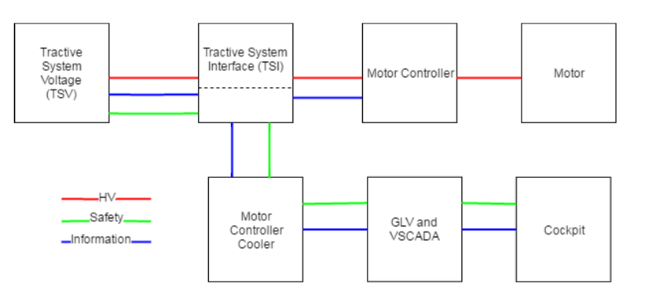
(Overall Simplified System Connection Diagram)

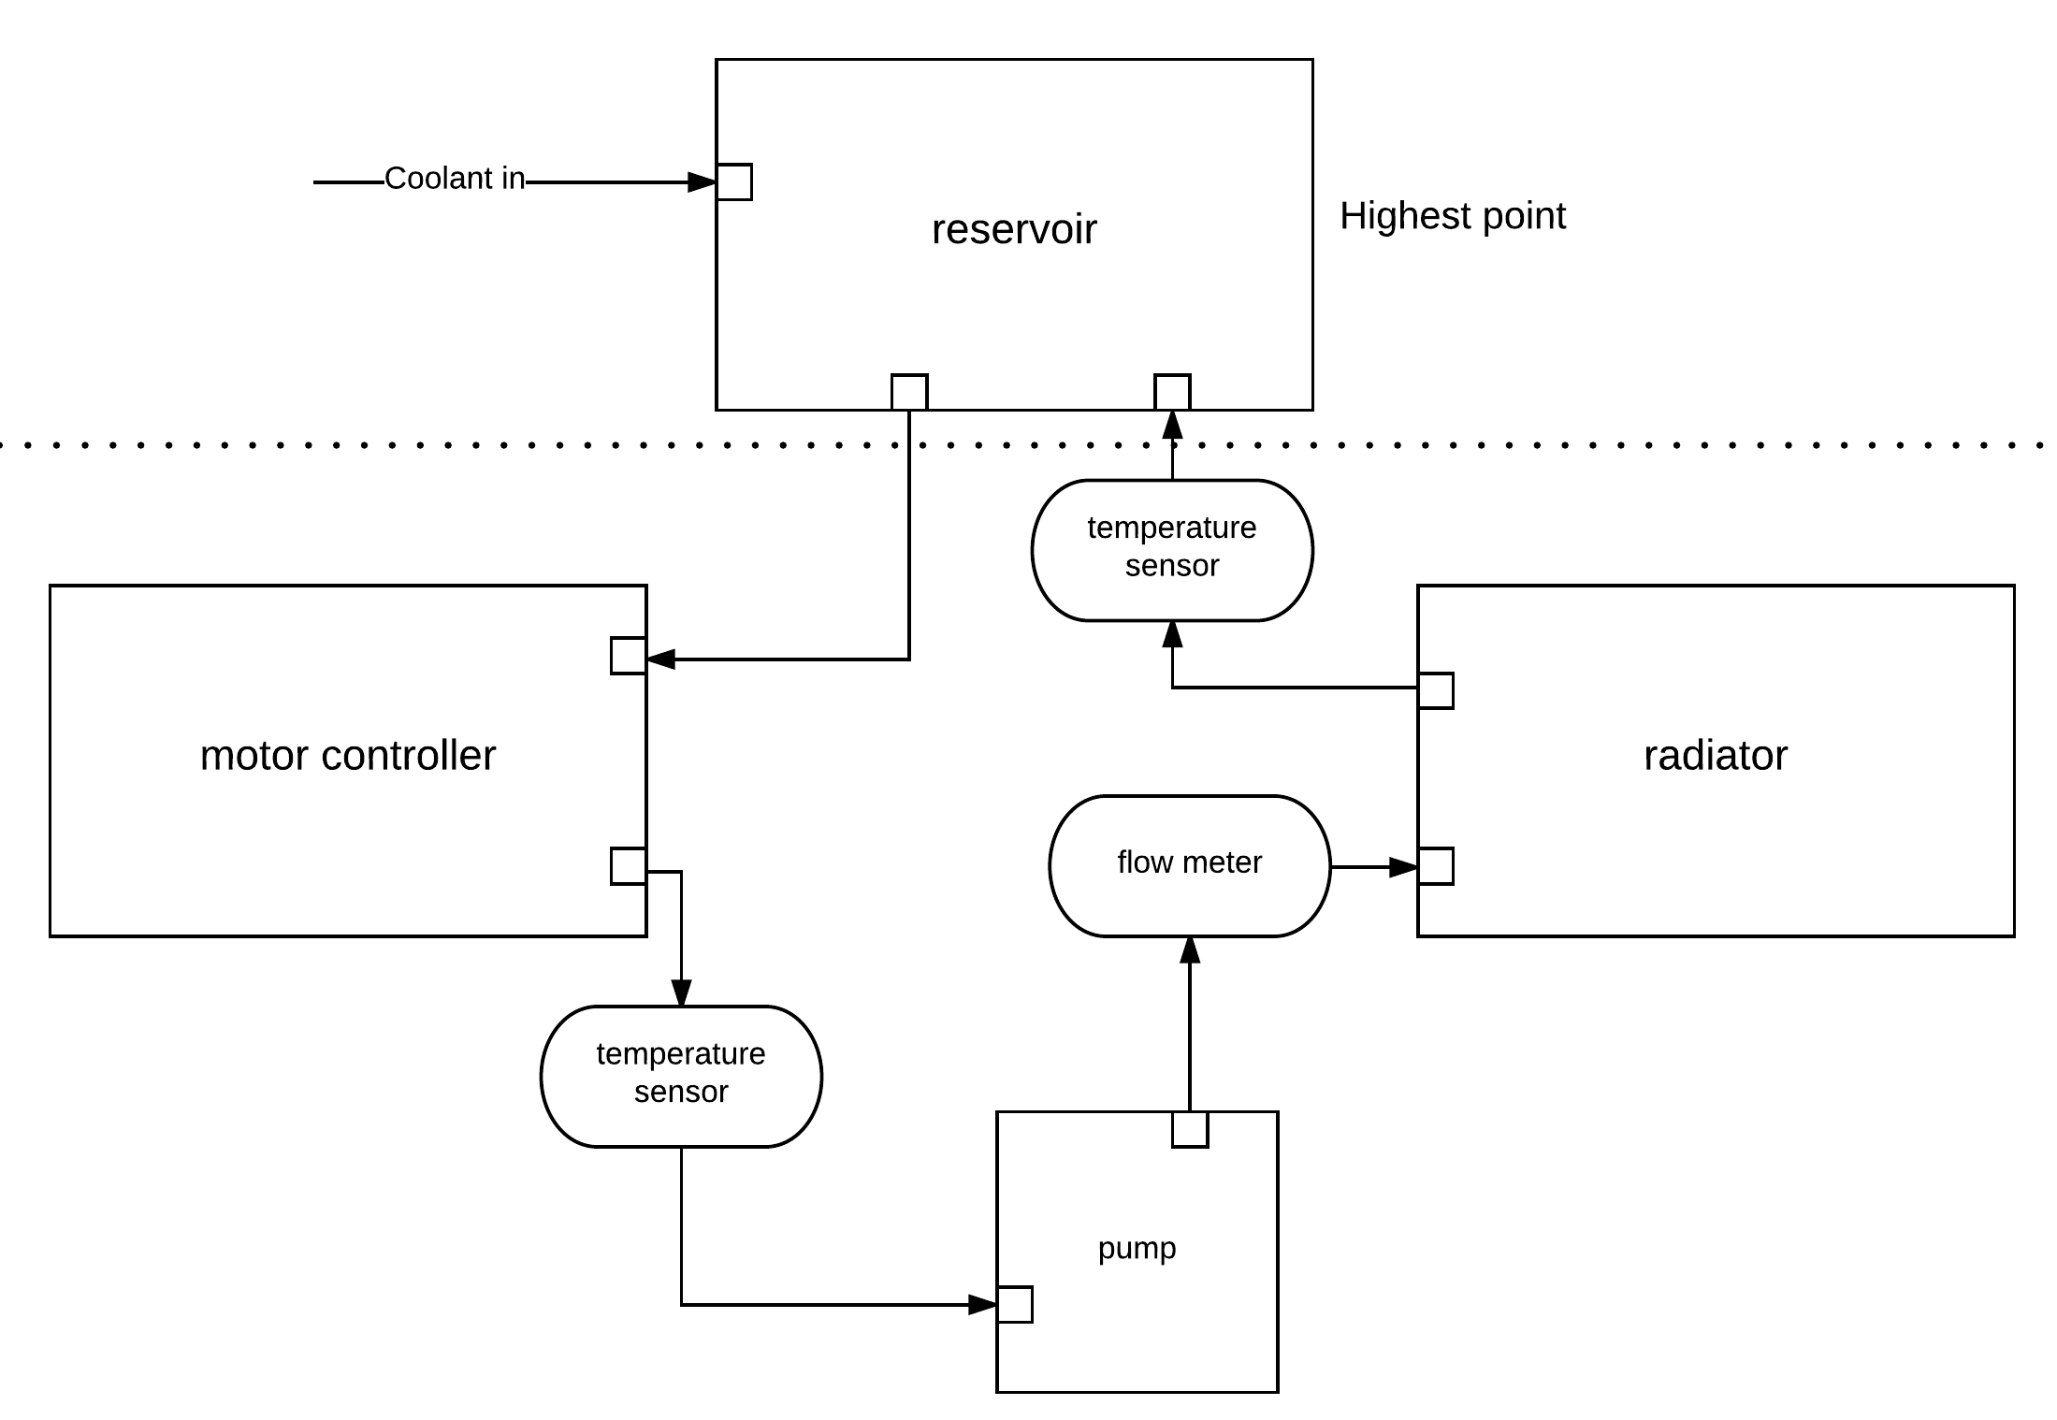
(Coolant Flow Diagram/Connection of Cooling Components)

Safety
The 2017 LFEV team utilized the safety procedures and guidelines set forth by previous LFEV teams. In general, personal protective equipment (PPE; consisting of eye protection, cotton clothing, close-toed shoes, etc) was utilized in a designated workspace with a 1 m barrier distance with a safety watch procedure enacted each time a pack was opened.

Safety documents detailing procedures, expectations and guidelines produced by previous LFEV teams and to which the 2017 LFEV team adhered can be found here:

http://sites.lafayette.edu/ece492-sp15/files/2015/02/SafetyPlan.pdf
https://sites.lafayette.edu/ece492-sp16/files/2016/03/2016SafetyPlan.pdf

Electrical System Components Maintenance
This diagram shows all the electrical connections on the central controller, one Arduino UNO R3. The detailed explanations of how internally/externally the pins are connected to various parts can be found in ICD documents of MCCS.

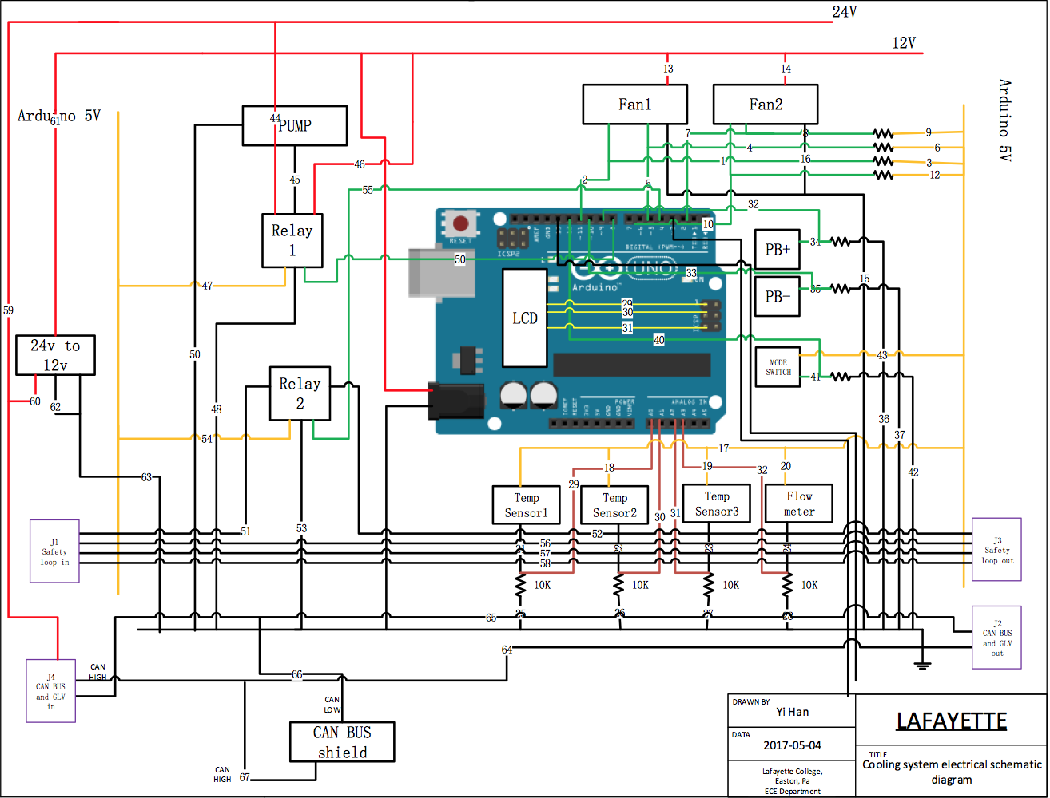

Maintenance
- Pump:
  - Koolance PMP-450s
  - Should be connected to 24V DC power.
  - Maximum Flow Rate: 12L/min (3.2 gal/min) @ 12V, 20L/min (5.3 gal/min) @ 24V
  - Maximum Head Pressure: 3.2m (10.5ft) @ 12V, 6m (19.7ft) @ 24V
  - Motor: Brushless DC, electronically commutated, spherical motor
  - Power: 8-24VDC, 3-50W, 0.13-2.1A
  - Startup Voltage: 9 to 13.2 VDC
  - Maximum System Pressure: 3.5 kgf/cm2 (50 PSI)
  - Maximum Temperature: 60°C (140°F)
  - Electrical Connector: 4-pin Molex power supply connection + 3-pin (single lead) tach
  - Hose Connections: 13mm (1/2in) ID hose barbs
  - Wetted Materials: PPO, Carbon/Allumina Ceramic, EPDM or Viton, 316 SS
  - Noise: Less than 40dBA
  - Weight: 862g (1.9lbs)
  - MTBF 50k hours

- Fan/Radiator:
  - Fans are working on 12V DC power, so a DC-DC 24V-12V converter is being used to convert the overall 24V GLV power to 12V.
  - Speed:1200RPM±10%
  - Air Flow:41.4CFM
  - Air Pressure:1.21mm-H20
  - Noise Level:16dB(A)
  - Input Power: 3.3W
  - Rated Voltage: DC12V
  - Input Current: 0.28A
  - Cable length: 40cm / 15.7in
  - Product Specification: 120mm(W)*120mm(D)*25mm(H)/4.7in(W)*4.7in(D)*1in(H)
  - Packing Size: 135mm(W)*135mm(D)*30mm(H)/5.5in(W)*5.5in(D)*1.25in(H)

- Relay(s):
  - The KEYES 5V Relay Module is powered by 5V output power from Arduino UNO R3 and controlled by a digital pin from Arduino UNO R3. The maximum DC current and voltage are 10A and 30VDC, so it can be used to switch 24V/12V DC voltage and be used to tap into the 24V GLV safety loop.
  - 5V – 12 V TTL control signal
  - Maximum AC current and voltage : 10A 250VAC
  - Maximum DC current and voltage : 10A 30VDC
  - The control signal DC or AC, 220V AC load can be controlled
  - There is a normally open and one normally closed contact
  - To make the coil of relay energized you must need to have an input of 1 in the signal pin.

- Low Power Components:
  - Parts like pushbuttons, switches and different types of sensors can be directly powered by 5V Arduino output power.

- Arduino:
  - Arduino UNO R3 can only source a total of 200mA; operating voltage should not exceed 12V.
  - Microcontroller ATmega328
  - Operating Voltage 5V
  - Input Voltage (recommended) 7-12V
  - Input Voltage (limits) 6-20V
  - Digital I/O Pins 14 (of which 6 provide PWM output)
  - Analog Input Pins 6 DC Current per I/O Pin 40 mA
  - DC Current for 3.3V Pin 50 mA
  - Flash Memory 32 KB (ATmega328) of which 0.5 KB used by bootloader
  - SRAM 2 KB (ATmega328)
  - EEPROM 1 KB (ATmega328)
  - Clock Speed 16 MHz

- SparkFun CAN Bus Shield:
  - Directly stacked on Arduino UNO R3, no other installation needed.
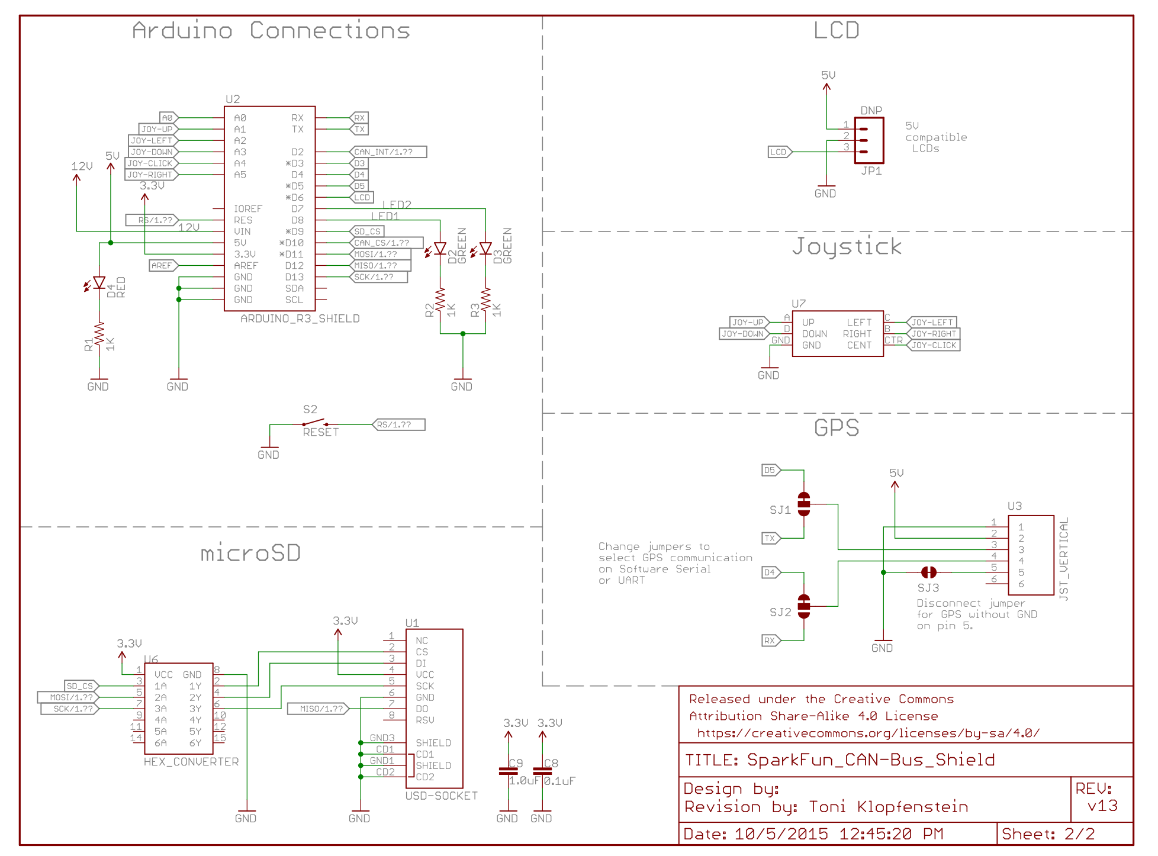

- SerLCD:
  - Powered by CAN Bus Shield, do not need extra power.
  - Embedded PIC 16F88 utilizes onboard UART for greater communication accuracy
  - 20x4 Black on Green LCD
  - Adjustable baud rates of 2400, 4800, 9600 (default), 14400, 19200 and 38400
  - Operational Backspace
  - Greater processing speed at 10MHz
  - Incoming buffer stores up to 80 characters
  - Backlight transistor can handle up to 1A
  - Pulse width modulation of backlight allows direct control of backlight brightness and current consumption
  - All surface mount design allows a backpack that is half the size of the original
  - Faster boot-up time
  - Boot-up display can be turned on/off via firmware
  - User definable splash screen

System Connections

- Internal System Connection:
  - Can be found in MCCS Internal ICD. But here is a schematic diagram:

Wire Number | Conn A | Conn B | Voltage
1 | FAN1 PWM | 10K Resistor | N/A
2 | FAN1 PWM | DIGITAL 11 | N/A
3 | 10K Resistor | Arduino 5V | 5V
4 | FAN1 Tachometer | 10K Resistor | N/A
5 | FAN1 Tachometer | DIGITAL 5 | N/A
6 | 10K Resistor | Arduino 5V | 5V
7 | FAN2 Tachometer | 10K Resistor | N/A
8 | FAN2 Tachometer | DIGITAL 2 | N/A
9 | 10K Resistor | Arduino 5V | 5V
10 | FAN2 PWM | DIGITAL 6 | N/A
11 | FAN2 PWM | 10K Resistor | N/A
12 | 10K Resistor | Arduino 5V | 5V
13 | FAN1 Power | 12V | 12V
14 | FAN2 Power | 12V | 12V
15 | FAN1 GND | GND | GND
16 | FAN2 GND | GND | GND
17 | TEMP SENSOR1 PIN1 | Arduino 5V | 5V
18 | TEMP SENSOR2 PIN1 | Arduino 5V | 5V
19 | TEMP SENSOR3 PIN1 | Arduino 5V | 5V
20 | FLOW METER PIN1 | Arduino 5V | 5V
21 | TEMP SENSOR1 PIN2 | 10K Resistor | N/A
22 | TEMP SENSOR2 PIN2 | 10K Resistor | N/A
23 | TEMP SENSOR3 PIN2 | 10K Resistor | N/A
24 | FLOW METER PIN2 | 10K Resistor | N/A
25 | TEMP SENSOR1 PIN2 | A0 | N/A
26 | TEMP SENSOR2 PIN2 | A1 | N/A
27 | TEMP SENSOR3 PIN2 | A2 | N/A
28 | FLOW METER PIN2 | A3 | N/A
29 | LCD TX | RX | N/A
30 | LCD + | LCD + on Arduino | N/A
31 | LCD - | LCD - on Arduino | N/A
32 | PB1 GND | DIGITAL 9 | N/A
33 | PB2 GND | DIGITAL 10 | N/A
34 | PB1 GND | 10K Resistor | N/A
35 | PB2 GND | 10K Resistor | N/A
36 | 10K Resistor | GND | GND
37 | 10K Resistor | GND | GND
38 | PB1 POWER | Arduino 5V | 5V
39 | PB2 POWER | Arduino 5V | 5V
40 | MODE SWICH GND | DIGITAL 12 | N/A
41 | MODE SWICH GND | 10K Resistor | N/A
42 | 10K Resistor | GND | GND
43 | MODE SWICH POWER | Arduino 5V | 5V
44 | RELAY1 PIN1 | 24V | 24V
45 | RELAY1 PIN2 | PUMP POWER | N/A
46 | RELAY1 PIN3 | 12V | 12V
47 | RELAY1 POWER | Arduino 5V | 5V
48 | RELAY1 GND | GND | GND
49 | RELAY1 S | DIGITAL 8 | N/A
50 | PUMP GND | GND | GND
51 | RELAY2 PIN1 | SAFETY LOOP1 IN | N/A
52 | RELAY2 PIN2 | SAFETY LOOP1 OUT | N/A
53 | RELAY2 GND | GND | GND
54 | RELAY2 POWER | Arduino 5V | 5V
55 | RELAY2 S | DIGITAL 4 | N/A
56 | J1 | J5 | N/A
57 | J1 | J5 | N/A
58 | J1 | J5 | N/A
59 | J4 | 24V | N/A
60 | 24V | DC TO DC CONVERTOR | 24V
61 | DC TO DC CONVERTOR | 12V | 12V
62 | DC TO DC CONVERTOR | GND | GND
63 | DC TO DC CONVERTOR | GND | GND
64 | J4 | J2 | N/A
65 | J4 | J2 | N/A
66 | CAN BUS SHILED | J2 | N/A
67 | CAN BUS SHILED | J2 | N/A

- External System Connection:

PANNEL 1:

SAFETY LOOP Panel (Left Side) – J1
Connector Type: DT04-4P Panel Mount
Pin 1: Safety loop input wire 1
Pin 2: Safety loop input wire 2
Pin 3: Safety loop input wire 3
Pin 4: Safety loop input wire 4

SAFETY LOOP Panel (Middle) – J3
Connector Type: DT04-4P Panel Mount
Pin 1: Safety loop output wire 1
Pin 2: Safety loop output wire 2
Pin 3: Safety loop output wire 3
Pin 4: Safety loop output wire 4

CAN and POWER Panel (Right Side) – J4
Connector Type: DT04-6P Panel Mount
Pin 1: CAN H
Pin 2: CAN L
Pin 3: SHIELD
Pin 4: CHGND
Pin 5: 24VDC
Pin 6: 24V RTN

PANNEL 2:

Pump and Sensors (left side) – J6
Connector Type: DT04-8P Panel Mount
Pin 1: Pump POWER
Pin 2: Pump GND
Pin 3: Sensors 5V
Pin 4: TEMP SENSOR 1 INPUT
Pin 5: TEMP SENSOR 2 INPUT
Pin 6: TEMP SENSOR 3 INPUT
Pin 7: FLOW METER INPUT
Pin 8: N/A

Pump and Sensors (Middle) – J5
Connector Type: DT04-8P Panel Mount
Pin 1: FANs POWER
Pin 2: FANs GND
Pin 3: FAN1 PWM
Pin 4: FAN2 PWM
Pin 5: FAN3 tachometer
Pin 6: FAN4 tachometer
Pin 7: N/A
Pin 8: N/A

CAN and POWER Panel (Right Side) – J2
Connector Type: DT04-6P Panel Mount
Pin 1: CAN H
Pin 2: CAN L
Pin 3: SHIELD
Pin 4: CHGND
Pin 5: 24VDC
Pin 6: 24V RTN

Troubleshooting
Arduino:
- Check whether Arduino driver is successfully installed.
- Check whether COM Port is set to the actual Arduino COM Port.
- Make sure have the SparkFun CAN libray integrated with Arduino.

Board:
- Resistors should be used when connect Arduino with sensors. Detailed connection construction can be found in ICD, which can be found on LFEV website also.
- Note: for Arduinos with 1 VCC pin can source a total of 200mA; Arduino UNO is one of the ones with only 1 VCC pin.

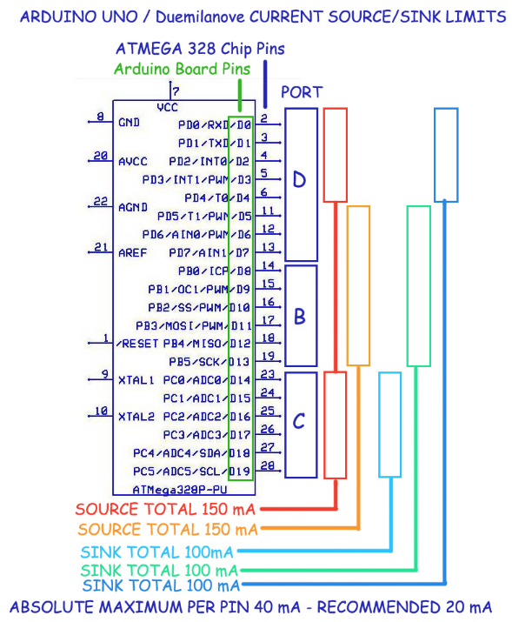
(http://playground.arduino.cc/Main/ArduinoPinCurrentLimitations)

