Cell Replacement Procedure
By Eric Martocci, Spring 2017

Tools Needed
5/32” Allen wrench
7mm socket and ratchet
(4) 1/4”-20 X 3/4” Button Head Allen Bolts
Cell compression tool
7/16” combination wrench
Utility knife

Cell Removal Procedure
- Remove top center panel and sides from pack.
- Remove AMS boards keeping track of their order on the cells. (Fig. 1)
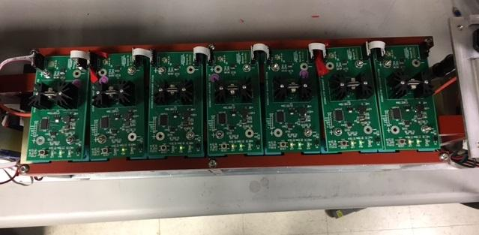
Fig. 1

- Using 7mm socket and ratchet, remove M4 hex head bolts and busbars from bad cell. (Fig. 2)
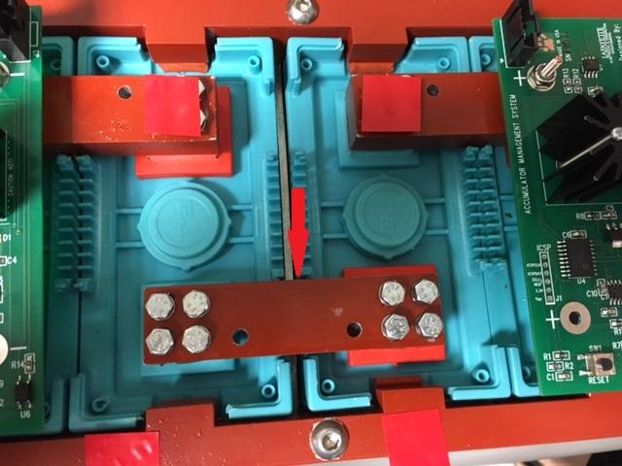
Fig. 2

- Lay pack on its side and loosen four 1/4”-20 button head allen bolts. (Fig. 3)
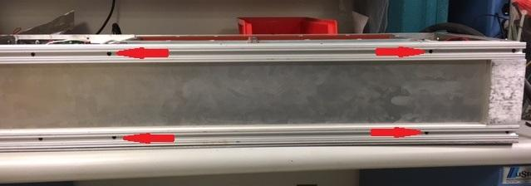
Fig. 3

- Install cell compression tool on side of cell section using (4) 1/4”-20 x 3/4” button head allen bolts and tension 1/4” rod using 7/16” combination wrench. (Fig. 4)
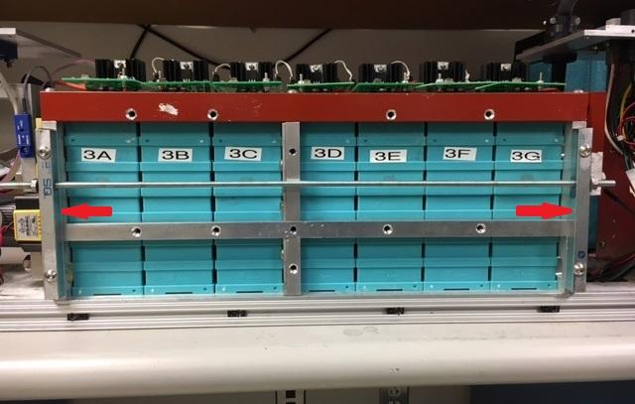
Fig. 4

- Remove (3) ¼”-20 button head allen bolts from top of cell hold down bar and remove bar. (Fig. 5)

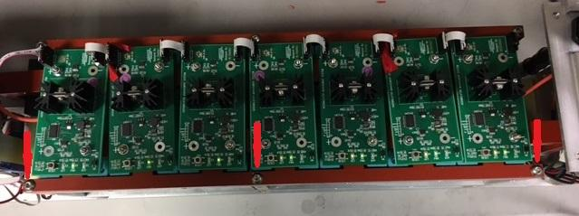
Fig. 5

- Remove tension from 1/4” rod on cell compression tool and remove compression tool from side of cell section.
- Repeat steps 5 -7 on opposite side of cell section.
- Remove bad cell.

Cell Installation Procedure
- Using the utility knife remove the nobs from the sides of the new cell. (Fig. 6)
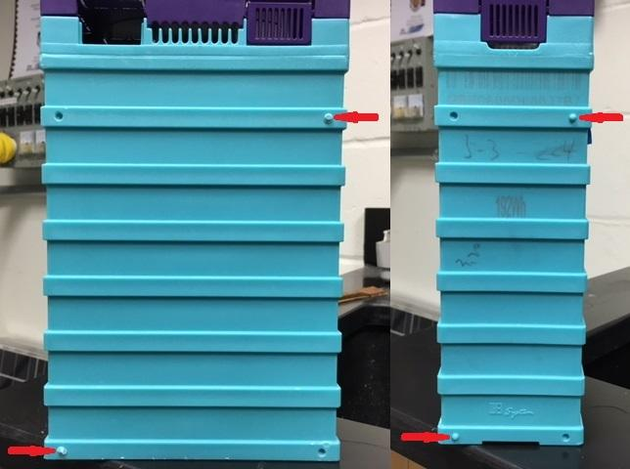
Fig. 6

- Slide new cell into pack.
- Install cell compression tool on side of cell section using (4) 1/4”-20 x 3/4” button head allen bolts and tension 1/4” rod using 7/16” combination wrench. (Fig. 4)
- Check that all cells have a rubber block on top of them and install cell hold down bar using (3) 1/4”-20 x 1-1/2” button head allen bolts. (Fig. 5)
- Remove tension from 1/4” rod on cell compression tool and remove compression tool from side of cell section.
- Repeat steps 3 – 5 on opposite side of cell section.
- Lay pack on its side and tighten four 1/4”-20 button head allen bolts. (Fig. 3)
- Place a thin layer of conductive grease on cell connection pads where busbars were removed and install busbars using M4 hex head bolts. (Fig. 2)
- Install all AMS boards keeping the same order in which they were removed. (Fig. 1)
- Install top center panel and sides on pack.

