Dyno User Manual
ECE 492 - Spring 2017

Abstract
This user manual is a high level document that explains all operational procedures and techniques needed to operate the Dynamometer system in a safe and effective manner. Anyone operating the Dynamometer system should be familiar with this document, and should refer back to this document in the event of a problem with the system.
Revision 3.0.0
March 30th, 2017
Richard Diego

Table of Contents

Introduction
 | Getting Started |  | 4
 | Reference Materials |  | 4

System Overview
 | System Diagram |  | 5
 | Power Supply |  | 6
 | Motor Controller |  | 7
 | Motor |  | 8
 | Dynamometer |  | 9
 | Huff Box (Data Acquisition Box) |  | 10
 | Temperature Sensor / Torque Sensor |  | 11
 | Test PC |  | 12
 | PC Remote Interface |  | 13
 | Water Cooling |  | 13
 | Test Stand |  | 14
 | Emergency Stop |  | 14
 | Connectors |  | 15
 | Room Layout |  | 16

System Operation
 | Power On |  | 17
 | Run Test |  | 25
 | Changing the Motor Controller Parameters |  | 25
 | Power Off |  | 27

Troubleshooting |  |  | 28

Maintenance and Calibration |  |  | 29
Safety |  |  | 30
Glossary |  |  | 31
FAQs |  |  | 31

Introduction

Getting Started

The Dynamometer Team provides a fully functioning Motor Control test stand to the operator. With this stand and an understanding of this document an operator will be able to run the Test Stand for data acquisition purposes. A system and subsystem breakdown will fully explain the different working parts in the test stand and how they function together. In addition to this procedures located in this document will provide step-by-step instructions that will allow for an operator to run a variety of test cases. Safety will also be discussed for the operators benefit. Anyone operating the Dynamometer system should be familiar with this document, and this document should be referred back to in the event of a problem with the system. If there are any questions please direct them to diegor@lafayette.edu.

References Materials

GLV Users Manual
VSCADA Users Manual
TSV Users Manual
Dynamometer Calibration and Maintenance
Safety Plan
Interface Control Document
Power Supply Documentation
Motor Documentation
Motor Controller Documentation
Dynamometer Documentation
Temperature Sensor Data Sheet

System Overview

System Diagram
Below is a simplified block diagram of the motor test system. It showcases an integrated test system with the VSCADA software. It highlight all of the major components in our test setup. The boxes and the connections between them will be described at length in the following sections.

Dynamometer System Diagram
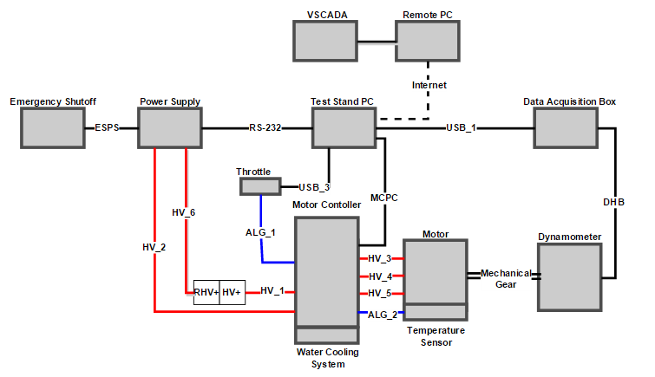
Figure 1 .Partially Integrated Test System.

This system configuration represents a partially integrated Dynamometer System. In this setup is that VSCADA controls the motor through the Test Stand PC and there is no TSV and GLV systems. This is the configuration that will be used in most testing.

Individual System Parts

Power Supply
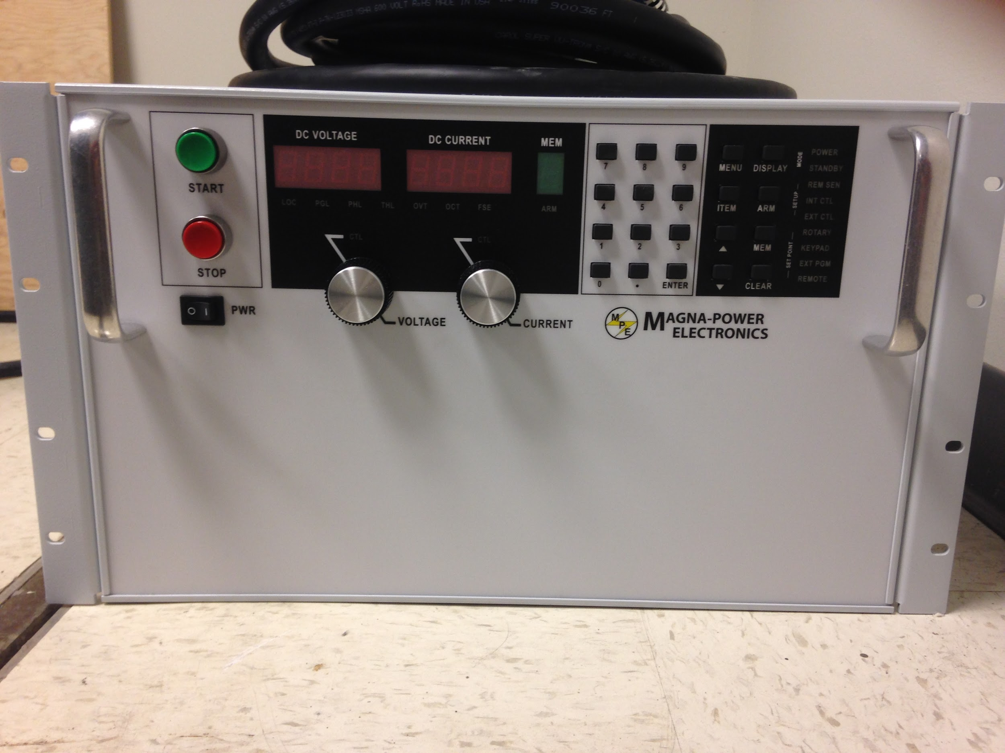
Figure 2. Magna Power TS Series IV

The Magna Power TS Series IV is a programmable DC power supply. The model number of our supply is TSD100-250/208. The model number indicated the parameters of our power supply. TS represents the TS series and the D determines that the front panel has a digital display attached that the user can you to program the output of the power supply. The 100-250 represents the maximum output DC voltage that can be produced by this unit is 100 volts and the maximum output current is 250 amperes. These are very high amounts of electricity and in order to reduce the risk of injury read the safety section with detail how to properly use the equipment. The last number in the model number, 208, represents the amount out input voltage the power supply can receive. For our supply we can receive 208 V-AC 3φ from the wall outlet. With these specifications we can know that our power supply will draw 25kW of power when operating at its maximum specifications. With these specifications we will be able to meet all of our needs for our dynamometer system so that we will be able to run test. More technical specifications that do not fall under the scope of this projects testing capabilities can be found in the Magna Power TS Series IV data sheet and manual. Using the software provided we can connect the power supply to the test stand PC via a RS232 cable to remotely control the supply. This will be used to power the motor system if the TSV Battery Packs are not being used.

Motor Controller
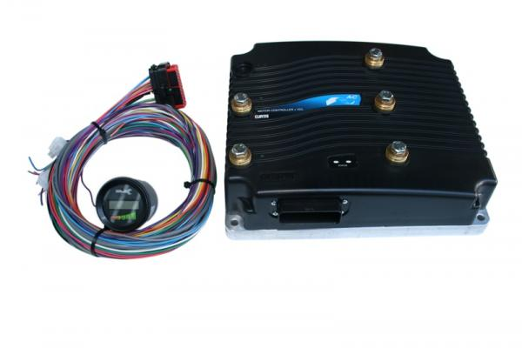
Figure 3. Curtis Model 1238-75.

The Curtis Model 1238-75 provides control of AC induction motors performing on-vehicle traction drive duties. It offers vehicle developers a highly cost-effective combination of power, performance and functionality. Designed for use as a traction controller for On-road electric and hybrid passenger vehicles using 72-96V system voltages, and other similar applications with low or medium duty cycle. It is interfaced to the computer by a 35 pin connector to USB. Curtis has developed their own language Curtis VCL in order to program the motor parameters that you desire. Using the software provided by Curtis we can monitor and change the parameters during the operation of the motor.

Motor
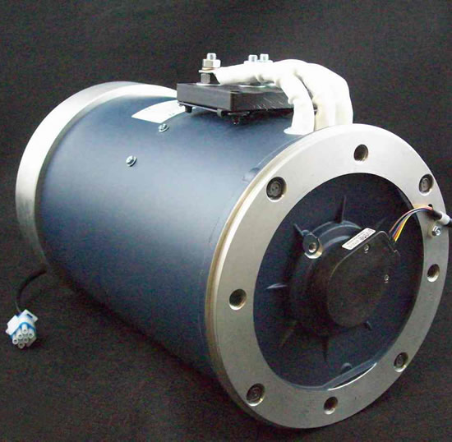
Figure 4. HPEVS AC 50 27-28.

The motor used for this project is the HPEVS AC 50. The AC 50 motor is an 8" motor that is capable of producing 71 horsepower and 120 ft-lbs of torque. It was designed for use in an automotive application with a curb weight of 3500 lbs or less. This system is used in other vehicles that require the torque and horsepower that this motor supplies. The motor has be attached to the dynamometer and with two gears and a connecting chain. The motor will be extensively tested in our setup in order to collect data to help create a better performing electric vehicle.

Dynamometer
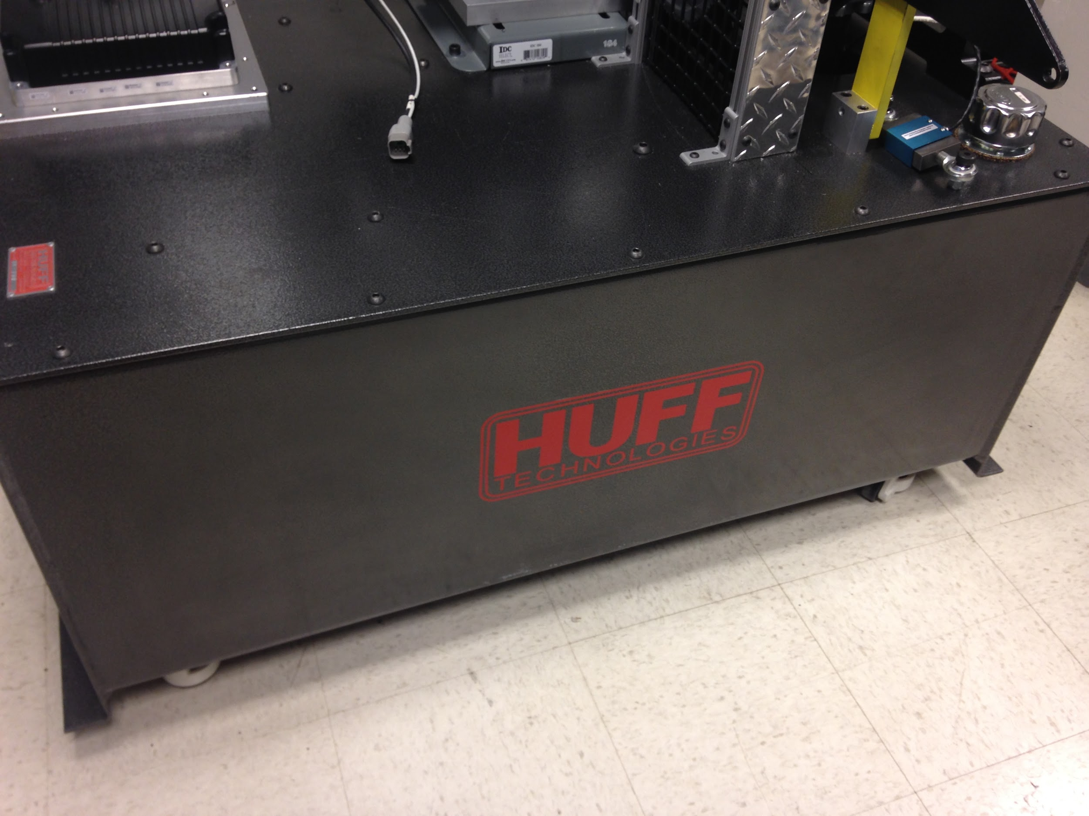
Figure 5.Huff HTH-100.

The Huff HTH-100, bought from Huff Technologies Inc. is capable of withstanding 150+ ft.lb. at 11,000+ rpm. These systems are self powered and do not require external pumps or water cooling for most applications. Power is transmitted to the dyno via. a 1.25" dia. shaft on the front of a 4.5" planetary gear drive. The drive is bolted directly to the front of a gear type hydraulic pump. The pump draws oil from an oil reservoir just below and forces the oil through a special valve pack directly mounted to the top of the pump. The valve pack adjusts its internal orifices to hold the motor at a set rpm by the user. The rpm remains constant even through varying throttle positions and can be made to sweep the engine up or down by changing the speed setting via a small DC motor which is provided.

Huff Box (Data Acquisition Box)
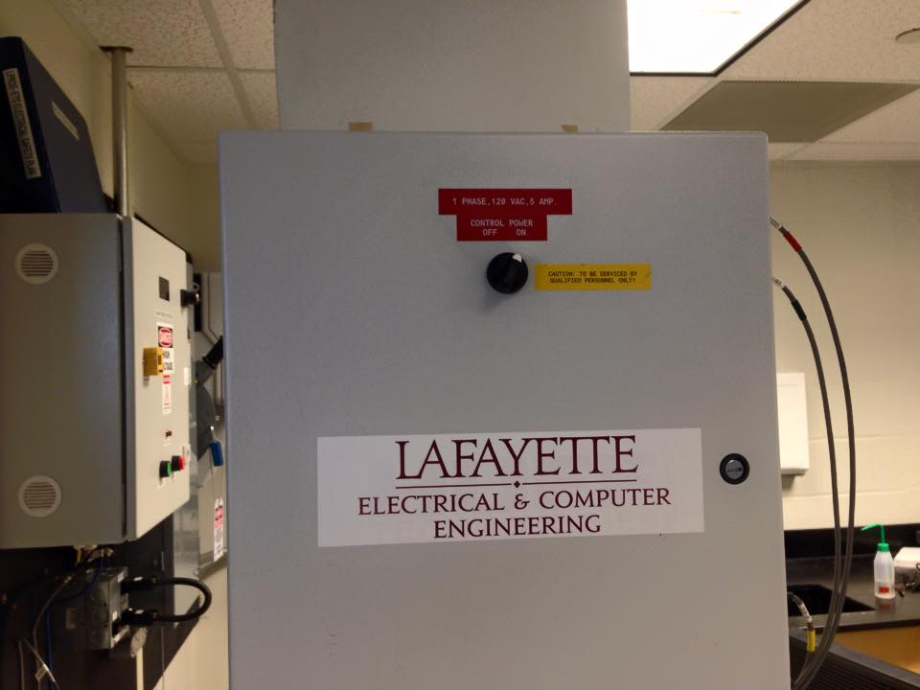
Figure 6.Huff HTH-100 Data Acquisition Box.

Huff Technologies Inc. has provided a box that will input all the dynamometer sensor data. This box will connect to the test stand PC via USB and will use the software provided to collect and track all the sensor on the dynamometer. This data will provide real-time information about the motor test system. The VSCADA will be able to log the data that is sent through this box.

Temperature Sensor
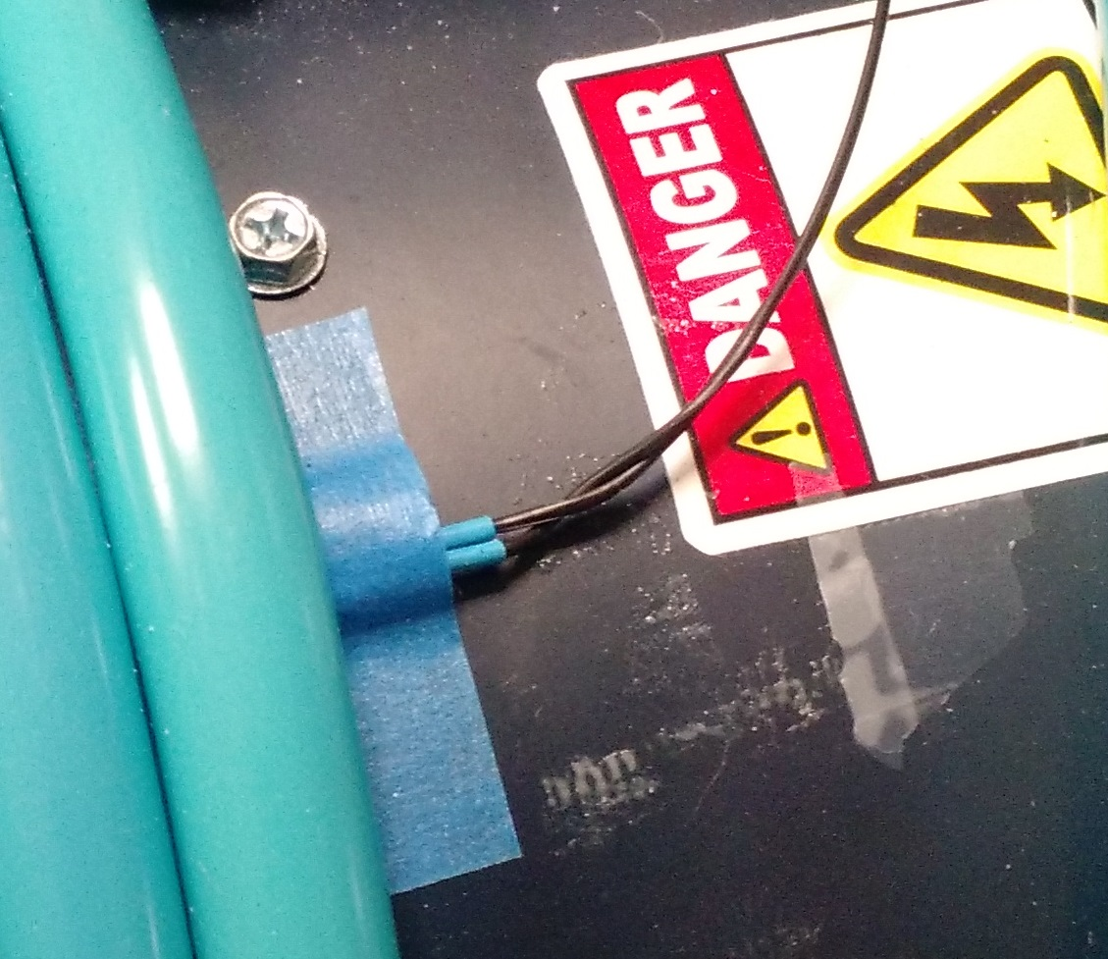
Figure 7.
The temperature sensor that is going to be connected to the motor controller will be a NXP Semiconductors KTY84/130,113. This will be used to calibrate the motor controller so that we will be able to read temperature data from the controller. This sensor offers high accuracy and reliability, Long-term stability and linear characteristics. Temperature range of this sensor is from −40 °C to +300 °C. This provides a suitable range for our operations.

Torque Sensor
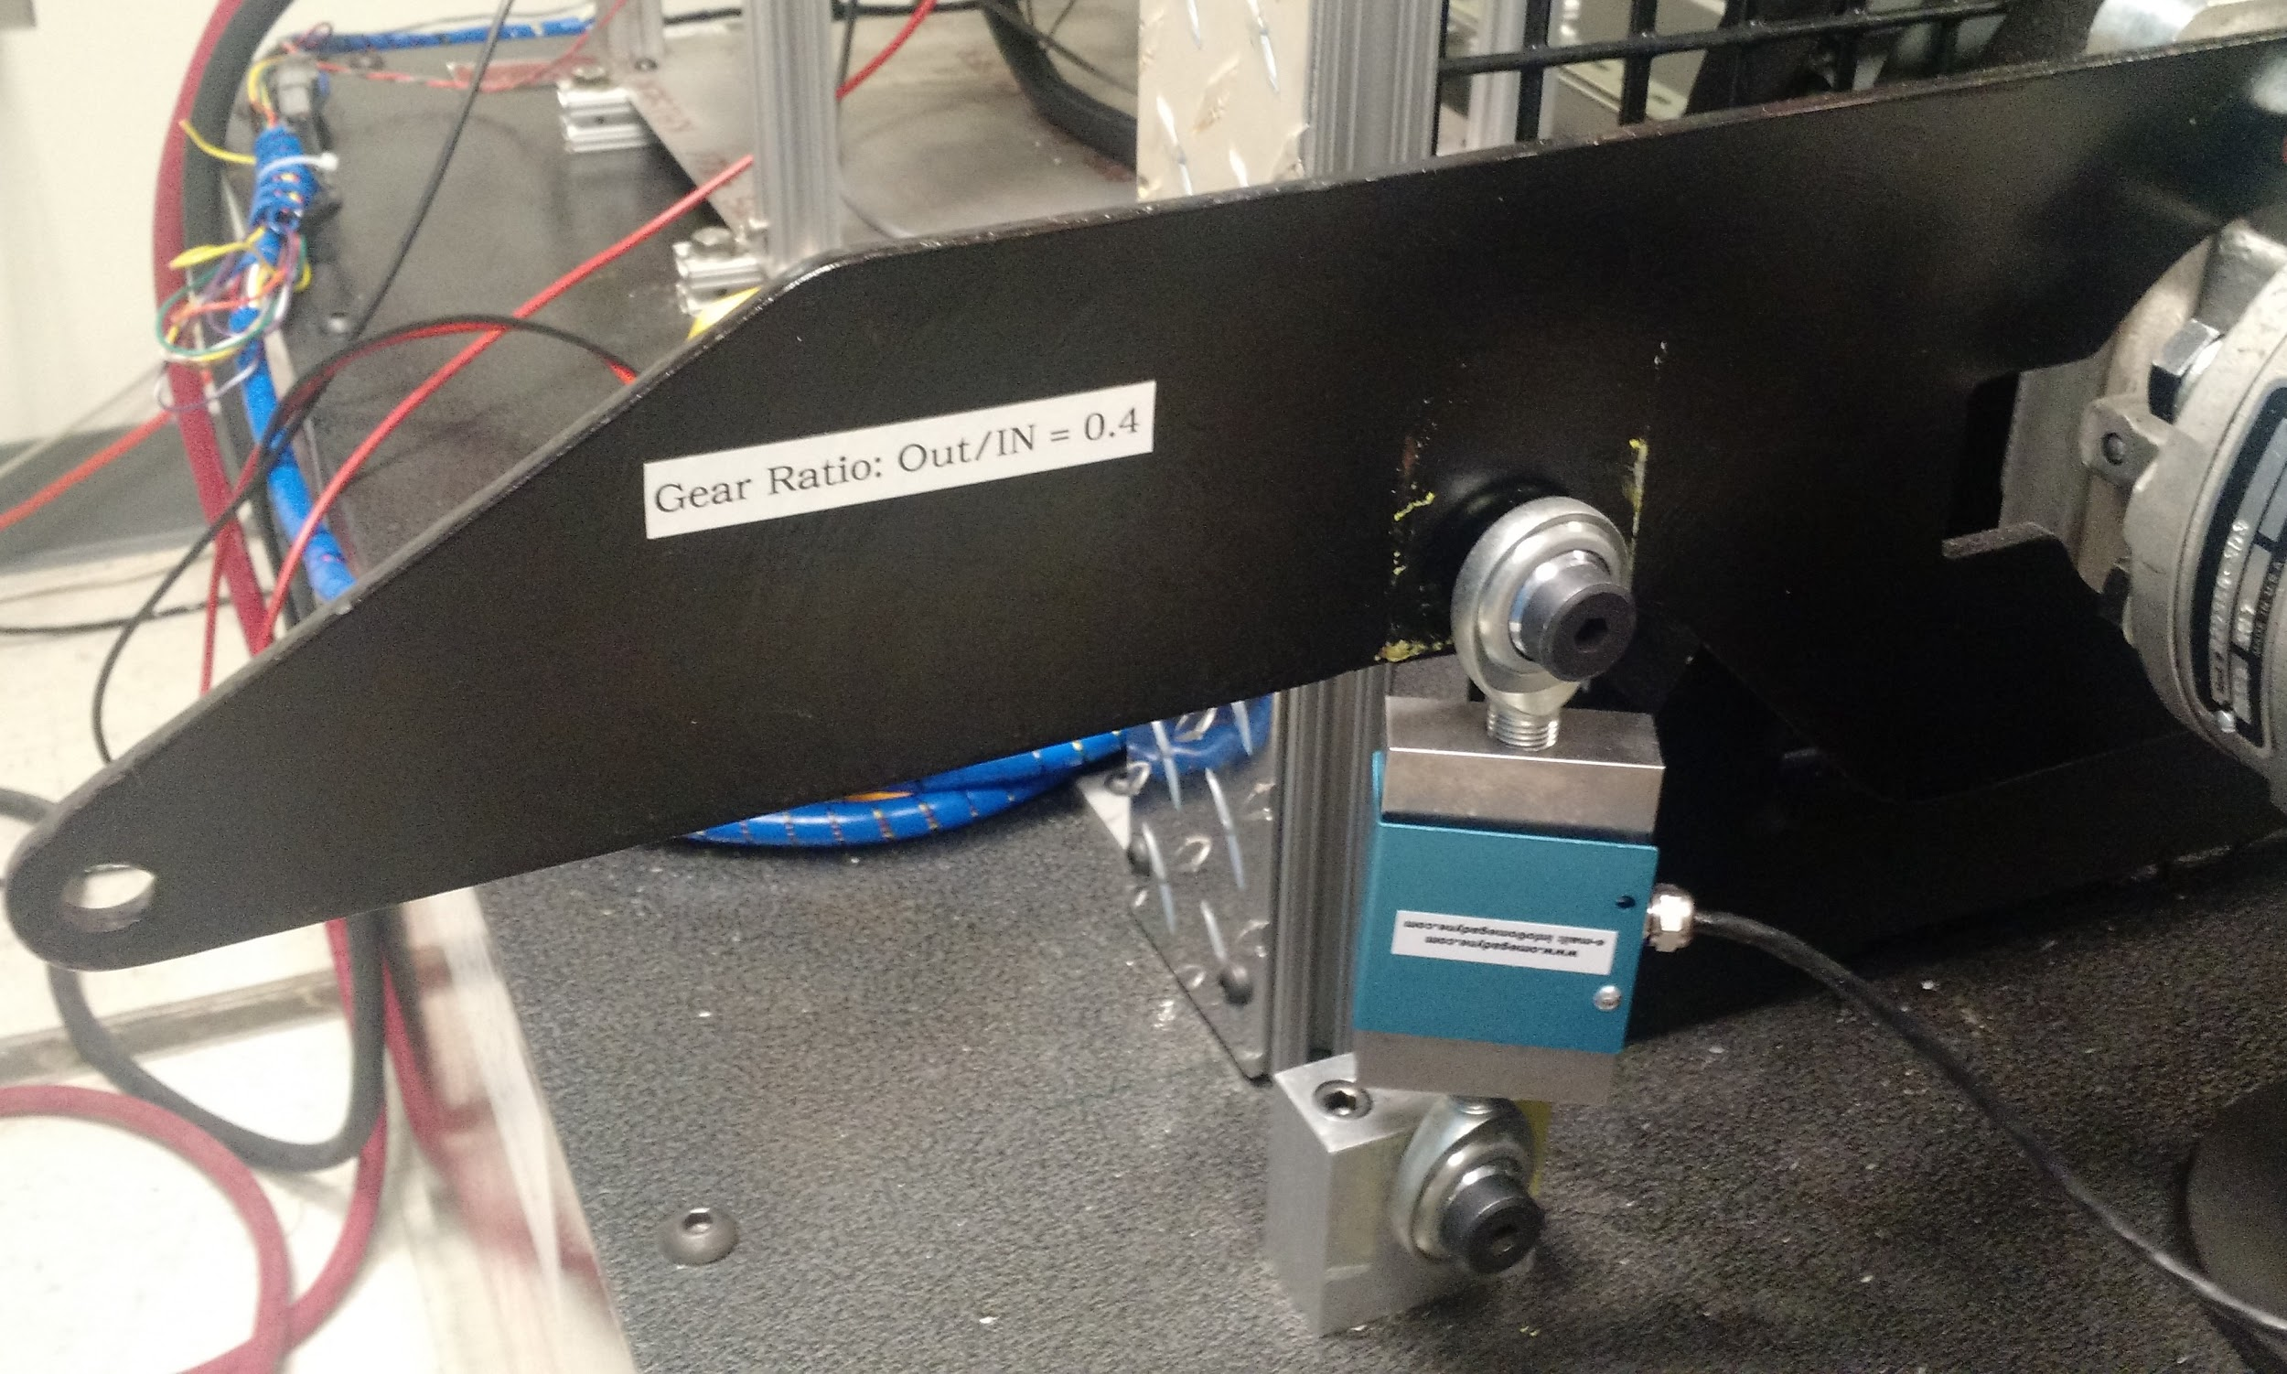
Figure 8. Torque Sensor

The torque sensor that we are using is a Omegadyne Low Range S-Beam Load Cell LCCE - 500. This will be used to calculate the amount of torque and mechanical power being created by the system so that we can calibrate the motor controller to the correct functionality for the car. The range of torque that this sensor can handle is 500 ft-lbs which is a suitable range for our operations.

Test Stand PC
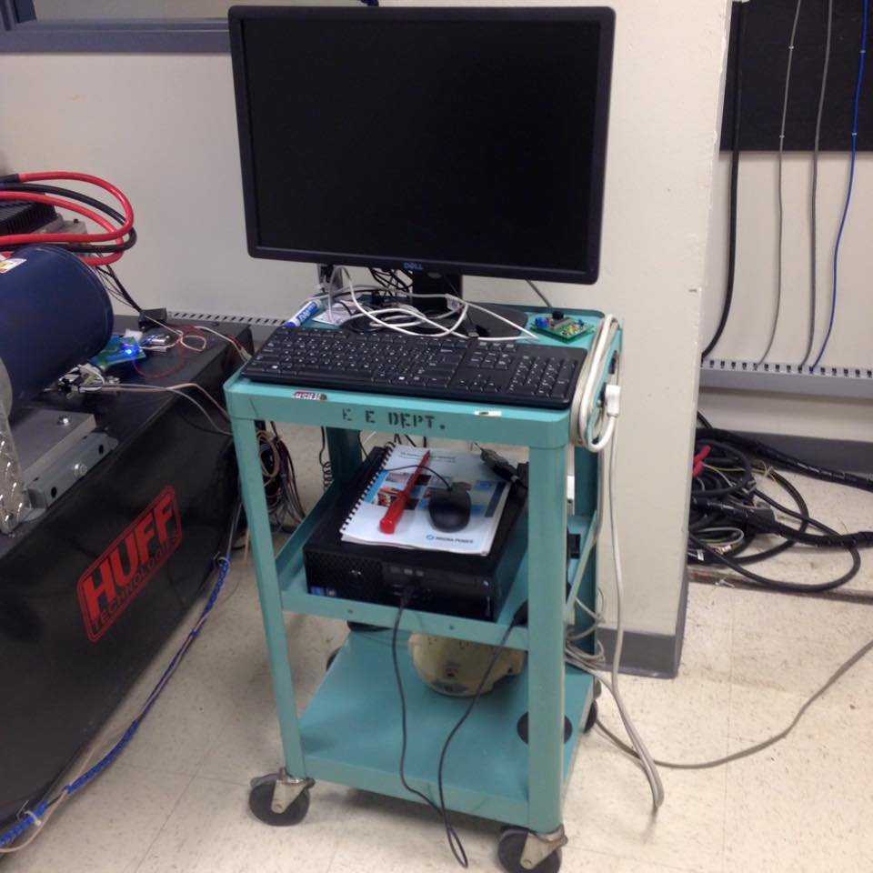
Figure 9. Test Stand PC.

In order to collect the data and program the motor control a PC is connect to the test stand to run all necessary software. The computer is a Dell Precision T1700 with Windows 7 installed as its operating system. This PC has four installed pieces of software that are necessary to run. The four programs are to operate the power supply, collect data from the dynamometer, remote desktop, and program the motor controller. They will be preinstalled on the computer ready for use. This computer must also be connected to the internet so that it can be remotely controlled by another computer that is located outside of the testing area.

PC Remote Interface
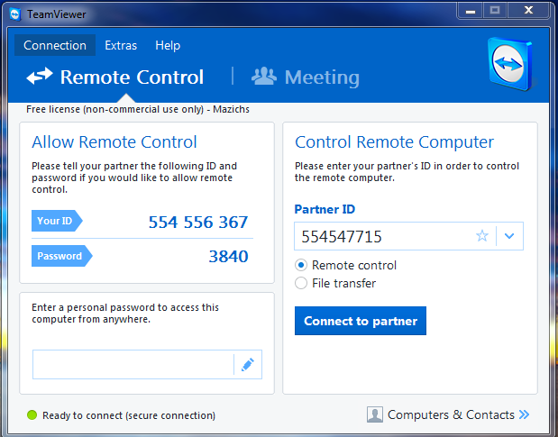
Figure 10. TeamViewer PC Remote Interface
Any computer with an internet connection can be used to remote into the test stand PC. This can be done by downloading TeamViewer onto the desired machine. With the dynamometer team login a user can view and operate all the software on the test PC.

Water Cooling System
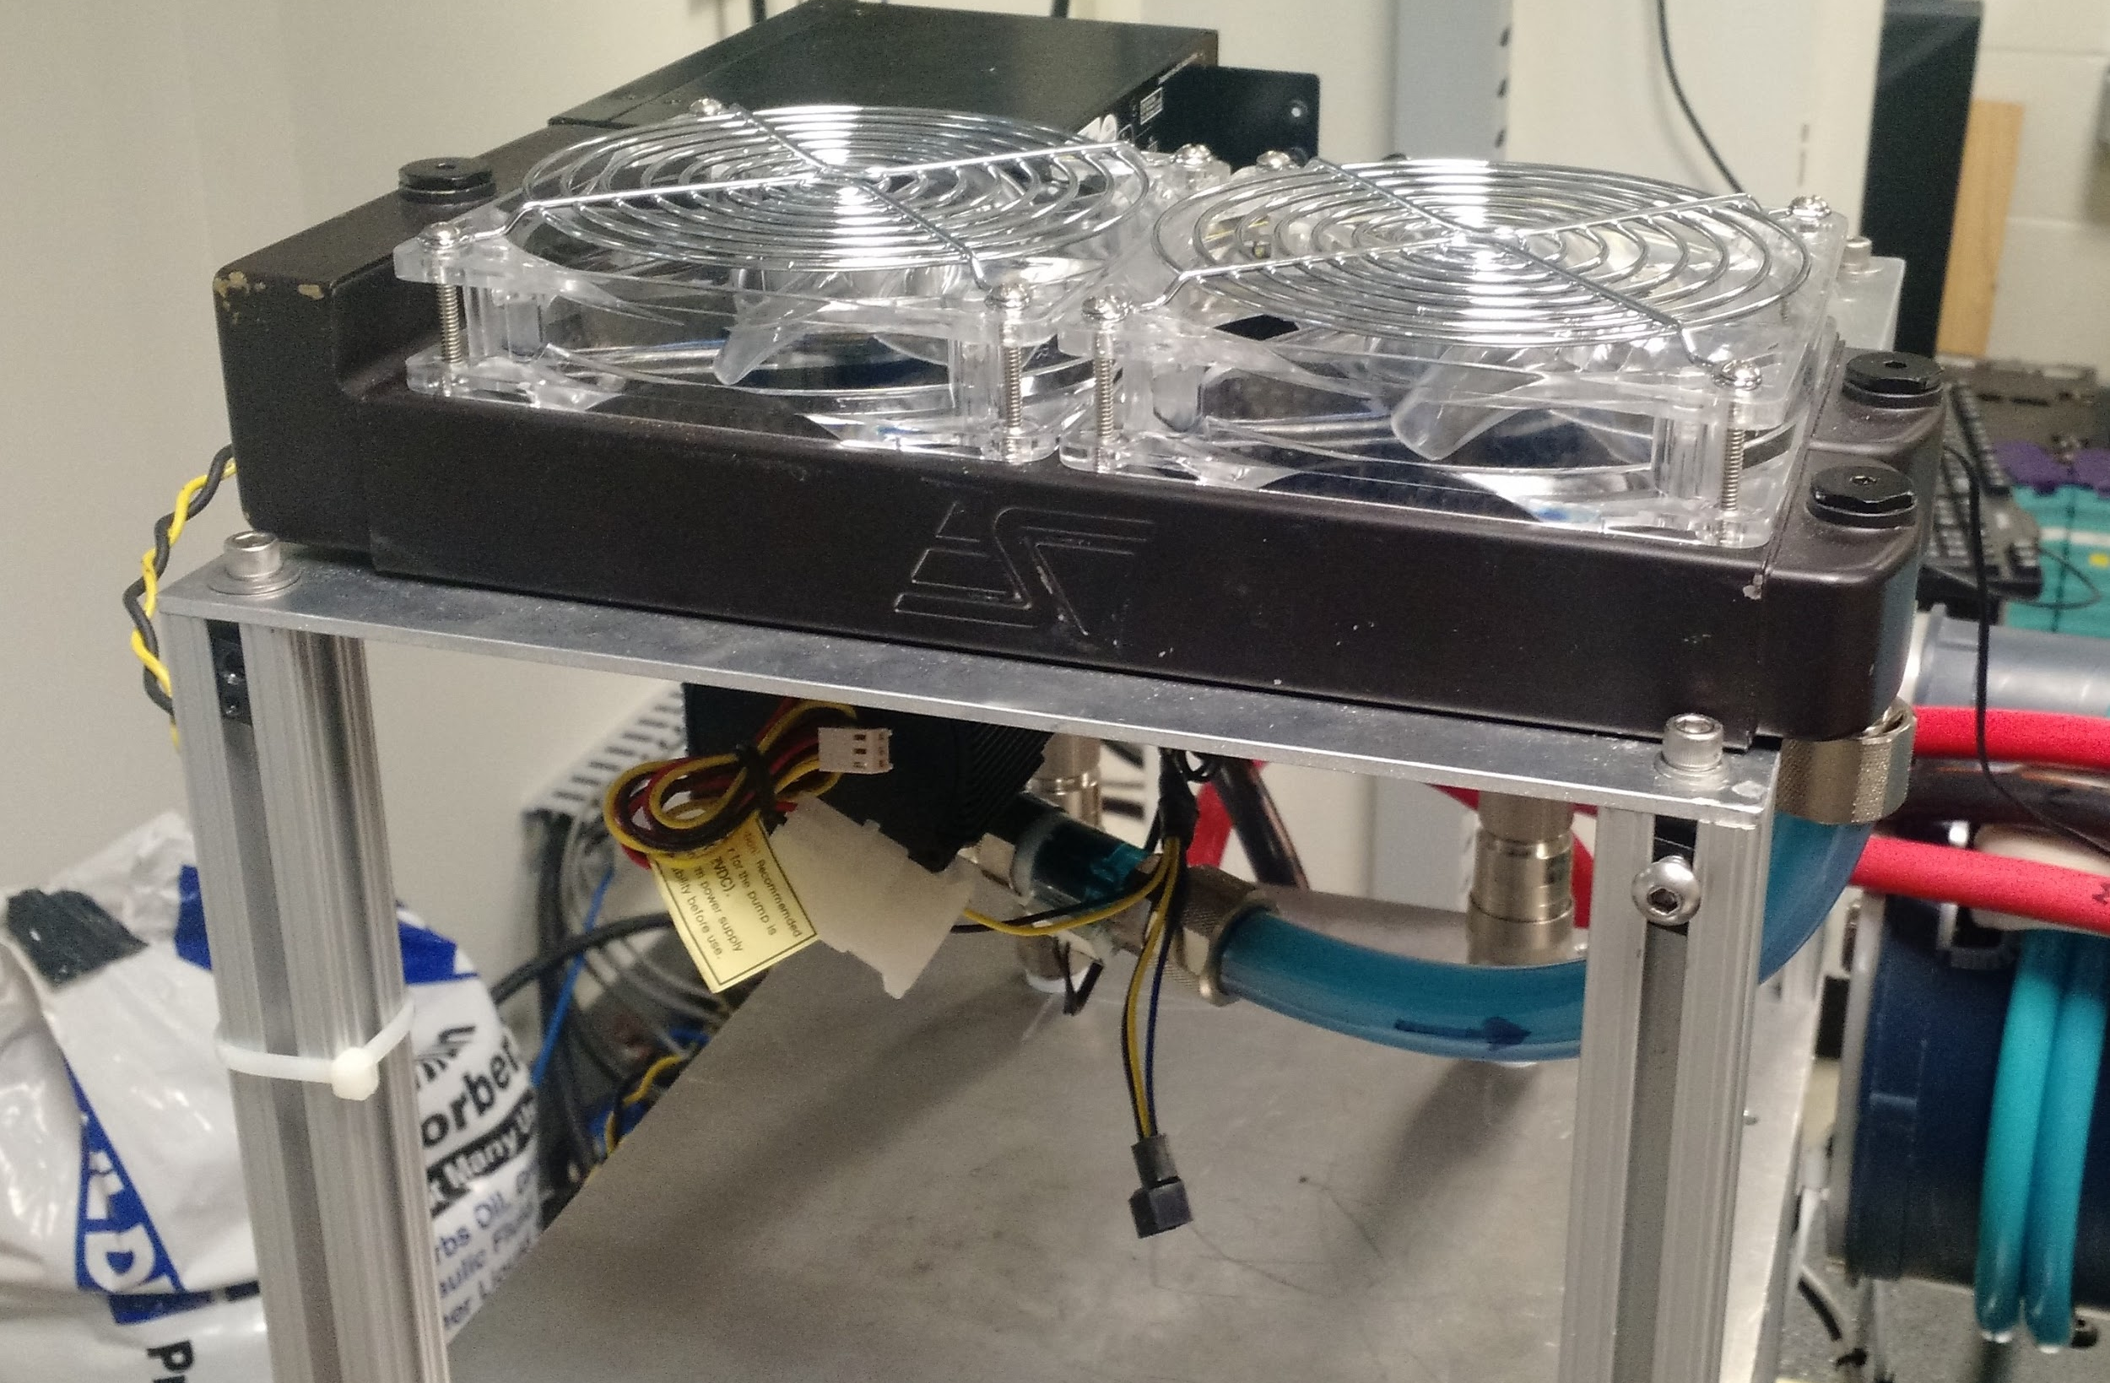
Figure 11. Water Cooling System.

In order to ensure that the Motor Controller does not overheat during the running of the motor we have installed a water cooling system. Currently we have a 12V cooling system that is powered by the test stand 24V power supply with a power converter. By the end of this year we should have a native 24V water cooling system that we can integrate with the dynamometer system.

Test Stand
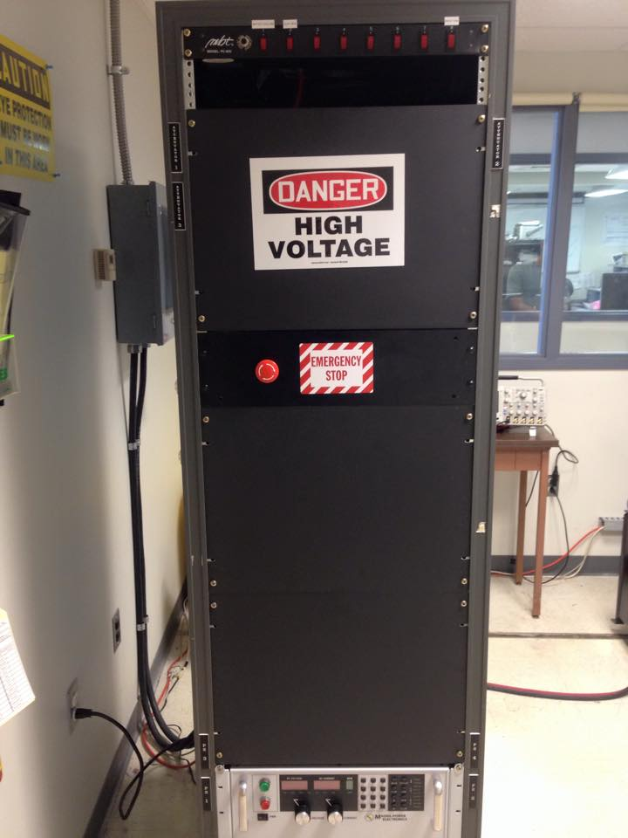
Figure 12. Test Stand.

Test stand houses the Power Supply, emergency stop button, the GLV safety loop and contains switches on the top of the rack that toggle power to other systems.

Emergency Stop / GLV Safety Loop

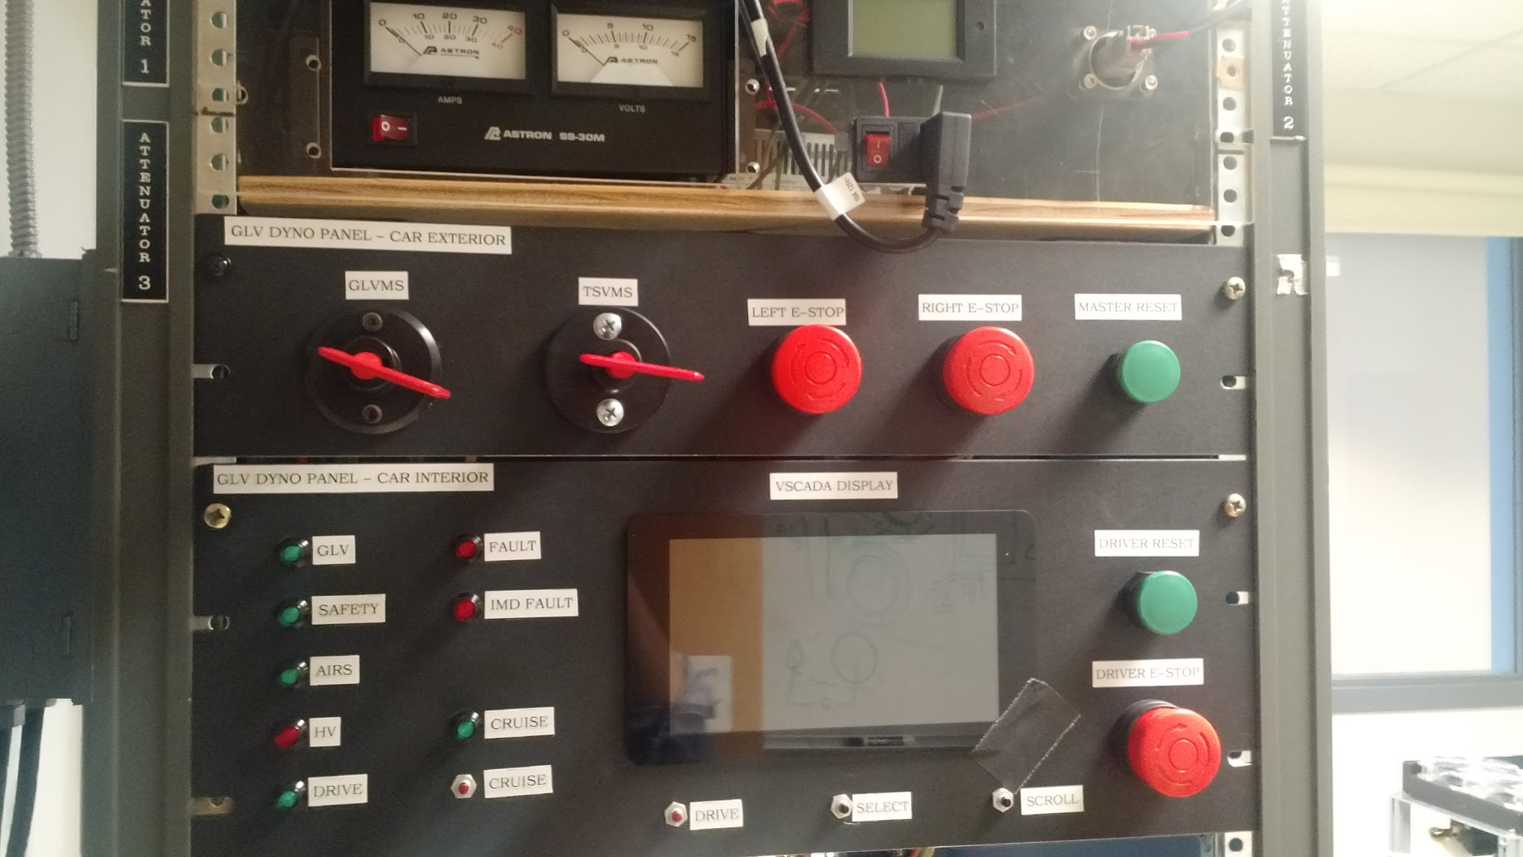
Figure 13. Emergency Stop Button.

Emergency Stop built into the test stand. This will be used to immediately cut power to the the motor controller and the power supply. Once the fully integrated system the VSCADA software will control the safety loop and cut power from the motor in case of emergency. To enable to emergency stop push the button in, then turn the knob clockwise to disable to emergency stop. We have integrated with the GLV Safety loop which can cut power from the motor in case of any failure and they also connect to the TSV battery packs which can cut the power in case of any potential failures.

Connectors
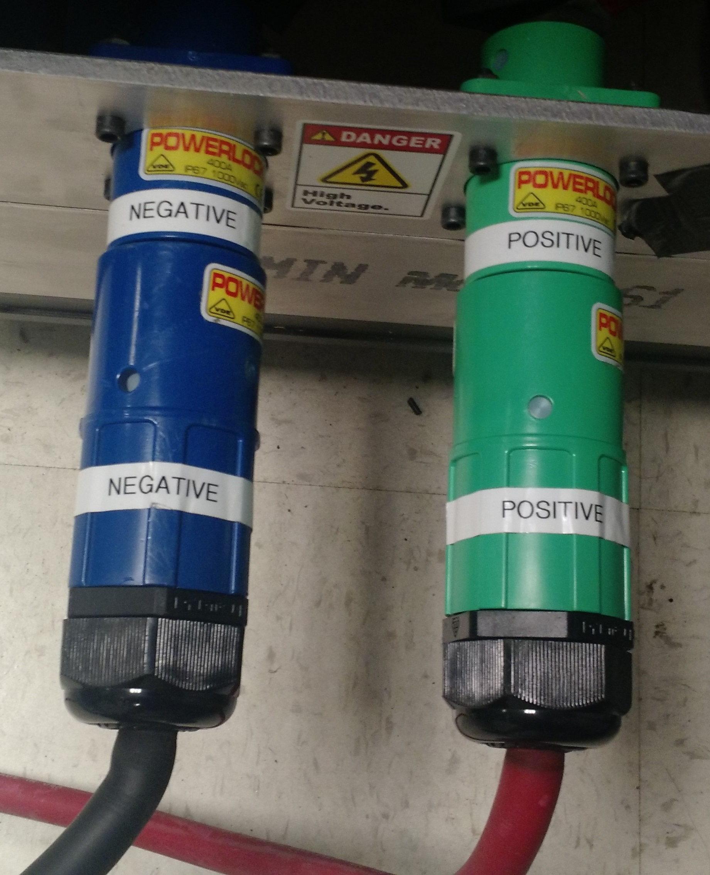
Figure 14. Power Supply Connections

In order to connect the battery pack or power supply to the motor controller the cables shown above will be used. They are AWG 2/0 and are rated beyond the current and voltage that will be used into the system. They are twist and lock connects that will attach to the power source while the other end of the wire will be tied down to the motor controller with a nut. In addition to these two connectors 3 more AWG 2/0 boltable wire will be used to connect the motor controller to the motor.

There are other connects that are not unique to the Dynamometer system. This other system connects can be found with more detailed description in the Interface Control Document.

Room Layout

Figure 15. 3D Layout of AEC 401.

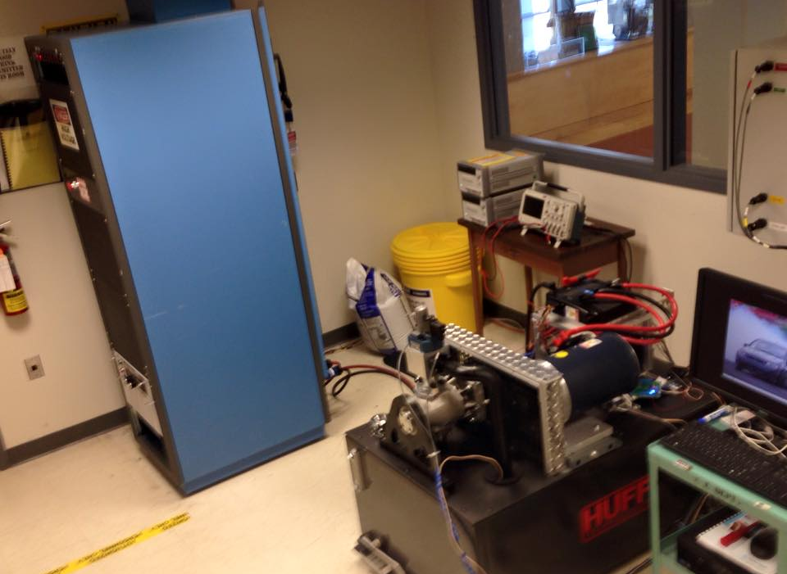

Figure 16. Layout of AEC 401.

System Operation
Power On

- Have Professor Nadovich Tag and Lock-Out so that the power is on to the power supply.
- Ensure the following
- Turn the power supply on. (Bottom Left Corner)

b. Use the switches at the top of the Test Stand and turn on power to the Huff Box, Water Cooling and Rack Fan

c. Ensure the Huff Box Control Power is switched on

d. The Emergency Stop is disabled (rotate clockwise)

e. Ensure the Test Stand PC is on and logged in (Password: AEC401)
- Leave the the Dyno Room and login into the remote PC.

- Launch Teamviewer and enter the following Partner ID: 554547715

- Enter the password: AEC401
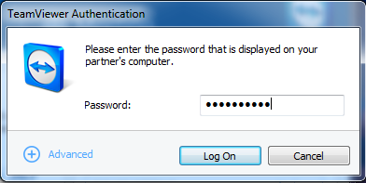

- Once launched open Oracle VM Virtual Box

- Select openSUSE and press Start
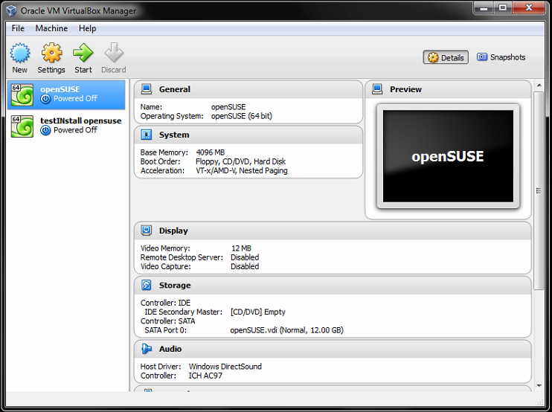

- Turn on the CANBus by opening the konsole, cd to VSCADA twice and run ./can_up and enter the password (AEC401)
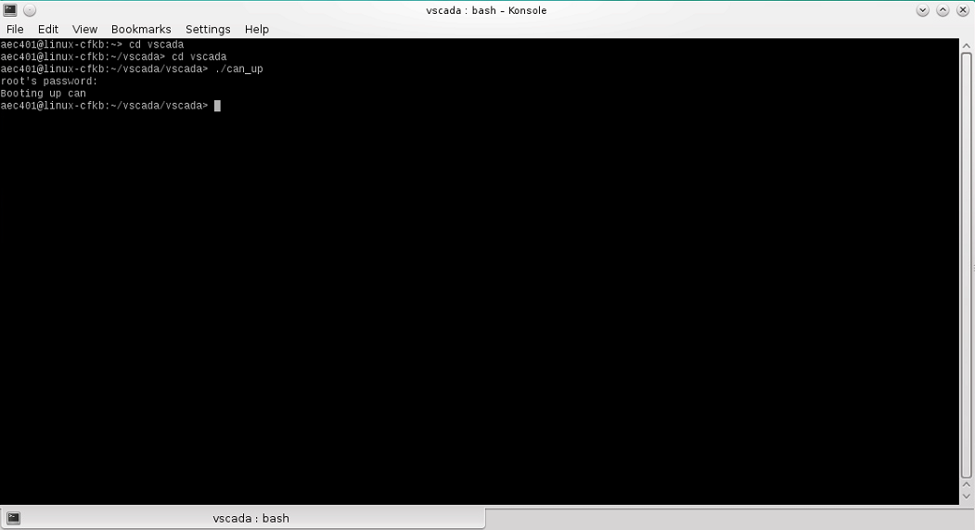
- Once open, Click on the Dyno Icon located on the desktop
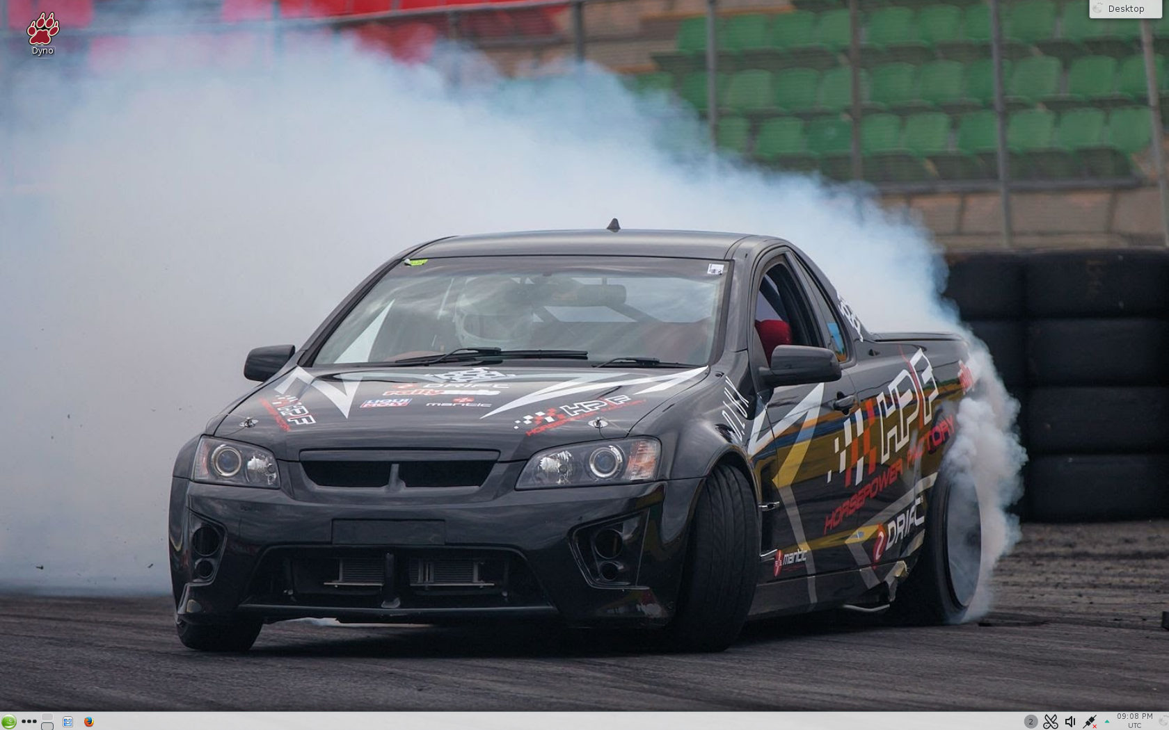

- Enter the password AEC401
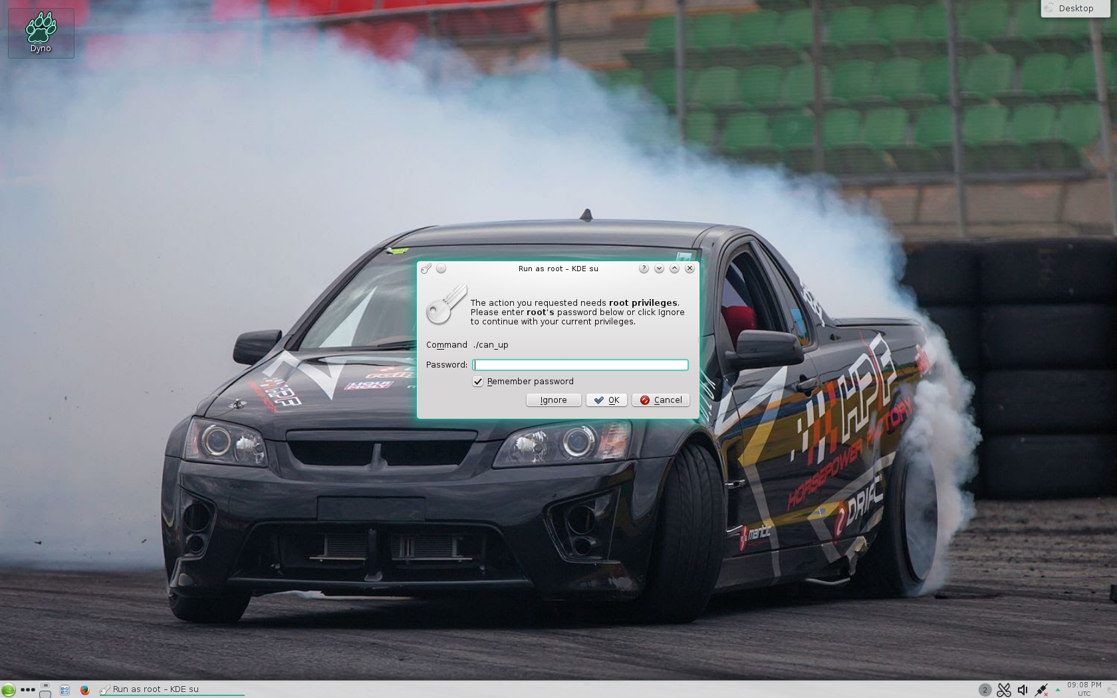
- Now the following two GUIs will be displayed and you will be able to control your test from these
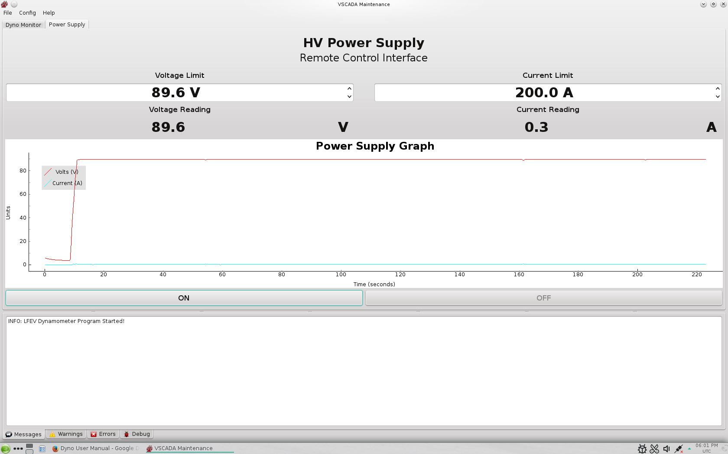

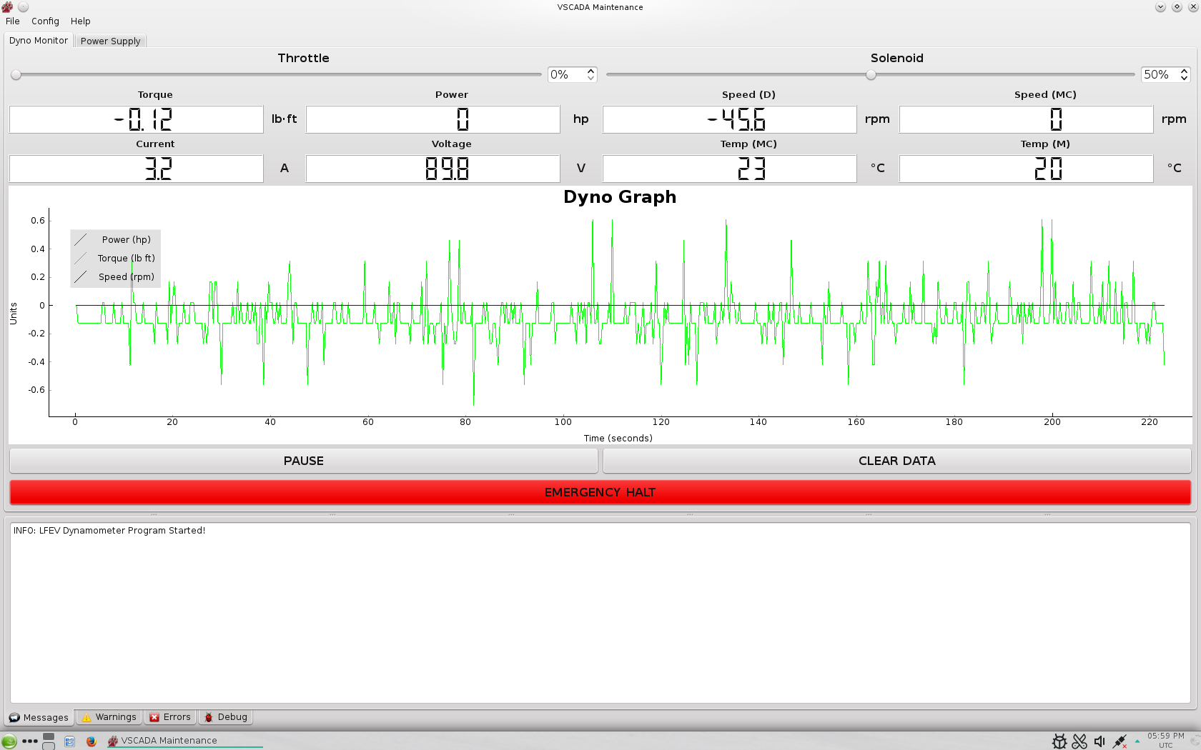
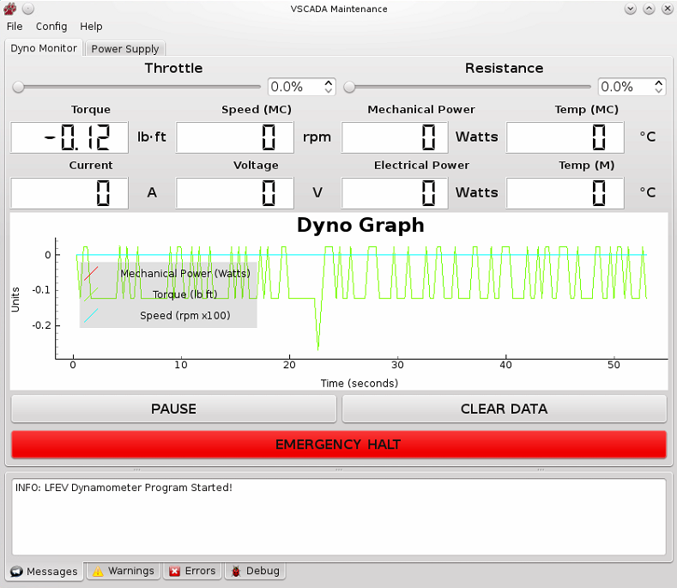

Run Test
Using the Dynamometer software Turn the power supply on by pressing “ON”. The most realistic values to set the power supply to are 89.6 Volts and a 200 Amp limit. This is most similar to how the batteries will behave. The user should be able to navigate to the Dyno software to run the type of test they wish to run by varying throttle and solenoid valves in the software. Pressing “Pause” on the GUI will stop data collection and pressing “clear data” will delete the current data being stored.
In case of a possible emergency turn the throttle down to 0 and the solenoid down to 0. If there is imminent danger press the “Emergency Halt” button to stop the motor.

Changing the Motor Controller Parameters
Repeat the same steps from “Power on”. Turn the power supply “ON” and to 89.6 Volts and 200 Amps. Minimize the Virtual Machine and enter the Windows screen of the Test Stand PC. From here launch the Curtis Software. Below are a list of parameters you have access to changing. Please consult the Curtis Documentation to know what each parameters does and how it will affect the system. Once you have changed your desired parameters press program and that will change the Motor Controller Parameters to your new settings.

Power Off

Stop all running tests and ensure that the motor is not spinning. Once the motor has stopped, use the VSCADA software to turn off the voltage and current to the motor controller, by pressing “OFF” in the power supply GUI window. Once this is completed, it is now safe to enter the room to turn off the power supply, the Huff Box and turn off the switches on the test stand. (The Test Stand PC does not need to be turned off.)

In the Dynamometer software go to File->Save. This will prompt the user to chose a location and name of the data csv file. Once data has been successfully recorded it is now safe to exit the software. Next have Professor Nadovich proceed to Tag and Lock-Out the power to the room.

Troubleshooting

System will not turn on
Verify that the the Tag and Lock out box has the power turned on by Professor Nadovich. If it is powered turn it off so that you can check that all connections are secure. If it powered off turn it on and attempt to reboot. When checking connections verify that all connection are secure to their respectively ports. After this turn the Tag and Lock switch back on and retry to run your test.

Huff Data is not showing up
Verify that the Huff box is on, on both the Test Rack and the Huff Box. After this unplug the USB connector to the Huff Box and plug it back in. Now restart the system and try again.

CanBus Data is not showing up
Verify that you are correctly hooked up to the CANBus through the Kvaser LeafLight. Then open the console on the desktop, cd to VSCADA twice (cd Vscada), and run canUp (./can_up) and enter the password (AEC401).

Motor will not spin
If the motor is not spinning verify that the system is powered on and that all connections are secure. Also make sure that the emergency stop is open. After this restart the system and try again.

Software is not Responding
Close out of the VSCADA software and re-enter it. If it is still not responding close the Virtual machine and relaunch in the system. If this also does not work power off the test stand PC and then retry.

Power Supply Data is not showing up
Close out of the VSCADA software and re-enter it. If it is still not responding close the Virtual machine and relaunch in the system. If this also does not work power off the test stand PC and then retry. /n.b. power supply off and on

Power Supply LCD Screen not on while powered
To fix this error you will have to unplug the serial cable from the RS232 to USB Connector attached to the testing computer. This will reset the LCD screen so that you can see currently used current and voltage.

Other Problems
Turn the entire system off and verify connections. After this turn the system back on and attempt your test. If a problem persists after these suggestions email diegor@lafayette.edu for further instructions.

Maintenance and Calibration

Water Cooling System Maintenance
In its current state the water cooling system is not maintainable. The water reservoir can not be emptied without removing the entire motor controller stand from the dynamometer. This issue must be addressed next year. A possible solution to consider is to move the main water basin off the dynamometer. This will let the water be changed more easily as well as air would be able to escape the system.

Dynamometer Oil Maintenance
The oil in the dynamometer does not need to be changed or replaced unless there is a spill. In the case of a spill there is oil absorbent located in AEC 402. After consulting an advisor proceed to apply the absorbent followed by a clean up of the room when the oil has been absorbed.
Once the new oil has arrived to replace the oil you must get the oil pump from the mechanical engineering workshop. They will instruct you on how to use this to refill the dynamometer with oil.

Software Maintenance
All software maintenance information can be find in the VSCADA maintenance manual.

Sensor Calibration
All sensor calibration can be found in the Dynamometer Calibration and Maintenance Manual. Depending on the sensor the data may be calibrated by the electrical system or can be altered in post by the VSCADA system. As of 5/12/2015 all sensors have been accurately calibrated.

Safety

There are several safety concerns when operating the motor controller system. The first one the user will come in contact with is the high voltage and current associated with the power supply. In order to minimize the reason of harm, twist lock connectors are being used to secure the connection between the power supply and motor controller. It is also important to ensure that the power is powered off any time the twist lock connectors are to be attached or removed.
Another safety precaution taken is not allowing anyone into the room during testing. This is to prevent serious harm in the event of catastrophic system failure. This failure could happen in two forms. The first form is mechanical failure. One or more components of the dynamometer or motor could fail. Due to the nature of the system components moving at high speeds under load critical failure could result in components being ejected from the motor controller system at high and potentially lethal speeds. The second form of failure is electrical. If the power supply or supporting electrical connection developed an electrical arc or electrical blast, serious bodily harm could come to anyone in the room. While the likelihood of this quite low it is yet another reason why it is required to remain outside the room during a test.

In order to safely use the power supply and the connecting wires there are casings that are too be modeled and manufactured in order to prevent tampering of the connectors. These causes will be drawn in AutoCAD and will be used in order to house the connections. We cause to create these housing as a safety precaution. As was mentioned before they will reduce unnecessary contact between the high voltage connectors and the outside world. They will also prevent any tampering with the connections while the power is on. On top of the casing will be safety reminders to not remove the housing unless the power supply is off. This will ensure that no operator will attempt to remove or change cables with the power supply is active. We believe that is a reasonable route to follow for safety because it will be cost-effective but also will ensure that there are not accidental injuries while using the connectors.

As per our own safety specification we are not allowed to be in the room while the motor is running. Because of this we will be using scripting and remote options to run the power supply while not in the room. Scripts will be generated that will allow any user to run pre-approved scripts that were generated and tested by the dynamometer team to ensure their safety and effectiveness. Anyone who wishes to run the motor must do so with a member of the dynamometer team. This will be ensured by the dynamometer team remote login information will only be known to the dynamometer team.

For further safety concerns and procedures refer to the ECE 492 Safety Plan written by Alex Hytha

Glossary
CAN → Controller Area Network
Dyno → Dynamometer
GLV → Grounded Low Voltage
JGB→ John Gehrig Board
LFEV → Lafayette Formula Electrical Vehicle
SAE → Society of Automotive Engineers
TSI → Tractive System Interface
TSV → Tractive System Voltage
VSCADA → Vehicle Supervisory Control and Data Acquisition

FAQs
Why did you select X part?
Power Supply- We chose this power supply because since our the TSV battery pack is expected to supply 90 volts and 200 amperes of current. Our power supply can supply 100 Volts and 250 Amps, this means we can adequately test the conditions of the battery pack even if we do not have all 4 built yet. In addition to this we can for data analysis purposes exceed the expected battery pack limit to perhaps find a more suitable range. Lastly this model of power supply will let us remotely control the power supply
Motor and Motor Controller- The motor we chose is a 3 phase AC induction motor. We chose this because with the TSV constant voltage we can spin the motor faster for varying the AC frequency. This is accomplished by the Motor Controller. Since Curtis and HPEVS partnered together to sell both the motor controller and motor we chose to purchase them because we knew they had been built to work together.
Dynamometer- The dynamometer was chosen because it was rated to withstand the horsepower generated by the motor. It also included a sensor box that allowed for sensor readings of the dynamometer system.

How much power does the system use?
This is dependent on the that is being run. If the power supply (or battery) is working at full capacity it will be about 89.9 Volts at 200 Amps. This means the system is using 18kWatts of power.

When is the motor operating most efficiently?
According to the HPEVS website the motor performs at peak performance when drawing 650 Amps.

What would cause the system to shutdown automatically?
If the safety loop is tripped or if the motor or motor controller begins to overheat it will shut itself down.

