ECE 492
Sensors Design History

- Change in obstacle detection process (December, 2024). The previous process couldn’t distinguish the main plane present, and had a higher failure rate in obstacle recognition. The previous design is presented in this diagram.
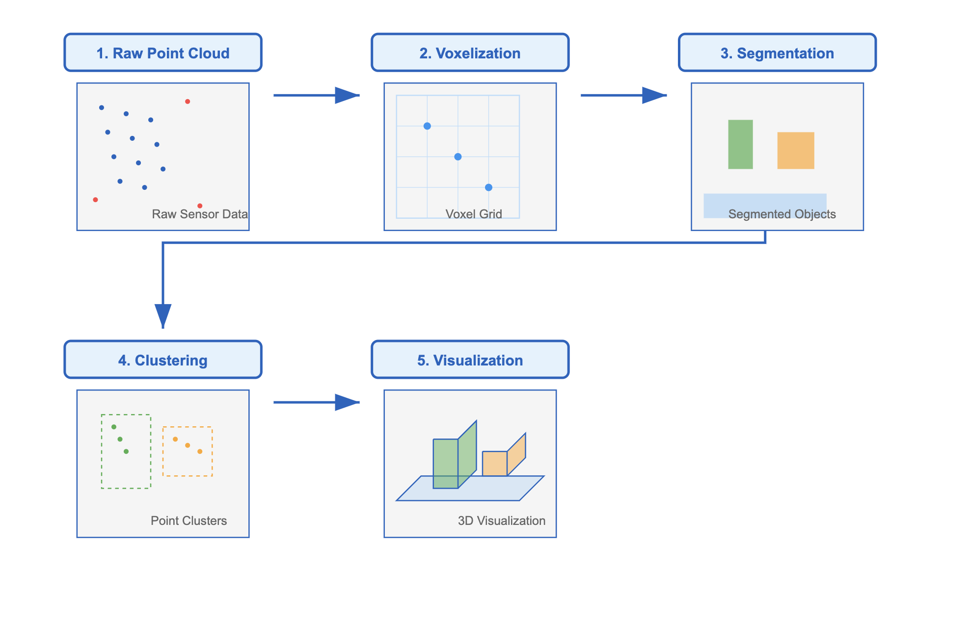

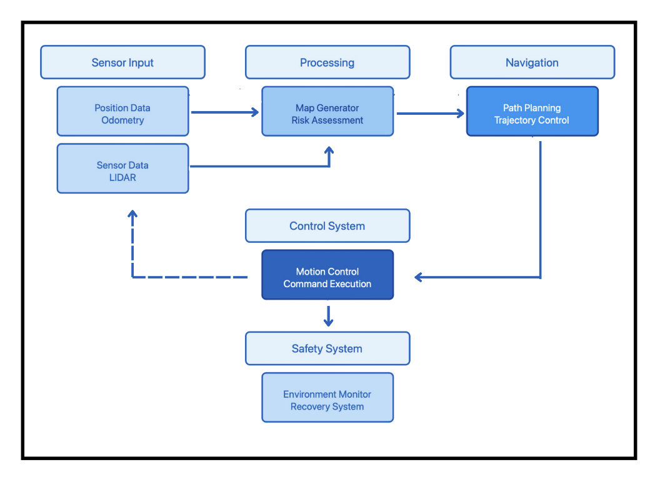
- Change in the way we process the data and we come to a decision (December, 2024). We analyze the results from the LiDAR and we analyze the results from all the other sensors and then we come to a common decision on how ar is the obstacles from us and our decision where we will move (distance, angle) and what will be our relative speed.

