ECE 492
Physical Design History

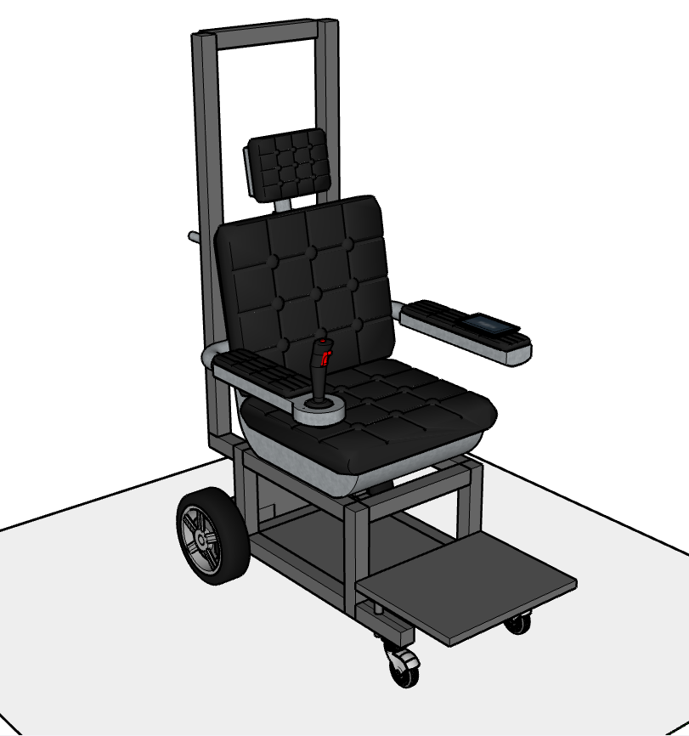
Fig. 1. Version 1, finalized 09/18/2024. Drawing created using Sketchup.

This is the first version of the overall physical wheelchair robot design conceptualized by the team. The design features an 80/20 aluminum frame which supports the chair, passenger, and associated components. Underneath the wheelchair, an aluminum box frame is left open to allow space for the electronic components, as well as the battery. For the footrest, a flat plate of aluminum serves as the rest for the passenger. On the back of the wheelchair, handles provide the ability for a nurse or caregiver to move the wheelchair manually while standing. For the wheels to power the robot, there are larger drive wheels and smaller front swivel wheels.
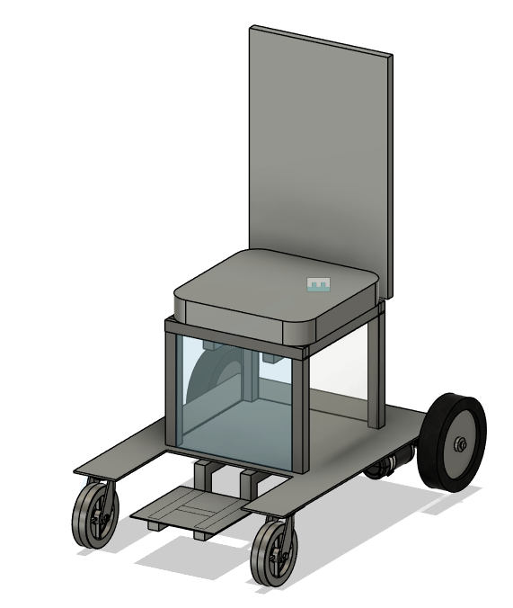
Fig. 2. Version 2, finalized 10/17/2024. Created using Autodesk Fusion.

Version 2 of the physical wheelchair assembly features a different box design supporting the chair. Instead of an open design, the box is enclosed on three sides with clear material, with one side left open to allow for making adjustments inside. The wheels are noticeably different from previously, as the front wheels become stronger castor wheels capable of supporting a heavy design compared to the smaller swivel wheels. Wheel choice was made after researching optimal power wheelchair sizes for drive and castor wheels and evaluating specifications of chairs on the market. Also, the motors chosen for the project are incorporated into the physical design, attached to the drive wheels. The new design features a separate wheelchair base plate and smaller, attached footrest plate to allow for greater leg room. Underneath the base plate, which is more U-shaped, there is an H-frame shaped frame providing support for the plate. Notably, the handles on the previous design and the tall frame for a light/sensor have been removed from this version, and the group will revisit this accessory component as the design is finalized.

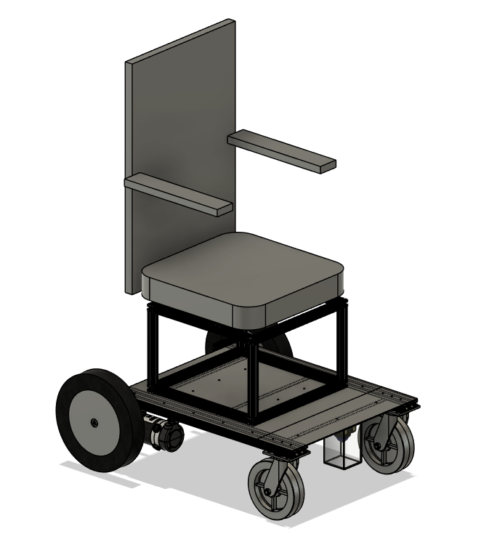
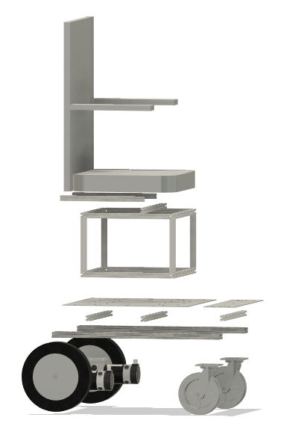
Fig. 3. Version 3, last updated 02/19/2025. Created using Autodesk Fusion.

This is Version 3 of the complete physical design. The most notable features of this design are the box frame, which is redesigned to be larger (close to the width of the seat) and provide greater stability and support for the passenger, and the footrest, which is now a narrow plate in line with the base plate. Due to concerns about stability of the footrest structure, the group decided to place the footrest plate on the same level as the base plate. Now, both footrest and base plates are supported by triple-wide 80/20 aluminum underneath, ensuring that the parts stay in place and are supported. The new footrest also allows the user more space, as they are not constrained by the narrow gap in the base plate. This final version of the robot system synthesizes all design considerations and structural/support concerns brought up by previous designs. Version 3 of the robot is in testing according to the predetermined ATP protocols detailed in the Final Project Report Proposal. All tests, including stability, weight limit, directionality, and speed tests, received passing marks.

Evolution of Individual Components

- Base plate
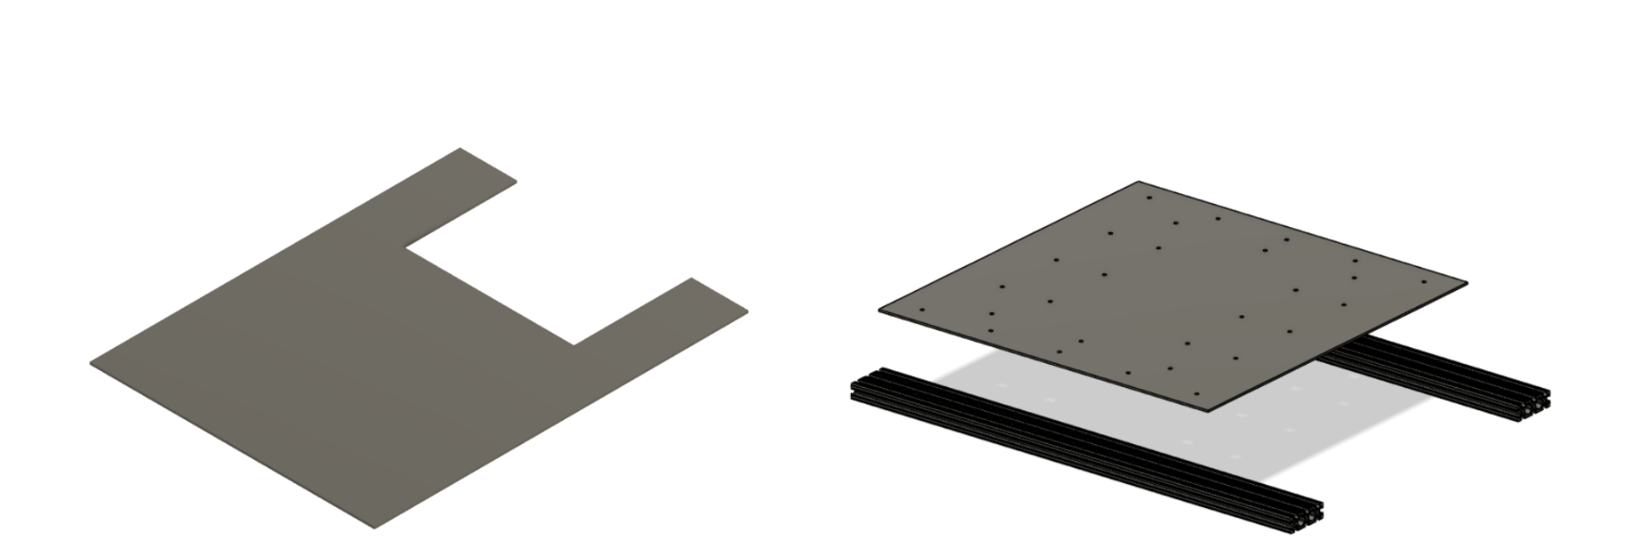
Fig. 4. Original design of the base plate (left) compared to the final version (right). Created using Autodesk Fusion.

In the original design, the aluminum base plate featured a rectangular cutout and H frame of 1-inch thick 80/20 underneath for support. This design left room for a lower attached footrest plate. In the final version, there is a square aluminum plate and double wide (3-inch) 80/20 for support. Along these 80/20 pieces, the footrest plate will be attached.

- Footrest

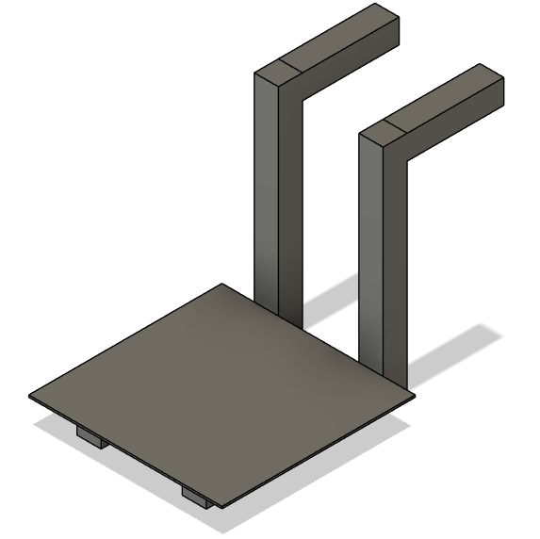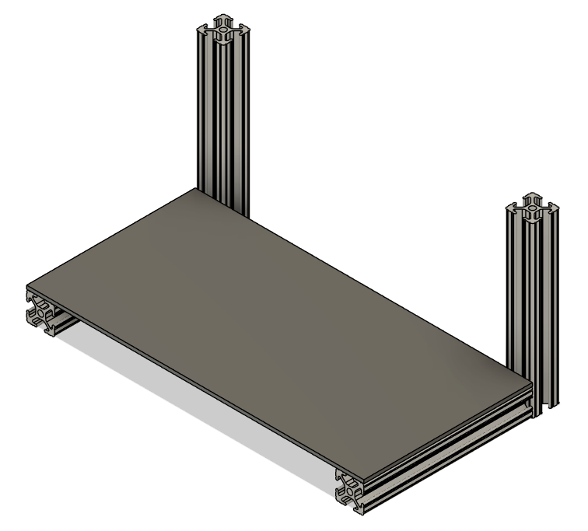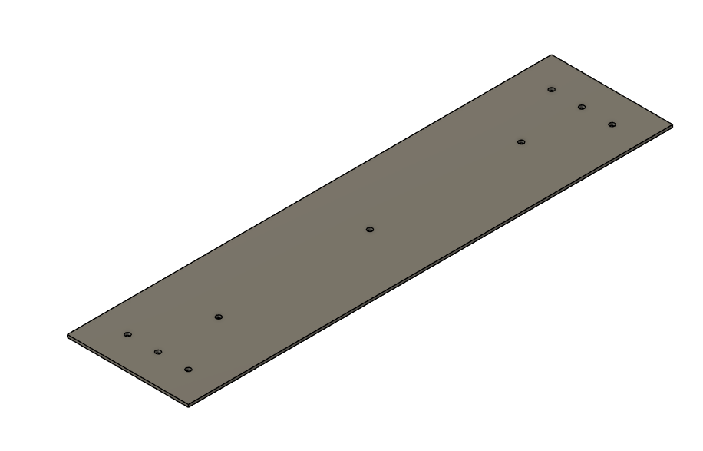
Fig. 5. Original design of the footrest (left) compared to the updated version (middle) and the final design (right). Created using Autodesk Fusion.

In the original design, the footrest is envisioned as a separate plate which is smaller than the width of the base plate, and is attached to the chair using 1-inch thick 80/20 which supports the bottom. The second updated design has the footrest wider than the previous version, with 80/20 continuing to support the underside of the footrest plate. In the final design, however, an aluminum plate, the same width as the base plate, serves as the footrest. This wide plate is supported by the triple-wide (3”) 80/20 aluminum attached to the base plate.

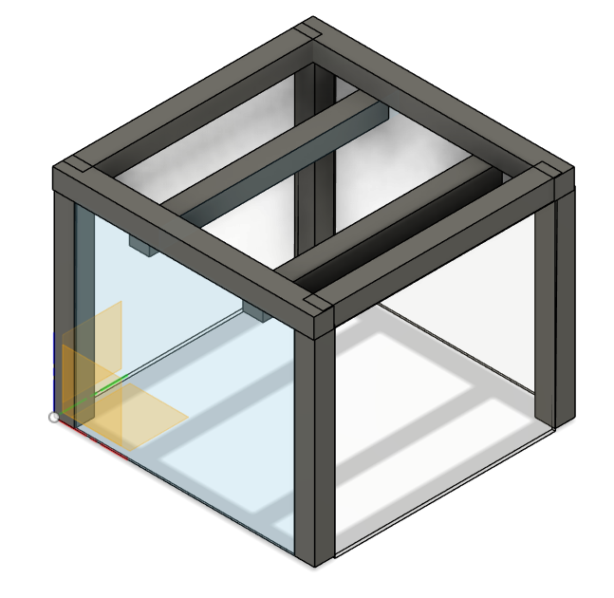
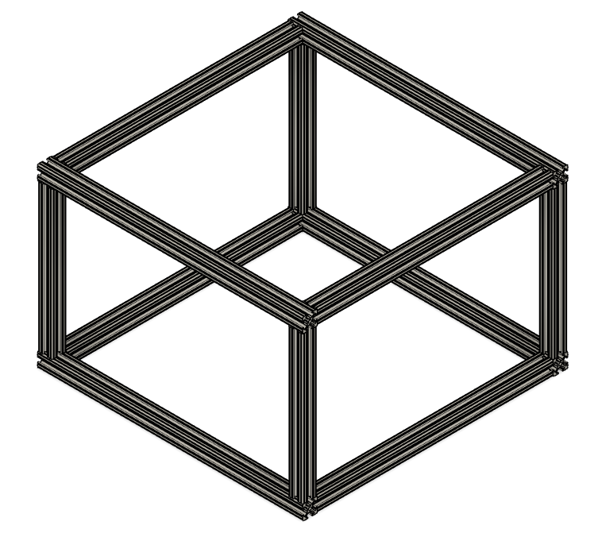
- Box
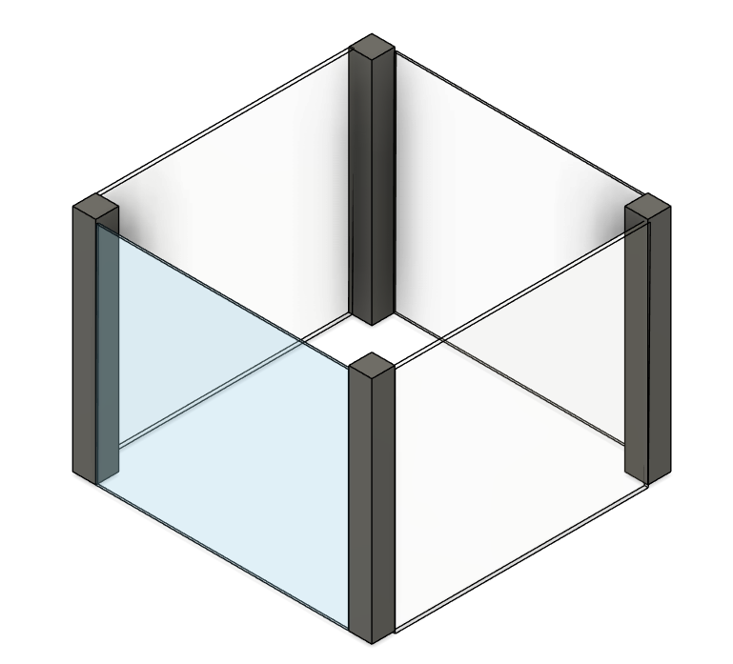

Fig. 6. Original design of the box and wall enclosure (left) compared to an updated version (middle) and the final box design (right). Created using Autodesk Fusion.

Fig. 6 shows the evolution of the box design enclosure for the robot system. Initially, it was planned to use four pieces of 1-inch thick 80/20 to comprise the pillars upon which clear plastic would be used as walls. After consideration of stability and weight, additional support was added in the form of 80/20 framing on the top of the box. The final design is simpler and improves stability, using a box skeleton frame connected by brackets to form the box inside of which electronics will be placed, and upon which the chair will rest.

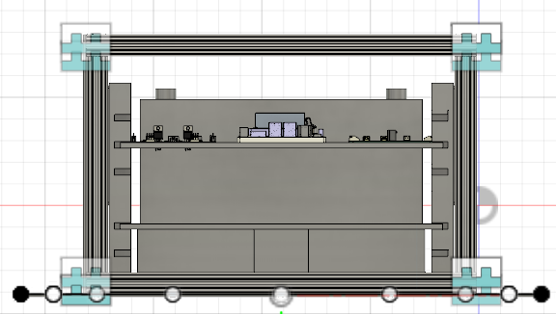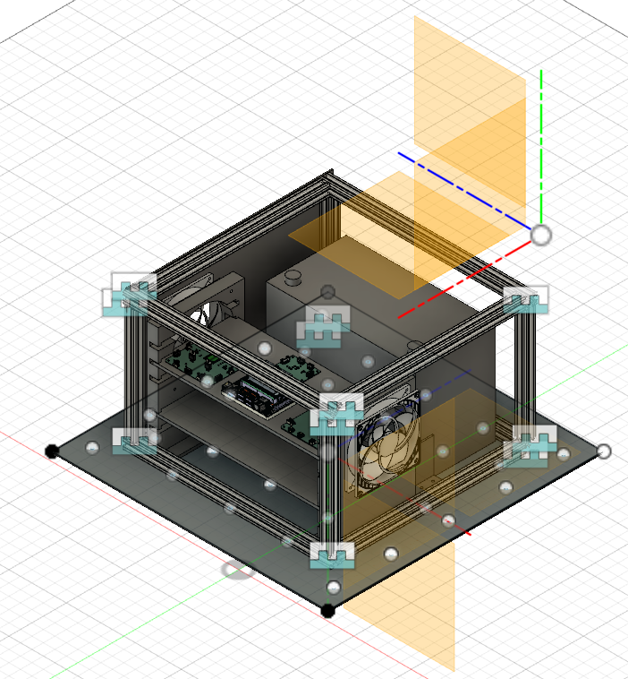

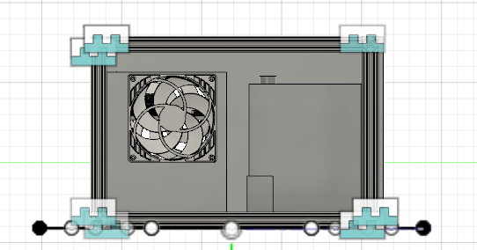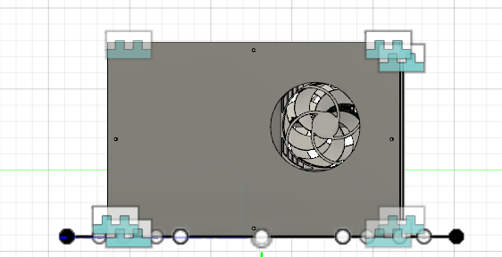
Fig. 7. Final design of the box, with a front view (top left), bird’s eye view (top right), right view (bottom left) and a left view (bottom right). Created using Autodesk Fusion.

Fig. 7 is the final version of the box design , which features a two tiered 3D printed shelving system to house electronic components and the fans, which are responsible for cooling. The shelves were designed by the team to fit the exact measurements of the electronic components, and they are able to slide in and out of place for easy access. The battery holders, also 3D printed, hold the battery in place on one side. On the other side, the battery is held flush against the 80/20 box frame. This final design has been tested, and all components fit securely in place and dimensions are verified by the team. Proper fit and security of components can be assured.
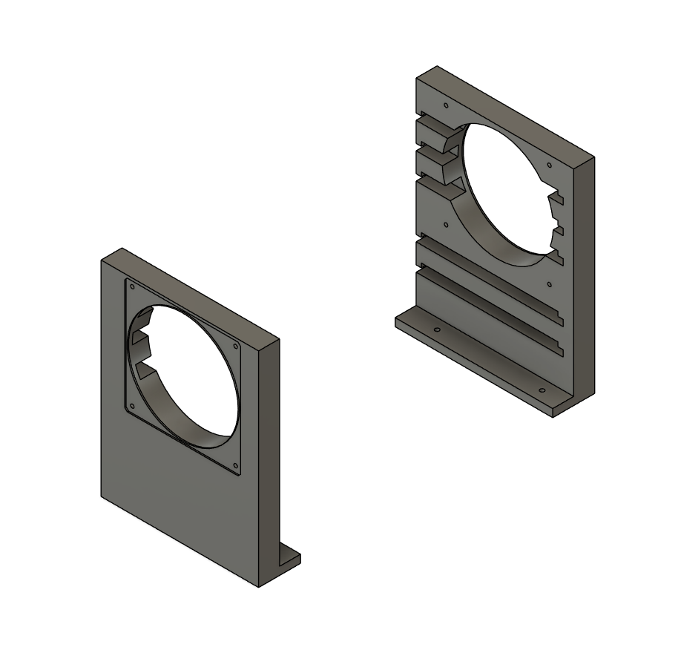
Fig. 8: 3D view of the shelf holders in Autodesk Fusion.

- Shelf Holders

As a set of two pieces, these shelf holders serve as parts responsible for holding the fans on either side of the robot, which are screwed into holes on the side, as well as two slide-in shelves which hold electronic components. The shelf holders are made of 3D-printed PLA material. The parts are screwed into the base plate, securing all associated components and ensuring that parts resist shifting during transport.
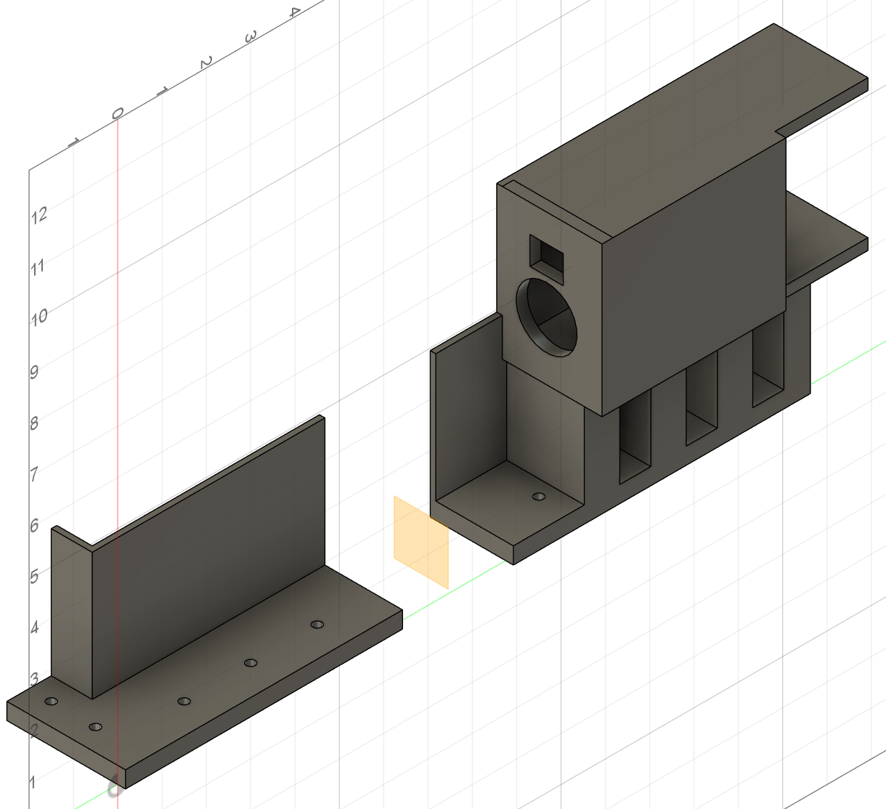
Fig. 9: 3D view of the battery holders in Autodesk Fusion.

- Battery Holders

The battery holders are used to secure the battery in place, as well as hold the charger for the battery. They are made of 3D-printed PLA material. These are secured to the base plate using screws to ensure that there is no movement of parts during transport. The battery holders are flush against the shelf holders.

- Shelves

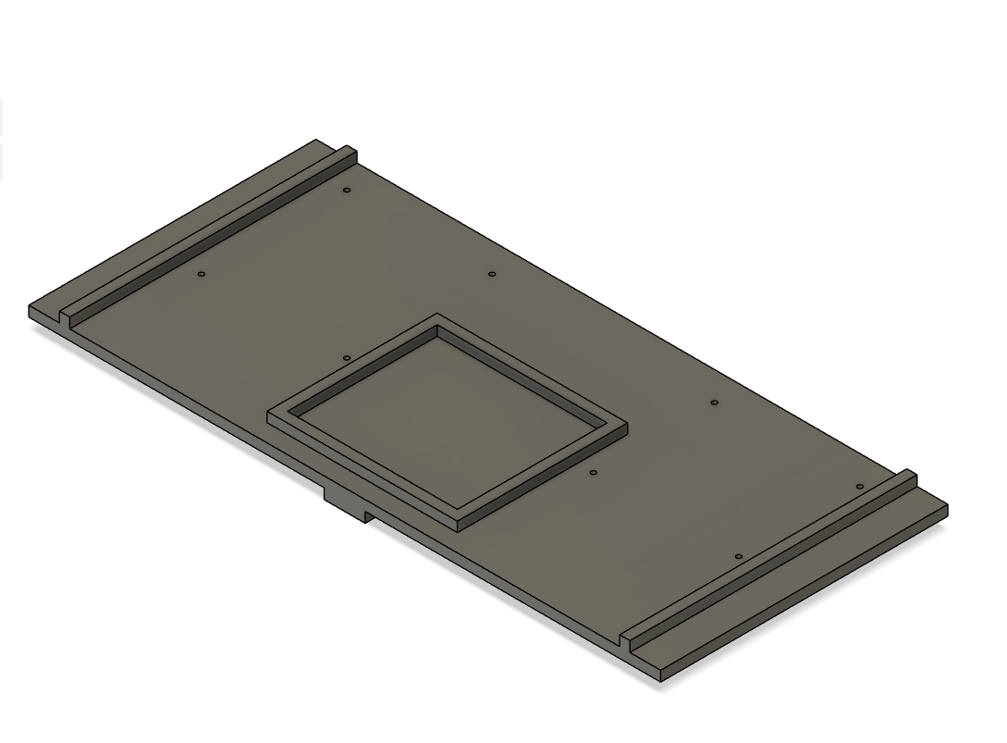
The shelves are responsible for housing the electronic components. On the bottom shelf, the two microcontrollers and their PSBs are held in place. On the top shelf, the Jetson Nano is held in place. The shelves were designed in Fusion to fit the exact dimensions of the electronic components, then they were 3D-printed using PLA.
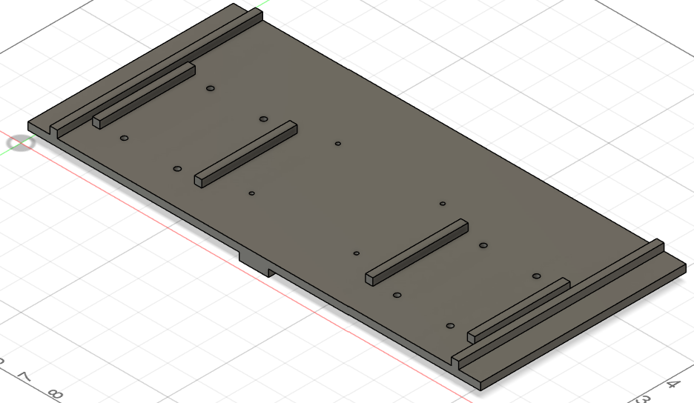

Fig. 10: 3D view of the bottom (left) and top (right) shelves created in Autodesk Fusion.
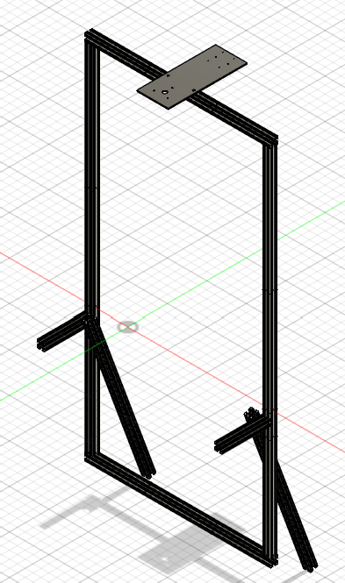
- Side covers

- Light Stand
The light stand is designed to hold the light for the system as well as the LiDAR Sensor at the top. The 80/20 Aluminum square frame connects to the robot at the bottom of the system. The light is placed on top of the square plate while the LiDAR is placed on the bottom of it. The other two 80/20 aluminum rods are made to stabilize the system on the robot. There are two more 80/20’s to act as rods to allow users to push the robot from the back.
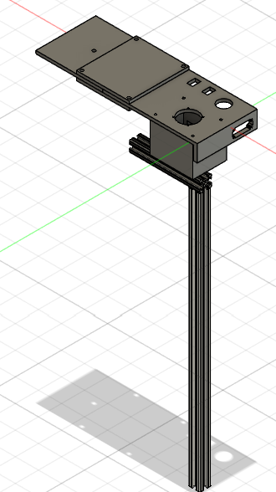
- Joystick Holder
The joystick holder is also the armrest of the system. This full model is 3D printed. The model consists of a section to connect to the original armrest, two different connectors to connect the front and end of the table in a stable manner, and a table end to hold each of the sensor components and the PCB holder box. The PCB holder box is connected to the bottom of the table, and houses the PCB for the Joystick and other components. The 80/20 bars underneath the table are to stabilize the design further, and connect to the plate of the system. The original design was much shorter than the final, but was cut due to this issue.

- Wheels
The drive wheels are 12.5 inch keyed hub wheels. These wheels are designed to fit into the motor’s hole themselves, and support the weight of the robot. The front wheels are 8 inch castor wheels made to swivel. The original wheels did not have a keyed hub, and had to be replaced with the current wheels.

