**10/21/22 Agenda**

1. We need better communication
   1. Every class we will be doing something
2. Communication
   1. Is lacking
   2. When you upload something to drive, you must inform the team
   3. We need to be presenting more to the class
      1. Just like when I do the agendas and show the new mechanical design
   4. Everyone is kinda doing their own thing
3. Better Organization
   1. Team Leaders
      1. They will meet and coordinate so everyone is aware
   2. Everyone will then report to me so we have a constant line of communication
      1. Administrative
         1. Roger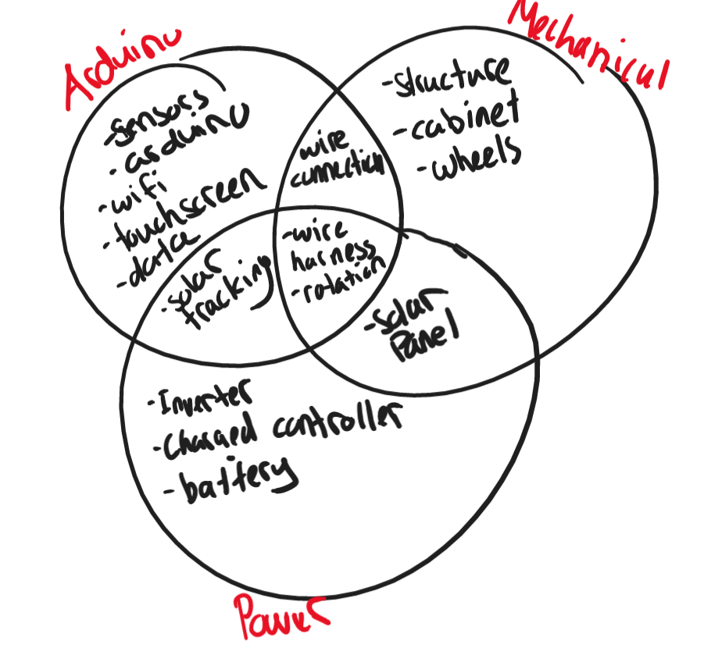
         2. Anna McKay
      2. Mechanical
         1. **Roger**
         2. Haki
         3. Henry
         4. Ziqi
      3. Arduino
         1. Boris
         2. **Will A**
         3. Will O
         4. Zheping
         5. Joe
      4. Power
         1. **Tim**
         2. Chiko
         3. Boris
         4. Will O
4. Final Proposal
   1. Haki is taking charge
   2. Needs in depth SPECS
      1. Power numbers, degrees of rotation, cost, all components, how to operate
   3. Statement of Work
   4. Dates
      1. Due November 9th
      2. Halloween- fleshed out table of contents for Wey to review
         1. After we submit, we will then be doing presentation and pinpointing particular items that still need to be bought for february
5. Separate sections for mechanical and electrical
   1. Roller bearings
6. Ardions are not controlling the motors
   1. Need H-bridges and level transfer for powering
      1. Through hole parts
   2. Need Level Transfer
7. Tim
   1. 18 W just for arduinos and screen is not reasonable
   2. Discuss with the team and show
8. Anna McKay and Zheping
   1. Work together on the usermanual
   2. Discuss how to use the display, how to assemble and disassemble, etc
9. Will O
   1. Diagrams, relative sizes
      1. Force sizes and components
10. Chiko
    1. Angles measurements and rotations
    2. Degrees of rotation
11. Boris
    1. Create a video demonstrating your arduinos
    2. Upload to drive