A Conceptual Plan for a Communal Green Space along Bushkill Creek: With a Focus on Well-Being, Ecology, and Integrating Communities

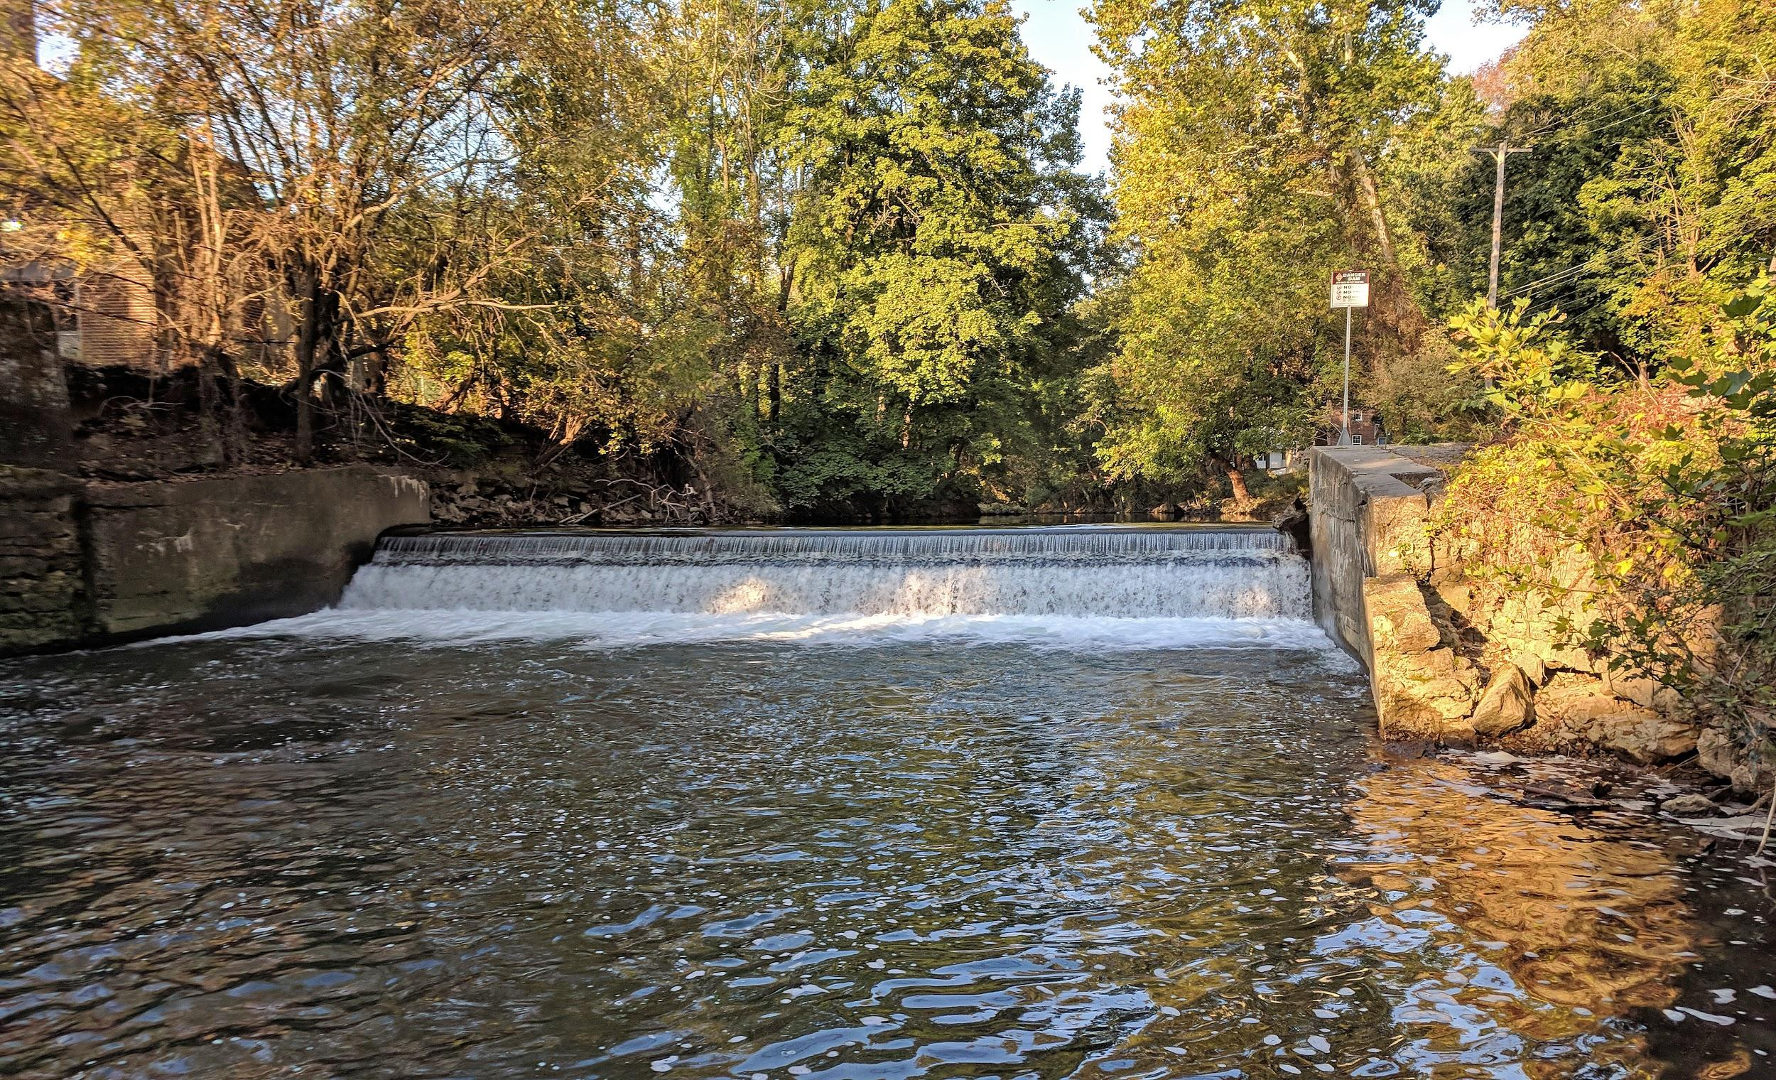

Prepared by:
Lafayette College Environmental Studies Capstone, EVST 400
Connar Dehnert ‘19
Hope Gernert ‘19
Kate Rubin ‘19
Elana Weinstein ‘19
Professor David Brandes

Prepared for:
Lafayette College
Easton, PA 18042-1779
Karl Stirner Art Trail

Fall 2018
Table of Contents

Introduction ……………………………………………………………………………………. 02

Our Process ……………………………………………………………………………………. 02

Bedrock Principles …………………………………………………………………………….. 02

Enhancing Green Space to Promote Well-Being ……………………………………………… 03

Building an Integrated Community ……………………………………………………………. 03

Restoring Stream Ecology Through Sustainability ……………………………………………. 04

Examples from Other Competing Colleges and Universities …………………………………. 05
- Hamilton College ……………………………………………………………………… 05
- Cornell University …………………………………………………………………….. 06
- Dickinson College …………………………………………………………………….. 07
- Colby College …………………………………………………………………………. 07

Our Proposal …………………………………………………………………………………....08

Estimated Costs………………………………………………………………………………...10

References ……………………………………………………………………………………. 11

Introduction

The Fall 2018 Environmental Studies Capstone has explored the possibility of converting the currently unused space along Bushkill Drive into a green space. This area runs parallel to Bushkill Creek, between The Spot and where it meets Sullivan Road (see Figure 1). This space presents great potential as a key location that connects the College, the City and the entrance to the Karl Stirner Arts Trail. Furthermore, sustainability is one of the College’s three core values, and the Environmental Studies Capstone class considers this value to be the focal point of this project proposal. The impetus for this project is threefold: the planned removal of Dam 1, owned by the College; the lack of communication between the Karl Stirner Arts Trail and the 3rd Street Arts Campus; and the City of Easton’s plan to close Bushkill Drive to traffic. Extensive research was conducted in September, October and November of 2018 to consider the possible advantages and disadvantages that a green space offers, the community’s desires, the ecological impacts, and the costs of implementation. A conceptual plan is presented in the following report to create a green space for the surrounding communities to enjoy.

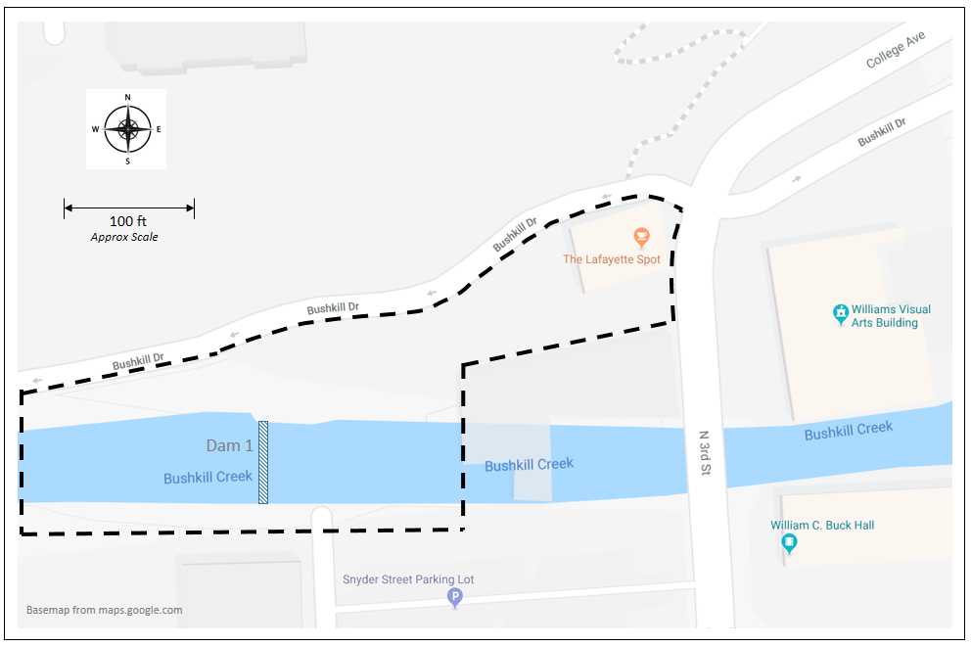
Figure 1. Map of the Project Area

Our Process

The students in the Environmental Capstone divided into three teams: Communications and Outreach, Restoration and Ecology, and Concept Planning. Each team communicated with local professionals in specific areas to gain information and inside thoughts on ideas for the Bushkill Creek area. Each team consists of three or four students. Professor David Brandes helped us all along the way. As a class, we brainstormed the bedrock principles of our project and revised them throughout the semester as the project evolved. These are shown below.

Bedrock Principles

- Building an integrated community
- Enhancing green space to promote well-being
- Restoring stream ecology through sustainability

Building an Integrated Community

Dam 1 sits at the intersection between College Hill and the Easton Downtown area. This project for stream restoration and enhancement provides the opportunity to bridge the two communities together and build a stronger, mutually beneficial relationship. In many other instances, green spaces have been found to initiate public dialogue around community values and inspire a commitment to stewardship of land and community (EPA). A green space in this community will create an opportunity for people of varying backgrounds to come together and for social interactions and relationships or partnerships to form (Wolf and Rozance). We anticipate that this green space will provide a place where people will want to congregate and engage in community and neighborhood life.

The town of Easton has already constructed the Karl Stirner Arts Trail along Bushkill Drive which provides a beautiful and accessible community space for people to gather at. Dam A sits at the head of the Arts Trail and has become degraded due to lack of maintenance. It is expected that remediating this area will bring even more people from the College and community to the Arts Trail as well as to the new Bushkill Green Space. Further, a new green space will be a place for people to socialize, relax and build interpersonal relationships.

Enhancing Green Space to Promote Well-Being

Green spaces provide numerous benefits to individual mental health as well as to the larger context of humankind’s relationship to nature. One such benefit focuses on the increased promotion of physical health that will stem from restoring the corridor along Bushkill Drive. In doing so, it may encourage and provide more opportunities for community members to get outside and exercise. Although the area along Bushkill Drive between The Spot and the Blue Bridge constitutes part of the Arts Trail, many students are unaware of this fact and instead think the Arts Trail begins around the corner of Butz Park. From there, the trail winds for exactly one mile before the parking lot at the Silk Mill. By restoring this trail connection, students will ideally be made aware that the Arts Trail is actually longer than that one-mile stretch and further extends to the 3rd Street Arts Campus. Thus, they will not only have the opportunity to prolong their walks and/or runs but will also likely be further encouraged to visit the Trail, as it will be closer and more welcoming.

Another benefit focuses on the positive impacts a green space can have on mental health. This time and space can “increase social interaction, soothe mental illness” (Abrams, 2017), and help community members “recover from stress and attention fatigue” (Lee et al., 2015). These health-promoting activities “have a direct relationship with the quality of life of urban dwellers” (Lee et al., 2015). One important feature of such green spaces is access to water. The ability to see, hear, and interact with running water has proven to be beneficial to one’s health (Abrams, 2017). Continuing along this line, studies have shown that “people who think of their local green spaces as more accessible and usable felt more satisfied with their neighborhood” (Abrams, 2017). Additionally, an improved general mental health of Lafayette community members will likely make the school more appealing to prospective students and faculty. Our community has heartbreakingly faced several deaths in recent years, and additional green spaces may offer more spaces for reflection and processing, thus aiding community members in their coping.

Restoring Stream Ecology Through Sustainability

Dam 1 on Bushkill Creek has been around for more than a century with an original purpose of providing power to the Mann & Allshouse mill that no longer exists. This man-made structure has ecological impacts on the surrounding environment, and the Wildlands Conservancy is currently managing a study of the removal of Dam 1 -- owned by Lafayette College -- as well as three other dams on Bushkill Creek. Assuming the engineering studies that are under way do not reveal any problems, it is likely that Dam 1 will be removed sometime in 2019 or 2020. Although some of our proposed plan could be implemented even if the dam remains, we assume that our plan would be most likely implemented immediately after dam removal, given the disturbance of the area that would have to occur during dam removal. The proposed removal of the dam will allow for positive restoration of the surrounding ecology.

Dam removal can be an effective long-term river restoration tool to improve a river’s water quality, sediment transport, and native resident and migratory species recovery. The Environmental Capstone did extensive research on the benefits and drawbacks of dam removals on river restoration; specifically focusing on the sustainability components of ecological, social and economic dimensions of dam removal.

The removal of Dam 1 located on Bushkill Creek is essential to restoring the river and the surrounding area. When the dam is removed, the ecological benefits include increased biodiversity and population densities of native aquatic organisms as the natural flow will be restored to the river. Currently, the dam is located in a flood plain, therefore when it is removed, flooding will occur less frequently. Reduced flooding will promote plant growth which will help create new habitat and food sources for a wide range of species in the area. The more biodiversity a space has, the more it flourishes and becomes a green, luscious space for humans and wildlife to enjoy.

Fishing near the Dam 1 site on Bushkill Creek is very popular, even with the reduced native migratory fish populations. Therefore, once the ecological aspects of the river are restored and more wildlife and fish species are restored, there will be more opportunities for people to fish and enjoy the river.

When the natural flow of a river is restored, it also creates an image of a cleaner space because nothing is left stagnant. When habitat quality is increased people view the area as a cleaner, safer space they can go to relax and participate in recreational activities. Additionally, researchers have found that people place substantial value on the existence of a free-flowing river and the knowledge that once a dam is removed, endangered species have an opportunity to recover (Headwater Economics, 2016).

Removing dams can be an effective way to restore entire watershed ecosystems, revive wild and sustainable fisheries and associated jobs, improve water quality, and improve the lives of adjacent communities and native cultures. There are many benefits of dam removal to help with river restoration. A benefit of removing aging dams is removing a safety factor; there is an increased chance of drowning at a dam site. In addition, weakened aging materials that old dams are made of pose a hazard to downstream communities. Removing a dam brings the possibility of restoring the natural flow and habitat of the river system. Other benefits include the restoration of species migration patterns and rebuilding wildlife habitat. There is also an aesthetic value that comes from removing man made structures from nature (Majilligan, et al).

Examples from Other Colleges and Universities

Many other colleges and universities have implemented some sort of green space on or around their campuses to promote community well-being. Below are a few examples of this from nearby and/or competing colleges and universities.

- Hamilton College (Clinton, NY)
- The Root Glen -- 7.5-acre arboretum located right on Hamilton’s campus
  - 65 tree species, walking paths, meditation area, benches
  - “I can say from personal experience that those glens are deeply beloved spaces on campus and integral parts of the Hamilton experience”
~ Luke Gernert ‘17
  - “The Glen enabled me to escape into a beautiful, natural setting whenever I wanted. It offered a serene space in which to enjoy the company of others or simply have some time alone to think and reflect. I went on beautiful walks and bike rides in the Glen. I explored. Sometimes I just sat and admired. Even when I didn't take advantage of its proximity, knowing it was there comforted me. Without doubt, the Glen was an integral part of my experience at Hamilton; its beauty and expansiveness allowed for some of my best memories.”
~ Jared Mandelbaum ‘18

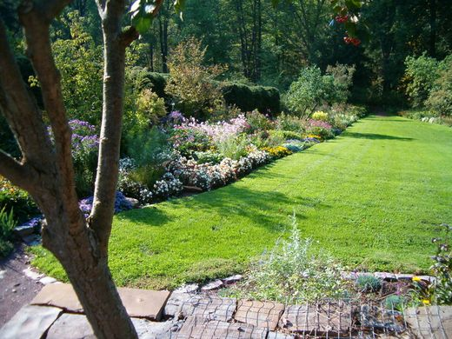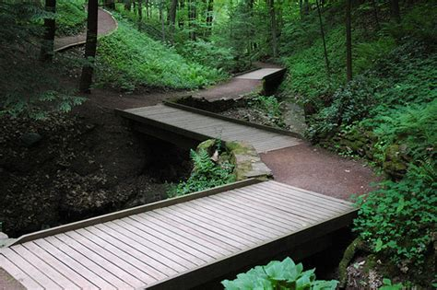
Photos of the lawn at the entrance of the Root Glen at Hamilton College (left) and the walking paths throughout the Glen (right).

- Cornell University (Ithaca, NY)
- The Cornell Botanic Gardens -- 4,300 acre botanic gardens and arboretum adjacent to Cornell’s campus
  - 25 acres of botanical gardens
  - 150 acres of arboretum
  - 3,400 acres of specialty gardens
  - Also maintains four gardens on Cornell’s central campus

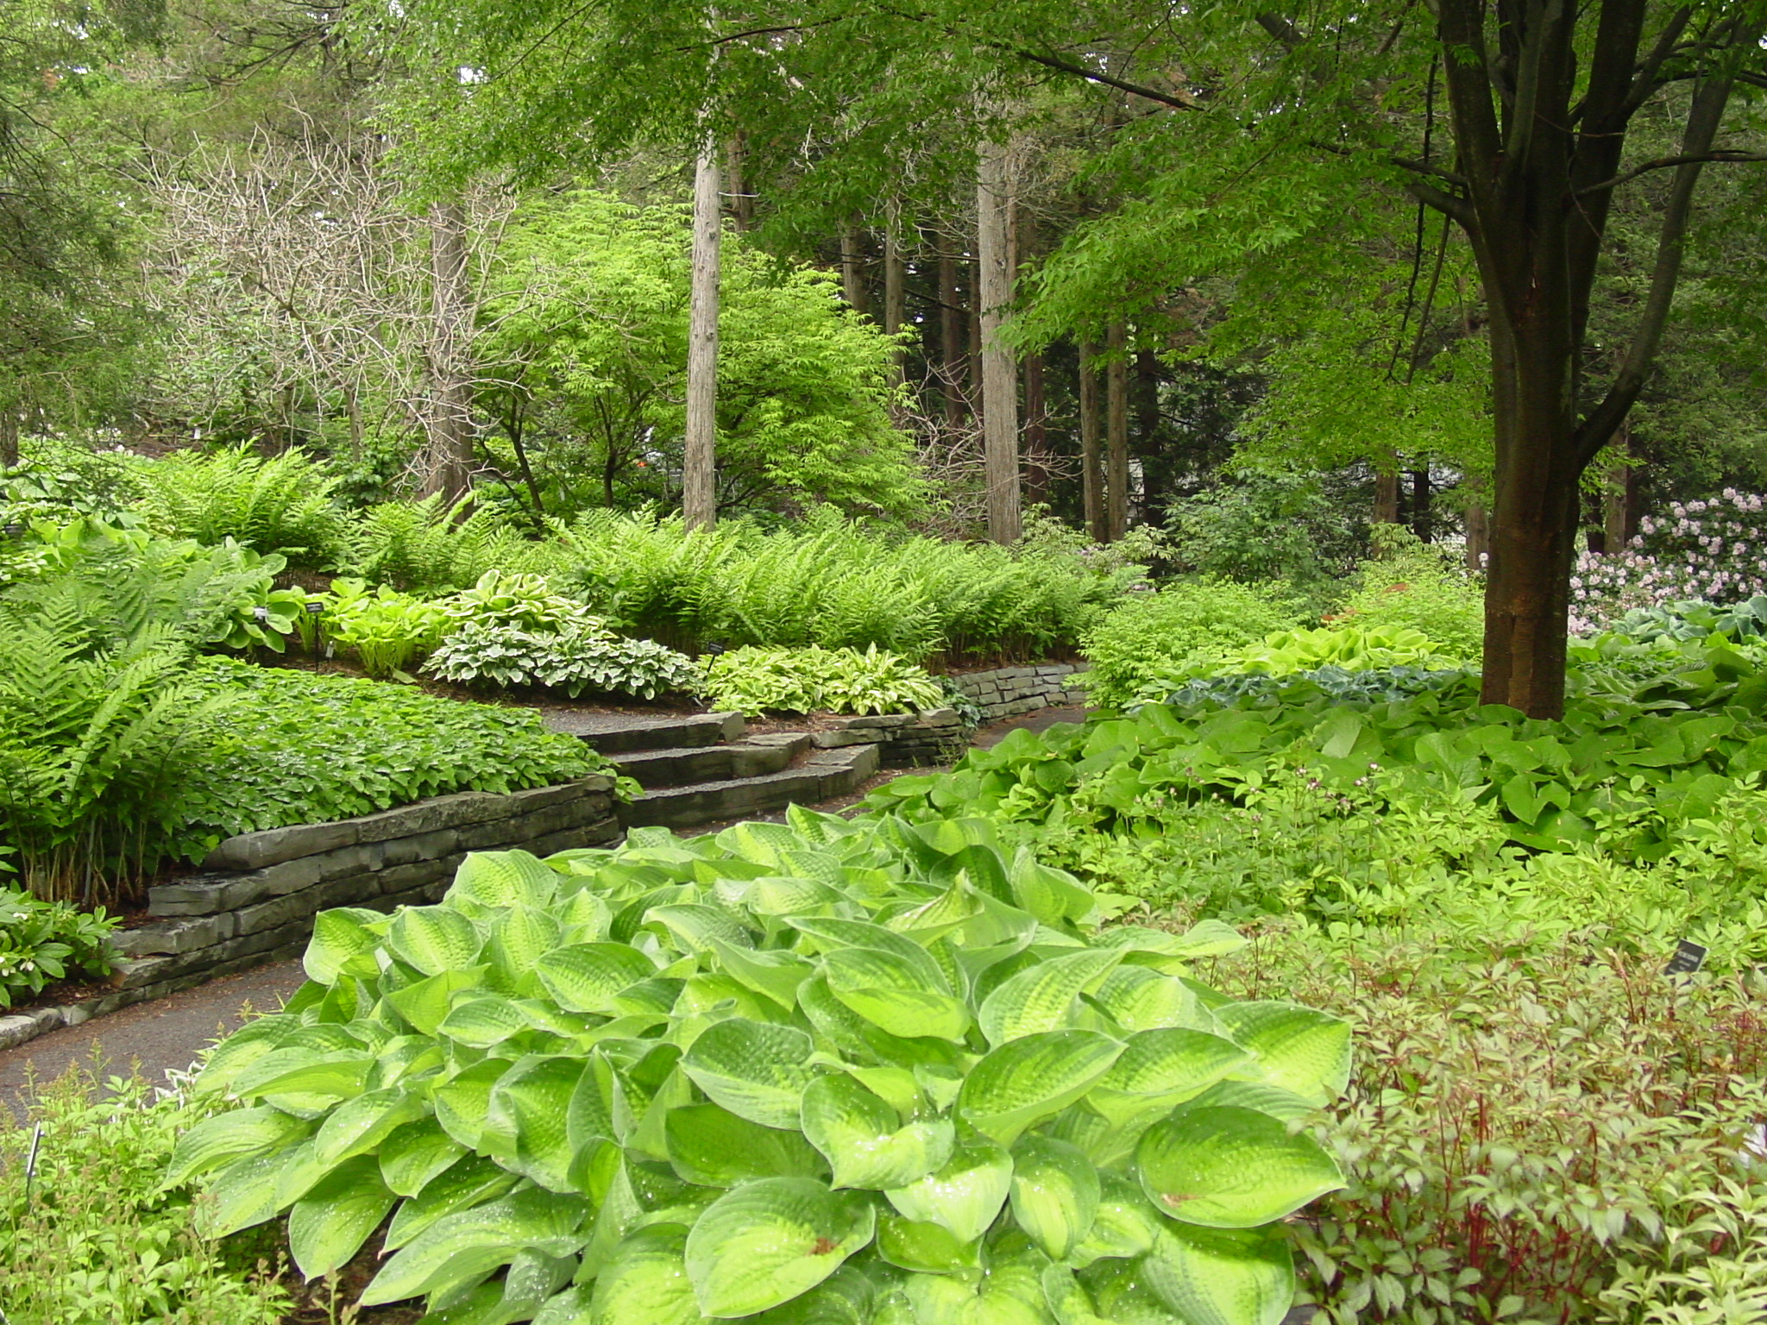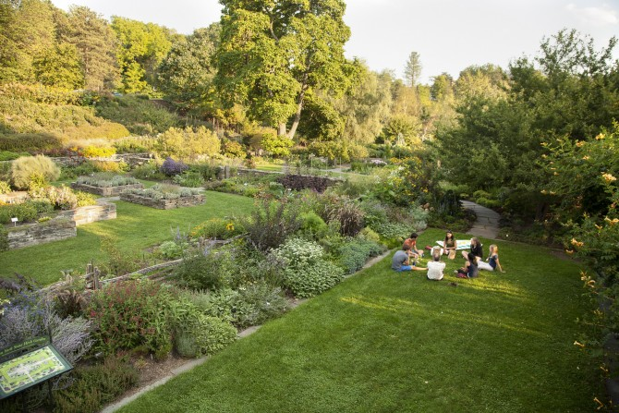
Photos of various areas of the Cornell Botanic Gardens.

- Colby College (Waterville, ME)
- Perkins Arboretum and Bird Sanctuary -- 128-acres, located right on Colby’s campus
  - Around two miles of walking trails
  - “...this year, my last summer as a student, I chose to stay on campus to do research. I spent hours each day before a computer, sorting data and making maps...And so I often found myself doing this at the end of the day: slipping into the woods, walking the trails” ~ Blair Braverman ‘11 (“A Map of Here”, 2010)

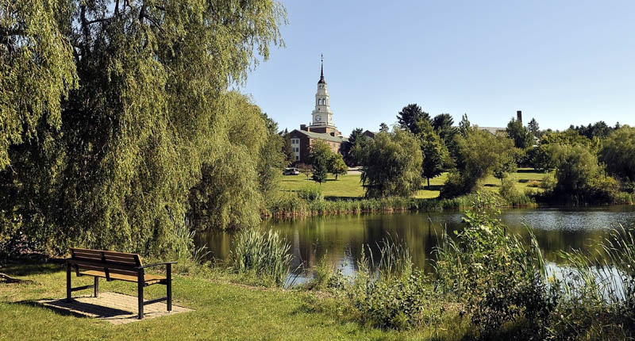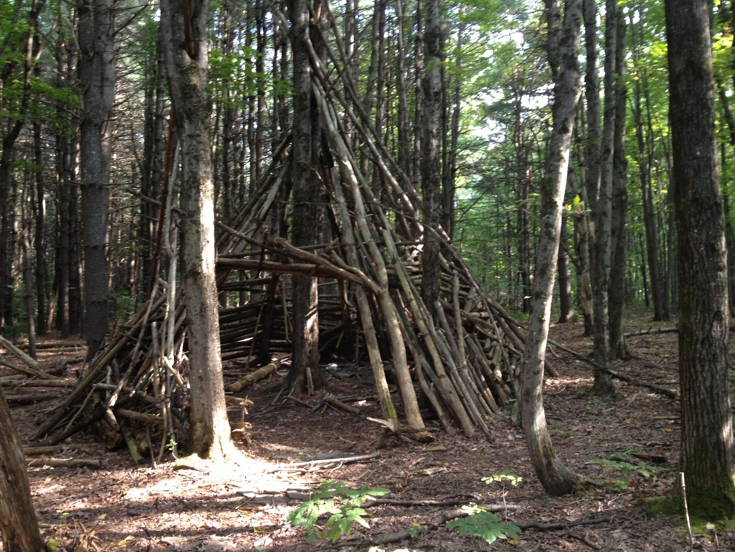
Photos of a bench facing Johnson Pond (left) and a hut built from tree branches (right), both in the arboretum.

Proposal
The restoration plan proposed for the Bushkill Creek location is to create a green space with picnic tables and waterfront seating such as benches and rocks for people to relax at before, while and after visiting the Arts Trail. The Bushkill Drive road area currently appears unwelcoming due to fencing, ‘Keep Out’ signs, utility poles, cement, and asphalt. The following list includes baseline proposed changes to the area to create a more welcoming area and enticing green space:

- Replace overhead utilities with underground utilities
- Remove asphalt and cement
- Remove chain-link fences blocking the river
- Remove signs saying ‘Keep Out’
- Create a path that goes along the Bushkill Creek
- Install bike racks

In addition, the Karl Stirner Arts Trail Organization has ordered an arch to be placed on Bushkill Drive to signal the start of the trail, as well as small flags to label the trail.

The images below are photoshopped images that display what the area will look like without telephone poles, fences, and signs:

Bushkill Area as is now:
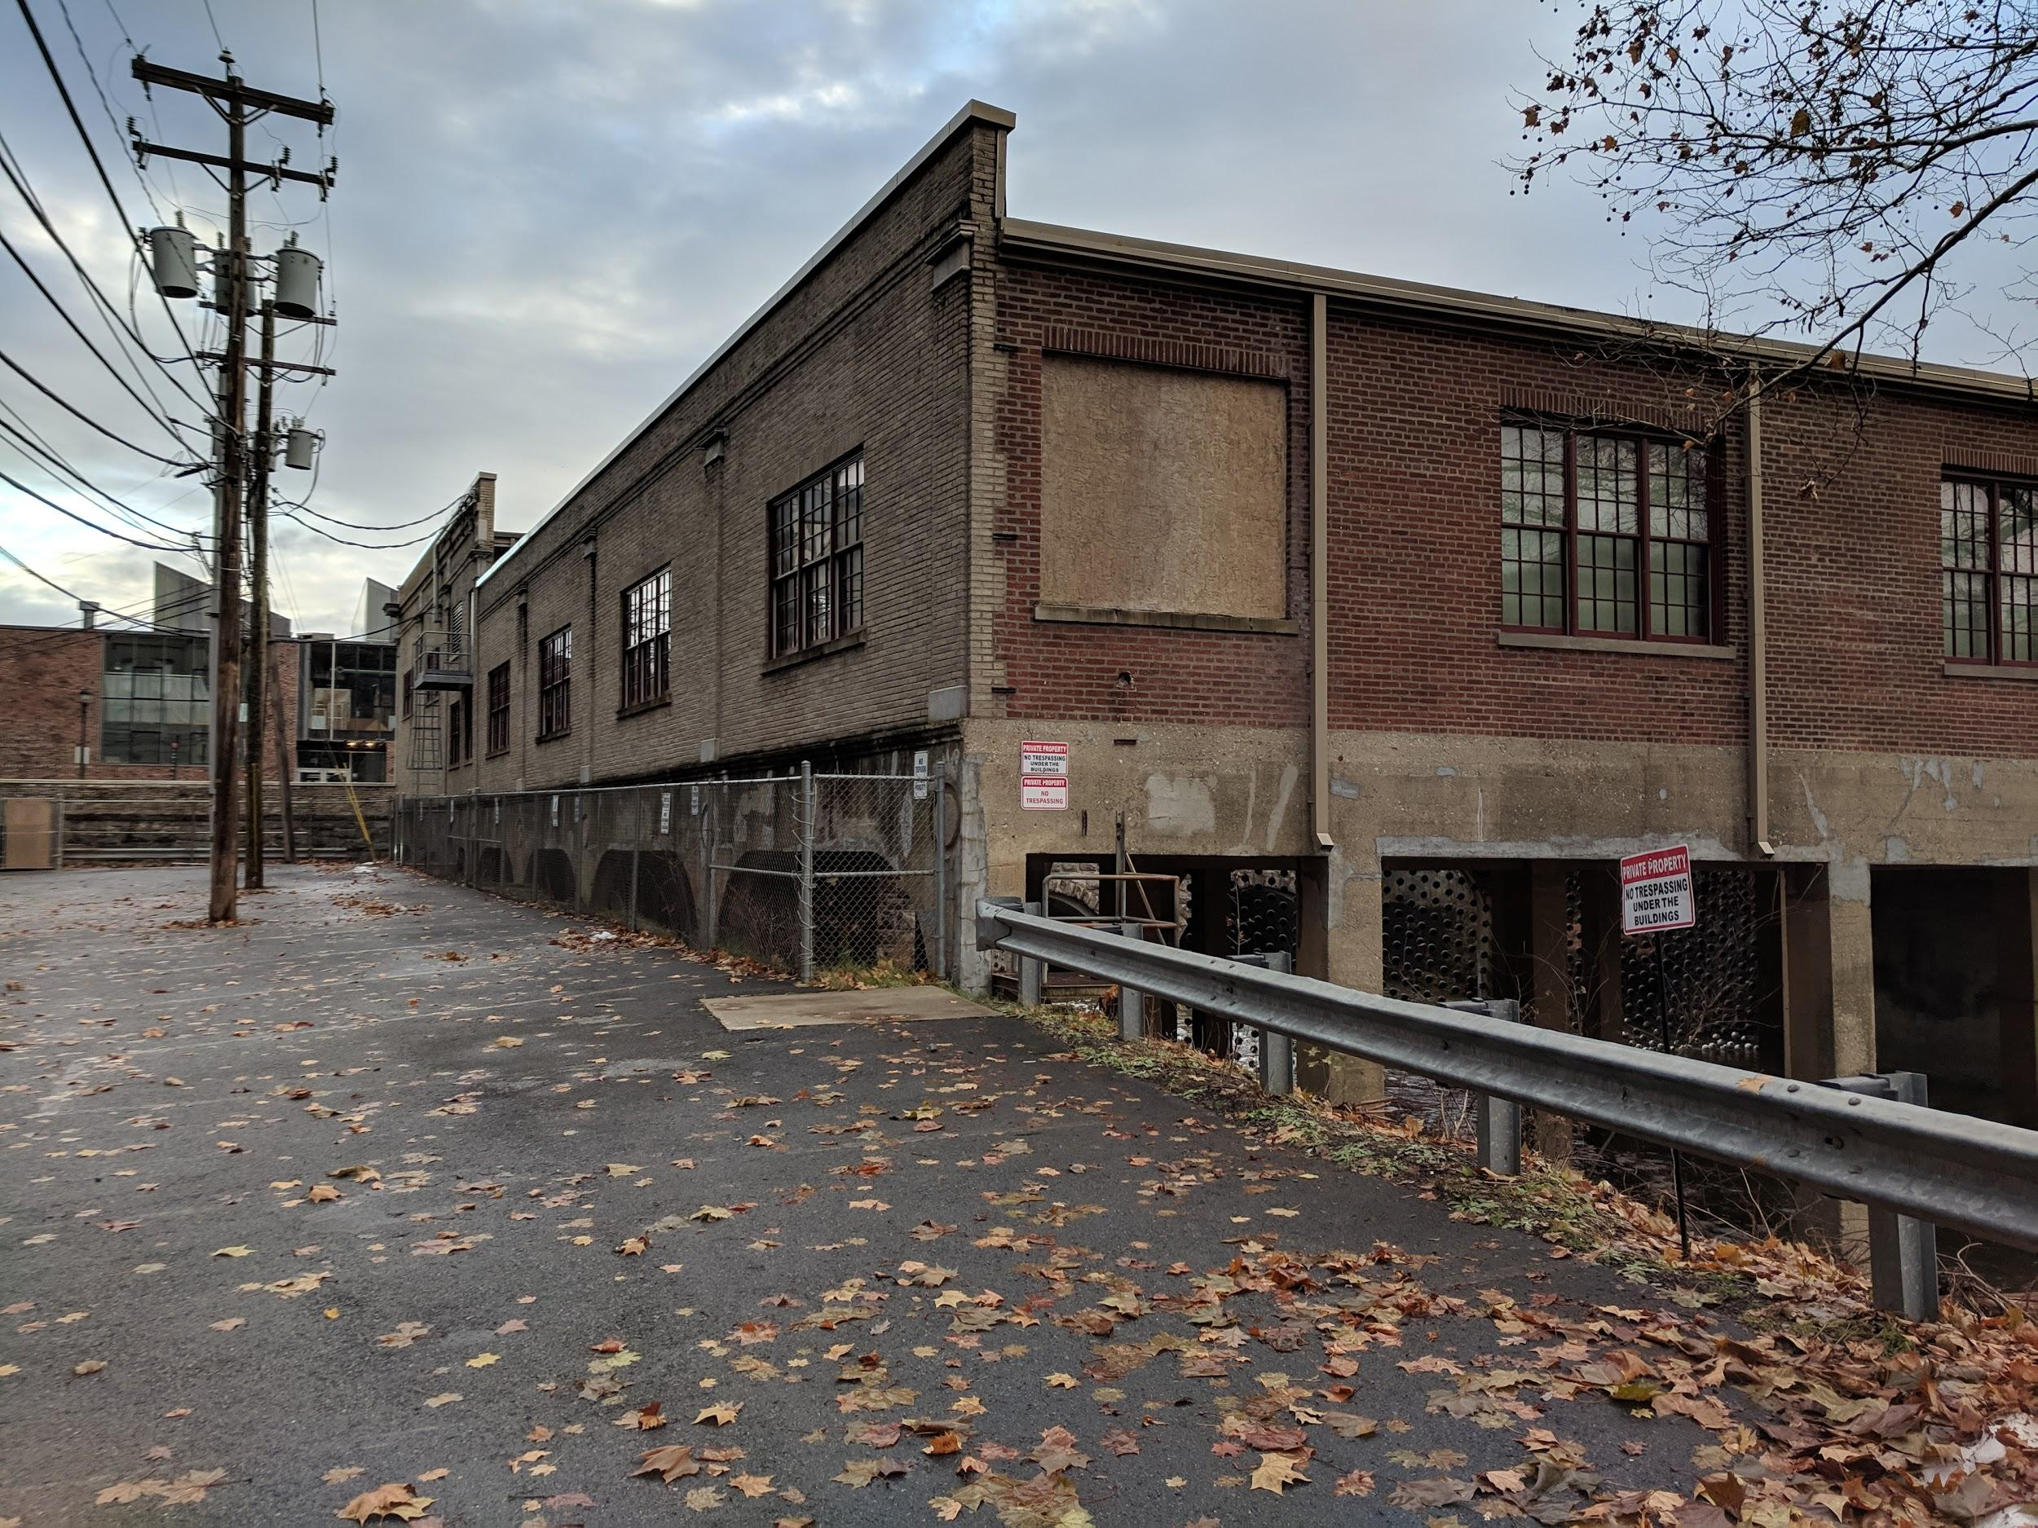
Image above shows photograph of Bushkill Creek area as it is now. Telephone poles and wires can be seen on right obstructing view. Red ‘keep out’ and ‘beware’ signs are present on building.
Bushkill Creek Area after Rewiring:
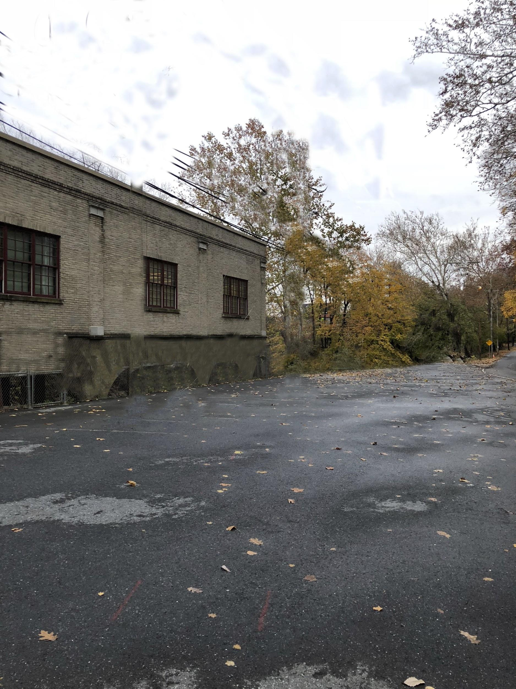
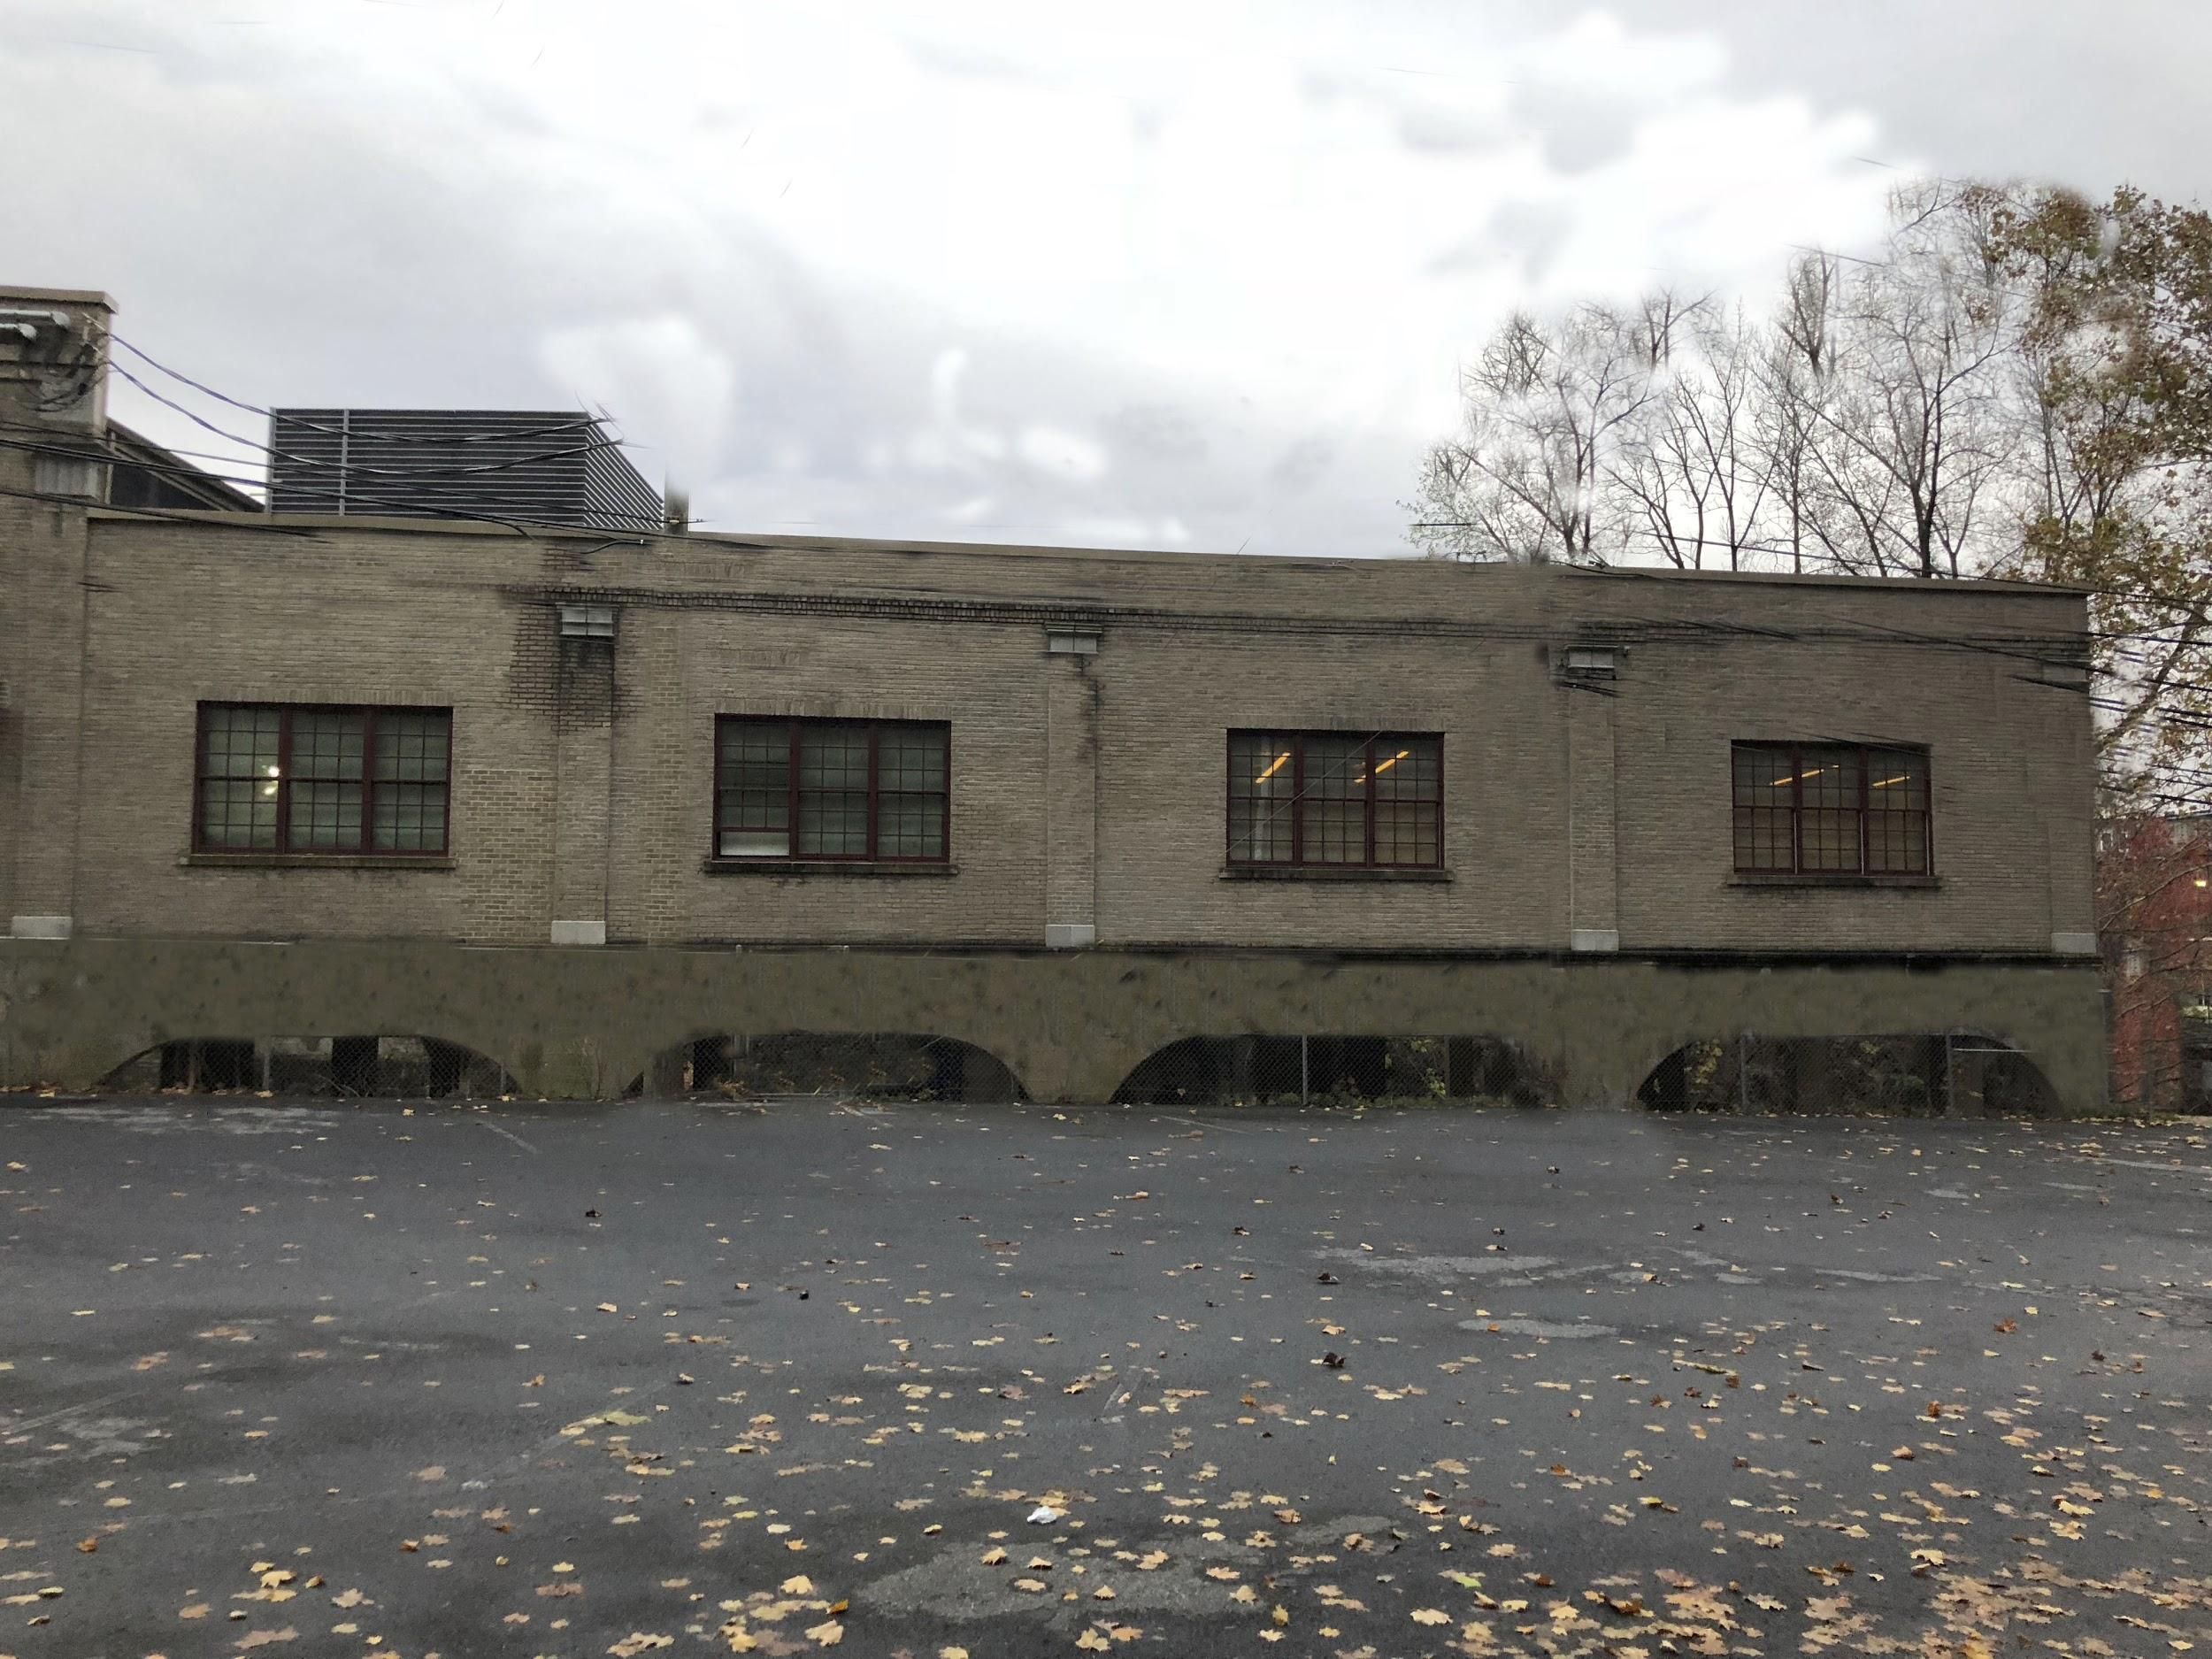
Images aboves show what the Bushkill Creek area will look like after moving overhead utilities underground and removing signage. Views will be unobstructed and the area will appear more welcoming.

Estimated Wire Removal Costs:

The costs of moving the power lines underground is estimated to be between $20 to $40 per foot. This is in comparison to the $10 per foot cost of building above ground power lines. However, in addition to being aesthetically pleasing, below ground power lines offer other benefits such as being less susceptible to damage and being kept safe.

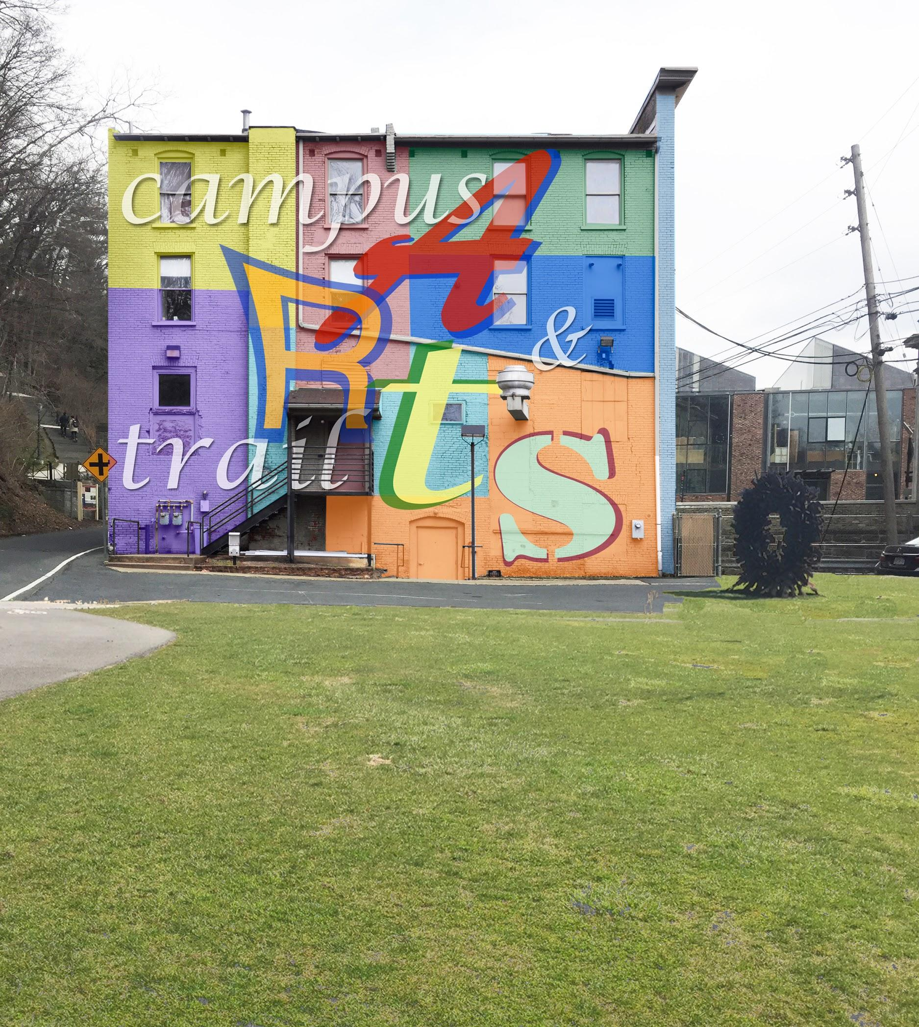
Mural:

Placing a mural on the back of The Spot is also another way to integrate art, the Art Trail and the college together.

Caption explaining the arts mural

Restoration Plans

Bushkill Drive - the road running along Bushkill Creek between The Spot and where it meets Sullivan Drive has considerable potential for restoration. Where there is currently a concrete parking area, we recommend planting a grass lawn with space for permanent benches, barbecue grills, and picnic areas. A path should extend from the road (which is part of the Karl Stirner Arts Trail) down to the creek, thus inviting people to sit by the water. This path will serve as a point of connecting campus and downtown to the arts trail. Additionally, we propose building a footbridge running across the Creek, allowing people quicker access to the Snyder Street Parking Lot.

Other recommended items to make the area more inviting include concrete steps down to the river where people can sit and gain access closer to the water. In addition, to appeal to the large fishing community there is the option to build a small fishing pier over the creek such as a small deck or a spile stone platform in the water. To tie into the concept of the arts trail, it is proposed that the green space have both natural and artistically styled picnic tables and benches. These could include artistic designs or natural materials such as stone slabs making up the items.
In addition to the aesthetic changes proposed, installing an electronic kiosk along the side of The Spot would allow for more community engagement and interaction. This kiosk would be programmed with information about the different art exhibited on the trail as well as current events going on in town and on campus.

Envisioned Steps down to Bushkill Creek Stream:
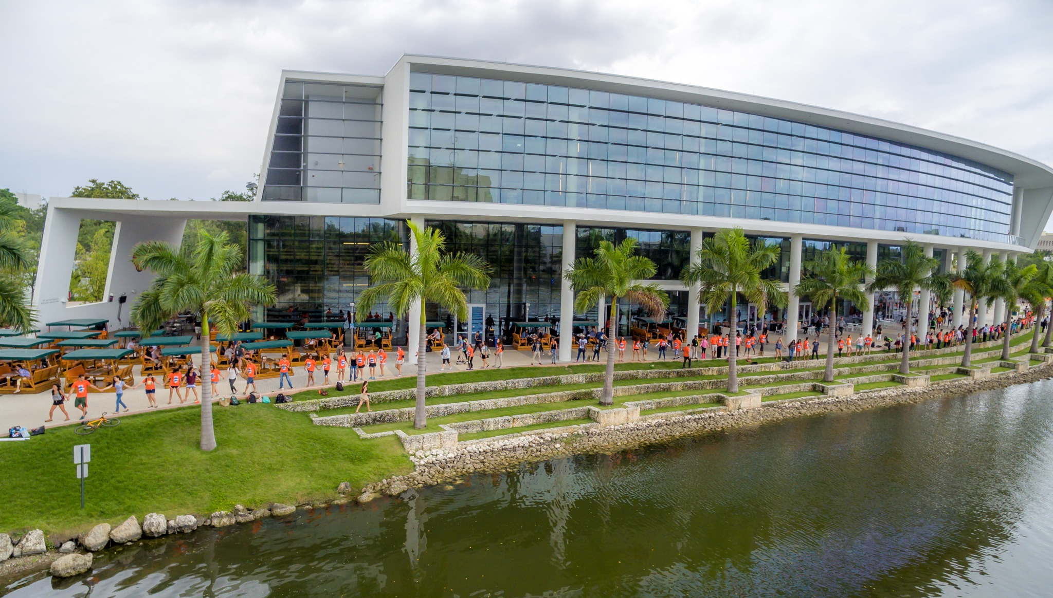

Images above shows photos of steps at City Creek Park in Salt Lake City (left), and University of Miami (right). Steps will provide access to the stream for water activities and should be designed to match natural esthetic.

Sitting Areas
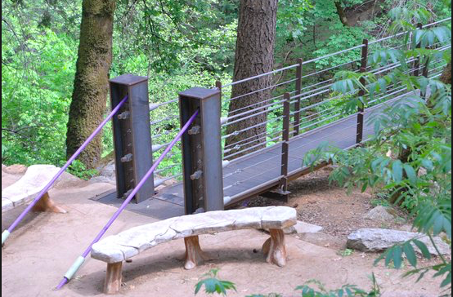
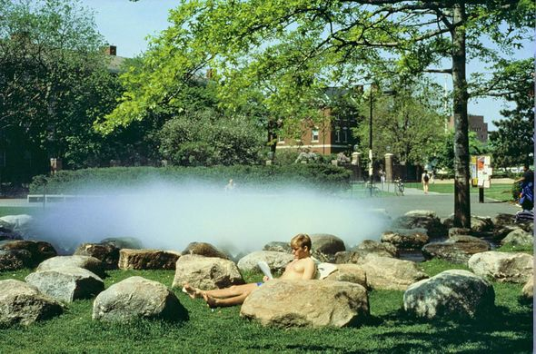

The images above show examples of proposed seating options that will display connection between the green space and environment. Photo on left shows examples of stone benches at City Creek Park in Salt Lake City and photo on right shows sitting stones at Harvard University. Both options provide options that fit in with the environment and are a great space for people and students to enjoy, relax on, and even study.

Bridge Across Stream
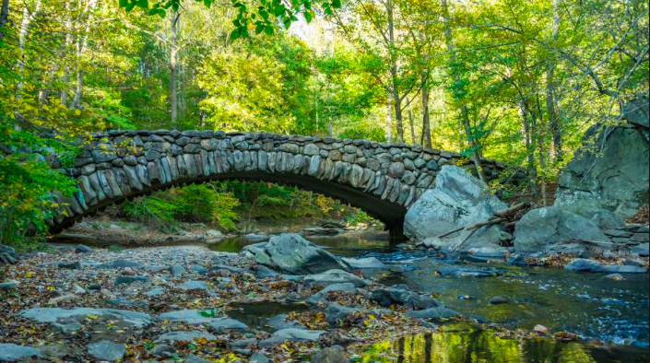
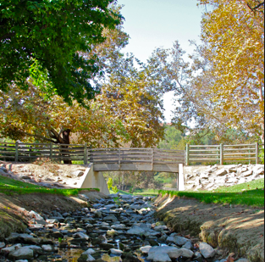
The proposed plan will include a bridge connecting Bushkill Creek Drive to Snyder Street parking lot. The images above show examples of such bridges from Snow Creek Park in Walnut California (left) and Walnut Creek Park in Washington DC (right).

The Trailhead Pub

After researching numerous college green spaces and speaking with members of the Easton and College community, we propose that the College opens a pub where The Spot currently resides, potentially named The Trailhead. In recent years, the College has expanded down the hill and now owns multiple buildings in the area surrounding the new Arts Campus. This area of campus and town is getting a lot more foot traffic than it used to, and would benefit from a dining area to feed everyone. The Spot is currently underutilized, but we expect that a pub style dining space will bring people to the area and will aid in forging a bridge between the Arts Trail, Lafayette’s campus and Easton’s downtown area. We propose an indoor area serving food and drinks, complemented by a deck space with outdoor seating and the potential for live music. Additionally, we envision a space behind the deck with lawn games such as corn hole, jenga, volleyball, etc. This will create a space for Lafayette and Easton community members alike to come together in a fun, stress-free environment right at the intersection of these two communities, and building a restored Bushkill Creek.

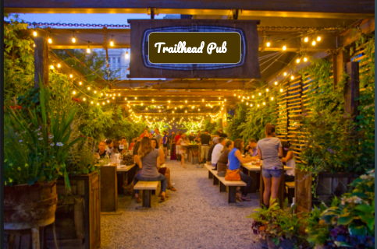

Legal Considerations Regarding the Trailhead Pub:

The team investigated the legal intricacies regarding opening a college-owned pub on campus. It is our understanding that Lafayette College already pays for a sitting liquor license, meaning the College is legally permitted to sell and/or distribute alcohol to anyone above the age of 21. Access to this sitting liquor license allows the easy opening of this bar. Multiple models were discussed, however the most feasible and profitable option found is the “pizza hut” model.

Elements of the “Pizza Hut Model”
- 50% of profit is from food therefore minors are allowed to be present when alcohol is served
- Minimum of 30 person seating required
- Identification is not required at door, everyone at table must be 21 or over when alcohol is served unless accompanied by a parent or guardian

The pizza hut model is the best option due to the surrounding community and the college demographic with only about 25% of the student body being 21 and over. Within this model there are multiple floor plan option that the college can continue. In the first option food would be served only on the first floor with the bar being on the second floor. The second would have security checking IDs so that only 21 and over could enter. The second could also be used for school events for instance senior sips. Option 2 would not serve alcohol in the vicinity until 9pm. After 9pm, everyone in the pub needs to be 21 years old or older. The third option is building a deck in the back of The Spot and this deck would only allow 21 years or older allowed. Permission to serve alcohol outside would just need to be permitted.

Estimated Costs:

Large Trail Construction Costs: $150,000 Small Picnic Area: $4,000
Maintenance Costs: 0.50 annually Maintenance Costs: $500 annually

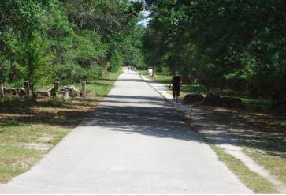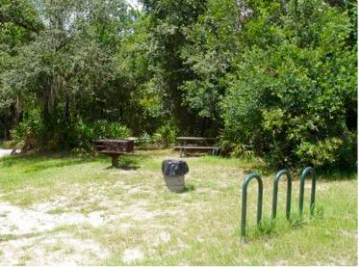

Large Lawn Construction Cost: $25,000
Maintenance Costs: $3,500 annually

Acknowledgements
Thank you to all the people we have met with!

References

A Map of Here. (2010). Colby Magazine: Reaching The World, (Vol. 99 No. 3), 60. Retrieved
from http://issuu.com/colbycollegelibrary/docs/2010_v099_n3/1?e=4376882/1683101

Abrams, A. (2017). What Green Spaces Can Do to Your Mood. Retrieved from
http://time.com/collection/guide-to-happiness/4881665/green-spaces-nature-happiness/

Bushkill Creek Restoration Partnership. (2018). EVST 400 Capstone Lafayette College.
Retrieved from https://sites.lafayette.edu/bushkillrestoration/

College Farm. Retrieved from https://www.dickinson.edu/farm

David D. Hart, Thomas E. Johnson, Karen L. Bushaw-Newtown. (2002). Dam Removal:
Challenges and Opportunities for Ecological Research and River Restoration. BioScience: American Institute of Biological Sciences. 52, p.669-682. Retrieved from https://academic.oup.com/bioscience/article/52/8/669/254910

Dynamics of Bushkill Creek After Dam Removal. Lafayette College. Retrieved from
https://www.arcgis.com/apps/MapSeries/index.html?appid=4cfa9a1c8fb742bba4e718758735ca62#

F.J. Magilligan, B.E. Graber, K.H. Nislow, J.W. Chipman, C.S. Sneddon, C.A. Fox. (2016).
River Restoration by Dam Removal; Enhancing Connectivity at Watershed Scales. Elem Sci Anth, 4. Retrieved from https://www.elementascience.org/articles/10.12952/journal.elementa.000108/

Lee, A., Jordan, H., & Horsley, J. (2015). Value of urban green spaces in promoting healthy
living and wellbeing: prospects for planning. Risk Management And Healthcare Policy,
131-136. doi: 10.2147/rmhp.s61654

Lawson, Megan. (2016). Dam Removal Case Studies. Headwaters Economics. Retrieved from
https://headwaterseconomics.org/economic-development/local-studies/dam-removal-case-studies/

PPL Martins Creek Natural Resource Damage Assessment: Environmental Assessment and
Restoration Plan. (2011). Pennsylvania Department of Environmental Protection.
2002. The Ecology of Dam Removal: A Summary of Benefits and Impacts. American Rivers. Retrieved from https://drive.google.com/drive/u/1/folders/1TRqtDKr5WseCPoQn0KmrWEzeQ1i9bLR3

