Research Guide for Environmental Site Assessment

Prof. Kney, Spring 2012
Need help? Contact: Amy Abruzzi
Email: abruzzia@lafayette.edu Phone: (610) 330 - 5631

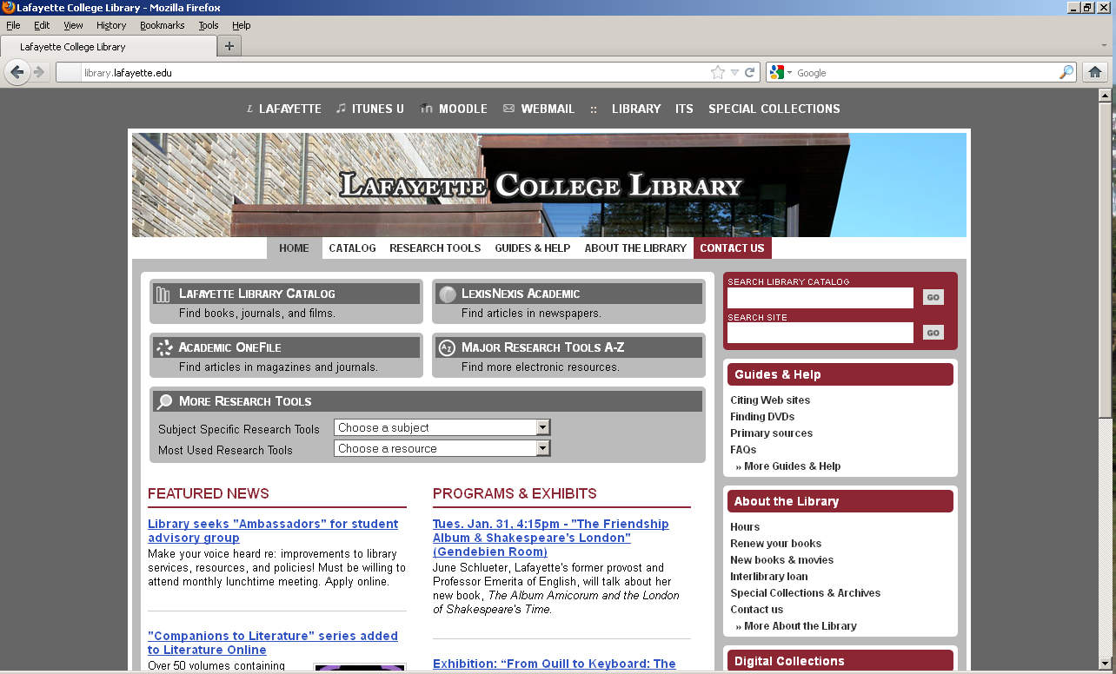
I. Library Website, at:
http://library.lafayette.edu/

To start, here are a few things you can do:
• Search the Lafayette Library Catalog
Key subject headings include:
Environmental law
Environmental auditing
Groundwater -- Pollution
Pollutants
Sanitary engineering
Toxicology
• Link to e-books (Ebrary)
• Link to e-journal collections and
research databases including Lexis-Nexis and Academic OneFile
• Make a PRA appointment
• Submit an Interlibrary loan

II. Selected Reference Sources

e-books:
Kirk-Othmer Encyclopedia of Chemical Technology (online)/ Connect through the Library Website
Wide scope of articles on chemical substances—including their properties, manufacturing, and uses. Additionally, environmental and health issues concerning chemical technology are also addressed.

TOXNET (Toxicology Data Network)/ http://toxnet.nlm.nih.gov/
Collection of databases from the National Library of Medicine on toxicology, hazardous chemicals, and related areas, including the Hazardous Substances Data Bank, TOXLINE, IRIS, and Toxics Release Inventory.

Ullmann's encyclopedia of industrial chemistry (online)/ Connect through the Library Website
Detailed articles on all areas of industrial chemistry.

Print collection:
A companion to American environmental history / Skillman Reference GE195 .C655 2010
Dictionary of Water and Waste Management. 2nd ed./ Skillman Reference TD9 .S37 2002x (2005)
Encyclopedia of environmental science and engineering. 5th ed. /Skillman Reference TD9 .E5 2006
Environmental Compliance Handbook. 2nd ed. / Skillman Reference KF3775 .B72 2001
Environmental engineering dictionary. 4th ed. /Skillman Reference TD9 .L44 2005
Groundwater Chemicals Desk Reference. 4th ed. / Skillman Reference TD426 .M66 2007 (on order)
Sax's dangerous properties of industrial materials. 11th ed./ Skillman Ref. T55.3.H3 L494 2004
III. Research Databases – find articles, reports, and other specialized publications.

Unless otherwise specified, access the databases listed below through the Library Website at: http://library.lafayette.edu/. Look under: “Subject Specific Resources: “Environmental Sciences” / “Civil Engineering” or, “Major Research Tools A to Z”

Indexes to the scientific literature:

Applied Science and Technology Abstracts, 1983-present. Indexes core periodicals in engineering and other technical fields.

GeoRef, 1966-present. Indexes the literature of geology, including journals, books, conference proceedings, maps, and USGS reports. Covers the geology of North America from 1669 to the present and the geology of the rest of the world from 1933 to the present.

TOXLINE, 1991 - through TOXNET, at http://toxnet.nlm.nih.gov/
From the National Library of Medicine, extensive array of references to literature on biochemical, pharmacological, physiological, and toxicological effects of drugs and other chemicals.

Web of Science, 1955-present. Electronic versions of Science Citation Index and Social Sciences Citation Index. Allows you to search for a topic, an author, or for articles that cite a known author or work.

Newspapers and other sources:

LexisNexis Academic , early/mid 1980’s – present. Full text of newspapers, business magazines, laws reviews, and legislative sources. (Historical NYTimes back to 1859 is also available electronically)

Morning Call via ProQuest, 1984-present. Offers full-text coverage and indexing of the Allentown Morning Call (Does not include images, charts and tables, or ads.).

Note: The Express-times (“Easton Express”). Skillman library has the current month only in paper copy; older years are available on microfilm at the Easton Public Library

IV. Interlibrary Loan

If you need something Lafayette doesn't own, we can usually get it for you via Interlibrary Loan. Just use the handy WebBridge link available in most of our databases or fill out the form available on our Web site. Most articles are delivered to your account electronically in just a few days.

V. Laws, Regulations, etc.

A. Federal Documents

Laws: Public Laws first appear as slip laws as they pass Congress and are signed by the President. Legal citations refer to them in the U.S. Statutes at Large, which is arranged by congress and the public law number or in the U.S. Code, which arranges them by area (“title and section”).

Regulations: Regulations are first published in the Federal Register and later arranged by agency (‘title and section’) in the Code of Federal Regulations. Note: Select regs can also be located via the EPA website at. This is an especially useful list: http://www.epa.gov/lawsregs/envtopics/index.html

…To Access through Lexis-Nexis Academic, select: U.S. Legal/ Federal Statues, Codes and Regulations/ and select one of the following

To find: | Source  (title;  legal citation;  example) | Use Lexis-Nexis file:  Federal Statutes, Codes and Regulations - | Search using Lexis-Nexis Citation format
Laws as passed by the U.S. Congress. | Slip law or U.S. Statutes at Large;  Public law no. or PL  Example:  Public law no. 101-509 | Public Laws | 101 PL 509
Codified laws including subsequent amendments. | U.S. Code;  USC or U.S.C.  Example:  5 U.S.C. § 5901 | Annotated U.S. Code | 5 USCS SEC 5901  5 USCS SECTION 5901  Tip: For following sections, click on “Show TOC”
Regulations as enacted by federal agencies. | Federal Register;  FR or F.R.  Example:  64 FR 71680 (Dec. 22, 1999) | Federal Register | 64 FR 71680  63 FR 33835
Codified regulations including subsequent amendments. | Code of Federal Regulations;  CFR or C.F.R.  Example:  40 C.F.R. §129.4 | CFR - Code of Federal Regulations | 40 CFR 129.4  20 CFR PART 404 APPENDIX I  17 CFR 230.429  Tip: For following sections, click on “Show TOC”

B. Pennsylvania Documents

Lexis-Nexis contains both PA laws and regulations. To Access through Lexis-Nexis Academic, select: U.S. Legal/ State Statues, Codes and Regulations/ Pennsylvania/ and select one of the following:

To find: | Source  (title;  legal citation;  example) | Use Lexis-Nexis file:  Pennsylvania - | Search using Lexis-Nexis Citation format
Codified laws including amendments enacted by the PA Legislature. | PA Statutes Annotated; Pa.C.S.  Example:  2 Pa.C.S. § 504 | Statutory Code | 2 AND 504
Codified rules and regulations adopted by PA state agencies* | PA Administrative Code;  Pa. Code  Example:  7 Pa. Code § 57.1 | Administrative Code | 7 AND 57.1
*These are also available at: http://www.pacode.com/

VI. Program information:

- Federal programs

Gateway:

Clean ups in My Community / http://iaspub.epa.gov/Cleanups/
Maps, lists and provides cleanup progress profiles for sites, facilities and properties that have been contaminated by hazardous materials and are being, or have been, cleaned up under EPA's Superfund, RCRA and/or Brownfields programs.

Envirofacts Data Warehouse/ http://www.epa.gov/enviro/index.html
“Your one-stop source for environmental information.” Search by Zipcode, City, County, or State. A quick way into data gathered for CERCLA, RCRA, documents etc.

Hazardous Waste Cleanup in Region 3/ http://www.epa.gov/reg3hwmd/index.htm

Contains Region 3 site info including Superfund, RCRA, Brownfields, Underground storage tanks, Mid-Atlantic oil program, Administrative Records on the Web, and more. etc..

Or, search specific programs directly:

Comprehensive Environmental Response, Compensation, and Liability Act (CERCLA)
Commonly known as Superfund, was enacted by Congress on December 11, 1980 and was amended by the Superfund Amendments and Reauthorization Act (SARA) on October 17, 1986. CERCLA established prohibitions and requirements concerning closed and abandoned hazardous waste sites, provided for liability of persons responsible for releases of hazardous waste at these sites, and established a trust fund to provide for cleanup when no responsible party could be identified. It also enabled the revision of the National Contingency Plan (NCP) which provides guidelines and procedures needed to respond to releases and threatened releases of hazardous substances, pollutants, or contaminants, as well as the National Priorities List (NPL).” Access CERCLA information through CERCLIS or go directly to:

Superfund/ http://www.epa.gov/superfund/index.htm
The gateway to data and information on Superfund.

Superfund Site Information/ http://www.epa.gov/superfund/sites/cursites/index.htm

Information on hazardous waste sites, potentially hazardous waste sites and remedial activities across the nation. The database includes sites that are on the National Priorities List (NPL) or being considered for the NPL. You may also wish to use the EnviroMapper for Superfund http://www.epa.gov/enviro/sf/

National Priorities List/ http://www.epa.gov/superfund/sites/npl/index.htm
List of national priorities among the known releases or threatened releases of hazardous substances, pollutants, or contaminants throughout the United States and its territories. The NPL is intended primarily to guide the EPA in determining which sites warrant further investigation.

Records of Decision System (RODS)/ http://www.epa.gov/superfund/sites/rods/index.htm
Contains full-text Records of Decision (RODs), ROD Abstracts, ROD Amendments (AMDs) and Explanations of Significant Differences (ESDs). A ROD provides the justification for the remedial action (treatment) chosen at a Superfund site. It also contains site history, site description, site characteristics, community participation, enforcement activities, past and present activities, contaminated media, the contaminants present, scope and role of response action and the remedy selected for cleanup.

Resource Conservation and Recovery Act Information (RCRAInfo)

National program management and inventory system about hazardous waste handlers. In general, all generators, transporters, treaters, storers, and disposers of hazardous waste are required to provide information about their activities to state environmental agencies. These agencies, in turn, pass on the information to regional and national EPA offices.

RCRA Info/ http://www.epa.gov/enviro/html/rcris/rcris_query_java.html

Comprehensive information system, providing access to data supporting the Resource Conservation and Recovery Act (RCRA) of 1976 and the Hazardous and Solid Waste Amendments (HSWA) of 1984. RCRAInfo replaces the data recording and reporting abilities of the Resource Conservation and Recovery Information System (RCRIS) and the Biennial Reporting System (BRS).

Brownfields and Land Revitalization

Brownfields are real property, the expansion, redevelopment, or reuse of which may be complicated by the presence or potential presence of a hazardous substance, pollutant, or contaminant. Cleaning up and reinvesting in these properties protects the environment, reduces blight, and takes development pressures off green spaces and working lands.

To access basic information, including grants and funding, laws and statutes, go to: http://www.epa.gov/brownfields/index.html

- Pennsylvania State or Local programs

Pennsylvania Dept. of Environmental Protection, Bureau of Waste Management/: http://www.depweb.state.pa.us/landrecwaste/site/default.asp

The agency responsible for overseeing environmental cleanup, recycling, storage tank and solid waste programs in PA. Click on the “BWM Homepage” option for a master directory of links to information on state-funded Hazardous Sites Cleanup Program, Pennsylvania Landfill List, Regulated Storage Tank Listings, Storage Tank Release Incidents, Land Recycling Programs, Solid Waste Programs, and any additional information on Superfund (CERCLA) In Pennsylvania.

Use this site to connect to:

PENN DEP Hazardous Site Response Actions List/ http://www.portal.state.pa.us/portal/server.pt?open=514&objID=589564&mode=2

This list represents hazardous sites response actions that have been taken since the enactment of the Hazardous Sites Cleanup Act (HSCA) on October 18, 1988. The information in this list is derived from DEP's eFACTS (Environment, Facility, Application, Compliance Tracking System). The list is current through October 9, 2009. The purpose of providing this listing is not to identify problem areas, rather to identify the status of all response actions that have been taken utilizing HSCA funding.

VI. Maps, City Directories, and Additional Sources of Data

Current - general:

Google Maps/ http://maps.google.com/ Search by address to display traffic, satellite and terrain images and more.

Google Earth/ http://earth.google.com 3D viewer for satellite imagery, aerial photography, maps and other information.

vPike.com/ http://www.vpike.com/, take a virtual tour around the neighborhood.

The National Map/ http://nationalmap.gov/ From the U. S. Geographic Service, create and view online interactive map with downloadable data using “I want to make a map” tools.

Current – PA:

Maps and Data:

Pennsylvania Spatial Data Access (PASDA)/ http://www.pasda.psu.edu/

Official public access geospatial information clearinghouse for the Commonwealth of Pennsylvania. Available data includes aerial photography, Elevation and topographic maps, which may be downloaded as files or used through a viewer. For mapping options, see:

PASDA- Online Mapping/ http://www.pasda.psu.edu/mapping/default.asp, which includes:

Pennsylvania Imagery Navigator/

http://maps.pasda.psu.edu/website/Imagery_Viewer/Viewer2.asp

Easy access to imagery and raster data such as topographic maps. Users can print the map image, identify and download multiple tiles for an area of interest, and new options for specifying area of interest.

Pennsylvania Atlas/

http://maps.psiee.psu.edu/paatlasdev/

Interactive map including environmental, political, census and imagery data, which may viewed on screen or downloaded for GIS programs.

Lehigh Valley Planning Commission. / http://www.lvpc.org

Includes data, reports, as well as some maps including those for surface terrain, stream quality, floodplains, wetlands, land use, mineral extraction areas, and water supply.

Lehigh Valley Research Consortium/ http://www.lehighvalleyresearch.org/

Collaborative effort from academic researchers, public officials, non-profits and business groups throughout the Lehigh Valley, to provide and examine data on social, political, economic, health and environmental issues and solutions in a regional context. Includes information on the environment, land use and infrastructure. Includes some maps, various publications and reports.

County office documents, including deeds:

Pennsylvania Recorders of Deeds Links. http://dsf.chesco.org/recorder/cwp/view.asp?A=1519&Q=607295
Links to county offices and other various organizations. In most cases, you have to navigate to the deeds info from a main county directory. Also, some sites require membership information.

LANDEX Document Publishing Service. http://www.landex.com/webstore/

Fee based service. Offers real-time access to county government records for select counties (Lehigh is included) in Pennsylvania. Document types include deeds, mortgages, gas leases, etc. Also available as a database to search by the minute. Visit LANDEX remote at: http://www.landex.com/remote/

Historic - PA:

Lehigh and Northampton Counties digital geographic data / Lehigh Valley Planning Commission. Version 2.0a. Allentown, Pa. : Lehigh Valley Planning Commission, 2002./ Skillman Upper Level G3823.L6 2002 L4x
Contains digital aerial photography and geospatial data layers in ArcView shape file format for the Lehigh and Northampton counties, Pennsylvania. Aerial photographs from earlier years may be located in the office of the Lehigh Valley Planning Commission. Be sure to check out their web page at http://www.lvpc.org or call: 610-264-4544

Penn Pilot/ http://www.pennpilot.psu.edu/

Sponsored by the Pennsylvania Geological Survey, this is an online library of digital historical aerial photography for the Commonwealth of Pennsylvania. Browse, view, and download thousands of photos covering the state from 1937 to 1942, 1952-1962, and 1967 to 1972.

Polk's Easton /Easton Pennsylvania city directory / Polk ... Easton Pennsylvania city directory (including portions of surrounding areas in PA and NJ). / Skillman Storage F159.E15 P65x

Skillman Library has paper copies of the local street directory, known under various titles, from 1959 to present. Most years are in storage and can be retrieved for you via the circulation desk./

Sanborn Fire Insurance Maps, 1867-1970 - Pennsylvania (Digital Sanborn Maps)

Access via Library Web Site.

Maps of towns or cities in Pennsylvania originally created for use by fire insurance companies. Maps are drawn to a scale of 50 feet to an inch, list street blocks and building numbers, and are coded for building materials used.

US Geological Survey Maps 7.5 Minute (Quadrangle) Topographic Maps, 1879-1992.

Produced at a scale of 1:24,000 (some metric maps are produced at a scale of 1:25,000) and typically portraying both natural and manmade features, these maps are commonly known as 7.5-minute quadrangle maps because each map covers a four-sided area of 7.5 minutes of latitude and 7.5 minutes of longitude. (USGS/ http://topomaps.usgs.gov/) Skillman Library has some U.S. Geological Survey maps for PA and NJ, which are located on the Lower Level of Skillman Library. Ask at the Reference desk for assistance.

Zoning/land use documents

These documents may be available through municipal or county planning boards (see above, Lehigh Valley Planning Commission at http://www.lvpc.org) Phone numbers for these departments are listed in the blue (government) pages of the most current telephone book. Ask at the Reference desk if you need assistance.

Rev’d AEA 01/27/12

