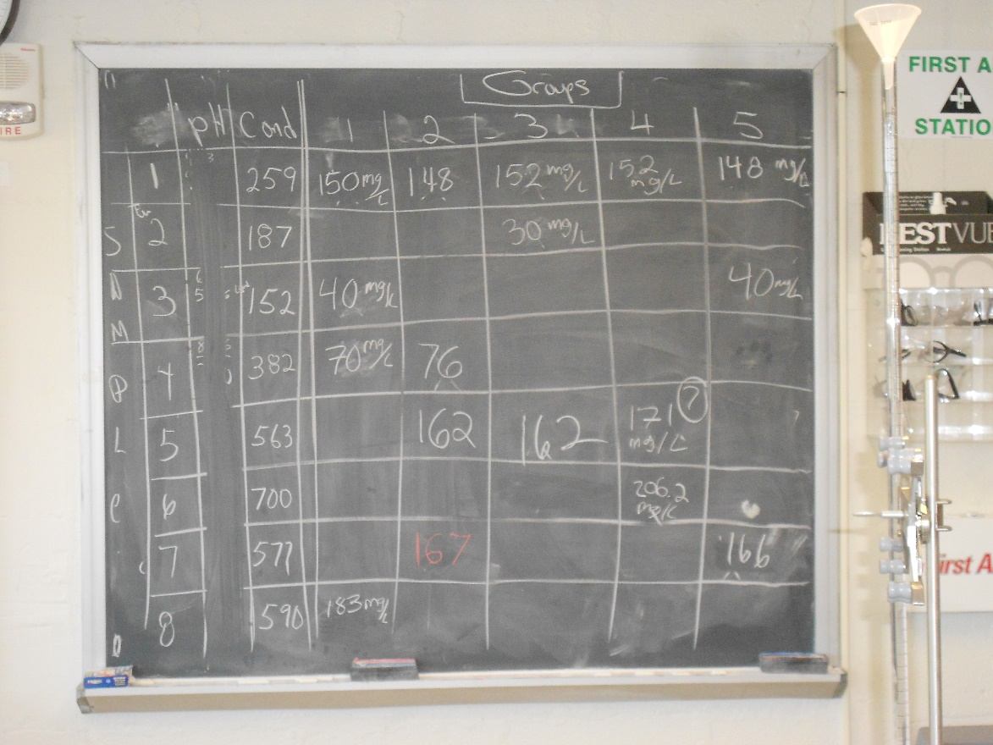

Tuesday Morning 2014

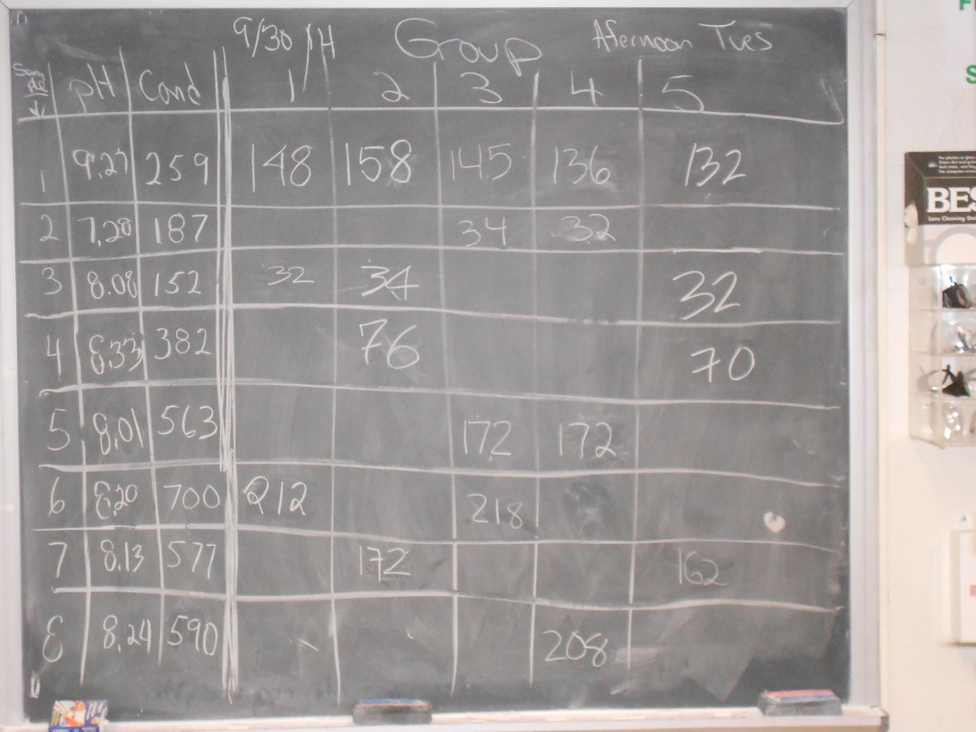

Tuesday Afternoon 2014

|  |  |
| --- | --- |
| **Tuesday Morning - 2014** | |
|  |  |
|  |  |
|  |  |
|  |  |

|  |  |
| --- | --- |
| **Tuesday Afternoon - 2014** | |
|  |  |
|  |  |
|  |  |
|  |  |

|  |  |
| --- | --- |
| Thursday Morning - 2014 | |
|  |  |
|  |  |
|  |  |
|  |  |