Tech Tips: How to turn your i-Movie Project into a Movie

Step I: Sharing
- On the menu bar in i-Movie, go to Share > QuickTime
- Compress movie for Expert Settings
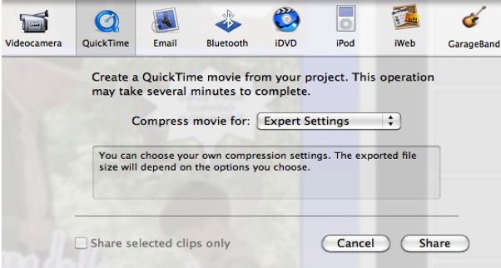
Select Expert Settings
Click Share

Step II: Saving
- At the prompt, save your movie in your folder in the Thawspace
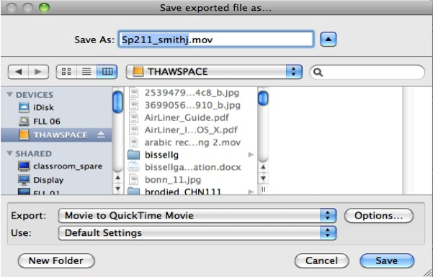
Settings

Step III: Submitting
- Upload your movie (not i-Movie Project) to the L Drive (Lingua server)
- To connect to the server from an Apple computer:
Questions? Ask the proctor!

