INDEX:

Section 1: Logging in as an administrator to your website

Section 2: Setting up your e-Portfolio

Section 3. The Appearance of your e-Portfolio

Section 4: Posts, Pages, Categories…

Section 5: Adding a new Post

Section 6: Adding a new Page

Section 7: Managing Categories

Section 8: Adding Media to your web pages

Section 9: Adding external links to your web pages

Section 10: Converting video files to .flv (flash) for display

Section 11: Working with Galleries

----------------------------

1. Logging in as an administrator to your website

As a student/faculty, you have a website on the lafolio.lafayette.edu server with your username- you can modify this site to create your Foreign Language ePortfolio.

- First, navigate to “lafolio.lafayette.edu/your-lafayette_user-name/wp-admin” and login with your network ID and password.

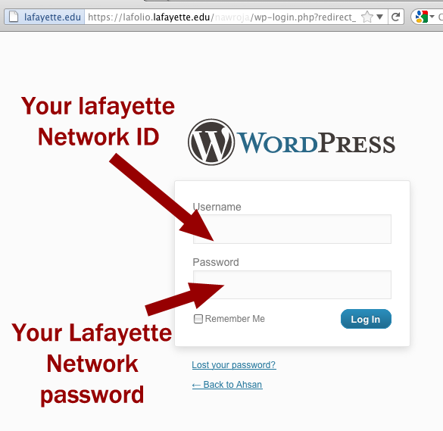
Figure 1: Login screen for the e-Portfolio

- You are directed to a page that is your "Dashboard". On the left hand panel, are the tools you can use to create and configure your web pages

----------------------------

2. Setting up your e-Portfolio

These basic changes to the site will customize the portfolio for you and set up the necessary tools for development of individual web pages:
  - Click on the “Settings” tab on the left of the Dashboard. Click on “General Settings” in the list that extends. Here you can change the title of your portfolio (to your name, perhaps) and add a tagline that describes your e-Portfolio
  - Click “Save” to save your progress
  - Click “Writing Settings” on the left and set the “Default Post Category” to “Miscellaneous”. This will make sure all your posts that you haven’t put into any category will be filed under Miscellaneous: until you get around to filing them more specifically with another category.
  - Click “Save” to save your progress
  - Click “Reading Settings” on the left.
- Select “Front page displays” to “A static page”
- Select “Front page” to be “Profile”
- Leave “Posts page” blank.
  - Click “Save” to save your progress
  - Click “Privacy Settings” on the left. Select the second option: “I would like to block search engines, but allow normal visitors”
  - Click “Save” to save your progress.

  - Click “TinyMCE Advanced” on the left. Drag the “Table” toolbar from the gray boxes and add it to the white box below: this allows you to use table creation and editing tools when you are developing individual web pages.
  - Click “Save” to save your progress.

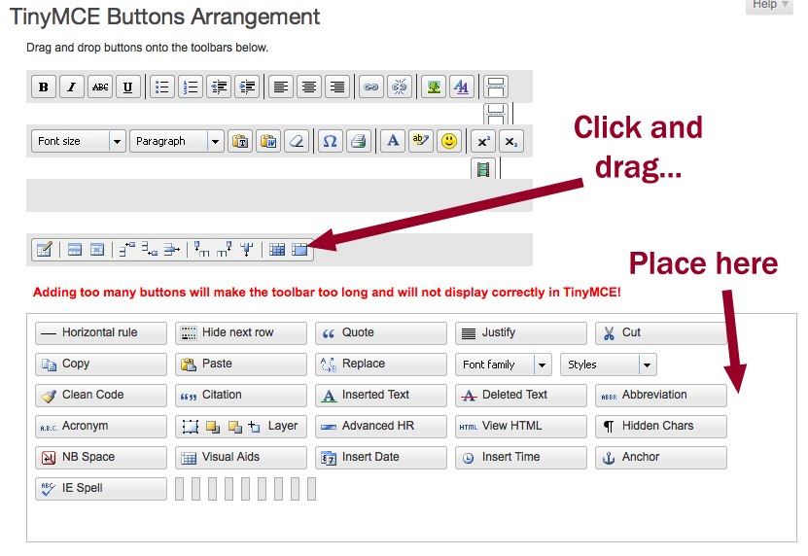
Figure 2: TinyMCE settings- locate and add "Tables" to the edit toolbar
----------------------------

3. The Appearance of your e-Portfolio

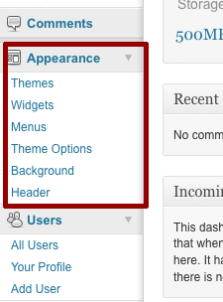
The Appearance tab on the left allows you to configure the way the entire portfolio looks. This includes changing the ‘header’ at the top of every page, the menu bar under the header holding the links to every page, colors of text, etc.
Figure 3: "Appearance" is on the left sidebar

  - Click on the “Menus” link under the Appearance tab.
  - Notice there is an existing menu called “main”. This menu is the one that shows up under the header of your web pages, showing links to all other pages in the site. On the right side of the screen, this menu is shown in detail.
- The “Page” titled “Profile” appears first in the menu: this makes sure that the home page (Profile) appears first (leftmost) on the actual menu bar
- The hierarchy of “Pages” and “Categories” create the hierarchy of the menu items: item A, when indented (dragged to the right) under another item B becomes one element in a sub-menu from the element B. This is shown below:

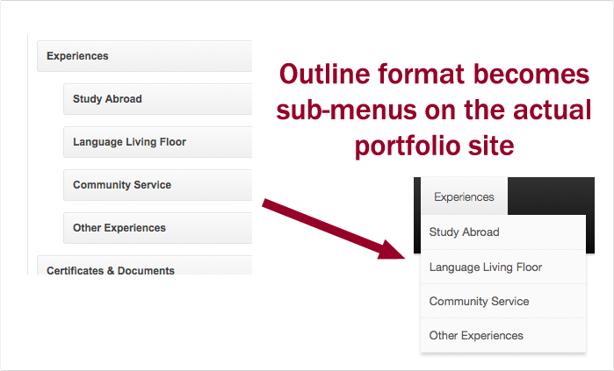
Figure 4: Menu items serving as an outline for the header links on the site

  - When you add a new “Page” or a “Category” and you wish to place a link to that item in your site header (as a new menu item or a submenu item to an existing item), just return to this “Menu” settings under “Appearance” and select the item you want to add (it has to be a Page or a Category).
- Click “View all” to the section for Pages/Categories, and check your new item.
- Click “Add to Menu” to add the item to the menu
- Look on the right side of the screen to find the item in the menu
- Drag it up or down to the position you want it to be in your menu (ordered from left to right)
- Drag it to the left or right to place the item as a submenu under an existing menu item

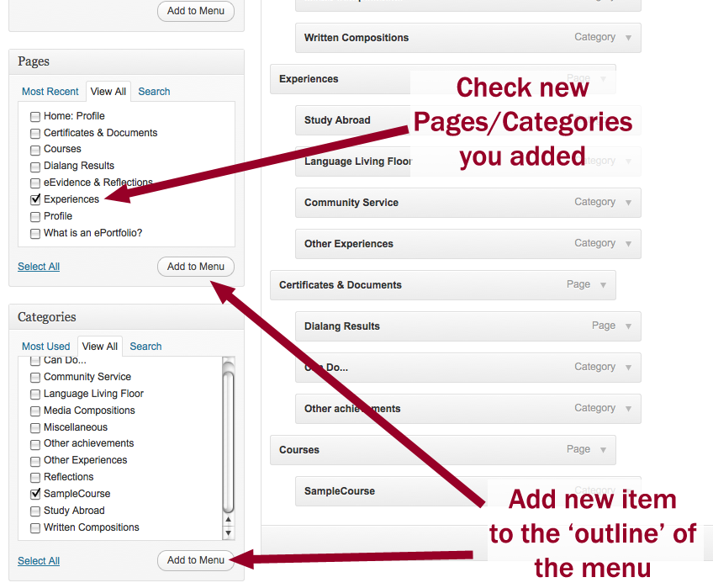
Figure 5: Adding a new item to the menu

  - Click “Header” under “Appearance” on the left sidebar
- Here you can change the header image on your website from the default one to something of your choosing
- You can also remove the header image entirely: leaving your site’s title and tagline as the only items (click “Remove Header Image”)
- You may even remove the text title and tagline (“Display Test: No”)
- The Text Color of the title and tagline can be set to one you choose: click “Select a Color” to choose your text color (FYI: the Lafayette College logo uses #970027)
- Make sure you click “Save Changes” to confirm the changes made so far

----------------------------

4. Posts, Pages, Categories…

Some (potentially confusing) terminology used on the Dashboard:
  - “Posts” are small articles that you can add about a topic. Often these are updates on existing articles, such as a new course description to the list of courses you have taken, or a new activity in your list of activities etc. (Note the tab titled “Posts” on the left-hand plane)
  - “Categories” are a label used to identify posts. When adding a post, you can add it to a category, so that when the category is made public, all the posts form a bank of posts, giving the appearance of a web “page”. In other words, ‘Courses’ is a collection of all the courses you have taken. Nested under “Courses”, you have a series of “categories” (Course 1, Course 2, etc.).
All the posts from a specific category are displayed as a specific course. (Categories are listed under the tab titled “Posts” in the left-hand plane)
  - "Pages" are web pages that may contain text and media, but they are not updated by posts. In this way pages are different from Categories since they are created as web pages. “Pages” are useful for information that you will not change very often; some default “Pages” are included in your website as you begin, e.g., “What is an ePortfolio?” and “Profile”. (Note the tab titled “Pages” on the left-hand plane)
  - "Media" is a tab on the left-hand plane as well. This provides a way to upload and store media files (jpg, mov, etc.) that you would like to use on your web pages. Once uploaded, every media item will be visible from your web page to allow you to add them to your web pages. Check the URL of each media item to use in your posts

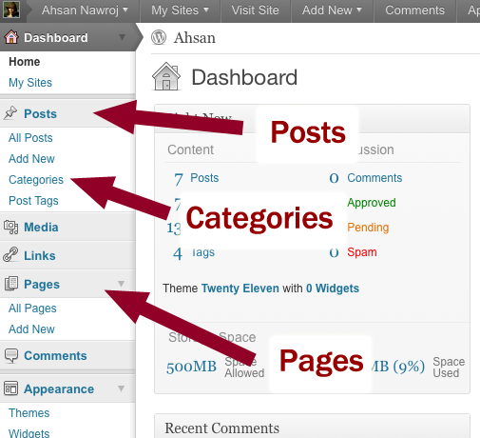

In order to use the ePortfolio Templates, you MUST BE ABLE TO ADD MEDIA, POSTS, CATEGORIES and PAGES to your website: details of which are in following subsections.

----------------------------

5. Creating a Post…

A Post is a small article, posted generally into a collection, called a ‘Category’. You can make a post using the following simple steps:

- Click the “Posts” pin on the bar to the left of your Dashboard to expand it
- Click “Add New”
- Enter a title for this post, and insert some text
- Notice on the right there is a list of Categories this post will be filed under
- Check the appropriate category for your post: for this sample post, you could use “Miscellaneous”
- Notice that it is also possible to add a new Category here if your post does not fit into any existing category.
- Click Publish when you are done and your post will be public.
- You can click “View Post” on the yellow update bar to see your new post!

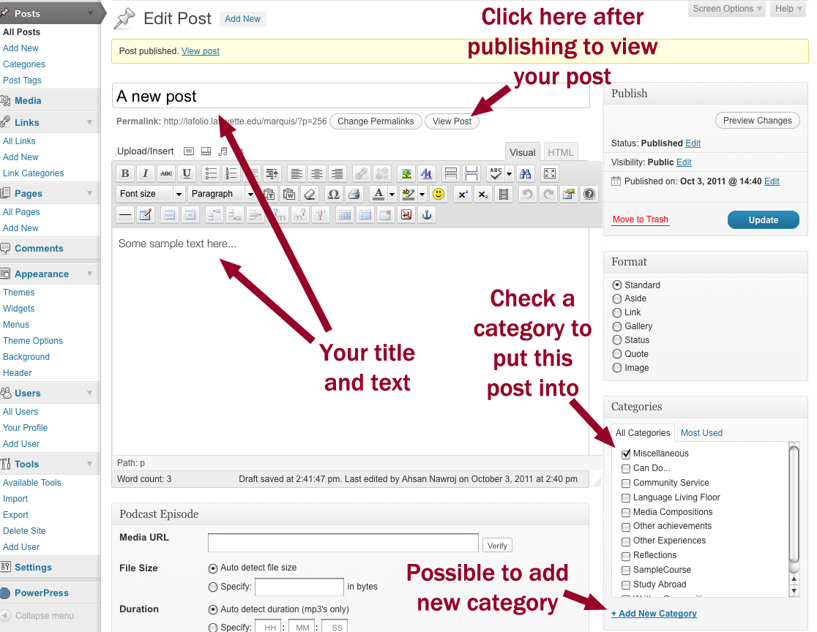
Figure 6: Adding a new post

----------------------------

6. Creating a Page…

A Page is an article, posted generally into its own web page and is defined by the important property that it contains relatively unchanging content. Unlike a Post that fits into a Category, a Page is meant to hold lasting information, updated only rarely, such as your Profile. Here is how you create a new Page:

- Click the “Pages” pin on the bar to the left of your Dashboard to expand it
- Click “Add New”
- Enter a title for this Page, and insert some text
- Click “Publish” on the right to publish this page
- Click “View Page” to view your new page!

- To place a link to this page on the header of the website, click “Menus” under “Appearance”

  - Click “View All” under “Pages” on the left and select your new page
  - Click “Add to Menu” to add it to the menu (You should see it appear on the right)
  - Drag the page up and down (click and drag) to place it in the appropriate order on the menu
  - It is also possible to make this page an item of a submenu of an existing page:
    - Click and drag the page to the left or right to put it under existing pages and make this page their submenu item

----------------------------

7. Managing Categories…

A category holds related posts on a particular topic. You can create categories by clicking “Categories” under the “Posts” section on the left side of the dashboard, or when you are making a post itself. For the latter technique, please see Section 5 (“Creating a Post”). To create and manage “Categories” when you are done making posts or before you begin one is as follows:

- Click the “Categories” under “Posts” on the left
- A list of existing categories will be visible on the right half of the display:
  - You can click the category title, or “Edit” under it, to open the category details
    - You can add a “Description” of this category here
    - This description will show up at the top of all the posts as a fixed piece of text. This description will not be moved down the visible web page as you keep adding incoming posts, so if you wish to write a short piece about the category itself that describes the posts in it (and you want it always visible when your category is clicked), you can write that here.
  - “Quick Edit” allows you to change the name of the category
- It is possible to add an entirely new category (to organize existing posts or to begin to add new ones)
  - Type in the name and a description on the left half of the “Categories” display
- To place a Category on the web page header, you must add it to the menu, and the technique is identical to adding a Page on the header, described in Section 6 (“Creating a Page”).

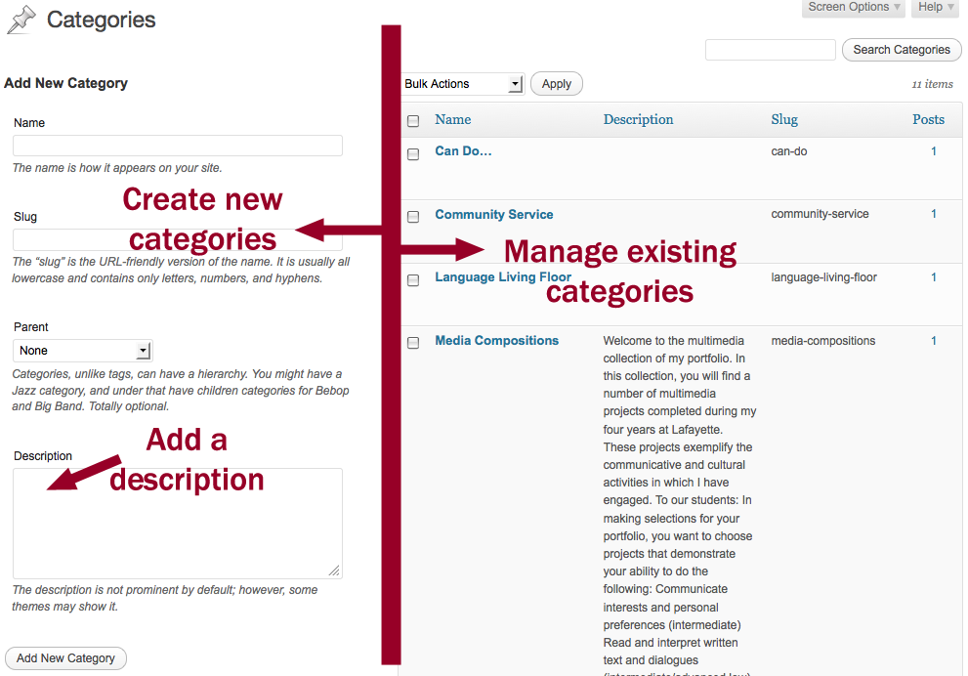
Figure 7: Adding and managing categories
----------------------------

8. Adding Media to your web pages…

An important aspect of your web page is digital media, and there are a number of different types (and formats) of media items you can add to your pages and posts.

First you will have to add media files to your web site, and this creates a repository online with your media items. You can choose from this repository to put items in your web pages when you need.
- Click “Media” on the left hand sidebar on the dashboard
- Click on “Library” to see the current media files on your site
- To add a new media item, click “Add New” on the left-side bar under “Library”
- Click “Browse” and select your media item, and then “Upload” to move the file from your computer to the website
- Please note that the following file formats are accepted by the site at this time and can be reliably added to your website:
  - Images: (.jpg), (.png)
  - Movies and Videos: (.flv), (.mov)*
  - Documents: (.doc), (.docx), (.pdf)

*.mov files made in QuickTime and PhotoBooth will be reliably visible on all platforms, if there are .mov files created from other software such as iMovieHD, etc. please convert them to .flv format to be sure that they will be visible on all browsers and operating systems

The most reliable video format is ”.flv”, and to convert other video formats to this one, you can use Adobe Media Encoder, which is installed on all the FLLRC machines, or a number of other open-source software as well.

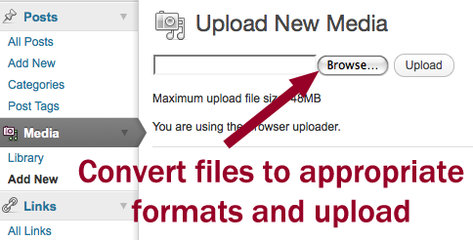
Figure 8: Adding a new media item to your gallery
----------------------------

9. Adding external Links to your web pages…

A convenient option for the footers and sidebars of your web pages may be the listing of some useful links to external web pages. For example, this may be useful to connect your web page describing a course you have taken to the Course website hosted by your Professor giving that particular course.

To add Links, click on “Link Categories” under “Links” on the dashboard. Create a new Category to store your links in by entering the Name and at least a short Description of the category of links. An example category may be “Course Sites”. Click “Add New Link Category” to add the category of links.

Links can be displayed by categories only, so if you would like to display certain links and not others- or have the option to do so, use different categories for different type of links. (eg. One Link Category for all your courses, another for external language assessment pages, etc.)

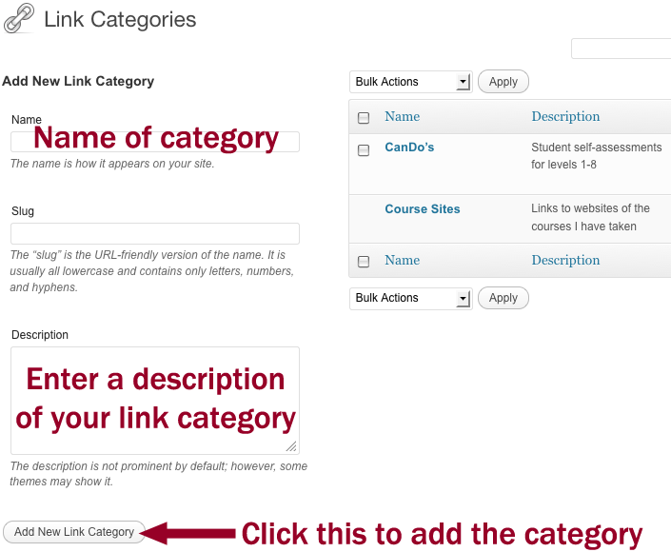
Figure 9: Adding a Link Category

Once you have your new category of links, you can add individual links to this category by clicking “Add New” under “Links” on the dashboard.

- Enter a Name to easily refer to the link on your page (the entire URL is not shown as the link, just this name)
- Enter a description of this particular link
- Select the category (or categories) to file this link under

Click “Add Link” on the right to add this link to your selected categories.
Repeat this process as many times as required and add as many links as you want in this category. Now we can make individual categories visible on the web page…

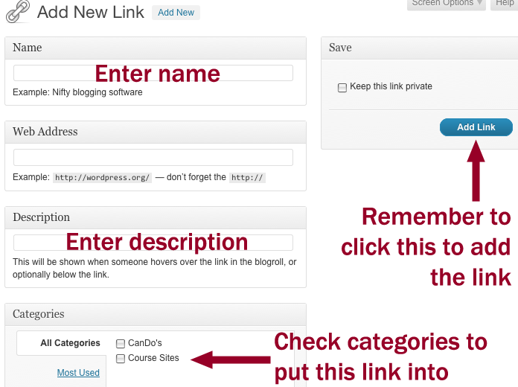

To make links visible on your web pages, we must activate a “Link Widget”. This can be found by clicking “Widgets” under “Appearance” on the dashboard.

Let us walk through adding this widget of links to the bottom of the page.
- Click on “Footer Area One” on the right side of the page: the area to open up showing what is already in this Footer Area.
- Click and drag “Links” from the central window titled “Available Widgets” onto your “Footer Area One” space.
- Once you see the “Links” widget added to the Footer Area, click on the arrow button to expand the Links description. Select from the list the particular Link Category you want to display on this widget.
- Click “Save” to update the widget.

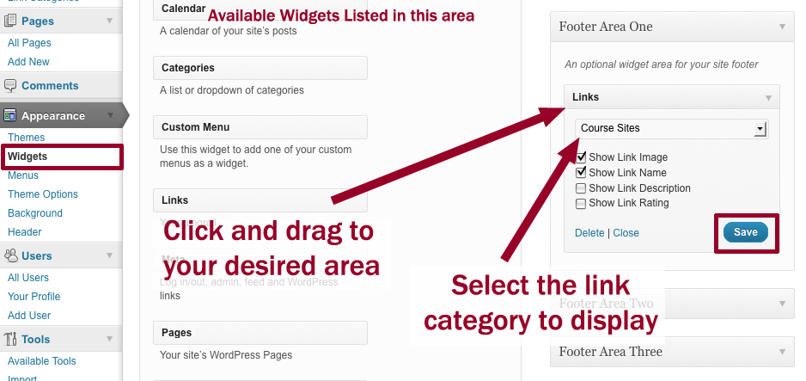
Figure 10: Adding a widget to hold a particular Link Category

To add multiple Link Categories:
- Option A: stack the Categories vertically:
  - This is more appropriate when you add links to the Sidebars
  - Click and drag another “Links” widget from the “Available Widgets” space and carefully place it after your current Link Widget on the Area you put your first widget on- but still in the same area
  - Select the category to display on this Link Widget as described before
  - Remember to click “Save” to update the widget
- Option B: list the Categories (and associated links) under separate columns:
  - This is more appropriate when adding multiple Link Categories in the Footer
  - Click and drag another “Links” widget from the “Available Widgets” space and carefully place it in another Footer Area. For example, with “Course Sites” in “Footer Area One”, we can add “Can-Do’s” to “Footer Area Two”
  - This creates two separate columns of Links from different Link Categories

----------------------------

10. Converting video files to .flv (flash) for display…

The most reliable of video file formats for your web pages on the lafolio site is (.flv) flash. Since video files you may generate from QuickTime, iMovieHD and PhotoBooth, etc. may not be in the necessary format, you can use the Adobe Media Encoder CS4 installed on all the Foreign Language Resource Center computers:

Figure 11: Media encoder icon on the Dock of FLLRC Macs
To convert files:
- Open Adobe Media Encoder CS4
- Click “Add” on the Media Encoder work panel on the right
- Set the “Preset” value to “FLV – Web Medium (Flash 8 and Higher)” by selecting the downward pointing arrow on your media item under “Preset” column
- Add as many media items as you need to convert: use the same video format for all of them
- Click “Start Queue” on the bottom right of the Media Encoder work panel
- Your media file, converted to the specific .flv format, is going to be saved in the same folder as your original file.
- Your original video file has not been replaced, so you can use it for other purposes in the high-quality formats you produced it in.

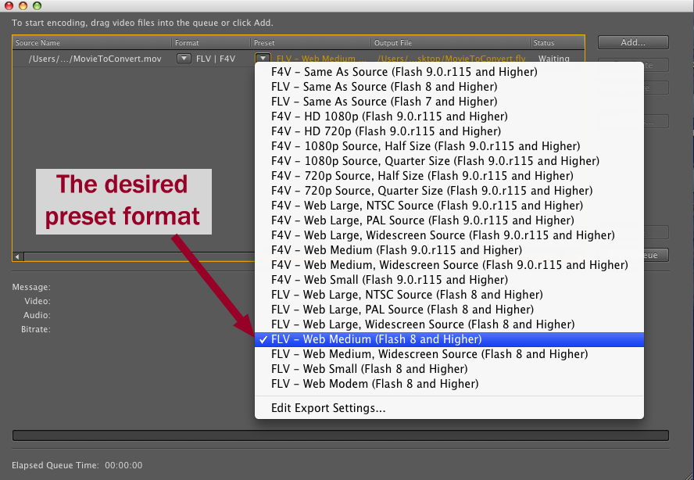
Figure 12: Selecting the right "Preset" format

----------------------------

11. Working with Galleries

“Galleries” is a construct that is present in Wordpress to display a tile of images on your web pages. These images are shown as small thumbnails to the full-sized images, which are displayed when the thumbnails are clicked. To set up a new gallery, follow the steps listed:
- Click on “Add New” under Posts on the dashboard
- Give your new gallery a name: this is the name of the post
- Click “Add an Image”, which is a little button next to the label “Upload/Insert” on the editing tool panel right above the text area
- To create a gallery, you must ‘Upload’ images from your computer, even if you have previously added them to your media library
  - On the “From Computer” tab, click “Browse” and find the images you wish to add to your gallery
  - Click “Upload”
  - As you upload each image, notice that a new tab has opened up in this image-upload box, “Gallery” with the number of images currently in the gallery shown in parentheses

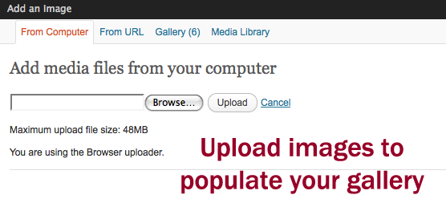
Figure 13: Upload all the images from your computer, even if they are in the media library of the web site already

- Once the images are all uploaded, click the newly formed “Gallery (image_number)” tab to look at your gallery and its image collection
- In the section titled “Gallery Settings”, for label “Link thumbnails to:” select “Attachment Page”
- Choose the number of columns to take for the gallery (this is only a suggestion to the software, and may not be exactly what is shown)
- Click “Insert gallery” at the bottom of this window to insert your gallery onto the webpage
- To edit this gallery further, click on the “Add an image” tab as before and you will be shown your current gallery in the same “Gallery (image_number)” tab, and you can make changes here. Don’t forget to click “Update Gallery Settings” when you make changes.
- Add text above or below your gallery as desired just like in any other post
- Select any categories this gallery should be listed under
- Click “Publish” and your gallery will now be visible along with all other posts in the category you selected!

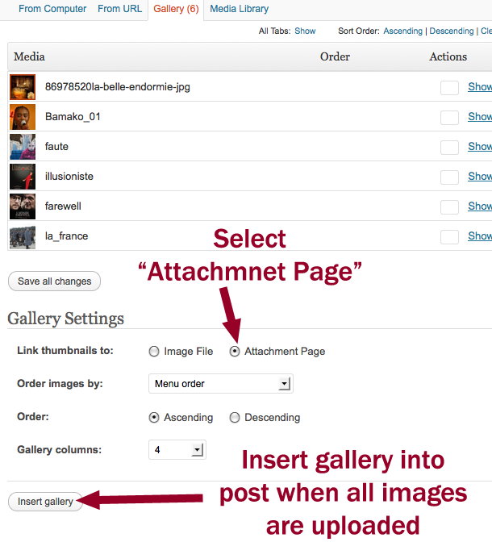
Figure 14: Insert gallery when settings are set and all images uploaded

Note: If you want to link to a webpage from a gallery “like” thumbnail, do not use a gallery. Use a table with the appropriate number of cells. Insert the images and link to pages.

