Converting video files to .flv (flash) for display…

The most reliable of video file formats for your web pages on the lafolio site is (.flv) flash. Since video files you may generate from QuickTime, iMovieHD and PhotoBooth, etc. may not be in the necessary format, you can use the Adobe Media Encoder CS4 installed on all the Foreign Language Resource Center computers:

Figure 1: Media encoder icon on the Dock of FLLRC Macs
To convert files:
- Open Adobe Media Encoder CS4
- Click “Add” on the Media Encoder work panel on the right
- Set the “Preset” value to “FLV – Web Medium (Flash 8 and Higher)” by selecting the downward pointing arrow on your media item under “Preset” column
- Add as many media items as you need to convert: use the same video format for all of them
- Click “Start Queue” on the bottom right of the Media Encoder work panel
- Your media file, converted to the specific .flv format, is going to be saved in the same folder as your original file.
- Your original video file has not been replaced, so you can use it for other purposes in the high-quality formats you produced it in.

- 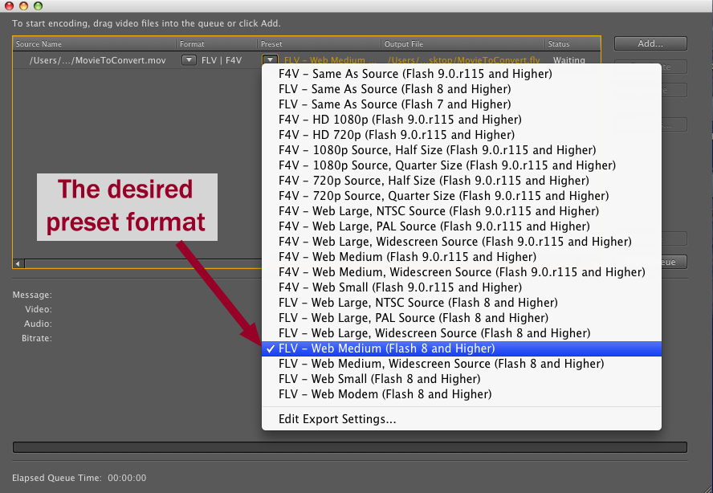
- Figure 2: Selecting the right "Preset" format

