Vietnam: A Second Look
Fred Benson '59
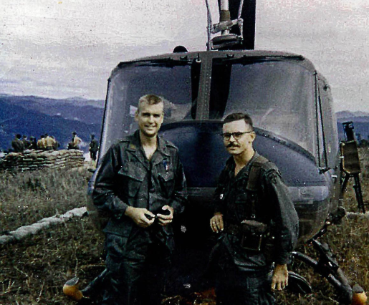

Monday, Noon, March 21st
Gendebien Room, Skillman Library
Lunch Provided

Prior to starting his business career, Fred Benson served in the United States Army for twenty years with responsibilities including senior positions in the offices of the Secretary of Defense and the Secretary of the Army, as well as aviation and ground command assignments in Korea, Vietnam, and Alaska. He retired as a full Colonel.

In 1966-67, he was the commander of a helicopter unit in the 1st Cavalry Division in Vietnam where he earned two Distinguished Flying Crosses, a Bronze Star Medal for Valor, and seventeen Air Medals.

Fred returned to Vietnam after an absence of 43 years last April along with 17 other former White House Fellows. What these travelers on this State Department-endorsed trip witnessed was the birth of a new nation: not a perfect transition from the old, but one more impressive than might have been imagined.

Fred will take us along with him as he describes, through pictures, what he learned about the Vietnamese and their new country, and what he personally experienced in this his return to the battleground that roiled our nation so long ago.

