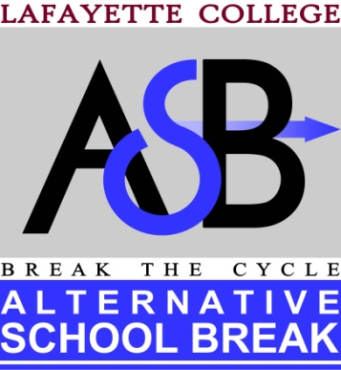

2014-2015 Returning Member Application
FORM 2
Applications are due no later than 11:59pm on Friday, April 25th. Please email asbclub@lafayette.edu with the subject line: Last Name, First Name, ASB Application. Include Form 1 and Form 2 as either Word or PDF attachments, saved as: Last Name, First Name, Form 1 and Last Name, First Name, Form 2. Do not include your name anywhere on Form 2 (except for the title of the document).

Part I: Background Information
Gender:
Class Year:
Major(s):
Previous ASB trip(s):
Do you have a Driver’s License? (If so, please answer the next three questions)
How long have you had it?
Are you Van Certified?
Are you willing to drive on an ASB trip if needed?

Please list activities on campus in which you are currently involved, including any jobs:

Trip Description
Fall Break, Oct. 10th – 14th, 2014
Urban Poverty and Community Development: Philadelphia, PA
This trip will focus on the role of city government in improving the quality of life for city residents, particularly those that reside in areas affected by poverty. We will be partnering with PhillyRising, an organization whose goal is to ensure that all of Philadelphia’s neighborhoods are desirable places to live and work. PhillyRising brings together City agencies and community partners to address chronic crime and quality of life concerns in neighborhoods around the city and coordinates the actions of these partners to help community members realize their vision for their neighborhoods. Volunteers can expect to be involved with service projects like painting park benches and murals, working in a community garden, and assisting with after-school programs, while learning about how urban poverty affects the development of communities.
Cost: $200 Team Leader: Aubrey Jones ‘16

Part II: Short Response
Please the following question in approximately 500 words. ASB values applicants who put time and thought into their responses.

- Reflecting on your past ASB experience(s), describe the integration of each component of the triangle of quality community service and how this shaped your development as an active citizen.
The following link may be helpful:
http://www.google.com/url?sa=t&rct=j&q=&esrc=s&source=web&cd=2&ved=0CDIQFjAB&url=http%3A%2F%2Fstudentactivities.tamu.edu%2Ffiles%2Flsc_agencies_triangle.pdf&ei=IEtMU-XeEaHy0gHfzIGAAw&usg=AFQjCNEbsl73_43-50Hs_pcythirFRqLWw&bvm=bv.64542518,d.dmQ

Short Response Answer:

