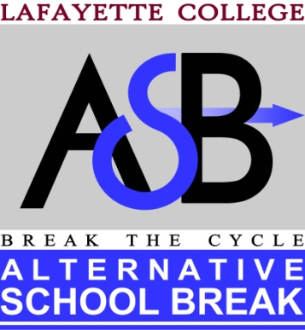

2014-2015 Application
The Alternative School Break Club’s goal is to empower the Lafayette College community to create positive change and foster passion for civic engagement through alternative break experiences. Our goal is to provide transformative experiences consisting of strong direct service, education and reflection. We believe the most successful teams consist of a diverse group of participants, because different perspectives contribute to meaningful dialogue and reflection. Our selection process is anonymous. Therefore, there are two parts to this application. Form 1 is included below and Form 2 is a separate document. Please email asbclub@lafayette.edu with the subject line: Last Name, First Name, ASB Application. Include Form 1 and Form 2 as either Word or PDF attachments, saved as: Last Name, First Name, Form 1 and Last Name, First Name, Form 2. Do not include your name anywhere on Form 2 (except for the title of the document). Applications are due no later than 11:59pm on Friday, April 25th.

FORM 1

Name (official, as it appears on Driver’s License/Passport. If you are selected, we will need your official name for ticketing purposes):

**Note: One of our goals in organizing a fall break trip is to increase participation in ASB among those who ordinarily would not be able to go on an interim or spring break trip (ex. athletes, students studying abroad in spring of 2015, etc.). While we will give preference to those applicants, all are welcome and encouraged to apply. If placed on the fall break trip, you will be ineligible to join an interim or spring break trip. If you apply but are not placed on the fall break trip, you will still be able to apply for the interim and spring break trips (applications will be available in the fall).

