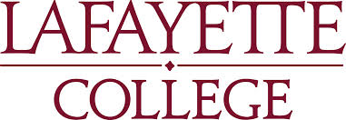

Office of Art Development
________________________________________________________________________________________________________________________________________________________________________________________________________________________________________________________________________

Easton, Pennsylvania 18042
www.lafayette.edu

To whom it may concern:

Hello, my name is Aidan Guilfoyle, and I am a junior at Lafayette College. I am an Art and Psychology double major, with a minor in French. Currently I am enrolled in an art class called Materials and Methods, where we look at various approaches to producing art, often ways that one would never think of. Currently we are studying performance art. We have been researching and looking into many well-known performance artists to learn about the craft and find inspiration for our own works.

Our research culminates into a project of our own, which is the reason that I am writing you today. I was hoping that Giant Food Stores would be willing to donate meat for my project. I would be so grateful and thankful for any help that I can receive. My project speaks to a lot of different subjects (my childhood, femininity, objectification, and just plain strangeness), and I am hoping that the viewer can decide how it best applies to his/her life. If you have any meat that is nearing the sell-by date, or any excess, or anything you would be willing to donate to my project, I would really appreciate it. Specifically I was looking for any type of a raw slab of meat, and also a lot of linked meat that I am planning on stringing together. If you do not have any of that available, I will take anything! I have been to several shops that have been unable to help me, so I am very flexible.

My project has the potential to be something really intriguing and thought provoking, and I can send you pictures when I am through with it all. I am hoping to execute it at the beginning of next week, so I can come by at your earliest convenience. Thank you so much for your consideration, generosity, and support of the art—as strange as it may be.

Sincerely,

Aidan Guilfoyle
Lafayette College

